# Pre Bill Account Review List

It shows all the **PRE-BILL** accounts of different hospitals which have been assigned to an   
auditor. For viewing accounts of a particular hospital, select the hospital ID from the filter panel available on the left side and the application will display all the accounts of that particular facility.

If no account is pending for review, the auditor will get the message **“No Account Review is   
 “Pending for the Facility”.**

When user select “Pre Bill Account Review List”

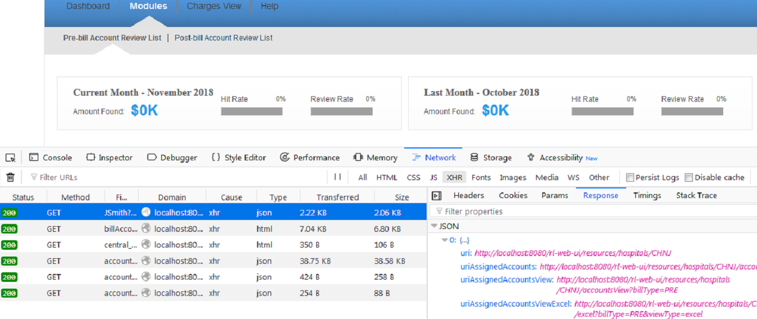

preBill.js -- preBill.initialize() Method

* Hospitals are loaded like (Pre, Post and CCI Hospitals).
* These contains URI’s for the corresponding hospitals.
* These URI’s are then used during Ajax calls to get further information for specific Hospital.
* After loading hospital URI’s the below methods are called.

preBill. drawScreen() Method

* Required templates for this page are loaded through **getSYNC** method.
* centralAuditorfilter.initialize() method is called to draw filter required for this page on the left panel.

preBill. loadCategoryDropdown() Method

* This method loads all the account categories

preBill. bindFunctionality() Method

* This method is used to bind all the event listener to the page.
* This method finally calls the **loadData** method to populate different parts of the screen (like categories, main accounts grid)

preBill. onFilterUpdate() Method

* This method is called whenever we update the filters on left panel changed.
* After this Central Auditor’s **updateScreen** method is called.

centralAuditorFilter.updateScreen() Method

* It calls the **constructURLdata** method which perform the below operations.
* It reads all the selected filter options on left panel.
* It creates the new filter parameters map and save these filters in localStorage.