

Global Dashboard

USER MANUAL GUIDELINES

2018

**Revision History**

|  |  |  |  |  |  |  |
| --- | --- | --- | --- | --- | --- | --- |
| **No.** | **Version** | **Release Date** | **Author** | **Reviewer** | **Revised Sections** | **Remarks** |
| 1 | 1 |  | Saurabh Goel |  |  |  |
|  |  |  |  |  |  |  |
|  |  |  |  |  |  |  |
|  |  |  |  |  |  |  |

|  |
| --- |
|  |

Table of Contents

1. Introduction 3

2. Filter Selection in all dashboard Reports 3

3. Current selection of filter 4

4. Account Volume Analysis Dashboard 4

5. Change Analysis Dashboard 6

6. Department Variance Analysis dashboard 8

7. Hit Rate Dashboard 8

8. Payment Adjustment Dashboard 11

9. Prediction Analysis 13

1. Introduction

Qlick View dashboard is basically used by Admin user, which is internal to the system. This dashboard keeps track of all the activity of both Revenue leakage application as well as Physician recon application. For example

* Account Volume Analysis Dashboard
* Charges Analysis Dashboard
* Dept Variance Analysis Dashboard
* Hit Rate Dashboard
* Payment Adjustment Dashboard
* Prediction Analysis

# **Filter Selection in all dashboard Reports**

Bottom left corner of each dashboard we have filter panel available. It is showing all the field which is filterable and we can change as per requirement. When we change any filter, all the widget will refresh the data based on selected filter. We can select multiple filter. Filter is coming based on the field link to the DB. We can add new filter also.

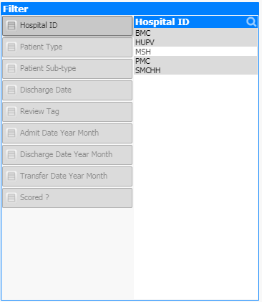

# **Current selection of filter**

Top left corner we have current selected filter available. Widget data is based on current selected filter. We can remove/modify the current selected filter and based on that widget data will refresh.

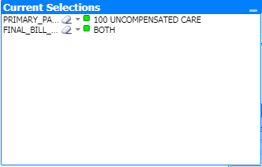

# **Account Volume Analysis Dashboard**

It consists of multiple widgets. Each widget is expandable and we can download that data in excel format.

* Facility
* Facilities by review tag
* # of Unique account in review tag
* Patient type
* Financial class
* LOS
* Transfer data and Discharge date
* Primary payer description
* Account count by discharge date
* Account count by transfer date
* Unbilled accounts distribution
* Transfer date by weekday
* Account by transfer date – discharge date
* Facilities by scorable population – Pre Bill
* Facilities by scorable population – Post Bill
* Transfer date – Discharge Date Distribution
* Flexible Pivot Table

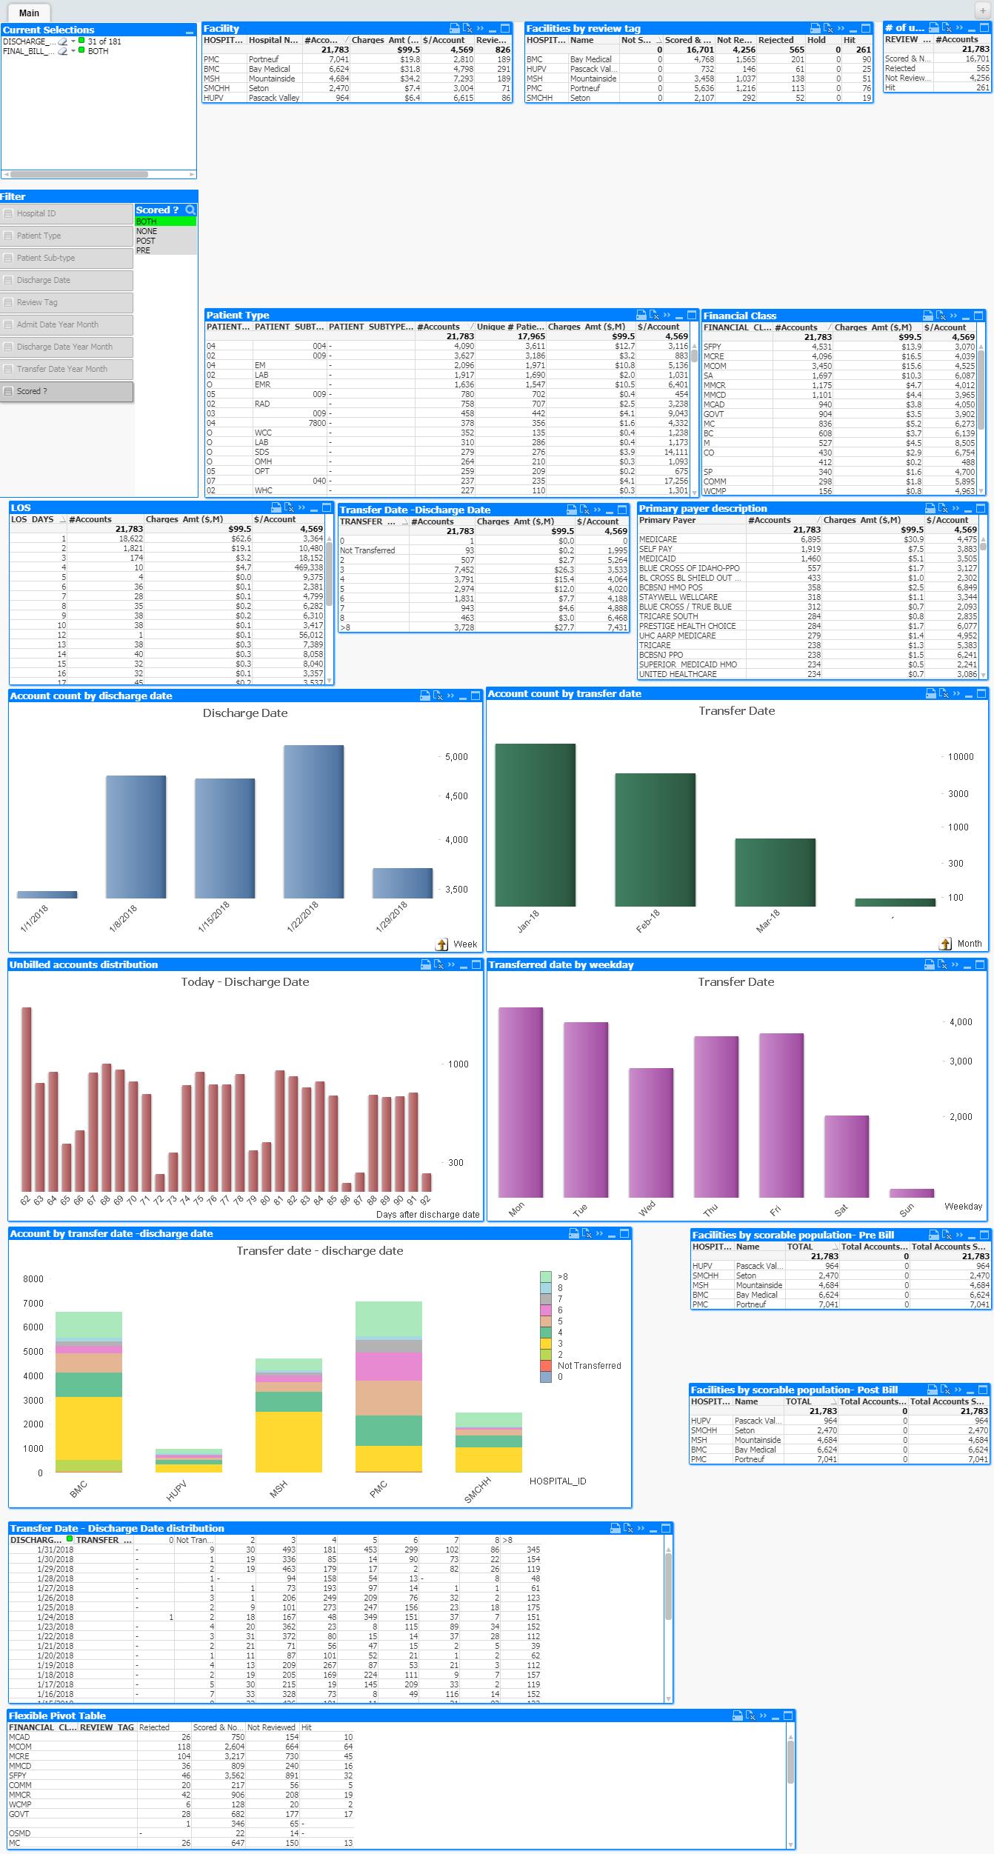

# **Change Analysis Dashboard**

* Hospital-wise distribution
* Hospital – Dept Distribution
* Revenue Code distribution
* HCPC code Distribution
* Charge Code Distribution
* Patient Type Distribution
* Patient Sub Type Distribution
* Trend by Charge Date
* Trend by Post date
* Transfer – Discharge date Distribution
* Post-date – Charge Distribution
* Post-date – Transfer Date Distribution
* Post Date – Discharge date Distribution
* Hospital account Distribution
* Post-date by weekday

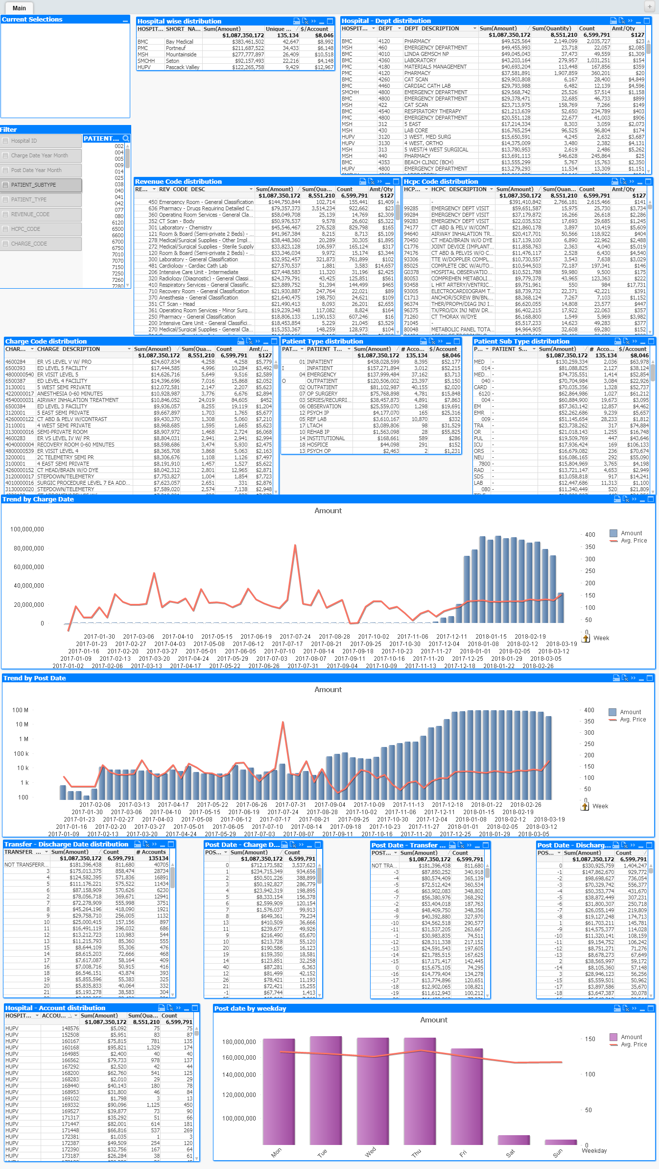

# **Department Variance Analysis dashboard**

* Charge Code distribution

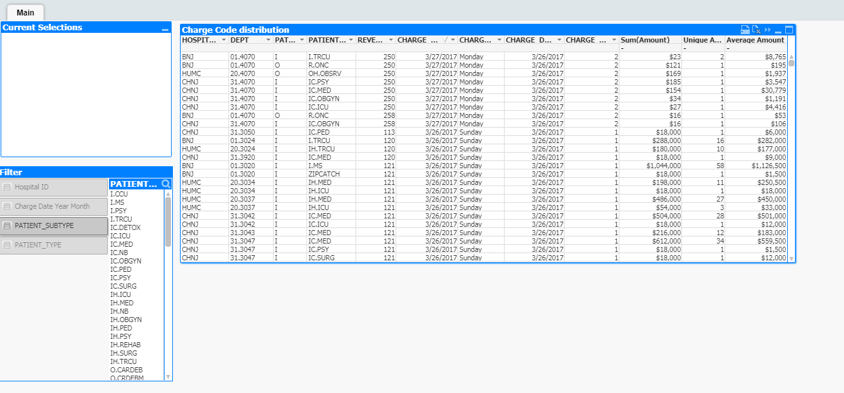

# **Hit Rate Dashboard**

* Hospital – Pred
* Bill Type
* Pred Classification
* Auditor
* Comments
* Patient Type
* Reason
* Week
* ENS Range
* Method
* Pred Code
* Week table
* EV Range
* Found By Response
* Payer Description
* Payer Group
* Hospital
* Patient Sub type
* Detail data

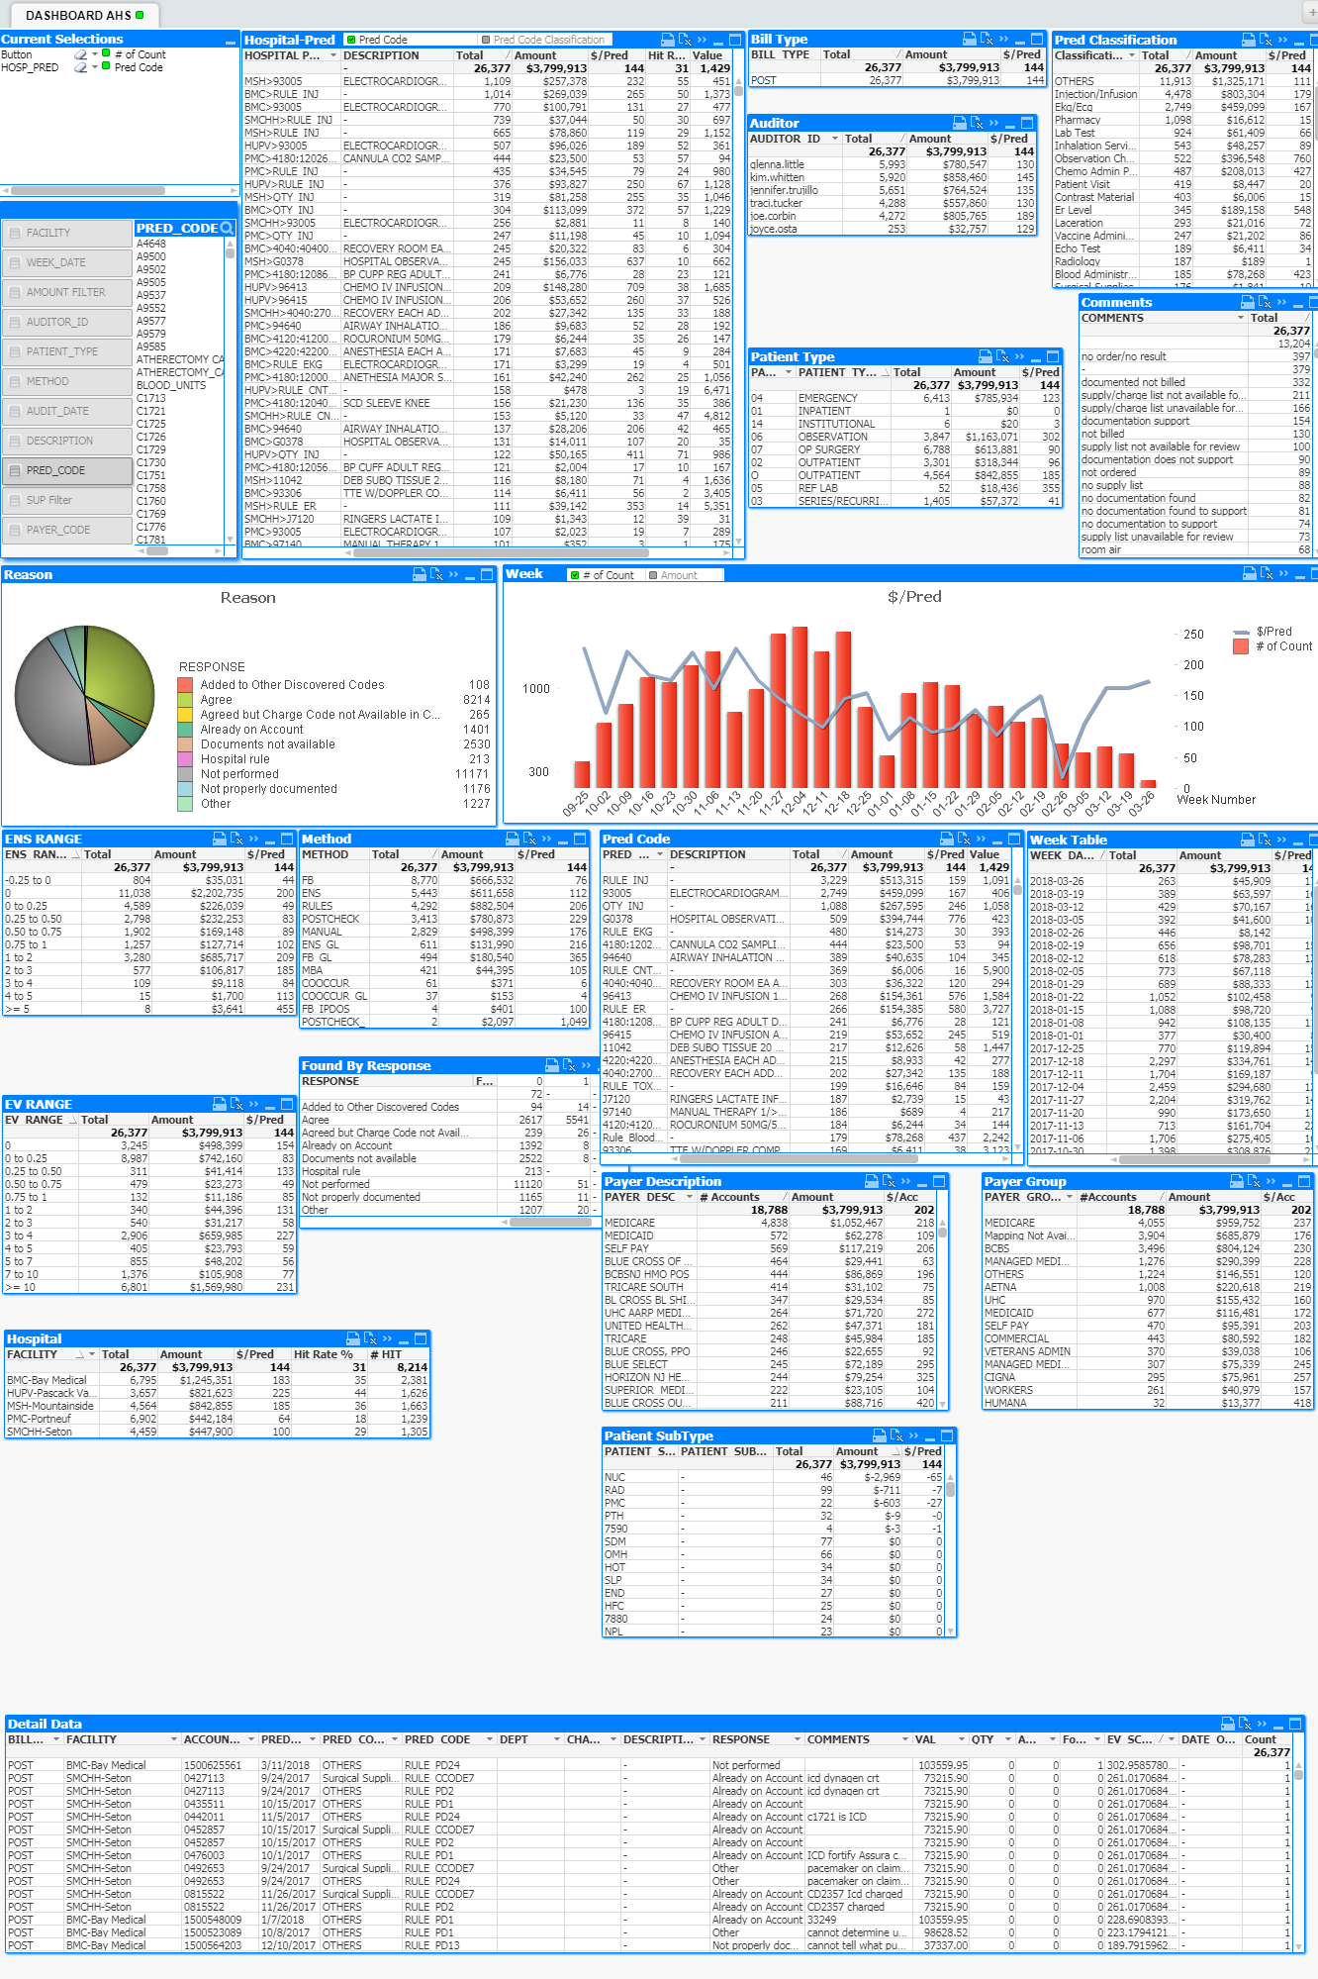

# **Payment Adjustment Dashboard**

* Account Balance Range Information
* Hospital Distribution
* Payment to charge Distribution
* Today – Transfer date
* Primary Insurance information
* Payer Type Distribution
* Transaction - Bill Date
* Account Information
* Today – transition Date
* Primary Payer Classification
* Payer Classification

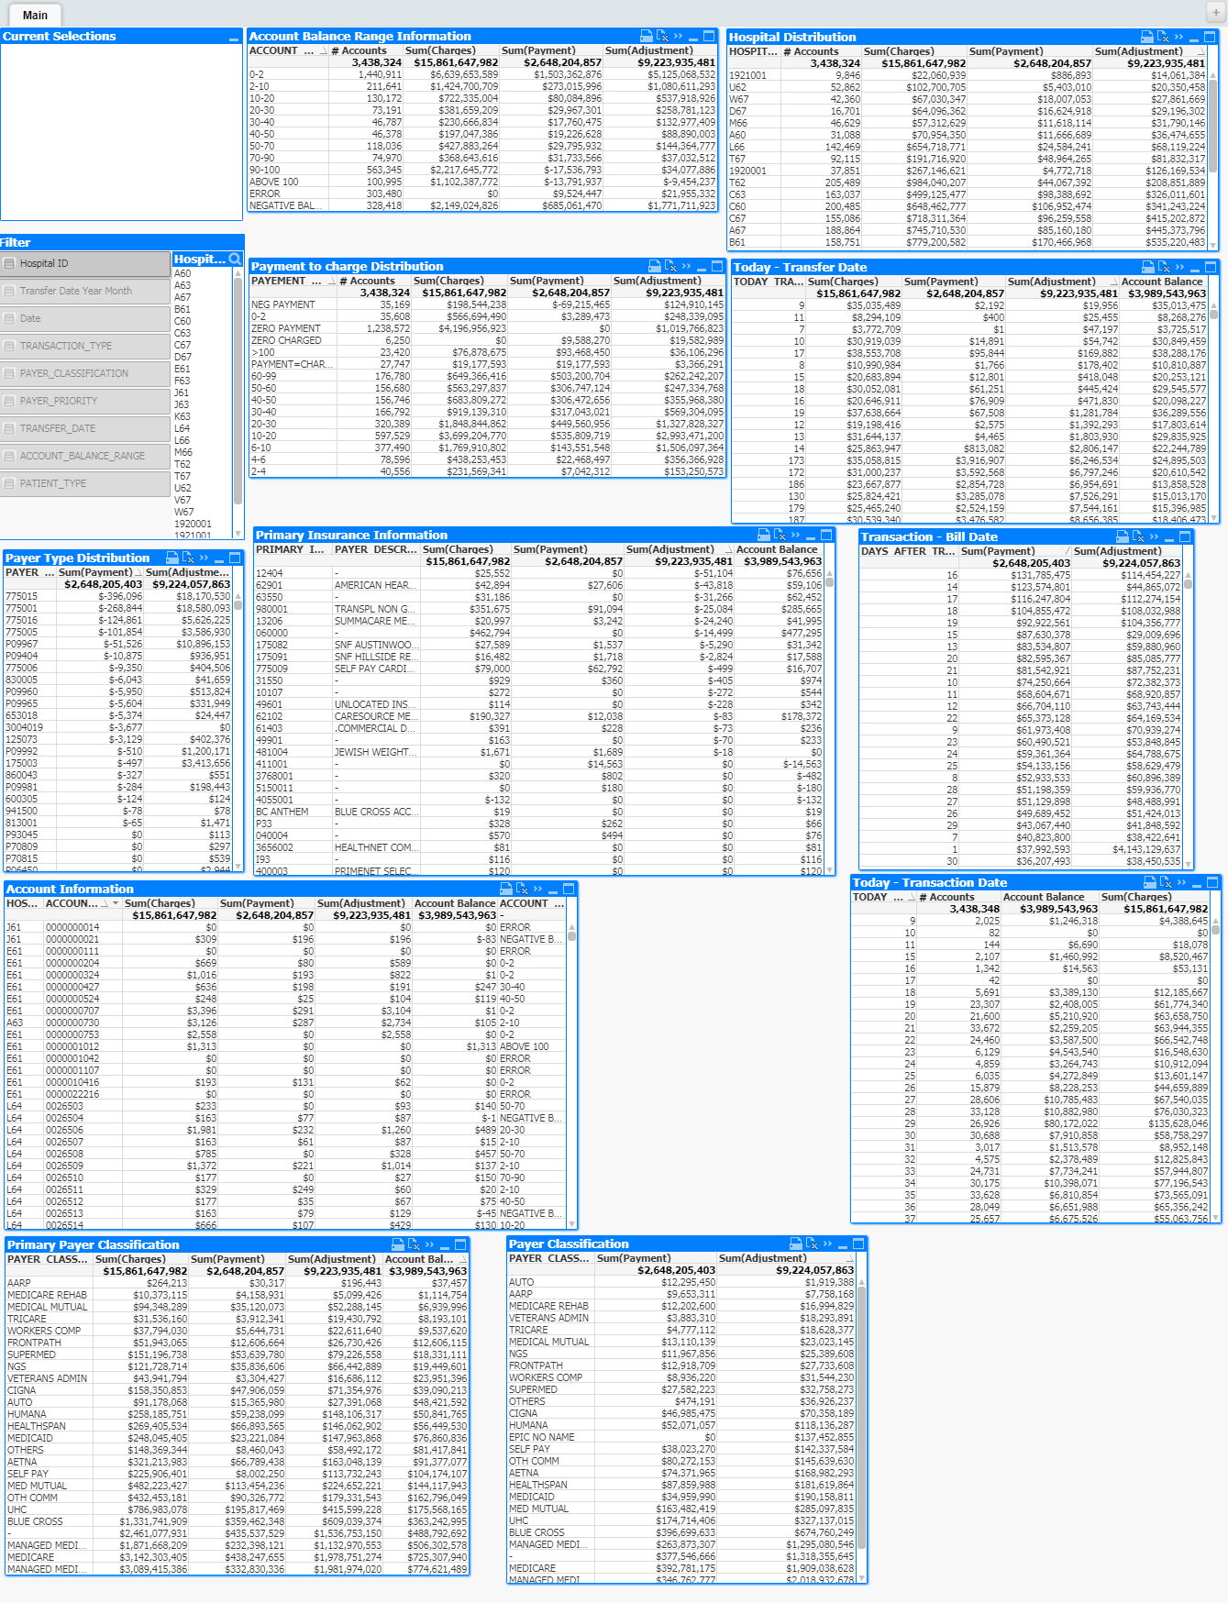

# **Prediction Analysis**

* Distribution of pred code By Send Flag
* Pred Code Distribution
* Distribution of Facility -Pred Code By Sent Flag
* Sent Flag Distribution
* Distribution of Pred date by sent flag
* Suppression Rules
* EV Score vs FB Score
* Method Type Distribution
* Code Distributions
* EV score Distributions
* FB Score Distributions
* ENS score Distributions
* Pred code Classifications

