**Getting Started in Revenue Leakage Platform**

Login

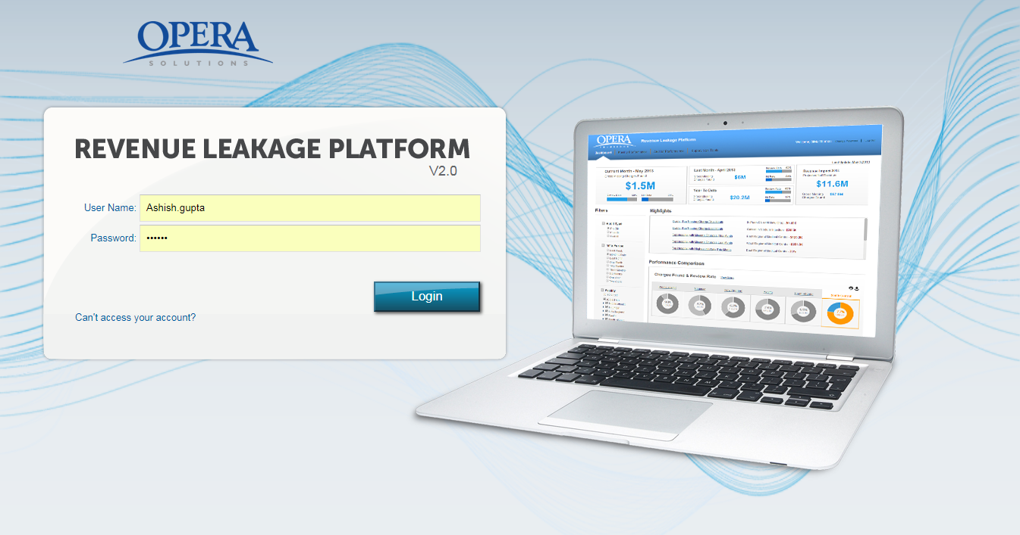

**Step 1:** The application can be accessed by entering the following URL into the address box:

_________________________________________

**Step 2:** Enter your “**Username”** and “**Password”**.

**Step 3:** Click “**Login”.**

**Step 4:** After entering the correct username and password, user is redirected to the Home page of Revenue Leakage Platform.

**Note:** Entering the wrong username and /or password three consecutive times will lock the account and then needs to be unlocked by other administrator.

After successful login index.html file is called.

Index.html

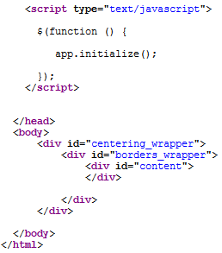

Inside Index.html app.initialize() method is called.

App.js -- App.initialize() Method

* Some global Ajax and other setup are done here. Like Ajax Start, Block UI, AjaxError, Disabling the browser back button etc.
* The global Ajax methods are called during every Ajax call that we made throughout the Application.
* Below methods are called here to draw the landing page.

App. loadBundles() Method

* This method load the messages_en.properties file and store it in a global variable in the form of a JSON map key, value pairs so that these will be available globally throughout the application.
* All the messages that we are going to use in the application are not hard coded instead stored in the properties file in the form of key value pair.

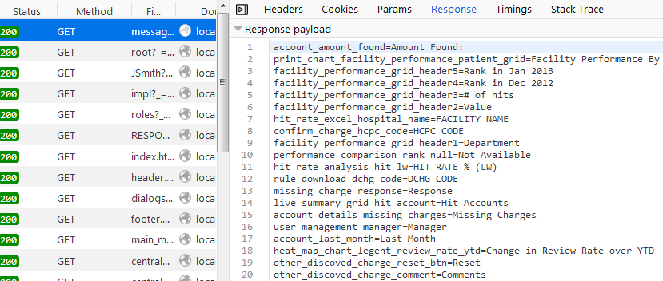

App. initialResourceLoad() Method

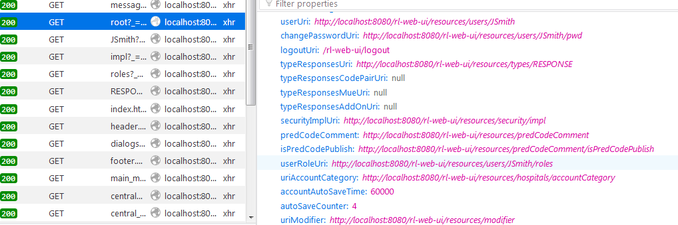

* This method loads all the resources and store it in a global variable in the form of JSON map with key, value pair. Later we use all these resources for Ajax calls.

App. initialAppDraw() Method

* Header, Footer template are called here with getSYNC('common/templates/header.html', function (data) {}).
* **getSYNC** is a wrapper function written for getting the html templates with Ajax calls.
* Page structure is complete here. Three sections have been prepared here for Header, Content and Footer.

App. checkForRole() Method

* The logged in user role is checked here.
* Menus are drawn based on the roles (Admin, Auditor, Supervisor, Executive etc.)

App. screenManager.showScreen() Method

* This method is used to draw the initial landing for the corresponding user.