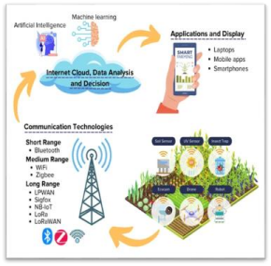

Smart Farming Enhancing Precision Agriculture With Climate Prediction Model

**Introduction**

This project harnesses the power of Artificial Neural Networks (ANN) to advance precision agriculture by predicting climate conditions with remarkable accuracy. Through data-driven insights, our model helps farmers make proactive, sustainable decisions—optimizing crop yields, water usage, and resource management. By integrating ANN-based climate predictions, smart farming adapts to changing environmental conditions, supporting resilient and efficient agricultural practices. Explore how cutting edge AI technology is shaping the future of farming and empowering farmers to cultivate smarter, healthier, and more productive fields. Join us as we explore the future of agriculture! This poster delves into how smart farming techniques, combined with climate prediction models, are revolutionizing precision agriculture. By integrating cutting-edge data analytics and forecasting tools, farmers can make informed decisions, optimize crop yields, and reduce environmental impact. Discover how technology is empowering agriculture to adapt to changing climates and meet global food demands sustainably. Embrace the future of farming with precision, resilience, and innovation!

**Algorithms Used**

****Arima 

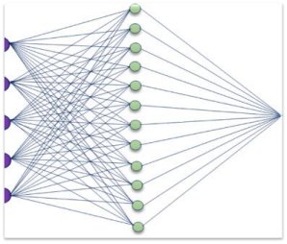

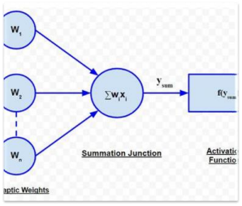

Ann and relu for

idden layer

**Datasets Used**

Synthetic Dataset DetailsDate: Ranges from January 1, 2023, to December 31, 2023.Temperature: Simulated as a seasonal pattern with a sinusoidal function, adding some random noise for variability.Rainfall: Another sinusoidal pattern representing seasonal rainfall, with added noise to mimic real-world fluctuations.Crop Yield: Generated based on a formula that relates crop yield to both temperature and rainfall, with additional random noise to represent variability.

**Key Components**

• Data collection and processing.

• ANN model development.

• Climate Prediction and Analaysis.

• Smart Farming System 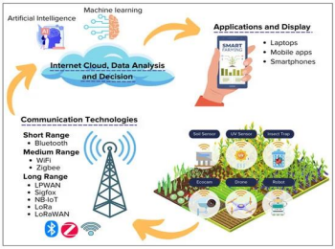

Integration

• User interface and Visualization

• Performance monitoring and

feedback

• Sustainability and impact

assessment

**Process of automation**

**1. Data Acquisition**: Collect real-time environmental data (e.g., soil moisture, temperature) using sensors. Install sensors in the fields to gather real-time data on soil moisture, temperature, humidity, light levels, and other environmental factors

**2. Data Processing**: Clean, normalize, and analyze the data before feeding it into the ANN model. Store the collected data in a central database or cloud system, ensuring easy access and organization for further analysis.

**3. Prediction and Analysis**: Use the ANN model to predict climate trends, influencing farming tasks like irrigation. Allow the system to learn from previous decisions, adjusting rules as it gathers more data to improve precision.

**4. Task Automation**: Automate irrigation, fertilization, and crop monitoring based on ANN outputs.

**5. Monitoring and Feedback**: Continuously monitor the system’s performance and adjust based on results.

**Inputs as X-Rays**

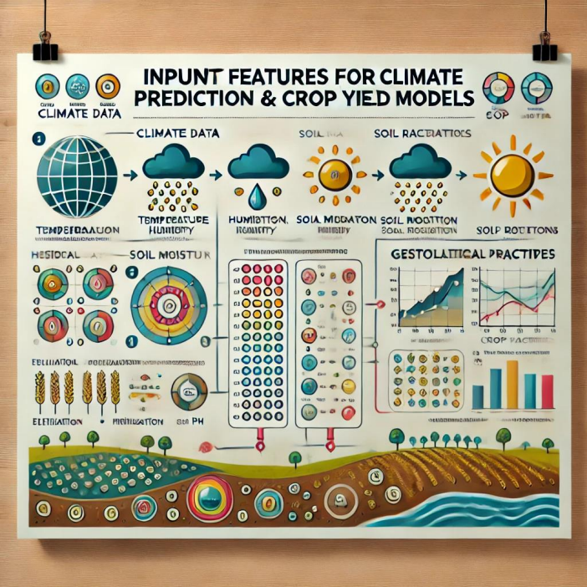

**Importance**

• The Smart Farming: Enhancing Precision Agriculture with Climate

**Future Applications**

The future applications of Smart Farming using ANN based climate prediction models are extensive and promise to further revolutionize agriculture. Beyond current uses in irrigation and fertilization, future advancements could allow these models to predict and manage pest infestations and disease outbreaks based on climate patterns, providing farmers with preventive strategies to protect crops. Integrating predictive models with regional agricultural databases and expanding to diverse crop types would enable broader adaptability, benefiting farmers across various climates and geographies. As technology advances, automated systems could leverage real-time data from additional sources, such as satellite imaging and advanced soil sensors, to make even more precise adjustments to farming practices. There is also significant potential to expand this model’s capabilities to track long-term environmental changes, helping farmers prepare for and mitigate the impacts of climate change over multiple seasons. Integrate with regional agricultural databases for broader applicability across different climates.

**Difference by Models**

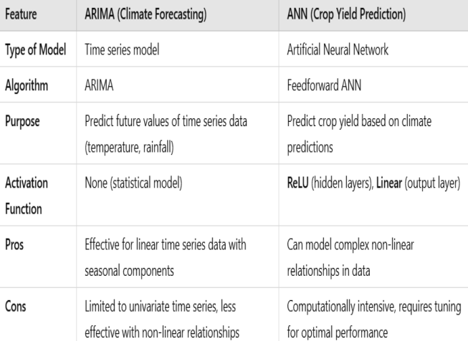

**Conclusion**

The integration of Artificial Neural Networks in precision agriculture stands to reshape farming as we know it, leading to smarter, more efficient, and sustainable practices. By providing actionable insights and automating critical tasks, this technology not only enhances productivity and crop quality but also promotes environmentally responsible farming. With its capacity to adapt to diverse farming needs and its potential for future innovation, this project contributes meaningfully to global food security and sustainability. As more farmers embrace smart technology, agriculture will become more resilient, efficient, and capable of meeting the growing food demands of an ever-evolving world.

**~~Team~~**

Prediction Models using ANN project holds significant importance for the future of agriculture, offering transformative benefits in efficiency, sustainability, and resilience. By optimizing resource use through data driven decisions, this approach enables farmers to conserve water, fertilizers, and pesticides, which reduces costs and minimizes environmental impact. Improved climate prediction allows farmers to better plan and adjust their practices, leading to increased crop yields and better quality produce. This adaptability is crucial in an era of climate change, where unpredictable weather poses a challenge to traditional farming. With accurate forecasting and automated systems, farmers can respond proactively to extreme weather, safeguarding crops and enhancing resilience. 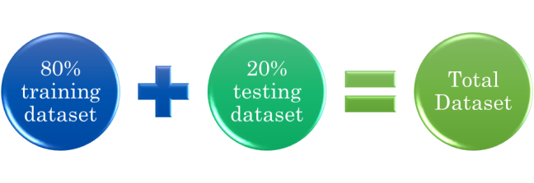

**Register No 1:** RA2211026010199 **Register No 2:** RA2211026010189**Register No 3:** RA2211026010163 **REGISTER NO 4:** RA2211026010181

**Name 1 :**

SHAIK SAMEER

**Name 2 :**

SHANKAR VADDE

**Name 3 :**

K.V. KUSHAL

**NAME 4:**

M.CHANDRA SEKHAR REDDY

**www.meteconferences.org**