***ADVANCED WEB TECHNOLOGIES***

***INDEX***

|  |  |  |
| --- | --- | --- |
| S. No. | Program Names | Page No. |
| 1. | Create a time table using HTML and CSS. | 02 |
| 2. | Create a static website for an online business which includes a registration page. | 09 |
| 3. | Create a static webpage for an online bookstore which contains a catalogue of available books. | 24 |
| 4. | Write a Javascript program to convert numbers to Roman numerals. | 39 |
| 5. | Write a Javascript program to validate a form. | 40 |
| 6. | Write a Javascript program to demonstrate pop-up boxes. | 50 |
| 7. | Create a simple calculator. | 58 |
| 8. | Create a portfolio website. | 63 |
| 9 | Write a Javascript program which takes an input of a number from a text box and converts it to words. | 70 |
| 10. | Write a program to implement Typescript classes with inheritance. | 73 |

***1. Create a time table using HTML and CSS.***

**index.html**

<!DOCTYPE html>

<html lang="en">

<head>

    <meta charset="UTF-8">

    <meta http-equiv="X-UA-Compatible" content="IE=edge">

    <meta name="viewport" content="width=device-width, initial-scale=1.0">

    <link rel="stylesheet" href="styles.css">

    <title>Timetable</title>

</head>

<body>

    <header>

        <h1>Timetable</h1>

        <h2>1st Year, <a href=https://www.sjc.ac.in/computerdepartment.php

target="_blank">M.Sc. Computer Science</a>, 2022-2024</h2>

    </header>

    <main>

        <table>

            <tr>

                <th>

                    Day/Time

                </th>

                <td>

                    9:15AM-10:05AM

                </td>

                <td>

                    10:10AM-11:00AM

                </td>

                <td>

                    11:05AM-11:55AM

                </td>

                <td>

                    12PM-12:55PM

                </td>

                <td>

                    12:55PM-1:50PM

                </td>

                <td>

                    1:50PM-2:40PM

                </td>

                <td>

                    2:45PM-3:35PM

                </td>

                <td>

                    3:35PM-4:30PM

                </td>

            </tr>

            <tr>

                <th>

                    Monday

                </th>

                <td>

                    AWT/ADBMS Lab

                </td>

                <td>

                    AWT/ADBMS Lab

                </td>

                <td>

                    AWT/ADBMS Lab

                </td>

                <td>

                    AWT

                </td>

                <td>

                    L

                </td>

                <td>

                    ADBMS

                </td>

                <td>

                    SPM

                </td>

                <td>

                    ML

                </td>

            </tr>

            <tr>

                <th>

                    Tuesday

                </th>

                <td>

                    ML Lab

                </td>

                <td>

                    ML Lab

                </td>

                <td>

                    ML Lab

                </td>

                <td>

                    CD

                </td>

                <td>

                    U

                </td>

                <td>

                    ML

                </td>

                <td>

                    ADBMS

                </td>

                <td>

                    Library

                </td>

            </tr>

            <tr>

                <th>

                    Wednesday

                </th>

                <td>

                    AWT/ADBMS Lab

                </td>

                <td>

                    AWT/ADBMS Lab

                </td>

                <td>

                    AWT/ADBMS Lab

                </td>

                <td>

                    SPM

                </td>

                <td>

                    N

                </td>

                <td>

                    CD

                </td>

                <td>

                    AWT

                </td>

                <td>

                    ML

                </td>

            </tr>

            <tr>

                <th>

                    Thursday

                </th>

                <td>

                    ML Lab

                </td>

                <td>

                    ML Lab

                </td>

                <td>

                    ML Lab

                </td>

                <td>

                    CD

                </td>

                <td>

                    C

                </td>

                <td>

                    AWT

                </td>

                <td>

                    SPM

                </td>

                <td>

                    Library

                </td>

            </tr>

            <tr>

                <th>

                    Friday

                </th>

                <td>

                    ADBMS

                </td>

                <td>

                    ML

                </td>

                <td>

                    AWT

                </td>

                <td>

                    SPM

                </td>

                <td>

                    H

                </td>

                <td>

                    ADBMS

                </td>

                <td>

                    CD

                </td>

                <td>

                    Library

                </td>

            </tr>

        </table>

    </main>

</body>

</html>

**styles.css**

body {

    font-family: 'Lucida Sans', 'Lucida Sans Regular', 'Lucida Grande', 'Lucida Sans Unicode', Geneva, Verdana, sans-serif;

    margin: auto;

}

header {

    padding: 5px;

    text-align: center;

    box-shadow: 10px 10px 8px #83dada;

}

table {

    width: 100%;

    max-width: 1500px;

    margin: 0 auto;

    box-shadow: 10px 10px 8px #5ca299;

}

table, th, td {

    border: 1px solid black;

    border-collapse: collapse;

    padding: 5px 3px;

    text-align: center;

}

a:default {

    color:rgb(14, 14, 85);

}

a:visited {

    color: #5ca299;

}

a:hover {

    color:rgb(189, 125, 169);

}

**OUTPUT**

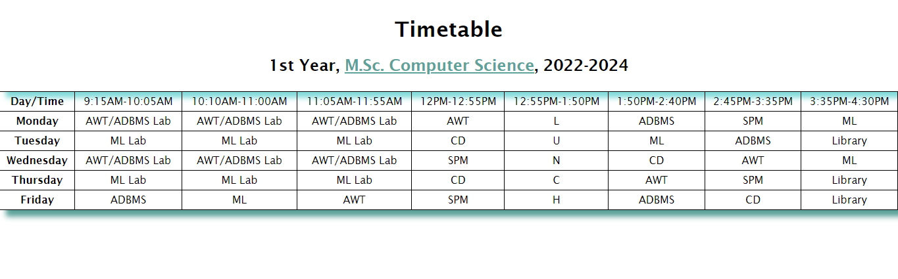

***2. Create a static website for an online business which includes a registration page, which contains these:***

***(a) Home (At least 3 div elements)***

***(b) Login (A Form)***

***(c) Registration Page (A Form)***

**index.html**

<!DOCTYPE html>

<html lang="en">

  <head>

    <meta charset="UTF-8" />

    <meta http-equiv="X-UA-Compatible" content="IE=edge" />

    <meta name="viewport" content="width=device-width, initial-scale=1.0" />

    <link rel="preconnect" href="https://fonts.googleapis.com" />

    <link rel="preconnect" href="https://fonts.gstatic.com" crossorigin />

    <link rel="stylesheet" href="styles.css" />

    <link

      href="https://fonts.googleapis.com/css2?family=Source+Serif+Pro&display=swa

p"

      rel="stylesheet"

    />

    <link href="https://fonts.googleapis.com/css2?family=Montserrat:wght@300&display=swap" rel="stylesheet">

    <link href="https://fonts.googleapis.com/css2?family=Philosopher&display=swap" rel="stylesheet">

    <title>Wholesome Bakes</title>

  </head>

  <body>

    <header>

      <div id="navbar">

        <h1 id="nav-logo">Wholesome Bakes</h1>

        <ul id="nav-list">

          <li><a href="#home">Home</a></li>

          <li><a href="#products">Products</a></li>

          <li><a href="#register">Register</a></li>

          <li><a href="#contact-us">Contact Us</a></li>

          <li><a href="login.html" target="_blank">Login</a></li>

        </ul>

      </div>

    </header>

    <main>

      <section id="home">

        <div id="home-header">

            <h2>Fresh, Delicious, Homely.</h2>

            <h3>We are committed to quality services, everywhere, all the

time.</h3>

            <figure>

                <img src="bakery.jpg" alt="Bakery Shop">

<figcaption>Photo by <a href="https://unsplash.com/fr/@blsnki?utm_source=unsplash&utm_medium=referral&utm_content=creditCopyText">Yeh Xintong</a> on <a href="https://unsplash.com/photos/go3DT3PpIw4?utm_source=unsplash&utm_medium=referral&utm_content=creditCopyText">Unsplash</a>

                </figcaption>

            </figure>

        </div>

      </section>

      <section id="about-us">

      </section>

      <section id="products">

      </section>

      <section id="register">

        <div>

            <h3>Register now!</h3>

            <form action="submitted.html" method="post" onsubmit="validate()">

                <section id="personal-details">

                  <label for="name"

                    >Enter your name:

                    <br />

                    <input type="text" name="name" id="name" placeholder="Enter

your name..." required />

                  </label>

                  <label for="email"

                    >Enter your email:

                    <br />

                    <input type="email" name="email" id="email"

placeholder="Enter your email..."required />

                  </label>

                  <label for="dob"

                    >Enter your date of birth:

                    <br />

                    <input type="date" name="dob" id="dob" required />

                  </label>

                </section>

                <section id="gender-details">

                  <label for="gender-choices">Select your gender:</label>

                  <ul>

                    <li>

                      <input type="radio" name="gender" id="gender-f" value="f"

/>F

                    </li>

                    <li>

                      <input type="radio" name="gender" id="gender-m" value="m"

/>M

                    </li>

                    <li>

                      <input

                        type="radio"

                        name="gender"

                        id="gender-o"

                        value="other"

                      />Other

                    </li>

                  </ul>

                </section>

                <section id="source-section">

                  <label for="sources">Where did you hear about us?</label>

                  <br />

                  <select name="" id="">

                    <option value="">(select one)</option>

                    <option value="instagram">Instagram</option>

                    <option value="twitter">Twitter</option>

                    <option value="facebook">Facebook</option>

                    <option value="website">Our Official Website</option>

                  </select>

                </section>

                <section id="comment-box">

                  <label for="comments">Any suggestions/comments for us?</label>

                  <br />

                  <textarea

                    name="comments-area"

                    id="comments"

                    cols="30"

                    rows="5"

                    placeholder="Enter your comments here..."

                  ></textarea>

                </section>

                <section>

                  <label for="password-box">Enter your password</label>

                  <br />

                  <input

                    type="password"

                    id="password-box"

                    name="password-box"

                    placeholder="Enter your password..."

                    required

                  />

                </section>

                <br />

                <section>

                  <label for="confirm-pwd">Re-enter your password</label>

                  <br />

                  <input type="password" id="confirm-pwd" name="confirm-pwd"

placeholder="Enter your password..."/>

                </section>

                <br />

                <section id="submit-section">

                  <input type="submit" name="" id="submit-btn" value="Submit" />

                </section>

              </form>

        </div>

    </section>

    </main>

    <footer>

      <section id="contact-us">

      </section>

    </footer>

  </body>

</html>

**login.html**

<!DOCTYPE html>

<html lang="en">

  <head>

    <meta charset="UTF-8" />

    <meta http-equiv="X-UA-Compatible" content="IE=edge" />

    <meta name="viewport" content="width=device-width, initial-scale=1.0" />

    <link rel="preconnect" href="https://fonts.googleapis.com" />

    <link rel="preconnect" href="https://fonts.gstatic.com" crossorigin />

    <link rel="stylesheet" href="styles.css" />

    <link

      href="https://fonts.googleapis.com/css2?family=Source+Serif+Pro&display=swap"

      rel="stylesheet"

    />

    <link

      href="https://fonts.googleapis.com/css2?family=Montserrat:wght@300&display=swap

" rel="stylesheet"

    />

    <link

      href="https://fonts.googleapis.com/css2?family=Philosopher&display=swap"

      rel="stylesheet"

    />

    <title>Login</title>

  </head>

  <body>

    <header id="login-header">

      <h1>Welcome to Wholesome Bakes!</h1>

    </header>

    <main>

      <section id="login-screen">

        <section id="login">

          <div>

            <h3>Log In</h3>

            <form action="submitted.html" method="post" onsubmit="validate()">

              <section id="personal-details">

                <label for="email"

                  >Enter your email:

                  <br />

                  <input

                    type="email"

                    name="email"

                    id="email"

                    placeholder="Enter your email..."

                    required

                  />

                </label>

              </section>

              <br />

              <section>

                <label for="password-box">Enter your password</label>

                <br />

                <input

                  type="password"

                  id="password-box"

                  name="password-box"

                  placeholder="Enter your password..."

                  required

                />

              </section>

              <br />

              <section id="submit-section">

                <input type="submit" name="" id="submit-btn" value="Submit" />

              </section>

            </form>

          </div>

        </section>

      </section>

    </main>

  </body>

</html>

**styles.css**

* {

  box-sizing: border-box;

}

html,

::before,

::after {

  box-sizing: inherit;

}

body {

  margin: 0;

  font-family: "Philosopher", sans-serif;

  background-color: #3a071b;

}

#navbar {

  display: grid;

  grid-template-columns: auto auto;

  align-items: center;

  background-color: #3a071b;

  background-size: cover;

  position: fixed;

  height: 12vh;

  width: 100vw;

  max-width: 100%;

}

#navbar #nav-logo {

  padding: 0 0.5rem 0 0.5rem;

  text-transform: uppercase;

  color: #ecd4f1;

  font-size: clamp(0.5rem, 10rem, 2rem);

}

#navbar #nav-list {

  display: flex;

  flex-direction: row;

  justify-content: space-evenly;

  align-items: center;

}

#nav-list li {

  list-style-type: none;

  text-transform: uppercase;

  font-size: clamp(0.2rem, 5rem, 1.1rem);

  font-weight: bold;

}

#nav-list a {

  text-decoration: none;

  color: #ecd4f1;

}

#nav-list a:hover {

  text-shadow: 1px 0.1px 5px rgba(255, 255, 255, 0.541);

}

#home {

  height: 110vh;

  width: 100vw;

  max-width: 100%;

  padding-top: 4.5rem;

  background-color: #d1bcd6;

}

#home #home-header {

  display: flex;

  flex-direction: column;

  text-align: center;

  font-family: "Source Serif Pro", serif;

}

#home-header h2,

#home-header h3 {

  margin: 0;

}

#home-header h2 {

  padding-top: 1rem;

  text-shadow: 1px 0.1px 5px #ffffff;

}

#home-header h3 {

  padding-top: 0.4rem;

  padding-bottom: 0.2rem;

  text-shadow: 1px 0.1px 5px #ffffff;

}

#home figure figcaption {

  font-family: "Source Serif Pro", serif;

  font-family: "Philosopher", sans-serif;

  font-size: clamp(0.1rem, 1rem, 0.6rem);

  color: rgba(0, 0, 0, 0.432);

}

#home figure figcaption a {

  color: rgba(0, 0, 0, 0.432);

  text-decoration: none;

}

#register {

  height: 120vh;

  background: #a36e84;

}

#register div,

#login div {

  display: flex;

  flex-direction: column;

  align-items: center;

}

#register div h3,

#login div h3 {

  text-transform: uppercase;

  font-size: clamp(1rem, 6rem, 2rem);

  text-shadow: 1px 0.5px 3px #ecd4f1;

}

form {

  background-color: rgba(25, 0, 0, 0.5);

  color: rgb(255, 255, 255);

  border: 1px solid #3a071b8e;

  border-radius: 13px;

  display: block;

  margin: 0 auto;

  width: 500px;

  padding: 1rem 1rem;

  font-family: "Source Serif Pro", serif;

  font-family: "Philosopher", sans-serif;

}

input {

  font-family: "Montserrat", sans-serif;

}

#personal-details label {

  display: block;

  padding-bottom: 5px;

}

#personal-details input {

  width: 150px;

}

#gender-details {

  margin-top: 5px;

}

#gender-details label {

  display: block;

  margin-bottom: -10px;

}

#gender-details ul {

  padding-left: 0;

}

#gender-details li {

  list-style-type: none;

}

#class-details {

  margin-top: -7px;

}

#class-details label {

  display: block;

  margin-bottom: -10px;

}

#class-details ul {

  padding-left: 0;

}

#class-details li {

  list-style-type: none;

}

#source-section {

  display: block;

  margin-top: -5px;

  margin-bottom: 15px;

}

#source-section select {

  font-family: "Montserrat", sans-serif;

}

#source-section option {

  font-family: "Montserrat", sans-serif;

  color: black;

  font-weight: 600;

}

#comment-box {

  margin-top: -5px;

  margin-bottom: 5px;

}

#comment-box textarea {

  font-family: "Montserrat", sans-serif;

  color: black;

}

#submit-btn {

  background: #3a071b;

  background-size: cover;

  background-repeat: no-repeat;

  color: aliceblue;

  border: 1px solid #d1bcd6;

  border-radius: 10px;

  width: 7vw;

  height: 4vh;

  text-transform: uppercase;

}

#submit-btn:hover {

  background-size: cover;

  background-repeat: no-repeat;

  color: #3a071b;

  background-color: #d1bcd6;

  border: 1px solid #3a071b;

}

#login-header,

#login-screen {

  display: flex;

  flex-direction: column;

*/* background: #a36e84; */*

  align-items: center;

}

#login-header {

  color:#ecd4f1;

}

#login-header h1 {

  text-transform: uppercase;

}

#login-screen #yum {

  color:#ecd4f1;

}

#login-screen #login-msg {

  color: #3a071b;

}

#login {

  height: 60vh;

  width: 100vw;

  background-color: #d1bcd6;

}

**OUTPUT**

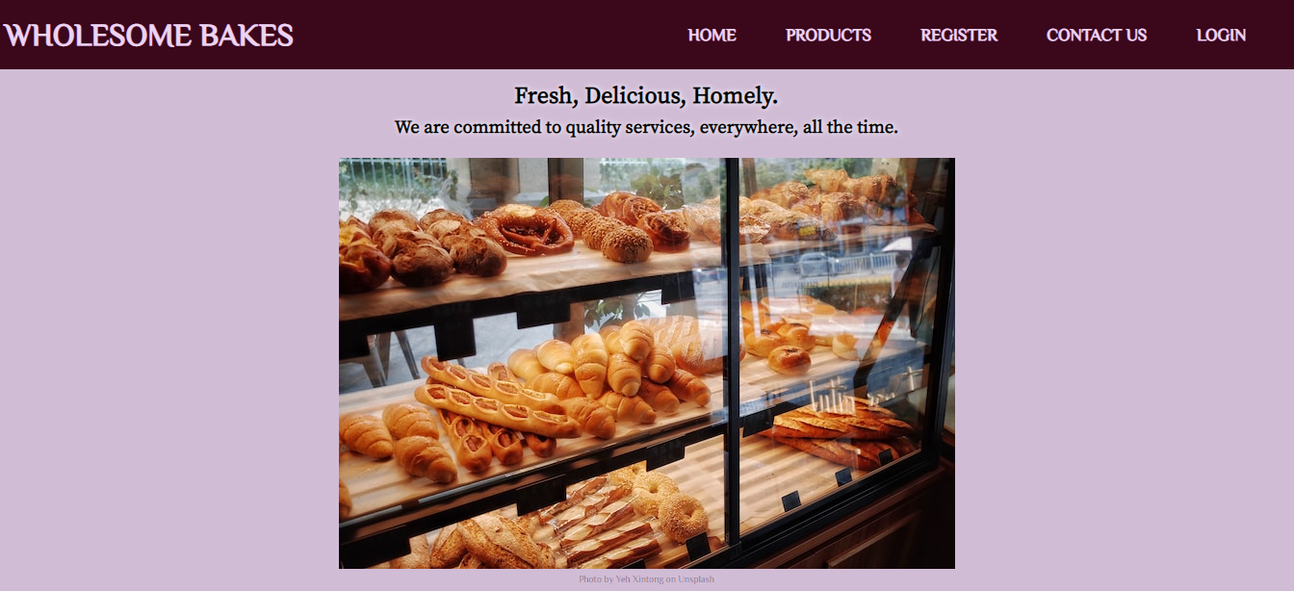

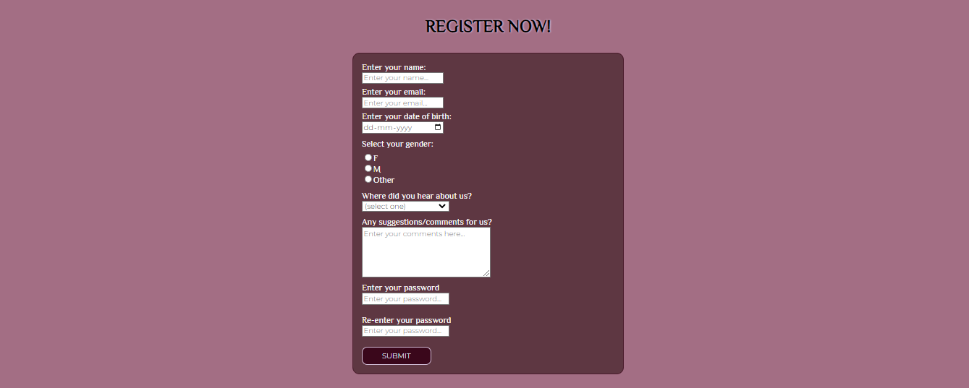



***3. Create a static webpage for an online bookstore which contains a catalogue of available books.***

**index.html**

<!DOCTYPE html>

<html lang="en">

  <head>

    <meta charset="UTF-8" />

    <meta http-equiv="X-UA-Compatible" content="IE=edge" />

    <meta name="viewport" content="width=device-width, initial-scale=1.0" />

    <link rel="preconnect" href="https://fonts.googleapis.com" />

    <link rel="preconnect" href="https://fonts.gstatic.com" crossorigin />

    <link rel="stylesheet" href="styles.css" />

    <link

      href="https://fonts.googleapis.com/css2?family=Montserrat:wght@300&display=swap

" rel="stylesheet"

    />

    <link

      href="https://fonts.googleapis.com/css2?family=IBM+Plex+Mono:wght@200&display=s

wap"

      rel="stylesheet"

    />

    <link

      href="https://fonts.googleapis.com/css2?family=Rokkitt:wght@100&display=swap"

      rel="stylesheet"

    />

    <link href="https://fonts.googleapis.com/css2?family=Roboto+Mono&display=swap"

rel="stylesheet">

    <title>Bookworm</title>

  </head>

  <body>

    <header>

      <div id="navbar">

        <h1 id="nav-logo">Bookworm</h1>

        <ul id="nav-list">

          <li><a href="#home">Home</a></li>

          <li><a href="#books">Books</a></li>

          <li><a href="#register">Register</a></li>

          <li><a href="#contact-us">Contact Us</a></li>

          <li><a href="login.html" target="_blank">Login</a></li>

        </ul>

      </div>

    </header>

    <main>

      <section id="home">

        <div id="home-header">

          <figure>

            <img src="bookstore.jpg" alt="Book Store" />

            <figcaption>

              Photo by

              <a

                href="https://unsplash.com/@ninjason?utm_source=unsplash&utm_medium=r

eferral&utm_content=creditCopyText"

                >Jason Leung</a

              >

              on

              <a

                href="https://unsplash.com/photos/gWZzETD0Ad4?utm_source=unsplash&utm

_medium=referral&utm_content=creditCopyText"

                >Unsplash</a

              >

            </figcaption>

          </figure>

          <h2>Enter a world, of your choice...</h2>

        </div>

      </section>

      <section id="about-us"></section>

      <section id="books">

        <div>

          <ul>

            <li>

              <figure>

                <img

                  src="https://images-na.ssl-images-

amazon.com/images/S/compressed.photo.goodreads.com/

books/1542542538i/42857229.jpg"

                  alt=""

                />

                <figcaption>The Year of the Ladybird, Graham Joyce</figcaption>

              </figure>

            </li>

            <li>

                <figure>

                    <img

                      src="https://m.media-amazon.com/images/W/IMAGERENDERING_521856-

T1/images/I/51I9fQLhnpL.jpg"

                      alt=""

                    />

                    <figcaption>Inception (The Marked Saga Book 1), Bianca

Scardoni</figcaption>

                  </figure>

            </li>

            <li><figure>

                <img

                  src="https://m.media-amazon.com/images/W/IMAGERENDERING_521856-

T1/images/I/81tNBrrGSJL.jpg"

                  alt=""

                />

                <figcaption>The Loser, Thomas Bernhard</figcaption>

              </figure></li>

          </ul>

        </div>

        <div>

          <ul>

            <li><figure>

                <img

                  src="https://m.media-amazon.com/images/W/IMAGERENDERING_521856-

T1/images/I/71SCqfZfHEL.jpg"

                  alt=""

                />

                <figcaption>Atonement, Ian McEwan</figcaption>

              </figure></li>

            <li><figure>

                <img

                  src="https://m.media-amazon.com/images/W/IMAGERENDERING_521856-

T1/images/I/71kW3I8WH5L.jpg"

                  alt=""

                />

                <figcaption>Gilead, Marilynne Robinson</figcaption>

              </figure></li>

            <li><figure>

                <img

                  src="https://m.media-amazon.com/images/W/IMAGERENDERING_521856-

T1/images/I/51GTpkH-JJL._SX343_BO1,204,203,200_.jpg"

                  alt=""

                />

                <figcaption>The Fire Eternal, Chris d'Lacey</figcaption>

              </figure></li>

          </ul>

        </div>

        <div>

          <ul>

            <li><figure>

                <img

                  src="https://m.media-amazon.com/images/W/IMAGERENDERING_521856-

T1/images/I/91ZaXXD8K8L.jpg"

                  alt=""

                />

                <figcaption>Ringworld, Larry Niven</figcaption>

              </figure></li>

            <li><figure>

                <img

                  src="https://m.media-amazon.com/images/W/IMAGERENDERING_521856-

T1/images/I/71mWiiUV9ZL.jpg"

                  alt=""

                />

                <figcaption>History Is All You Left Me, Adam Silvera</figcaption>

              </figure></li>

            <li><figure>

                <img

                  src="https://m.media-amazon.com/images/W/IMAGERENDERING_521856-

T1/images/I/71XtGTK8OpL.jpg"

                  alt=""

                />

                <figcaption>Trainspotting, Irvine Welsh</figcaption>

              </figure></li>

          </ul>

        </div>

      </section>

      <section id="register">

        <div>

          <h3>Register now!</h3>

          <form action="submitted.html" method="post" onsubmit="validate()">

            <section id="personal-details">

              <label for="name"

                >Enter your name:

                <br />

                <input

                  type="text"

                  name="name"

                  id="name"

                  placeholder="Enter your name..."

                  required

                />

              </label>

              <label for="email"

                >Enter your email:

                <br />

                <input

                  type="email"

                  name="email"

                  id="email"

                  placeholder="Enter your email..."

                  required

                />

              </label>

              <label for="dob"

                >Enter your date of birth:

                <br />

                <input type="date" name="dob" id="dob" required />

              </label>

            </section>

            <section id="gender-details">

              <label for="gender-choices">Select your gender:</label>

              <ul>

                <li>

                  <input type="radio" name="gender" id="gender-f" value="f" />F

                </li>

                <li>

                  <input type="radio" name="gender" id="gender-m" value="m" />M

                </li>

                <li>

                  <input

                    type="radio"

                    name="gender"

                    id="gender-o"

                    value="other"

                  />Other

                </li>

              </ul>

            </section>

            <section id="source-section">

              <label for="sources">Where did you hear about us?</label>

              <br />

              <select name="" id="">

                <option value="">(select one)</option>

                <option value="instagram">Instagram</option>

                <option value="twitter">Twitter</option>

                <option value="facebook">Facebook</option>

                <option value="website">Our Official Website</option>

              </select>

            </section>

            <section id="comment-box">

              <label for="comments">Any suggestions/comments for us?</label>

              <br />

              <textarea

                name="comments-area"

                id="comments"

                cols="30"

                rows="5"

                placeholder="Enter your comments here..."

              ></textarea>

            </section>

            <section>

              <label for="password-box">Enter your password</label>

              <br />

              <input

                type="password"

                id="password-box"

                name="password-box"

                placeholder="Enter your password..."

                required

              />

            </section>

            <br />

            <section>

              <label for="confirm-pwd">Re-enter your password</label>

              <br />

              <input

                type="password"

                id="confirm-pwd"

                name="confirm-pwd"

                placeholder="Enter your password..."

              />

            </section>

            <br />

            <section id="submit-section">

              <input type="submit" name="" id="submit-btn" value="Submit" />

            </section>

          </form>

        </div>

      </section>

    </main>

    <footer>

      <section id="contact-us"></section>

    </footer>

  </body>

</html>

**styles.css**

* {

    box-sizing: border-box;

  }

  html,

  ::before,

  ::after {

    box-sizing: inherit;

  }

  body {

    margin: 0;

    font-family: 'IBM Plex Mono', monospace;

    background-color: #7591ec;

  }

  #navbar {

    display: grid;

    grid-template-columns: auto auto;

    align-items: center;

    background-color: #07153a;

    background-size: cover;

    position: fixed;

    height: 13vh;

    width: 100vw;

    max-width: 100%;

  }

  #navbar #nav-logo {

    padding: 0 0.5rem 0 0.5rem;

    text-transform: uppercase;

    color: #ffffff;

    font-size: clamp(0.5rem, 10rem, 2rem);

  }

  #navbar #nav-list {

    display: flex;

    flex-direction: row;

    justify-content: space-evenly;

    align-items: center;

  }

  #nav-list li {

    list-style-type: none;

    text-transform: uppercase;

    font-size: clamp(0.2rem, 5rem, 1.1rem);

    font-weight: bold;

  }

  #nav-list a {

    text-decoration: none;

    color: #ffffff;

  }

  #nav-list a:hover {

    text-shadow: 1px 0.1px 5px rgba(255, 255, 255, 0.541);

  }

  #home {

    height: 105vh;

    width: 100vw;

    max-width: 100%;

    padding-top: 4.5rem;

    background-color: #bfccf7;

  }

  #home #home-header {

    display: flex;

    flex-direction: column;

    text-align: center;

    font-family: 'IBM Plex Mono', monospace;

    font-style: italic;

    letter-spacing: 0.2rem;

*/* font-family: 'Rokkitt', serif;    */*

  }

  #home-header h2,

  #home-header h3 {

    margin: 0;

    font-weight: 600;

  }

  #home figure {

    margin-bottom: 0;

    padding-bottom: 1.4rem;

}

  #home figure figcaption {

    font-family: 'Rokkitt', serif;

    font-size: clamp(0.1rem, 1rem, 0.7rem);

    font-weight: 600;

    color: #00000085;

  }

  #home figure figcaption a {

    color: rgba(0, 0, 0, 0.774);

    text-decoration: none;

  }

  #books {

    display: grid;

    grid-template-columns: auto auto auto;

    height: 150vh;

    padding-top:1rem;

    background-color: #07153a;

}

  #books li {

    list-style-type: none;

  }

  #books figure {

    display: flex;

    flex-direction: column;

    align-items: center;

  }

  #books figure figcaption{

    padding-top: 0.1rem;

    color:#b0c1f8;

    font-size: clamp(0.2rem, 1rem, 0.7rem);

    font-family: 'Roboto Mono', monospace;

    font-style: italic;

    letter-spacing: 0.5px;

}

  #books img {

    height: 40vh;

    width:fit-content;

  }

  #register {

    height: 120vh;

    background-color: #7591ec;

  }

  #register div,

  #login div {

    display: flex;

    flex-direction: column;

    align-items: center;

  }

  #register div h3,

  #login div h3 {

    text-transform: uppercase;

    font-size: clamp(1rem, 6rem, 2rem);

    text-shadow: 1px 0.5px 3px #07153abd;

  }

  form {

    background-color: #07153abd;

    color: rgb(255, 255, 255);

    border: 1px solid #07153ac2;

    border-radius: 13px;

    display: block;

    margin: 0 auto;

    width: 500px;

    padding: 1rem 1rem;

    font-family: 'Rokkitt', serif;

    font-weight: 500;

    font-size: clamp(0.5rem,3rem,1.2rem);

  }

  input {

    font-family: "Montserrat", sans-serif;

  }

  #personal-details label {

    display: block;

    padding-bottom: 5px;

  }

  #personal-details input {

    width: 150px;

  }

  #gender-details {

    margin-top: 5px;

  }

  #gender-details label {

    display: block;

    margin-bottom: -10px;

  }

  #gender-details ul {

    padding-left: 0;

  }

  #gender-details li {

    list-style-type: none;

  }

  #class-details {

    margin-top: -7px;

  }

  #class-details label {

    display: block;

    margin-bottom: -10px;

  }

  #class-details ul {

    padding-left: 0;

  }

  #class-details li {

    list-style-type: none;

  }

  #source-section {

    display: block;

    margin-top: -5px;

    margin-bottom: 15px;

  }

  #source-section select {

    font-family: "Montserrat", sans-serif;

  }

  #source-section option {

    font-family: "Montserrat", sans-serif;

    color: black;

    font-weight: 600;

  }

  #comment-box {

    margin-top: -5px;

    margin-bottom: 5px;

  }

  #comment-box textarea {

    font-family: "Montserrat", sans-serif;

    color: black;

  }

  #submit-btn {

    background: #07153a;

    background-size: cover;

    background-repeat: no-repeat;

    color: aliceblue;

    border: 1px solid #7591ec;

    border-radius: 10px;

    width: 7vw;

    height: 4vh;

    text-transform: uppercase;

  }

  #submit-btn:hover {

    background-size: cover;

    background-repeat: no-repeat;

    color: #07153a;

    background-color: #7591ec;

    border: 1px solid #07153a;

  }

  #login-header,

  #login-screen {

    display: flex;

    flex-direction: column;

*/* background: #a36e84; */*

    align-items: center;

  }

  #login-header {

    color:#ecd4f1;

  }

  #login-header h1 {

    text-transform: uppercase;

  }

  #login-screen #yum {

    color:#ecd4f1;

  }

  #login-screen #login-msg {

    color: #3a071b;

  }

  #login {

    height: 60vh;

    width: 100vw;

    background-color: #d1bcd6;

  }

**OUTPUT**

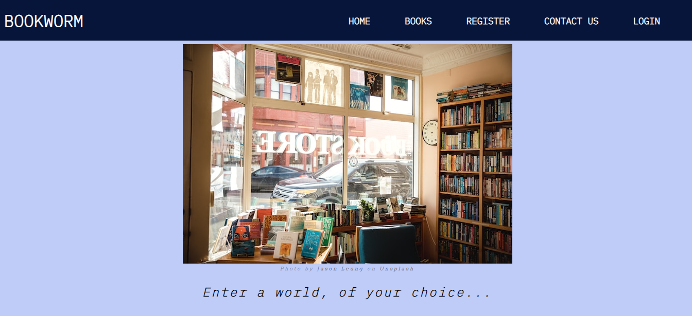

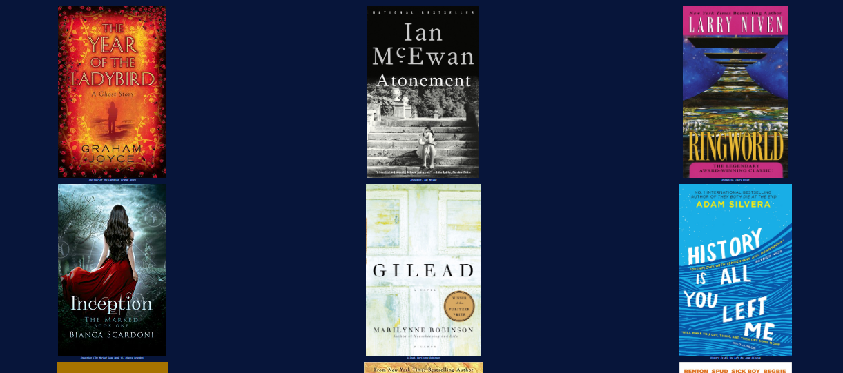

***4. Write a Javascript program to convert numbers to Roman numerals.***

**convert.js**

function convertToRoman(num) {

var l = [1000,900,500,400,100,90,50,40,10,9,5,4,1];

var sym = ['M','CM','D','CD','C','XC','L','XL','X','IX','V','IV','I']

var str = "";

let i = 0;

while(num>0){

if(l[i]<=num){

str+=sym[i];

num-=l[i];

}

else{

i++;

}

}

return str;

}

console.log(convertToRoman(36));

**OUTPUT**

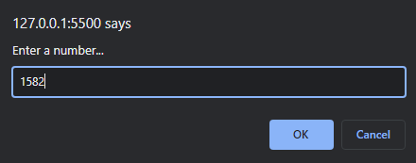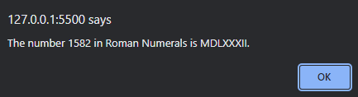

***5. Write a Javascript program to validate a form, which satisfies the conditions:***

***(a) Name should only contain alphabets.***

***(b) Password should not be less than 6 characters length.***

***(c) E-mail id must follow the pattern [name@domain.com](mailto:name@domain.com).***

***(d) Phone number should contain 10 digits only.***

***(e) Last Name and Address should not be empty.***

**index.html**

<!DOCTYPE html>

<html lang="en">

  <head>

    <meta charset="UTF-8" />

    <meta http-equiv="X-UA-Compatible" content="IE=edge" />

    <meta name="viewport" content="width=device-width, initial-scale=1.0" />

    <link rel="stylesheet" href="styles.css" />

    <link rel="preconnect" href="https://fonts.googleapis.com" />

    <link rel="preconnect" href="https://fonts.gstatic.com" crossorigin />

    <link

      href="https://fonts.googleapis.com/css2?family=Nunito&display=swap"

      rel="stylesheet"

    />

    <link

      rel="shortcut icon"

      href="https://cdn-icons-png.flaticon.com/512/9318/9318633.png"

      type="image/x-icon"

    />

    <title>Webvy</title>

    <script>

**const** validate = () **=>**{

**const** phVal = document.getElementById('number').value;

**const** pwdVal = document.getElementById('pwd').value;

**const** fnameVal = document.getElementById('name').value;

            if (String(phVal).length != 10){

                alert("Phone no. should have 10 digits");

                return false;

            }

            if (fnameVal.length < 7){

                alert("First name has to be 6 charaters long!");

                return false;

            }

            if (!/^[a-zA-z]*$/g.test(fnameVal)){

                alert("First name has to be characters only!");

                return false;

            }

            if(pwdVal.length < 7){

                 alert("Password should be greater than 6 characters!");

                return false;

            }

            return true;

        }

    </script>

  </head>

  <body>

    <main>

      <div id="form-heading">

        <h1 id="title">Webvy Registration</h1>

        <p id="description">For Students</p>

      </div>

      <form action="#index.html" id="survey-form" method="post" onsubmit="return

validate()">

        <div id="form-body">

          <fieldset id="personal-details">

            <h2>Personal Details</h2>

            <hr>

            <label id="name-label" for="name"

              >First Name

              <input

                id="name"

                type="text"

                placeholder="Enter your first name"

                required

              />

</label>

             <label id="lname-label" for="lname"

              >Last Name

              <input

                id="lname"

                type="text"

                placeholder="Enter your last name"

                required

              />

            </label>

            <label id="email-label" for="email"

              >Email

              <input

                id="email"

                type="email"

                placeholder="Enter your email"

                required

              />

            </label>

            <label id="number-label" for="number"

              >Phone No.

              <input

                id="phone"

                type="phone"

                placeholder="Enter your number"

                required

              />

</label>

            <label id="pwd-label" for="pwd"

              >Password

              <input

                id="pwd"

                type="password"

                placeholder="Enter your password"

                required

              />

            </label>

          </fieldset>

          <fieldset id="learning-details">

            <h2>Learning Progress</h2>

            <hr>

            <label id="radio-buttons" class="learning-q">

              Are you currently learning web development?

              <label for="yes-web">

                <input type="radio" name="recs" id="yes-adopt" value="yes" />

                Yes

              </label>

              <label for="no-web">

                <input type="radio" name="recs" id="no-adopt" value="no" />

                No

              </label>

            </label>

            <label id="checkbox-options" class="learning-q">

              What have you learnt so far?

              <label for="html-skill">

                <input

                  type="checkbox"

                  name="skill-set"

                  id="html-skill"

                  value="html-skill"

                />

                HTML

              </label>

              <label for="css-skill">

                <input

                  type="checkbox"

                  name="skill-set"

                  id="css-skill"

                  value="css-skill"

                />

                CSS

              </label>

              <label for="js-skill">

                <input

                  type="checkbox"

                  name="skill-set"

                  id="js-skill"

                  value="js-skill"

                />

                Javascript

              </label>

              <label for="frameworks">

                <input

                  type="checkbox"

                  name="skill-set"

                  id="frameworks"

                  value="frameworks"

                />

                Frameworks(Bootstrap, React, etc..)

              </label>

            </label>

            <label for="dropdown" class="learning-q">

              What do you find most difficult to learn?

              <select id="dropdown" name="dropdown" >

                <option value="" name="options">(select one)</option>

                <option value="1" name="options">The Box Model</option>

                <option value="3" name="options">Grid and Flexbox</option>

                <option value="2" name="options">Javascript programming</option>

                <option value="2" name="options">None of the above</option>

              </select>

            </label>

          </fieldset>

          <fieldset id="student-feedback">

            <h2>About Me</h2>

            <hr>

            <label for="feedback">

              Please tell us about yourself and how got into web development

              <textarea

                name="feedback"

                id="feedback"

                cols="45"

                rows="10"

                placeholder="Enter your feedback here..."

                required

              ></textarea>

            </label>

          </fieldset>

          <fieldset id="submit-button"><button id="submit" type="submit">

Submit</button>

          </fieldset>

        </div>

      </form>

    </main>

  </body>

</html>

**styles.css**

html {

  box-sizing: border-box;

}

*,

::before,

::after {

  box-sizing: inherit;

}

body {

  background-image: linear-gradient(

    90deg,

    #1c3c6b 0%,

    #7ebffc 35%,

    #7ebffc 50%,

    #7ebffc 70%,

    #1c3c6b 100%

  );

  background-color: white;

  background-size: cover;

  margin: 0;

  font-family: "Nunito", sans-serif;

  color: white;

}

#form-heading {

  text-align: center;

  margin: 0 auto;

}

#form-heading h1 {

  margin-top: -0.1rem;

  font-size: 2.3rem;

  color: white;

  text-shadow: 1px 0.1px 20px #ffffffe1;

}

#form-heading p {

  margin-top: -1.7rem;

  font-size: 1.3rem;

  font-weight: 600;

  color: #ffffffe1;

}

#form-body {

  margin-top: -1.5rem;

  background: #1c3c6b70;

  border-radius: 5px;

}

form {

  width: 50vw;

  max-width: 500px;

  min-width: 350px;

  margin: 0 auto;

  padding: 1% 0;

}

form h2 {

  margin-top: 1px;

  margin-bottom: 0;

}

form hr {

  width: 45%;

  margin: 0 0 5px 0;

  opacity: 45%;

}

fieldset {

  border: none;

  padding: 0.7rem 0.5rem;

  border-bottom: 1px solid rgba(226, 215, 175, 0.5);

}

label {

  display: block;

  margin: 0.5rem 0;

}

input,

select,

textarea {

  font-size: small;

  font-style: italic;

  margin: 10px 0 0 0;

  font-family: "Nunito", sans-serif;

  border-radius: 5px;

  border: 1px solid transparent;

}

#name,

#lname,

#email,

#phone,

#pwd {

  display: block;

  width: 55%;

  padding-bottom: 1%;

}

#learning-details .learning-q {

  padding-top: 15px;

}

select#dropdown {

  display: block;

  background: #1c3c6b70;

  color: white;

  width: 57%;

  border: none;

  font-family: "Nunito", sans-serif;

}

#submit-button {

  border-bottom: none;

}

#submit {

  border: none;

  display: block;

  height: 20%;

  width: 85px;

  text-align: center;

  margin: 0 auto;

  font-family: "Nunito", sans-serif;

  background: #1c3c6b70;

  color: white;

  font-size: 17px;

  border-radius: 10px;

}

button#submit:hover {

  background: #7ebffc;

}

**OUTPUT**

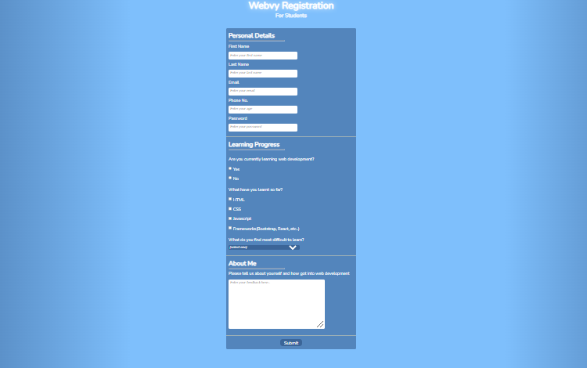

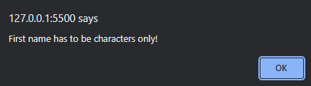

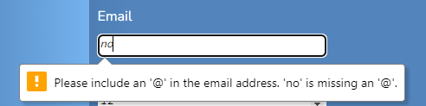

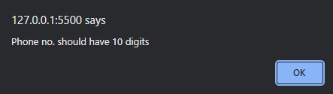

***6. Write a Javascript program to demonstrate pop-up boxes, for the following:***

***(a) Display date***

***(b) Factorial of a number***

***(c) A multiplication table of numbers from 1 to 10***

***(d) Sum of n numbers***

**popupboxes.html**

<!DOCTYPE html>

<html lang="en">

  <head>

    <meta charset="UTF-8" />

    <meta http-equiv="X-UA-Compatible" content="IE=edge" />

    <meta name="viewport" content="width=device-width, initial-scale=1.0" />

    <link rel="stylesheet" href="styles.css" />

    <link rel="preconnect" href="https://fonts.googleapis.com" />

    <link rel="preconnect" href="https://fonts.gstatic.com" crossorigin />

    <link

      href="https://fonts.googleapis.com/css2?family=Anonymous+Pro&display=swap"

      rel="stylesheet"

    />

    <title>Pop Up Box Demo</title>

  </head>

  <body>

    <header>

      <h1>Random Operations 4 Fun <sup>Javascript</sup></h1>

    </header>

    <main>

      <div>

        <button onclick="displayDate()">Today's Date</button>

        <button onclick="promtDemo()">Factorial of a number</button>

        <button onclick="alertDemo()" onmouseout="mouseOut()">

          Multiplication table

        </button>

        <button onclick="confirmDemo()" onmouseout="mouseOut()">

          Sum of 2 numbers

        </button>

      </div>

    </main>

    <script>

      const displayDate = () => {

        date = new Date();

        day = date.getDate();

        month = date.getMonth() + 1;

        year = date.getFullYear();

        window.alert(`Today's date is ${day}/${month}/${year}.`);

      };

      const promtDemo = () => {

        let n = window.prompt("Enter a number...");

        console.log("your number is " + n);

        let fact = 1;

        for (let i = n; i > 1; i--) {

          fact *= i;

        }

        window.alert(" The factorial of " + n + " is " + fact + ".");

      };

      const alertDemo = () => {

        let n = window.prompt("Enter a number...");

        str = "";

        for (let i = 1; i <= 10; i++) {

          str += `${n} x ${i} = ${n * i} \n`;

        }

        window.alert("Multiplication table of " + parseInt(n) + "\n" + str);

      };

      const confirmDemo = () => {

        let num1 = window.prompt("Enter number 1");

        if (

          window.confirm(

            "Press OK if number 2 = 10\nPress Cancel if number 2 = 20"

          )

        ) {

          num2 = 10;

        } else {

          num2 = 20;

        }

        let num3 = window.prompt("Enter number 3");

        num1 = parseInt(num1);

        num2 = parseInt(num2);

        num3 = parseInt(num3);

        window.alert(

          num1 + " + " + num2 + " + " + num3 + " = " + (num1 + num2 + num3)

        );

      };

    </script>

  </body>

</html>

**styles.css**

* {

  box-sizing: border-box;

}

html,

::before,

::after {

  box-sizing: inherit;

}

body {

  background: linear-gradient(

      180deg,

      #a4ff4fcc,

      #f3c80686 70.71%

    ),

    linear-gradient(127deg, #00ff4ccc, #0099ff00 70.71%),

    linear-gradient(

      336deg,

      #11ff45cc,

      #ff00f200 70.71%

    );

  background-attachment: fixed;

  margin: 0;

  font-family: "Anonymous Pro", monospace;

  padding: 1rem;

}

header {

    display: flex;

    flex-direction: row;

    justify-content: center;

}

header h1 {

    font-size: clamp(1rem, 4rem, 2rem);

    color: #063d01;

    text-shadow: 1px 0.5px 1px #90ff11cc, 1px 0.5px 1px #063d01;

}

header sup {

    vertical-align: top;

    font-size: clamp(0.2rem, 2rem, 1rem);

    position: relative;

    top: -0.7em;

    color: #063d01;

    text-shadow: 1px 0.5px 1px #90ff11cc;

    text-transform: uppercase;

    letter-spacing: 1.5px;

}

main div {

    padding: 1rem;

    display: grid;

    grid-template-columns: auto auto auto auto;

    gap: 2rem;

    justify-content: center;

}

main div button {

    width: 15vw;

    height: 10vh;

    background-color: #268f1da8;

    border: 1px solid #32bb2660;

    border-radius: 3px 8px;

    box-shadow: 1px 0.5px 8px #90ff11cc;

    font-family: "Anonymous Pro", monospace;

    font-weight: 600;

    color: #acffa6;

    text-transform: uppercase;

    font-size: clamp(0.5rem, 3rem, 1rem);

}

main div button:hover {

    background-color: #90ff11cc;

    border: 1px solid #5eff004f;

    color: #1f6e18;

    box-shadow: 1px 0.1px 10px #5eff00;

}

**OUTPUT**

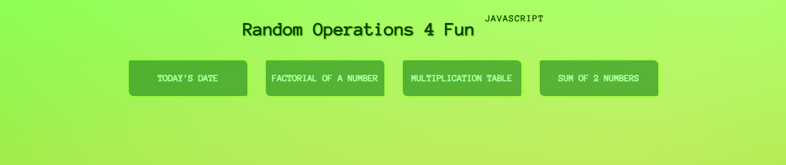

Today’s Date

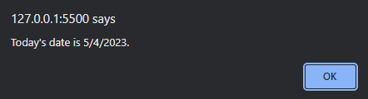

Factorial of a number

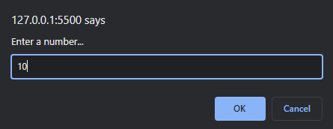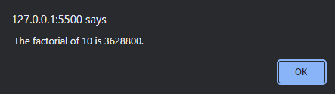

Multiplication Table

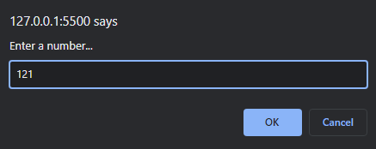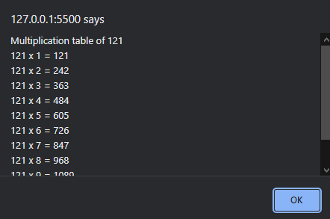

Sum of numbers

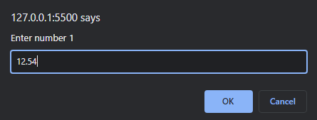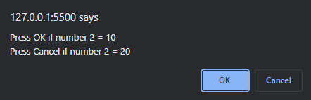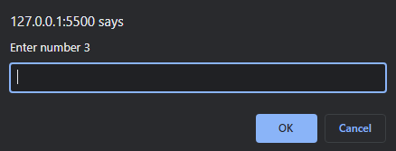

***7. Create a simple calculator.***

**calculator.html**

<!DOCTYPE html>

<html lang="en">

  <head>

    <meta charset="UTF-8" />

    <meta name="viewport" content="width=device-width, initial-scale=1.0" />

    <title>Calculator</title>

    <style>

      .container {

        display: flex;

        justify-content: center;

        align-items: center;

        height: 100vh;

      }

      #calculator {

        justify-self: center;

        background-color: black;

        border-radius: 8px;

        padding: 8px;

        font-family: "Courier New", Courier, monospace;

        box-shadow: 2px 4px 8px black; */* offset-x offset-y shadow-radius color*/*

      }

      button {

        background: darkmagenta;

        color: white;

        border: none;

        border-radius: 2px;

        padding: 8px;

        width: calc(4em + 8px);

        justify-content: center;

        margin: 4px 2px;

      }

      .last {

        width: calc(2em + 8px);

      }

      #clear,

      #equals {

        background-color: deeppink;

      }

      #display {

        display: inline-block;

        background-color: white;

        padding: 8px;

        text-align: end;

        margin: 4px 2px;

        border-radius: 2px;

        color: black;

        width: calc(12em + 4px);

      }

    </style>

  </head>

  <body>

    <div class="container">

      <div id="calculator">

        <div>

          <div id="display">0</div>

          <button type="button" class="last" id="clear">C</button>

        </div>

        <div>

          <button type="button">1</button>

          <button type="button">2</button>

          <button type="button">3</button>

          <button type="button" class="last">/</button>

        </div>

        <div>

          <button type="button">4</button>

          <button type="button">5</button>

          <button type="button">6</button>

          <button type="button" class="last">-</button>

        </div>

        <div>

          <button type="button">7</button>

          <button type="button">8</button>

          <button type="button">9</button>

          <button type="button" class="last">+</button>

        </div>

        <div>

          <button type="button">.</button>

          <button type="button">0</button>

          <button type="button" id="equals">=</button>

          <button type="button" class="last">*</button>

        </div>

      </div>

    </div>

    <script>

      var buttons = Array.prototype.slice.call(

        document.getElementsByTagName("button")

      );

      var display = document.getElementById("display");

      var operation = undefined;

      var first = undefined;

      var second = undefined;

      var result = undefined;

      const handler = (event) => {

        let value = event.target.innerHTML;

        if (isNaN(value)) {

          if (first !== undefined)

            switch (value) {

              case "+":

              case "-":

              case "/":

              case "*":

                operation = value;

                break;

              case "C":

                operation = undefined;

                first = undefined;

                second = undefined;

                result = undefined;

                break;

              case ".":

                display.innerHTML = operation === undefined ? (first * 1.0) : (second

* 1.0);

                break;

              case "=":

                if (

                  first !== undefined &&

                  second !== undefined &&

                  operation !== undefined

                ) {

                  switch (operation) {

                    case "*":

                      result = first * second;

                      break;

                    case "/":

                      result = first / second;

                      break;

                    case "+":

                      result = first + second;

                      break;

                    case "-":

                      result = first - second;

                      break;

                  }

                }

                break;

              default:

                console.warn(value);

                break;

            }

        } else {

          if (operation === undefined) {

            if (first === undefined) first = parseInt(value);

            else first = parseInt(first + value);

          } else {

            if (second === undefined) second = parseInt(value);

            else second = parseInt(second + value);

          }

        }

        if (first === undefined) {

          display.innerHTML = 0;

        } else if (first !== undefined && operation === undefined)

          display.innerHTML = first;

          else if(second !== undefined) {

            display.innerHTML = second;

          }

          if(result !== undefined) {

            display.innerHTML = result;

          }

      };

      buttons.forEach((button) => {

        button.addEventListener("click", handler);

        button.addEventListener("touch", handler);

      });

    </script>

  </body>

</html>

**OUTPUT**

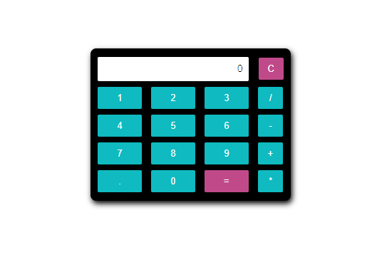

***8. Create a portfolio website. Demonstrate use of inline, internal and external CSS stylesheets.***

**index.html**

<!DOCTYPE html>

<html lang="en">

<head>

<meta charset="UTF-8" />

<meta http-equiv="X-UA-Compatible" content="IE=edge" />

<meta name="viewport" content="width=device-width, initial-scale=1.0" />

<link rel="stylesheet" href="styles.css" />

<link rel="preconnect" href="https://fonts.googleapis.com" />

<link rel="preconnect" href="https://fonts.gstatic.com" crossorigin />

<link

href="https://fonts.googleapis.com/css2?family=Montserrat&display=swap"

rel="stylesheet"

/>

<link

href="https://fonts.googleapis.com/css2?family=Unbounded&display=swap"

rel="stylesheet"

/>

<title>Portfolio</title>

</head>

<body>

<!-- HEADER -->

<header>

<nav id="navbar">

<ul id="nav-list">

<li><a href="#welcome-section" class="nav-link">About</a></li>

<li><a href="#projects-section" class="nav-link">Projects</a></li>

<li><a href="#contact-section" class="nav-link">Contact</a></li>

</ul>

</nav>

</header>

<!-- MAIN -->

<main>

<!-- ABOUT ME -->

<section id="welcome-section">

<h1>Hi! I'm Ady.</h1>

<h2>An aspiring <span class="special-text">web developer</span>.</h2>

</section>

<!-- PROJECTS -->

<section id="projects-section">

<h2>These are some of my projects.</h2>

<div id="project-grid">

<a

href="https://codepen.io/codeyady/full/YzjYXwm"

target="_blank"

class="project-tile"

>

<img src="https://shots.codepen.io/codeyady/pen/YzjYXwm-

1280.webp?version=1674412125" alt="Project-1" />

<p>FCC Documentation Page</p>

</a>

<a

href="https://codepen.io/codeyady/full/ZEjvwqj"

target="_blank"

class="project-tile"

><img src="https://shots.codepen.io/codeyady/pen/ZEjvwqj-

512.webp?version=1675013670" alt="Project-2" />

<p>FCC Survey Form</p>

</a>

<a

href="https://codepen.io/codeyady/full/VwBzmqM"

target="_blank"

class="project-tile"

><img src=" https://shots.codepen.io/codeyady/pen/VwBzmqM-

512.webp?version=1674315629" alt="Project-3" />

<p>Silly Cat Page</p>

</a>

</div>

<div id="codepen-box">

<a href="https://codepen.io/codeyady" id="codepen-link">Show all</a>

</div>

</section>

<!-- CONTACT ME -->

<section id="contact-section">

<h2>Find me on...</h2>

<div id="profile-list">

<a

href="https://github.com/adelicia-js"

class="profile-link"

target="_blank"

><img src="https://cdn-icons-png.flaticon.com/512/2111/2111432.png"

alt=""> </a

>

<a

href="https://codepen.io/codeyady"

class="profile-link"

target="_blank"

><img src="https://cdn-icons-png.flaticon.com/512/2111/2111501.png"

alt=""> </a

>

</div>

</section>

</main>

</body>

</html>

**styles.css**

html {

box-sizing: border-box;

}

*, ::before, ::after {

box-sizing: inherit;

}

body {

margin: 0;

padding: 0;

font-family: 'Montserrat',sans-serif;

background: rgba(9, 183, 252, 0.1);

width: 100%;

height: auto;

background-size: cover;

}

/* NAV BAR */

#navbar {

display: flex;

justify-content: center;

position: fixed;

top: 0;

left: 0;

width: 100%;

background-color: #201136;

z-index: 10;

overflow: hidden;

}

#nav-list {

display: flex;

gap: 25rem;

}

#nav-list li {

list-style-type: none;

margin-right: 1rem;

font-weight: 600;

padding-left: 0;

}

.nav-link {

font-size: 1.2rem;

color: rgb(255, 255, 255);

text-decoration: none;

text-transform: uppercase;

letter-spacing: 0.3rem;

}

.nav-link:hover {

color: #9f80cf;

text-shadow: 1px 0.1px 5px #201136,0 0 2px #201136, 0 0 2px #ffffff;

}

/* MAIN */

/* WELCOME */

#welcome-section {

display: flex;

width: 100%;

height: 100vh;

flex-direction: column;

justify-content: center;

align-items: center;

background-color: black;

/* background-image: #9f80cf; */

background-image: linear-gradient(62deg, #9f80cf 0%, #9f80cf 50%, #9f80cf 100%);

padding: 5rem;

margin: 0;

}

#welcome-section h1, #welcome-section h2 {

font-family: 'Unbounded',sans-serif;

text-align: center;

}

#welcome-section h1{

font-size: 3rem;

color: white;

margin-bottom: 0;

}

#welcome-section h2 {

font-size: 2rem;

font-style: oblique;

color: #201136;

margin-top: 0.1rem;

}

/* PROJECTS */

#projects-section {

/* width: 100%; */

/* height: 70vh; */

text-align: center;

padding: 2rem 1rem;

background-color: rgb(0, 0, 0);

background-image: linear-gradient(62deg, #c2a9e9 0%, #dad3e7 50%, #9c7ad4 100%);

}

#projects-section h2 {

color: white;

/* text-shadow: 1px 0.1px 10px #ffae00; */

text-shadow: 1px 0.1px 10px #201136;

font-family: 'Unbounded',sans-serif;

padding-bottom: 0.5rem;

}

#project-grid {

display: grid;

width: 100%;

max-width: 1500px;

margin: 0;

margin-bottom: 1rem;

grid-template-columns: repeat(auto-fit, minmax(350px, 1fr));

gap: 2rem;

padding-bottom: 0.5rem;

}

.project-tile {

background-color: #201136;

border-radius: 5px;

text-decoration: none;

}

.project-tile img {

width: 100%;

height: 87%;

object-fit: cover;

border-radius: 5px 5px 0 0;

color: rgba(255, 255, 255, 0.801);

}

.project-tile p {

color: white;

text-decoration: none;

margin: 0;

font-weight: 600;

font-family: 'Unbounded',sans-serif;

/* font-style: ; */

font-weight: normal;

}

.project-tile:hover {

box-shadow: 1px 0.1px 40px #4d3177;

}

#codepen-box {

padding-top: 1rem;

padding-bottom: 2rem;

}

#codepen-link {

background: #ffffff;

padding: 0.5rem 1rem;

border-radius: 5px;

color: #201136;

text-decoration: none;

}

#codepen-link:hover {

background: #201136;

color: #ffffff;

box-shadow: 1px 0.1px 10px #4d3177;

}

/* CONTACT */

#contact-section {

width: 100%;

text-align: center;

padding: 2rem 1rem;

background-color: rgb(0, 0, 0);

background-image: linear-gradient(118deg, #2b1b42 0%, #4d3177 50%, #201136 100%);

color: white;

}

#profile-list {

display: flex;

flex-direction: row;

flex-wrap: wrap;

justify-content: center;

align-items: center;

gap: 2rem;

width: 100%;

max-width: 1500px;

}

.profile-link img {

width: 2rem;

height: auto;

max-width: 20vw;

object-fit: cover;

}

**OUTPUT**

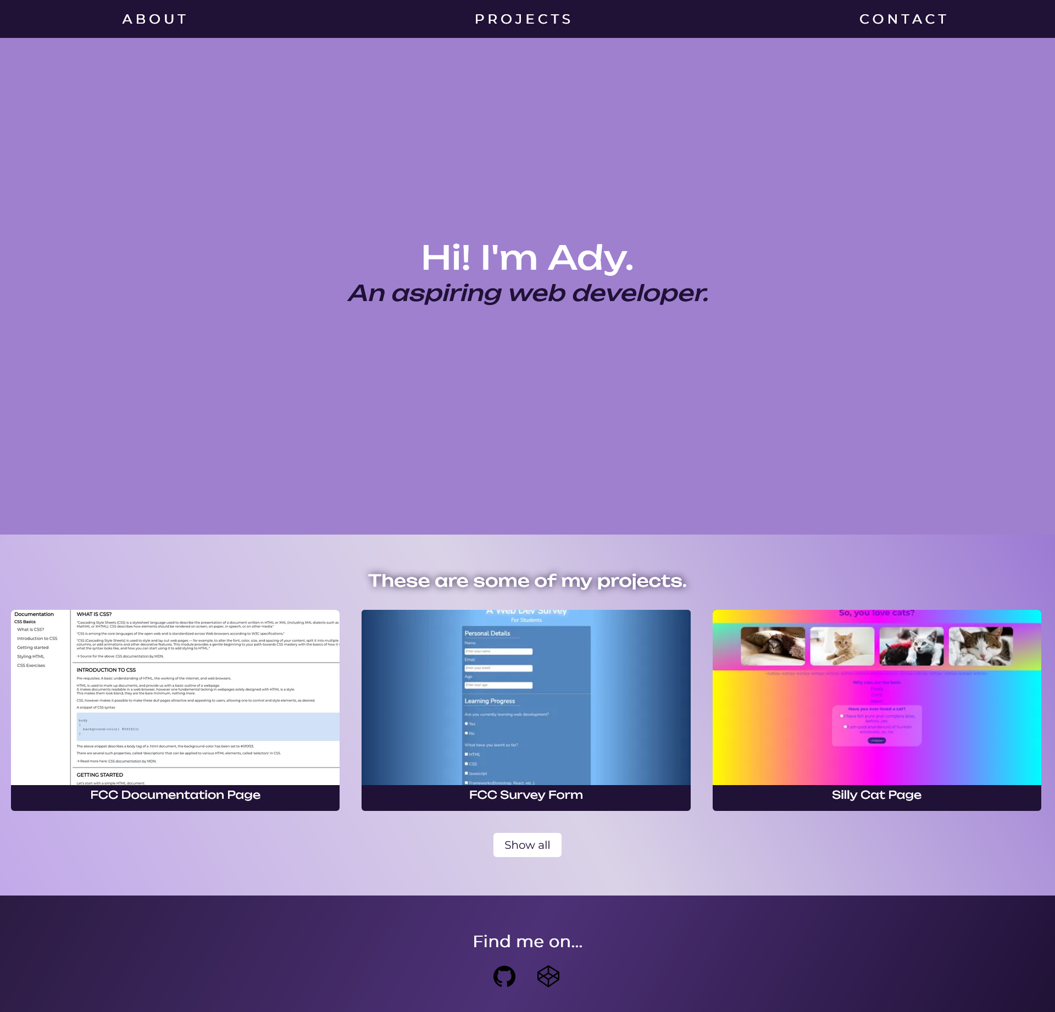

***9. Write a Javascript program which takes an input of a number from a text box and converts it to words.***

**index.html**

<!DOCTYPE html>

<html lang="en">

  <head>

    <meta charset="UTF-8" />

    <meta name="viewport" content="width=device-width, initial-scale=1.0" />

    <title>Digits to words</title>

  </head>

  <body>

    <div>

      <input id="number" type="number" />

      <div id="words"></div>

    </div>

  </body>

  <script>

    var a = [

      "",

      "one ",

      "two ",

      "three ",

      "four ",

      "five ",

      "six ",

      "seven ",

      "eight ",

      "nine ",

      "ten ",

      "eleven ",

      "twelve ",

      "thirteen ",

      "fourteen ",

      "fifteen ",

      "sixteen ",

      "seventeen ",

      "eighteen ",

      "nineteen ",

    ];

    var b = [

      "",

      "",

      "twenty",

      "thirty",

      "forty",

      "fifty",

      "sixty",

      "seventy",

      "eighty",

      "ninety",

    ];

    function inWords(num) {

      if ((num = num.toString()).length > 9) return "overflow";

      n = ("000000000" + num)

        .substr(-9)

        .match(/^(\d{2})(\d{2})(\d{2})(\d{1})(\d{2})$/);

      if (!n) return;

      var str = "";

      str +=

        n[1] != 0

          ? (a[Number(n[1])] || b[n[1][0]] + " " + a[n[1][1]]) + "crore "

          : "";

      str +=

        n[2] != 0

          ? (a[Number(n[2])] || b[n[2][0]] + " " + a[n[2][1]]) + "lakh "

          : "";

      str +=

        n[3] != 0

          ? (a[Number(n[3])] || b[n[3][0]] + " " + a[n[3][1]]) + "thousand "

          : "";

      str +=

        n[4] != 0

          ? (a[Number(n[4])] || b[n[4][0]] + " " + a[n[4][1]]) + "hundred "

          : "";

      str +=

        n[5] != 0

          ? (str != "" ? "and " : "") +

            (a[Number(n[5])] || b[n[5][0]] + " " + a[n[5][1]]) +

            "only "

          : "";

      return str;

    }

    document.getElementById("number").onkeyup = function () {

      document.getElementById("words").innerHTML = inWords(

        document.getElementById("number").value

      );

    };

  </script>

</html>

**OUTPUT**



***10. Write a program to implement Typescript classes with inheritance.***

**BankAccount.ts**

class BankAccount {

    balance: number;

    constructor() {

        this.balance = 0;

    }

    deposit(amount: number) {

        this.balance += amount;

    }

    withdraw(amount: number) {

        if (this.balance > amount)

            this.balance -= amount;

    }

    transfer(amount: number, toAccount: BankAccount) {

        this.balance -= amount;

        toAccount.balance += amount;

    }

}

const adyAccount = new BankAccount();

const celAccount = new BankAccount();

adyAccount.deposit(5500);

celAccount.deposit(2000);

celAccount.transfer(2500, adyAccount);

console.log(adyAccount.balance);

console.log(celAccount.balance);

**Output**

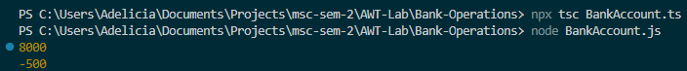

***ADVANCED DATABASE MANAGEMENT SYSTEMS***

***INDEX***

|  |  |  |
| --- | --- | --- |
| S. No. | Program Names | Page No. |
| 1. | Demonstrate queries on DDL Commands. | 75 |
| 2. | Demonstrate queries on DML Commands. | 80 |
| 3. | Demonstrate queries on TCL Commands. | 82 |
| 4. | Demonstrate queries on DQL Commands. | 84 |
| 5. | Demonstrate queries on DCL Commands. | 85 |
| 6. | Demonstrate queries on Views. | 88 |
| 7. | Demonstrate queries on Aggregate Functions. | 89 |
| 8. | Demonstrate queries on Date/Time Functions. | 92 |
| 9 | Demonstrate queries on Joins. | 94 |

***1. Demonstrate queries on DDL Commands (Data Definition Language).***

**CREATE**

create database college_db;



use college_db;

create table Students (

    Registration_Number varchar(6) primary key,

    Student_Name varchar(100) not null,

    Age integer not null,

    Class char(10) not null,

    Phone_Number bigint not null,

    Email varchar(100) not null,

    Date_Of_Birth date not null

);

create table Internals (

    Subject_Code varchar(100) not null,

    Subject_Name varchar(100) not null,

    Semester integer not null,

    Test_1 integer not null,

    Test_2 integer not null,

    Activity integer not null,

    Total integer not null,

    foreign key (Registration_Number) references Students(Registration_Number)

);

create table Finals (

    Subject_Code varchar(100) not null,

    Subject_Name varchar(100) not null,

    Semester integer not null,

    Theory integer not null,

    Practicals integer not null,

    Total integer not null,

    Grade varchar(10) not null,

    foreign key (Registration_Number) references Students(Registration_Number)

);

create table Department (

    Department_ID varchar(10) primary key,

    Department_Name varchar(20) not null,

    Staff_Strength integer not null,

    HOD_ID varchar(20) not null

);

create table Staff (

    Department_ID varchar(20) not null,

    Staff_ID varchar(20) primary key,

    Staff_Name varchar(100) not null,

    foreign key (Department_ID) references Department(Department_ID)

);

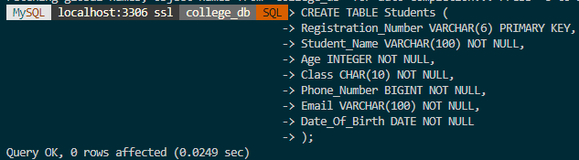

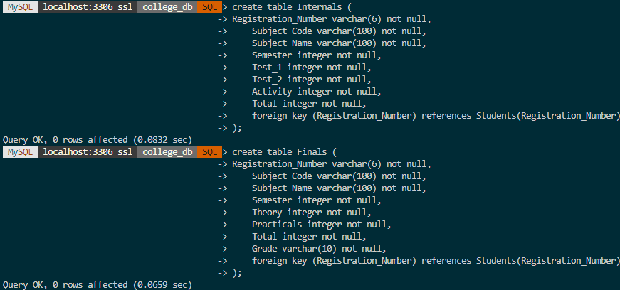

**DESCRIBE**

describe Students;

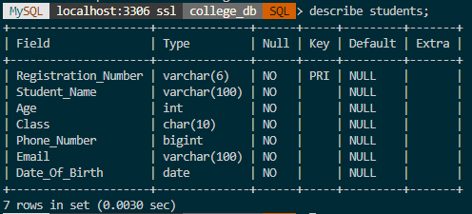

describe Department;

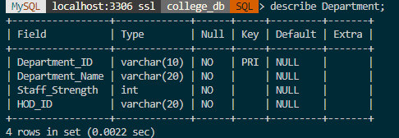

**ALTER**

alter table Students

add Gender char(6) not null;

describe Students;

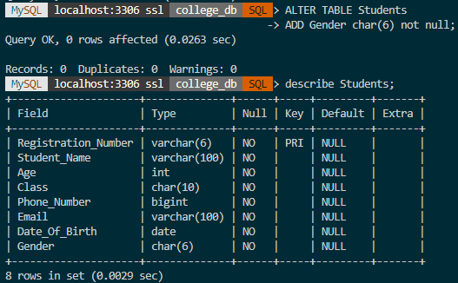

alter table department

modify HOD_ID integer not null;

describe Department;

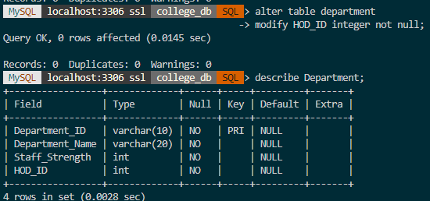

**DROP**

drop table Department;

describe Department;

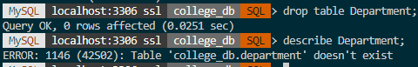

**TRUNCATE**

truncate table Students;

select * from Students;

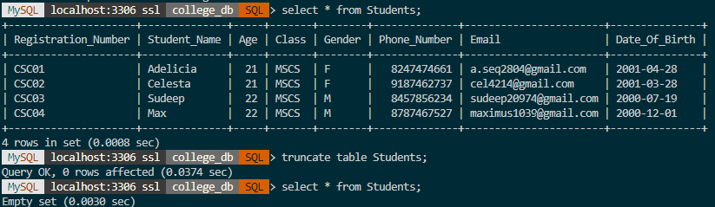

***2. Demonstrate queries on DML Commands (Data Manipulation Language).***

**INSERT**

insert into Staff(Department_ID, Staff_ID, Staff_Name)

values('SJU01', 'SJU0101', 'Angelina'),

('SJU01', 'SJU0102', 'Mary'),

('SJU01', 'SJU0103', 'Karen'),

('SJU01', 'SJU0104', 'Joseph'),

('SJU02', 'SJU0201', 'Jonathan'),

('SJU02','SJU0202','Sanjana'),

('SJU02','SJU0203','David'),

('SJU03', 'SJU0301', 'Javier'),

('SJU03','SJU0302','Mridula'),

('SJU03','SJU0303','Sumanth'),

('SJU03','SJU0304','Josephine'),

('SJU03','SJU0305','Karim'),

('SJU04', 'SJU0401', 'Oindrila'),

('SJU04','SJU0402','Ila'),

('SJU04','SJU0403','Swapnil'),

('SJU04','SJU0404','Meryn'),

('SJU04','SJU0405','Sapna'),

('SJU04','SJU0406','Muthoot'),

('SJU04','SJU0407','Priya');

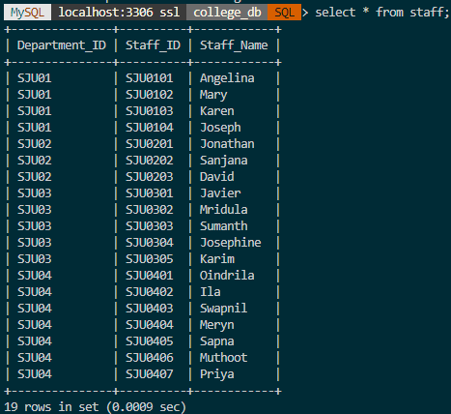

**UPDATE**

update Internals

set Subject_Name = ‘Theory Of Computation’

where Subject_Code = ‘C01’;

select * from Internals;

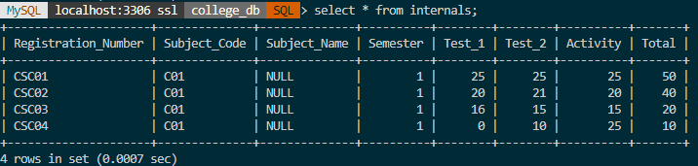 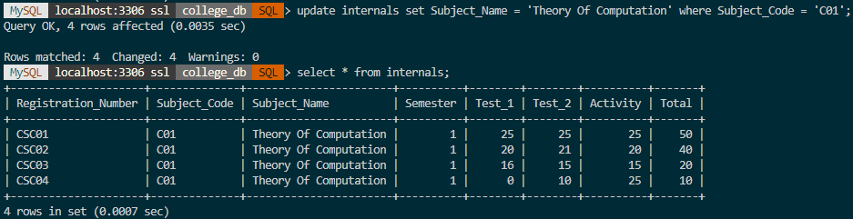

**DELETE**

delete from Internals

where Test_1 = 0;

select * from Internals;

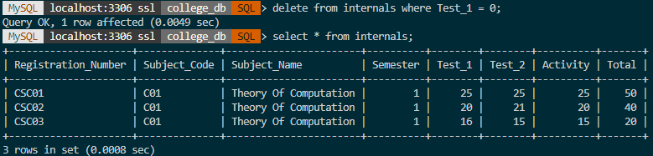

***3. Demonstrate queries on TCL Commands (Transaction Control Language).***

**SAVEPOINT**

start transaction;

savepoint college_save;



**COMMIT**

start transaction;

select * from Finals;

delete from Finals

where Theory < 50;

select * from Finals;

savepoint college_save;

commit;

***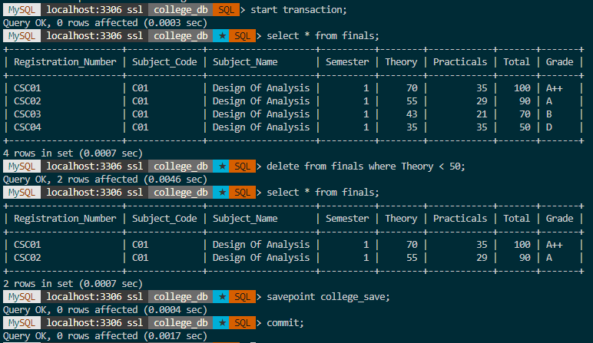*ROLLBACK**

start transaction;

select * from Finals;

delete from Finals

where Theory > 50;

select * from Finals;

rollback;

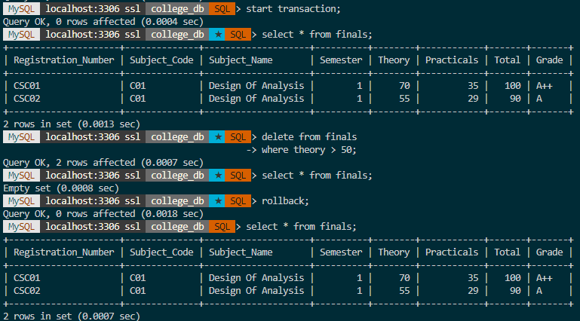

start transaction;

select * from Finals;

savepoint college_save;

delete from Finals

where Subject_Code = ‘C01’;

rollback to savepoint college_save;

select * from Finals;

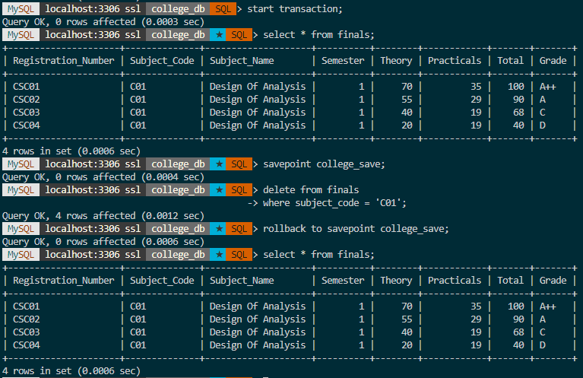

***4. Demonstrate queries on DQL Commands (Data Query Language).***

**SELECT**

select * from Students;

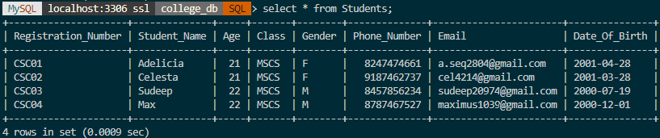

**ORDER BY**

select Student_Name

from Students

order by Student_Name asc;

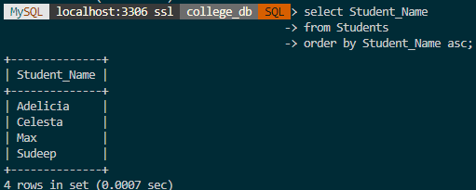

**GROUP BY**

select count(Staff_ID) from Staff

group by Department_ID;

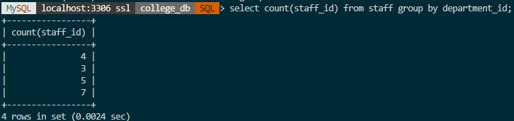

***5. Demonstrate queries on DCL Commands (Data Control Language).***

**CREATE USER**

Create user ady@localhost identified by ‘ady2838’;



*Connecting to new user…*

>mysqlsh

>\sql

>\connect ady@localhost -p

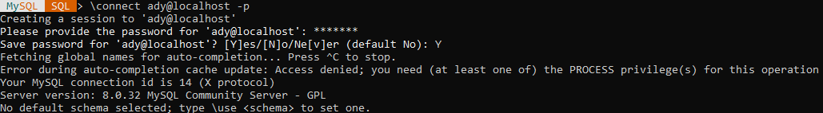

**GRANT**

grant all on college_db.* to ady@localhost;

show grants for ady@localhost;

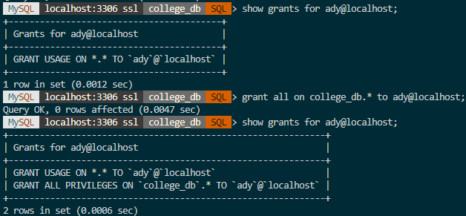

*Connecting to other user…*

insert into values (‘SJU05’, ‘Big Data Analytics’, 10, ‘H05’);

select * from Dsepartment;

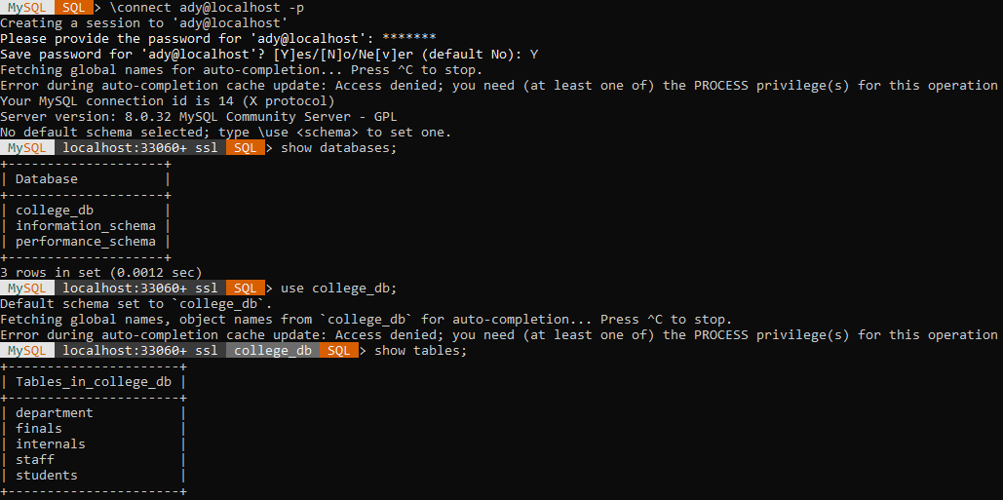

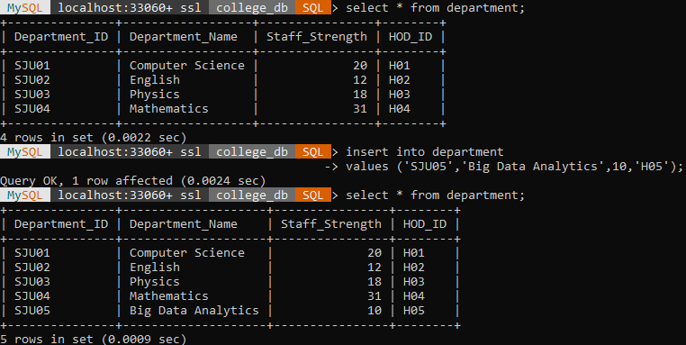

**REVOKE**

revoke all on college_db.* from ady@localhost;

show grants for ady@localhost;

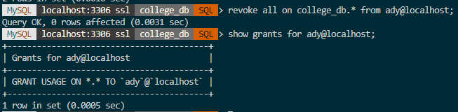

***6. Demonstrate Views.***

**CREATE VIEW**

create view StudentName as

select Registration_Number, Student_Name from Students;

select * from StudentName;

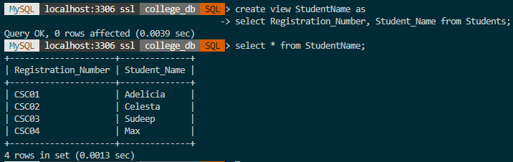

create view ady_details as

select * from Students

where Registration_Number = ‘CSC01’;

select * from ady_details;

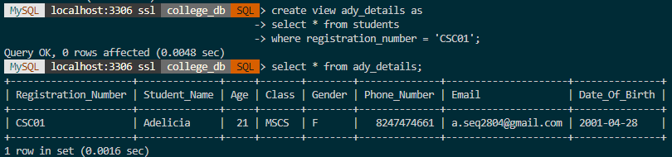

***7. Demonstrate Aggregate Functions.***

**COUNT**

select count(Staff_ID) from Staff;

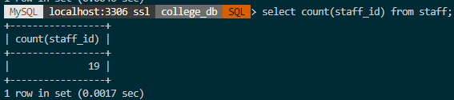

**SUM**

select sum(Age) from Students;

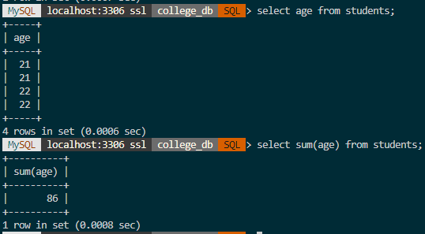

**AVERAGE**

select Theory from Finals;

select avg(Theory) from Finals;

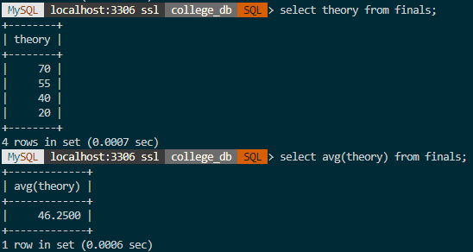

**MINIMUM**

select Activity from Internals;

select min(Activity) from Internals;

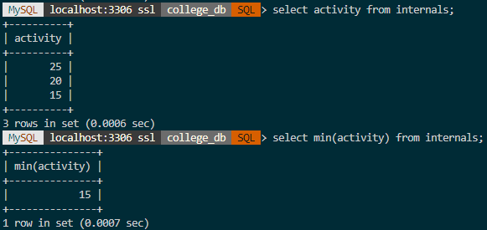

**MAXIMUM**

select Practicals from Finals;

select max(Practicals) from Finals;

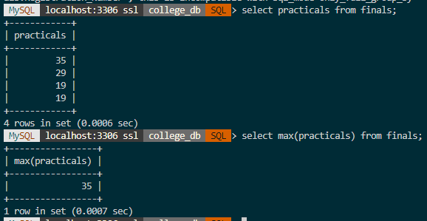

***8. Demonstrate Date /Time Functions.***

**SYSDATE()**

select sysdate();

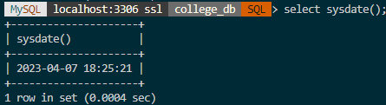

**CURDATE()**

select curdate();

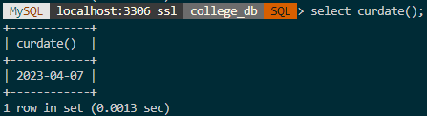

**CONVERT_TZ ()**

select convert_tz('2001-04-28 12:00:00', '+00:00', '+06:30');

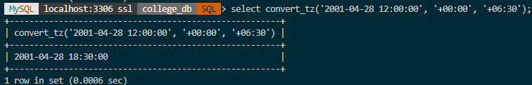

**CURTIME ()**

select curtime();

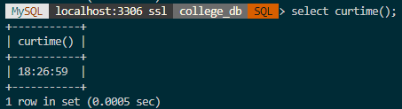

**DATEDIFF ()**

select datediff('2001-04-28 22:59:59','2001-04-30');

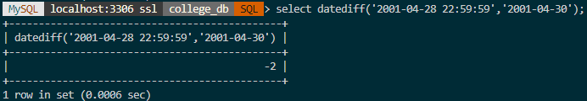

**DATE_ADD()**

select date_add('1900-01-01 00:00:00', INTERVAL '-1 12' DAY_HOUR);

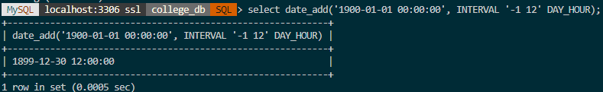

**DATE_FORMAT()**

select date_format('2001-04-28 23:00:00', '%W %D %M %Y');

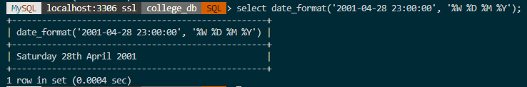

***9. Demonstrate Joins.***

**INNER JOINS**

select Students.Student_Name, Internals.Test_1

from Students

inner join Internals on Internals.Registration_Number = Students.Registration_Number;

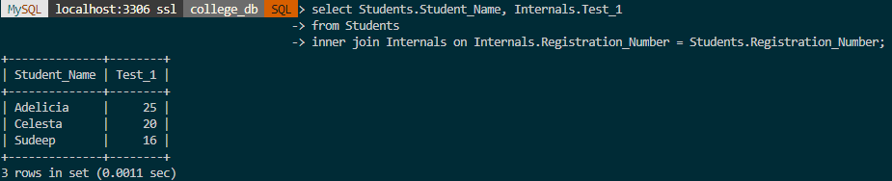

**LEFT JOINS**

select Students.Student_Name, Internals.Test_1

from Students

left join Internals on Internals.Registration_Number = Students.Registration_Number

order by Internals.Test_1;

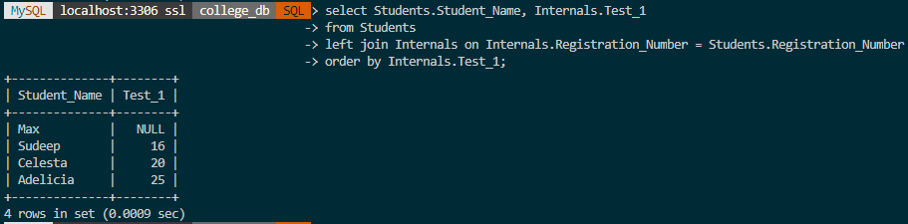

**RIGHT JOINS**

select Students.Student_Name, Internals.Test_1

from Students

right join Internals on Internals.Registration_Number = Students.Registration_Number

order by Students.Age desc;

