***INDEX***

|  |  |  |
| --- | --- | --- |
| Sl. No. | Program Name | Page No. |
| 1. | For a given set of training data examples stored in a .CSV file, implement and demonstrate the Candidate-Elimination algorithm to output a description of the set of all hypotheses consistent with the training examples. | 02 |
| 2. | Demonstrate the working of the decision tree. Use an appropriate data set for building the decision tree and apply this knowledge to classify a new sample. | 05 |
| 3. | Build an Artificial Neural Network by test the same using appropriate data sets. | 07 |
| 4. | Implement the Naïve Bayesian classifier for a sample training data set stored as a .CSV file. Compute the accuracy of the classifier, considering few test data sets. | 13 |
| 5. | Implement Find S Algorithm. | 15 |
| 6. | Apply K-Means clustering algorithm to cluster data stored in a .CSV file. | 17 |
| 7. | Implement k-Nearest Neighbour algorithm to classify the iris data set. Print both correct and wrong predictions. | 20 |
| 8. | Implement the parametric Linear Regression algorithm in order to fit data points. Select appropriate data set for your experiment and draw graphs. | 22 |

***1. For a given set of training data examples stored in a .CSV file, implement and demonstrate the Candidate-Elimination algorithm to output a description of the set of all hypotheses consistent with the training examples.***

import csv

a = []

print("\n The Given Training Data Set")

with open('enjoysport.csv', 'r') as csvFile:

    reader = csv.reader(csvFile)

    for row in reader:

        a.append (row)

        print(row)

num_attributes = len(a[0])-1

print("\n The initial value of hypothesis: ")

S = ['0'] * num_attributes

G = ['?'] * num_attributes

print ("\n The most specific hypothesis S0 : [0,0,0,0,0,0]")

print (" \n The most general hypothesis G0 : [?,?,?,?,?,?]")

for j in range(0,num_attributes):

    S[j]=a[0][j]

print("\n Candidate Elimination algorithm Hypotheses Version Space Computation\n")

temp=[]

for i in range(0,len(a)):

    if a[i][num_attributes]=='Yes':

        for j in range(0,num_attributes):

            if a[i][j]!=S[j]:

                S[j]='?'

        for j in range(0,num_attributes):

            for k in range(1,len(temp)):

                if temp[k][j]!='?' and temp[k][j]!=S[j]:

                    del temp[k]

        print("----------------------------------------------------------------------------- ")

        print(" For Training Example No :{0} the hypothesis is S{0} ".format(i+1),S)

        if (len(temp)==0):

            print(" For Training Example No :{0} the hypothesis is G{0} ".format(i+1),G)

        else:

            print(" For  Positive Training Example No :{0} the hypothesis is G{0}".format(i+1),temp)

    if a[i][num_attributes]=='No':

        for j in range(0,num_attributes):

            if S[j] != a[i][j] and S[j]!= '?':

                G[j]=S[j]

                temp.append(G)

                G = ['?'] * num_attributes

        print("----------------------------------------------------------------------------- ")

        print(" For Training Example No :{0} the hypothesis is S{0} ".format(i+1),S)

        print(" For Training Example No :{0} the hypothesis is G{0}".format(i+1),temp)

**Output**

The Given Training Data Set

['sunny', 'warm', 'normal', 'strong', 'warm', 'same', 'Yes']

['sunny', 'warm', 'high', 'strong', 'warm', 'same', 'Yes']

['rainy', 'cold', 'high', 'strong', 'warm', 'change', 'No']

['sunny', 'warm', 'high', 'strong', 'cool', 'change', 'Yes']

The initial value of hypothesis:

The most specific hypothesis S0 : [0,0,0,0,0,0]

The most general hypothesis G0 : [?,?,?,?,?,?]

Candidate Elimination algorithm Hypotheses Version Space Computation

-----------------------------------------------------------------------------

For Training Example No :1 the hypothesis is S1 ['sunny', 'warm', 'normal', 'strong', 'warm', 'same']

For Training Example No :1 the hypothesis is G1 ['?', '?', '?', '?', '?', '?']

-----------------------------------------------------------------------------

For Training Example No :2 the hypothesis is S2 ['sunny', 'warm', '?', 'strong', 'warm', 'same']

For Training Example No :2 the hypothesis is G2 ['?', '?', '?', '?', '?', '?']

-----------------------------------------------------------------------------

For Training Example No :3 the hypothesis is S3 ['sunny', 'warm', '?', 'strong', 'warm', 'same']

For Training Example No :3 the hypothesis is G3 [['sunny', '?', '?', '?', '?', '?'], ['?', 'warm', '?', '?', '?', '?'], ['?', '?', '?', '?', '?', 'same']]

-----------------------------------------------------------------------------

For Training Example No :4 the hypothesis is S4 ['sunny', 'warm', '?', 'strong', '?', '?']

For Positive Training Example No :4 the hypothesis is G4 [['sunny', '?', '?', '?', '?', '?'], ['?', 'warm', '?', '?', '?', '?']]

***2. Demonstrate the working of the Decision Tree. Use an appropriate data set for building the decision tree and apply this knowledge to classify a new sample.***

import pandas as pd # Load libraries

from sklearn.tree import DecisionTreeClassifier # Import Decision Tree Classifier

from sklearn.model_selection import train_test_split # Import train_test_split function

from sklearn import metrics #Import scikit-learn metrics module for accuracy calculation

from sklearn import tree #Import scikit-learn tree module for plotting

import matplotlib.pyplot as plt #Import matplotlib for plotting

# load dataset

pima = pd.read_csv("diabetes.csv")

pima.columns

#split dataset in features and target variable

feature_cols = ['Pregnancies', 'Insulin', 'BMI', 'Age', 'Glucose', 'BloodPressure', 'DiabetesPedigreeFunction']

X = pima[feature_cols] # Features

y = pima.Outcome # Target variable

# Split dataset into training set and test set

X_train, X_test, y_train, y_test = train_test_split(X, y, test_size=0.3, random_state=1) # 70% training and 30% test

# Create Decision Tree classifer object

clf = DecisionTreeClassifier()

# Train Decision Tree Classifer

clf = clf.fit(X_train,y_train)

#Predict the response for test dataset

y_pred = clf.predict(X_test)

# Model Accuracy, how often is the classifier correct?

print("Accuracy:",metrics.accuracy_score(y_test, y_pred))

plt.figure(figsize=(10,8))

tree.plot_tree(clf, feature_names=feature_cols, class_names=['0','1'], label=all, filled=True, proportion=True, rounded=True, fontsize=3)

print('Number of correct predictions are')

diff = list(y_pred - y_test)

print(diff.count(0)," out of ",len(diff))

**Output**

Index(['Pregnancies', 'Glucose', 'BloodPressure', 'SkinThickness', 'Insulin',

'BMI', 'DiabetesPedigreeFunction', 'Age', 'Outcome'],

dtype='object')

Accuracy: 0.683982683982684

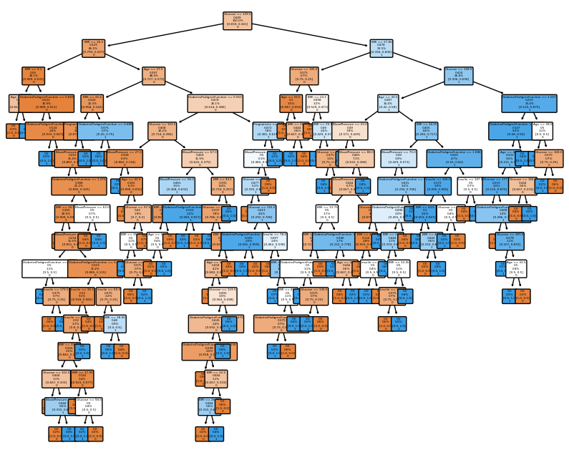

***3. Build an Artificial Neural Network by testing the same using appropriate data sets.***

import numpy as np

import pandas as pd

from matplotlib import pyplot as plt

data = pd.read_csv('digit-recognizer/train.csv')

data = np.array(data)

m, n = data.shape

np.random.shuffle(data) # shuffle before splitting into dev and training sets

data_dev = data[0:1000].T

Y_dev = data_dev[0]

X_dev = data_dev[1:n]

X_dev = X_dev / 255.

data_train = data[1000:m].T

Y_train = data_train[0]

X_train = data_train[1:n]

X_train = X_train / 255.

_,m_train = X_train.shape

Y_train

def init_params():

    W1 = np.random.rand(10, 784) - 0.5

    b1 = np.random.rand(10, 1) - 0.5

    W2 = np.random.rand(10, 10) - 0.5

    b2 = np.random.rand(10, 1) - 0.5

    return W1, b1, W2, b2

def ReLU(Z):

    return np.maximum(Z, 0)

def softmax(Z):

    A = np.exp(Z) / sum(np.exp(Z))

    return A

def forward_prop(W1, b1, W2, b2, X):

    Z1 = W1.dot(X) + b1

    A1 = ReLU(Z1)

    Z2 = W2.dot(A1) + b2

    A2 = softmax(Z2)

    return Z1, A1, Z2, A2

def ReLU_deriv(Z):

    return Z > 0

def one_hot(Y):

    one_hot_Y = np.zeros((Y.size, Y.max() + 1))

    one_hot_Y[np.arange(Y.size), Y] = 1

    one_hot_Y = one_hot_Y.T

    return one_hot_Y

def backward_prop(Z1, A1, Z2, A2, W1, W2, X, Y):

    one_hot_Y = one_hot(Y)

    dZ2 = A2 - one_hot_Y

    dW2 = 1 / m * dZ2.dot(A1.T)

    db2 = 1 / m * np.sum(dZ2)

    dZ1 = W2.T.dot(dZ2) * ReLU_deriv(Z1)

    dW1 = 1 / m * dZ1.dot(X.T)

    db1 = 1 / m * np.sum(dZ1)

    return dW1, db1, dW2, db2

def update_params(W1, b1, W2, b2, dW1, db1, dW2, db2, alpha):

    W1 = W1 - alpha * dW1

    b1 = b1 - alpha * db1

    W2 = W2 - alpha * dW2

    b2 = b2 - alpha * db2

    return W1, b1, W2, b2

def get_predictions(A2):

    return np.argmax(A2, 0)

def get_accuracy(predictions, Y):

    print(predictions, Y)

    return np.sum(predictions == Y) / Y.size

def gradient_descent(X, Y, alpha, iterations):

    W1, b1, W2, b2 = init_params()

    for i in range(iterations):

        Z1, A1, Z2, A2 = forward_prop(W1, b1, W2, b2, X)

        dW1, db1, dW2, db2 = backward_prop(Z1, A1, Z2, A2, W1, W2, X, Y)

        W1, b1, W2, b2 = update_params(W1, b1, W2, b2, dW1, db1, dW2, db2, alpha)

        if i % 10 == 0:

            print("Iteration: ", i)

            predictions = get_predictions(A2)

            print(get_accuracy(predictions, Y))

    return W1, b1, W2, b2

W1, b1, W2, b2 = gradient_descent(X_train, Y_train, 0.10, 500)

def make_predictions(X, W1, b1, W2, b2):

    _, _, _, A2 = forward_prop(W1, b1, W2, b2, X)

    predictions = get_predictions(A2)

    return predictions

def test_prediction(index, W1, b1, W2, b2):

    current_image = X_train[:, index, None]

    prediction = make_predictions(X_train[:, index, None], W1, b1, W2, b2)

    label = Y_train[index]

    print("Prediction: ", prediction)

    print("Label: ", label)

    current_image = current_image.reshape((28, 28)) * 255

    plt.gray()

    plt.imshow(current_image, interpolation='nearest')

    plt.show()

test_prediction(0, W1, b1, W2, b2)

test_prediction(1, W1, b1, W2, b2)

test_prediction(2, W1, b1, W2, b2)

test_prediction(3, W1, b1, W2, b2)

dev_predictions = make_predictions(X_dev, W1, b1, W2, b2)

get_accuracy(dev_predictions, Y_dev)

**Output**

array([6, 4, 7, ..., 4, 1, 0], dtype=int64)

Output exceeds the [size limit](command:workbench.action.openSettings?%5B%22notebook.output.textLineLimit%22%5D). Open the full output data [in a text editor](command:workbench.action.openLargeOutput?c972c805-afa0-44ef-9dde-0342e7295bf9)

Iteration: 0

[6 2 6 ... 6 6 6] [6 4 7 ... 4 1 0]

0.09565853658536586

Iteration: 10

[4 8 9 ... 8 9 1] [6 4 7 ... 4 1 0]

0.1646829268292683

Iteration: 20

[4 8 9 ... 8 6 0] [6 4 7 ... 4 1 0]

0.2276829268292683

Iteration: 30

[4 8 9 ... 8 6 0] [6 4 7 ... 4 1 0]

0.2939512195121951

Iteration: 40

[4 4 9 ... 8 6 0] [6 4 7 ... 4 1 0]

0.3631951219512195

Iteration: 50

[4 4 3 ... 8 6 0] [6 4 7 ... 4 1 0]

0.4305121951219512

Iteration: 60

[6 4 3 ... 7 6 0] [6 4 7 ... 4 1 0]

0.48236585365853657

Iteration: 70

[6 4 3 ... 9 6 0] [6 4 7 ... 4 1 0]

0.5249512195121951

Iteration: 80

...

0.8472439024390244

Iteration: 490

[6 4 2 ... 9 8 0] [6 4 7 ... 4 1 0]

0.8479756097560975

Prediction: [6]

Label: 6

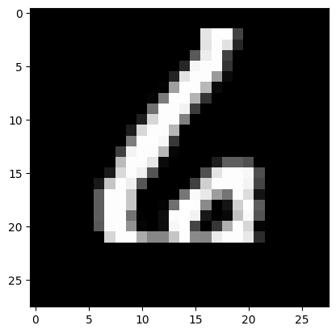

Prediction: [4]

Label: 4

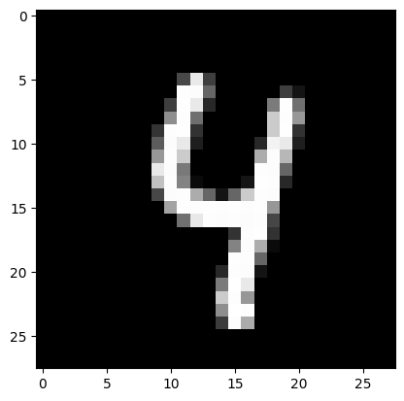

[8 2 8 6 3 9 5 3 5 6 1 4 6 0 9 0 7 5 1 1 9 3 3 3 1 2 1 4 2 7 4 8 9 4 6 7 1

7 9 7 5 1 1 3 9 1 1 9 1 5 2 4 8 4 3 6 8 6 6 9 8 9 7 6 9 1 8 1 6 4 4 6 5 3

6 5 1 3 2 5 9 1 9 7 6 3 4 3 4 3 5 6 2 2 2 6 9 6 5 5 8 1 5 7 0 9 6 5 0 2 2

3 5 5 0 8 6 7 2 2 1 9 8 9 9 2 1 2 8 4 8 6 0 8 8 0 5 7 7 4 9 3 5 1 9 6 2 1

9 9 5 4 1 1 2 0 2 7 3 1 6 5 7 3 6 4 0 2 4 1 3 1 5 9 0 6 9 9 8 7 8 6 7 3 1

2 2 2 4 5 8 4 3 1 0 2 9 1 0 4 4 2 0 8 4 8 3 5 0 9 2 2 0 1 9 7 2 6 2 0 7 1

8 6 8 1 9 8 9 4 9 5 1 1 4 5 4 9 2 1 3 0 8 9 2 6 8 3 8 1 4 0 2 4 0 8 3 7 8

3 6 2 8 3 1 8 7 9 4 7 7 4 8 9 3 0 7 4 0 5 4 3 7 2 6 1 2 0 5 0 6 9 0 6 6 1

1 8 7 3 4 1 3 4 6 5 2 0 3 6 4 7 1 6 4 9 5 7 8 8 6 1 2 2 4 4 9 2 3 6 6 0 6

9 1 8 2 2 8 9 9 5 7 8 2 9 9 7 6 0 7 1 6 6 0 6 6 7 6 2 6 3 8 2 6 0 3 8 0 1

2 0 3 0 4 1 0 7 1 2 4 6 3 4 8 3 7 2 8 4 8 6 2 1 0 3 2 9 6 0 7 6 6 0 4 9 3

6 1 8 4 5 6 0 9 4 0 7 6 7 5 9 4 7 6 9 2 2 5 5 6 2 6 4 7 5 2 6 3 3 4 3 3 4

5 2 8 6 2 7 7 1 2 7 7 1 7 3 3 0 1 1 0 8 7 4 7 8 9 5 1 5 2 6 9 8 7 7 3 1 8

4 6 0 3 4 2 5 2 7 6 5 1 6 2 5 8 7 4 1 3 1 7 3 9 4 0 8 9 5 8 1 8 8 3 3 1 9

3 8 2 7 4 8 8 5 6 3 2 4 8 3 7 0 0 5 6 7 1 0 8 2 8 5 8 8 2 4 3 1 7 5 2 6 1

6 7 8 5 9 6 3 6 2 7 2 1 0 4 1 3 6 0 6 1 0 7 7 6 9 0 8 2 0 4 3 6 7 3 1 4 0

9 6 3 7 1 1 3 5 8 2 6 8 8 4 2 8 7 2 8 0 9 9 4 7 7 6 5 1 1 8 2 3 6 1 3 8 6

4 1 7 8 1 2 2 7 3 4 2 3 5 6 9 4 6 0 1 7 1 1 2 6 4 7 1 7 7 8 8 9 8 3 0 4 8

8 3 4 4 4 1 7 2 6 2 1 9 7 4 7 7 4 5 2 4 1 7 1 5 0 2 8 2 4 5 8 9 4 0 0 1 8

7 7 9 7 1 7 7 2 9 4 4 7 2 0 9 1 6 6 2 0 2 2 4 8 1 8 2 4 0 5 5 3 6 8 9 0 6

1 2 6 1 8 5 9 0 7 6 4 0 6 2 4 3 1 5 0 9 7 7 3 6 4 8 5 2 8 7 4 8 3 9 9 1 6

1 2 1 5 7 7 7 8 3 9 4 7 0 5 4 9 6 4 2 1 0 3 9 7 9 9 4 4 9 6 4 6 4 5 4 6 2

3 5 9 6 8 4 9 0 9 6 1 3 8 0 0 7 4 1 5 5 2 1 0 7 5 0 8 5 0 6 7 1 0 3 8 6 7

0 5 7 7 5 5 5 4 0 2 8 6 1 9 8 4 3 9 4 6 3 0 5 2 2 0 6 9 1 8 4 3 8 4 8 1 7

2 3 7 3 1 8 1 6 5 3 4 0 9 8 7 3 6 6 8 9 3 1 5 3 1 6 7 9 2 6 1 0 0 3 9 1 8

...

2 3 7 3 1 3 1 6 5 3 4 0 9 8 7 5 6 6 2 9 5 1 5 3 1 3 7 9 2 6 1 0 0 3 7 1 8

3 6 0 6 0 9 9 5 9 1 4 8 7 8 1 4 7 0 3 7 4 2 1 1 6 4 7 4 5 1 6 7 0 5 1 5 1

6 1 1 0 9 8 8 5 6 6 2 7 7 5 1 0 2 0 8 7 0 4 4 6 1 8 1 7 3 1 7 2 1 6 0 9 7

1]

0.843

***4. Implement the Naïve Bayesian Classifier for a sample training data set stored as a .CSV file. Compute the accuracy of the classifier, considering few test data sets.***

from sklearn.datasets import load_iris

from sklearn.model_selection import train_test_split

from sklearn.naive_bayes import GaussianNB

X, y = load_iris(return_X_y=True)

X_train, X_test, y_train, y_test = train_test_split(X, y, test_size=0.3, random_state=0)

X

y

model = GaussianNB()

y_pred = model.fit(X_train, y_train).predict(X_test)

y_pred

y_test

diff = y_pred - y_test

diff

print('Number of incorrect classifications are: ',len(y_pred) - list(diff).count(0))

**Output**

array([[5.1, 3.5, 1.4, 0.2],

[4.9, 3. , 1.4, 0.2],

[4.7, 3.2, 1.3, 0.2],

[4.6, 3.1, 1.5, 0.2],

[5. , 3.6, 1.4, 0.2],

[5.4, 3.9, 1.7, 0.4],

[4.6, 3.4, 1.4, 0.3],

[5. , 3.4, 1.5, 0.2],

[4.4, 2.9, 1.4, 0.2],

[4.9, 3.1, 1.5, 0.1],

[5.4, 3.7, 1.5, 0.2],

[4.8, 3.4, 1.6, 0.2],

[4.8, 3. , 1.4, 0.1],

[4.3, 3. , 1.1, 0.1],

[5.8, 4. , 1.2, 0.2],

[5.7, 4.4, 1.5, 0.4],

...

[6.7, 3. , 5.2, 2.3],

[6.3, 2.5, 5. , 1.9],

[6.5, 3. , 5.2, 2. ],

[6.2, 3.4, 5.4, 2.3],

[5.9, 3. , 5.1, 1.8]])

array([0, 0, 0, 0, 0, 0, 0, 0, 0, 0, 0, 0, 0, 0, 0, 0, 0, 0, 0, 0, 0, 0,

0, 0, 0, 0, 0, 0, 0, 0, 0, 0, 0, 0, 0, 0, 0, 0, 0, 0, 0, 0, 0, 0,

0, 0, 0, 0, 0, 0, 1, 1, 1, 1, 1, 1, 1, 1, 1, 1, 1, 1, 1, 1, 1, 1,

1, 1, 1, 1, 1, 1, 1, 1, 1, 1, 1, 1, 1, 1, 1, 1, 1, 1, 1, 1, 1, 1,

1, 1, 1, 1, 1, 1, 1, 1, 1, 1, 1, 1, 2, 2, 2, 2, 2, 2, 2, 2, 2, 2,

2, 2, 2, 2, 2, 2, 2, 2, 2, 2, 2, 2, 2, 2, 2, 2, 2, 2, 2, 2, 2, 2,

2, 2, 2, 2, 2, 2, 2, 2, 2, 2, 2, 2, 2, 2, 2, 2, 2, 2])

array([2, 1, 0, 2, 0, 2, 0, 1, 1, 1, 2, 1, 1, 1, 1, 0, 1, 1, 0, 0, 2, 1,

0, 0, 2, 0, 0, 1, 1, 0, 2, 1, 0, 2, 2, 1, 0, 1, 1, 1, 2, 0, 2, 0,

0])

array([2, 1, 0, 2, 0, 2, 0, 1, 1, 1, 2, 1, 1, 1, 1, 0, 1, 1, 0, 0, 2, 1,

0, 0, 2, 0, 0, 1, 1, 0, 2, 1, 0, 2, 2, 1, 0, 1, 1, 1, 2, 0, 2, 0,

0])

array([0, 0, 0, 0, 0, 0, 0, 0, 0, 0, 0, 0, 0, 0, 0, 0, 0, 0, 0, 0, 0, 0,

0, 0, 0, 0, 0, 0, 0, 0, 0, 0, 0, 0, 0, 0, 0, 0, 0, 0, 0, 0, 0, 0,

0])

Number of incorrect classifications are: 0

***5. Implement Find S Algorithm.***

import csv

def read_csv(filename):

    with open(filename, 'r') as csvfile:

        datareader = csv.reader(csvfile, delimiter=',')

        traindata = []

        for row in datareader:

            traindata.append(row)

        print(traindata)

    return traindata

attributes = ['Sky', 'Temp', 'Humidity', 'Wind', 'Water', 'Forecast']

print("Attributes: ",attributes)

num_attributes = len(attributes)

dataset = read_csv("EnjoySport.csv")

dataset

len(dataset)

hypothesis = ['0']*len(attributes)

hypothesis

print("Initial Hypothesis: ",hypothesis)

for j in range(0, num_attributes):

    hypothesis[j] = dataset[0][j]

print("Find S: Finding a Maximally Specific Hypothesis")

for i in range(len(dataset)):

    if dataset[i][num_attributes] == "Yes":

        for j in range(num_attributes):

            if dataset[i][j] != hypothesis[j]:

                hypothesis[j] = "?"

    else:

        continue

i

print("Hypothesis")

print(hypothesis)

**Output**

Attributes: ['Sky', 'Temp', 'Humidity', 'Wind', 'Water', 'Forecast']

[['sunny', 'warm', 'normal', 'strong', 'warm', 'same', 'Yes'], ['sunny', 'warm', 'high', 'strong', 'warm', 'same', 'Yes'], ['rainy', 'cold', 'high', 'strong', 'warm', 'change', 'No'], ['sunny', 'warm', 'high', 'strong', 'cool', 'change', 'Yes']]

Initial Hypothesis: ['0', '0', '0', '0', '0', '0']

Find S: Finding a Maximally Specific Hypothesis

Hypothesis

['sunny', 'warm', '?', 'strong', '?', '?']

***6. Apply K-Means Clustering algorithm to cluster data stored in a .CSV file.***

import matplotlib.pyplot as plt

from sklearn import datasets

from sklearn.cluster import KMeans

import sklearn.metrics as sm

import pandas as pd

import numpy as np

# import some data to play with

iris = datasets.load_iris()

# print("\n IRIS DATA :",iris.data);

# print("\n IRIS FEATURES :\n",iris.feature_names)

# print("\n IRIS TARGET :\n",iris.target)

# print("\n IRIS TARGET NAMES:\n",iris.target_names)

# Store the inputs as a Pandas Dataframe and set the column names

X = pd.DataFrame(iris.data)

X.columns = ['Sepal_Length','Sepal_Width','Petal_Length','Petal_Width']

y = pd.DataFrame(iris.target)

y.columns = ['Targets']

# Set the size of the plot

plt.figure(figsize=(14,7))

# Create a colormap

colormap = np.array(['red', 'lime', 'black'])

# Plot Sepal

plt.subplot(1, 2, 1)

plt.scatter(X.Sepal_Length,X.Sepal_Width, c=colormap[y.Targets], s=40)

plt.title('Sepal')

plt.subplot(1, 2, 2)

plt.scatter(X.Petal_Length,X.Petal_Width, c=colormap[y.Targets], s=40)

plt.title('Petal')

# K Means Cluster

model = KMeans(n_clusters=3, n_init='auto')

model.fit(X)

model.labels_

# View the results

# Set the size of the plot

plt.figure(figsize=(14,7))

# Create a colormap

colormap = np.array(['red', 'lime', 'black'])

# Plot the Original Classifications

plt.subplot(1, 2, 1)

plt.scatter(X.Petal_Length, X.Petal_Width, c=colormap[y.Targets], s=40)

plt.title('Real Classification')

# Plot the Models Classifications

plt.subplot(1, 2, 2)

plt.scatter(X.Petal_Length, X.Petal_Width, c=colormap[model.labels_], s=40)

plt.title('K Mean Classification')

**Output**

Before K Means Clustering

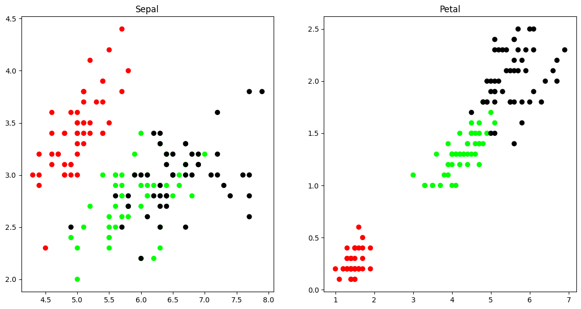

After K Means Clustering

array([1, 1, 1, 1, 1, 1, 1, 1, 1, 1, 1, 1, 1, 1, 1, 1, 1, 1, 1, 1, 1, 1,

1, 1, 1, 1, 1, 1, 1, 1, 1, 1, 1, 1, 1, 1, 1, 1, 1, 1, 1, 1, 1, 1,

1, 1, 1, 1, 1, 1, 0, 0, 2, 0, 0, 0, 0, 0, 0, 0, 0, 0, 0, 0, 0, 0,

0, 0, 0, 0, 0, 0, 0, 0, 0, 0, 0, 2, 0, 0, 0, 0, 0, 0, 0, 0, 0, 0,

0, 0, 0, 0, 0, 0, 0, 0, 0, 0, 0, 0, 2, 0, 2, 2, 2, 2, 0, 2, 2, 2,

2, 2, 2, 0, 0, 2, 2, 2, 2, 0, 2, 0, 2, 0, 2, 2, 0, 0, 2, 2, 2, 2,

2, 0, 2, 2, 2, 2, 0, 2, 2, 2, 0, 2, 2, 2, 0, 2, 2, 0])

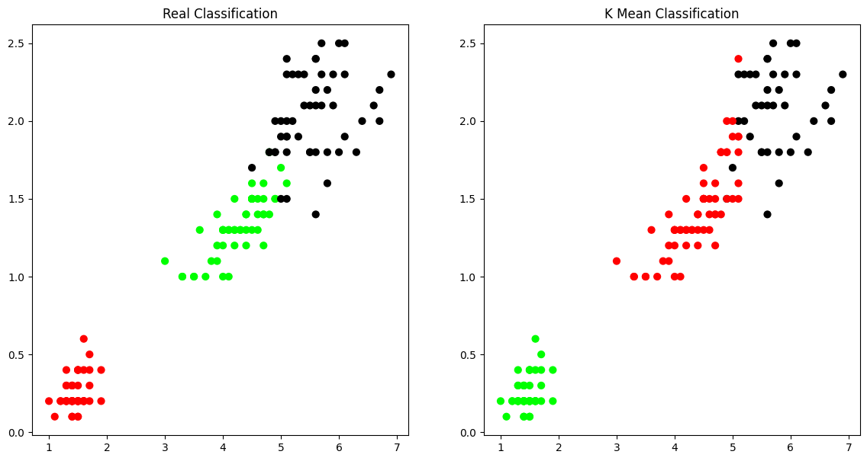

***7. Implement k-Nearest Neighbour algorithm to classify the iris data set. Print both correct and wrong predictions.***

import pandas as pd

from sklearn.neighbors import KNeighborsClassifier

from sklearn.model_selection import train_test_split

from sklearn.datasets import load_iris

import numpy as np

df = pd.read_csv('iris.csv')

df.head()

df['variety'].unique()

x = df[['sepal.length','sepal.width','petal.length','petal.width']]

y = df['variety'].replace({'Setosa':1, 'Versicolor':2, 'Virginica':3 })

train_x, test_x , train_y, test_y= train_test_split(x,y,test_size=0.1,random_state=3, shuffle=True)

knn = KNeighborsClassifier(n_neighbors=3)

knn.fit(train_x,train_y)

pred_y = knn.predict(test_x)

print('The prediction is',pred_y)

print('Actual expected results are:', list(test_y))

print('Number of incorrect classifications are')

diff = np.array(pred_y) - np.array(test_y)

print(len(diff) - list(diff).count(0))

**Output**

array(['Setosa', 'Versicolor', 'Virginica'], dtype=object)

The prediction is [1 1 1 1 1 3 2 1 3 2 2 1 2 2 3]

Actual expected results are: [1, 1, 1, 1, 1, 3, 2, 1, 3, 2, 2, 1, 2, 2, 3]

Number of incorrect classifications are

0

***8. Implement the parametric Linear Regression algorithm in order to fit data points. Select appropriate data set for your experiment and draw graphs***

import numpy as np

import pandas as pd

import matplotlib.pyplot as plt

from sklearn.model_selection import train_test_split

from sklearn import linear_model

df = pd.read_csv('iris.csv')

newdf = df[['petal.length','petal.width']]

train_x, test_x , train_y, test_y= train_test_split(newdf['petal.length'],newdf['petal.width'],test_size=0.1,random_state=3, shuffle=True)

train_x = np.array(train_x).reshape(-1,1)

test_x = np.array(test_x).reshape(-1,1)

train_y = np.array(train_y).reshape(-1,1)

test_y = np.array(test_y).reshape(-1,1)

lr = linear_model.LinearRegression()

lr.fit(train_x,train_y)

import matplotlib.pyplot as plt

plt.scatter(test_x,test_y)

y_predict = lr.predict(test_x)

plt.scatter(test_x,y_predict,color = 'red')

plt.xlabel("petal length")

plt.ylabel("petal width")

from sklearn.metrics import mean_squared_error

sd = (10/4)**0.5

se = sd/(5**0.5)

print('Standard Error ',se )

print('Mean Square Error ', mean_squared_error(test_y,y_predict))

**Output**

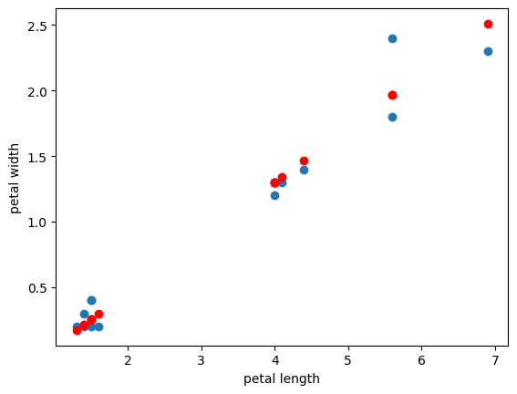

Standard Error 0.7071067811865476

Mean Square Error 0.022523547640619812