Shankly Richard Cragg

[shc27@aber.ac.uk](mailto:SHC27@ABER.AC.UK)

05/05/2015

Patience

# Contents

Contents 1

Introduction 2

Requirements Analysis (Use Case Diagram) 3

Design 4

Testing 6

ID 1.1 9

ID 2.2 10

ID 3.1 11

ID 4.1 12

ID 5.1 14

ID 6.1 16

ID 7.1 18

ID 8.1 20

ID 9.1 21

ID 10.1 22

ID 11.1 23

ID 12.1 24

Evaluation 25

# Introduction

What is to follow, is the design, creation, and testing of a card game called Patience. The game involves placing cards from a deck onto a table, and where you can place a card on top of another if 2 conditions are met. One is the placement of the cards. The 2 cards must be either next to each other, or have 2 cards between them. The other, that both cards share the same value, or suit. The aim of the game is to have 1 pile of cards at the end, once all cards have been drawn.

# Requirements Analysis (Use Case Diagram)

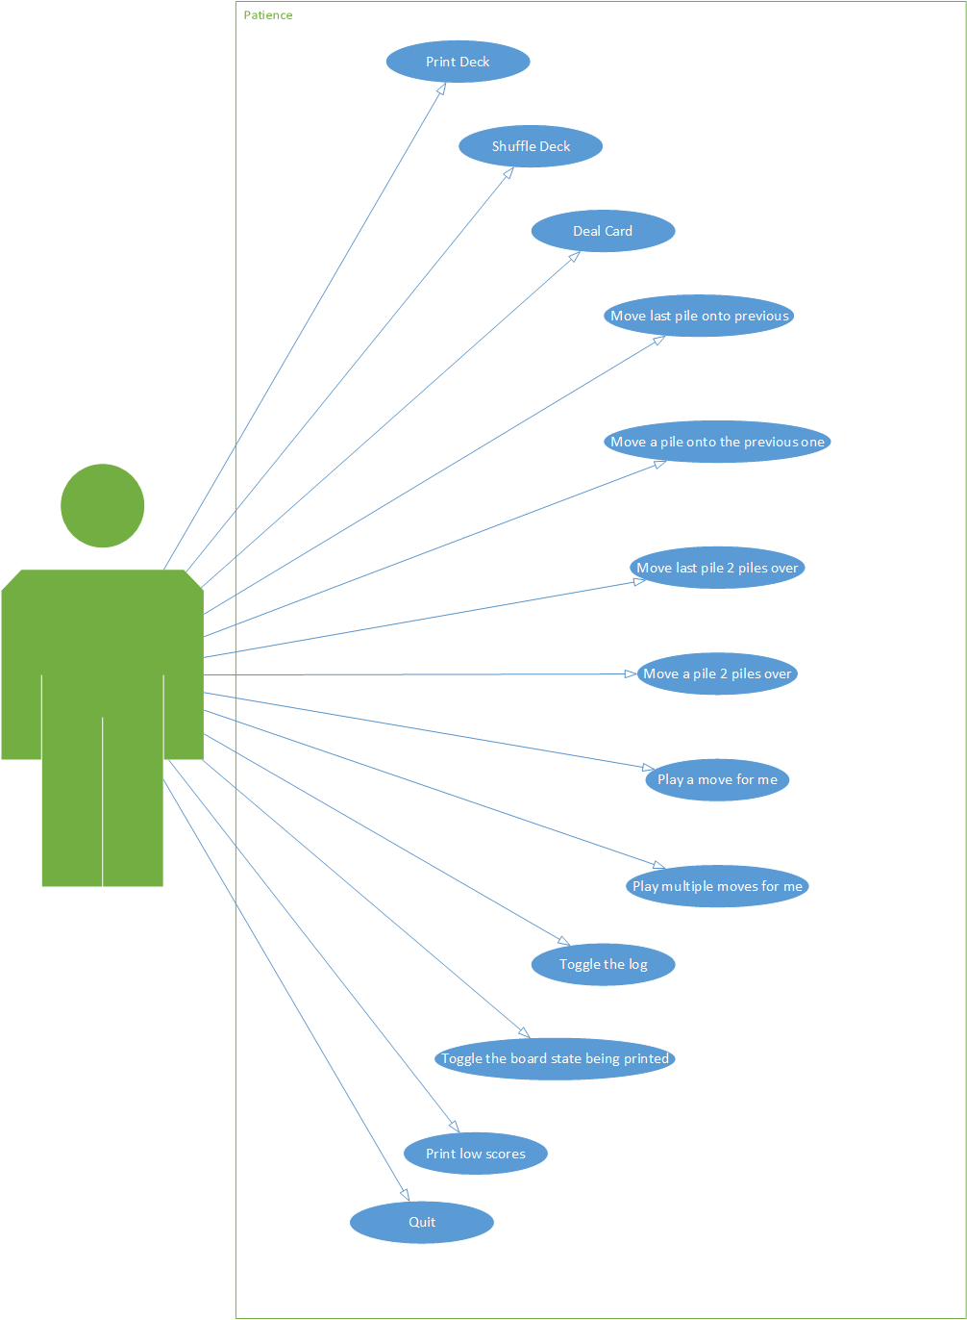

# Design

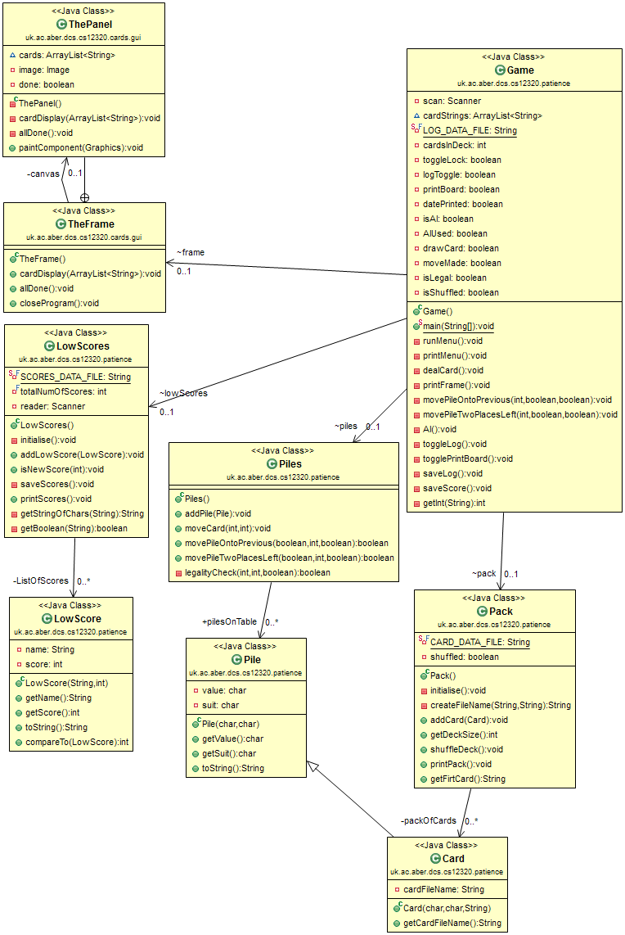

1..1

1..1

0..*.

1..1

1..1

1..1

1..1

1..1

1..1

A sequence diagram of the AI running, when there are no possible moves on the board.

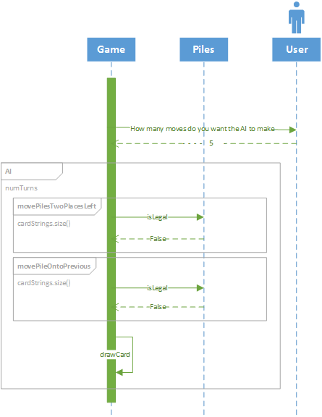

Pseudo code for the moving of a pile on the table over two piles

PileToBeMoved = someInt  
LocationToBeMoved = someInt – 3  
Pile x = arrayListOfPiles.get(pileToMoveMoved)  
Pile y = arrayListOfPiles.get(locationToBeMoved  
Boolean canYouMove = MethdToCheckWheverTheCardsShareAValue(x, y)  
if (canYouMove) {  
 while indexOf(x) != indexOf(y) {  
 sway y with pile to the left  
 }  
 arrayListOfPiles.remove(y)  
 methodToUpdateTheGUI()  
}  
else {  
 System.out.println(“These cards cannot be moved!”)  
}

# Testing

Requirements:

|  |  |
| --- | --- |
| **ID** | **Description** |
| R1 | Shuffle the pack or cards |
| R2 | Show the pack |
| R3 | Deal a card |
| R4 | Make a move: move last pile onto previous one |
| R5 | Make a move. Move last pile over 2 piles |
| R6 | Amalgamate piles in the middle (May only move from right to left) |
| R7 | Play for me once |
| R8 | Play for me a number of time |
| R9 | Show low scores |
| R10 | Select whether text output is also required and if so whether to the console, a file or, both |

|  |  |  |  |  |  |  |
| --- | --- | --- | --- | --- | --- | --- |
| **ID** | **Require-ment** | **Description** | **Inputs** | **Expected outputs** | **Pass/**  **Fail** | **Comments** |
| **1.1** | **R2** | **Print the contents of the deck to the command line** | **1** | **Screenshot SS1 is displayed** | **Pass** | Works as intended |
| 2.1 | R1 | Randomises the order of the cards in the arrayList packOfCards | 2 | Screenshot SS2 is displayed | Pass | Works as intended |
| 3.1 | R3 | Takes a card from the deck, puts it onto the table as long as there are cards in the deck remaining | 3 | Screenshot SS3 is displayed | Pass | Works as intended |
| Screenshot SS4 is displayed | Pass |
| 4.1 | R4 | Moves the last pile onto the previous if the suits or values are the same | 4 | Screenshot SS5 is displayed | Pass | Works as intended |
| Screenshot SS6 is displayed | Pass |
| Screenshot SS7 is displayed | Pass |
| 5.1 | R5 | Moves the last pile over two piles | 5 | Screenshot SS8 is displayed | Pass | Works as intended |
| Screenshot SS9 is displayed | Pass |
| Screenshot SS10 is displayed | Pass |
| 6.1 | R6 | Moves a pile onto the one to the left of it | 6 | Screenshot SS11 is displayed | Pass | Works as intended |
| Screenshot SS12 is displayed | Pass |
| Screenshot SS13 is displayed | Pass |
| 7.1 | R6 | Moves a pile over 2 piles | 7 | Screenshot SS14 is displayed | Pass | Works as intended |
| Screenshot SS15 is displayed | Pass |
| Screenshot SS16 is displayed | Pass |
| 8.1 | R7 | Automatically makes a move for the user | 8 | Screenshot SS17 is displayed | Pass | Works as intended |
| 9.1 | R8 | Automatically make as many moves for the user as they wish. | 9 | Screenshot SS18 is displayed | Pass | Works as intended |
| 10.1 | R10 | Toggles whether the game is logged to the log file or not | 10 | Screenshot SS19 is displayed | Pass | Works as intended |
| 11.1 | R10 | Toggles whether the board state is printed to the command line after a move | 11 | Screenshot SS20 is displayed | Pass | Works as intended |
| 12.1 | R9 | Prints the low score | 12 | Screenshot SS21 is displayed | Pass | Works as intended |

### ID 1.1

SS1

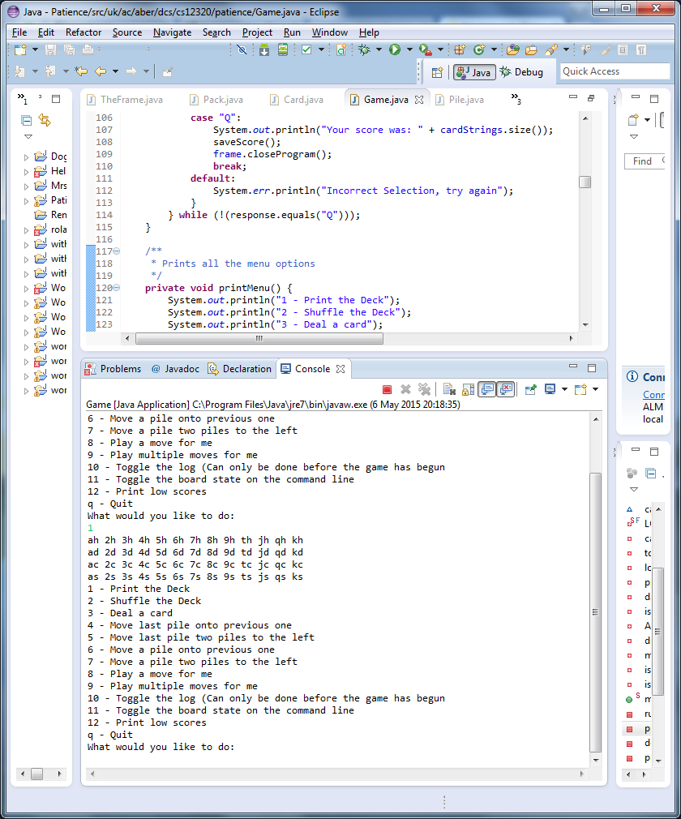

The contents of the deck are printed

### ID 2.2

SS2

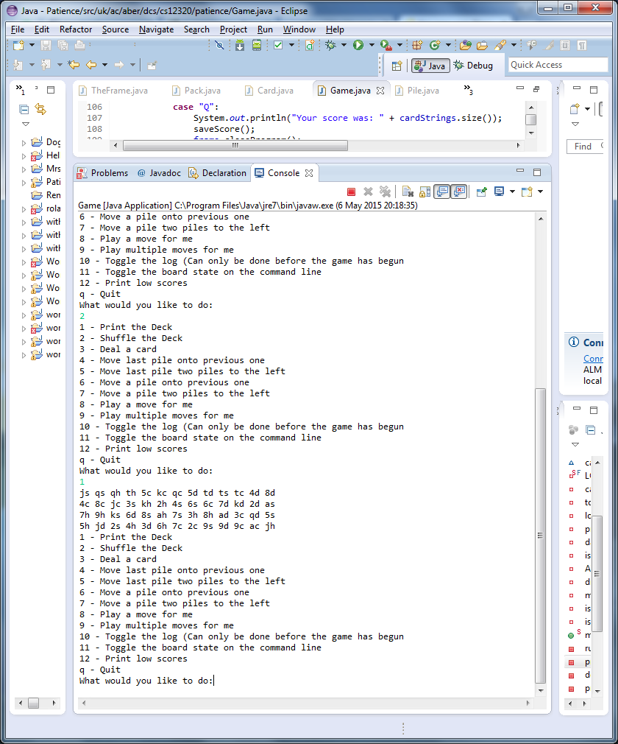

When the deck is printed after shuffling, the cards are in a random order

### ID 3.1

SS3

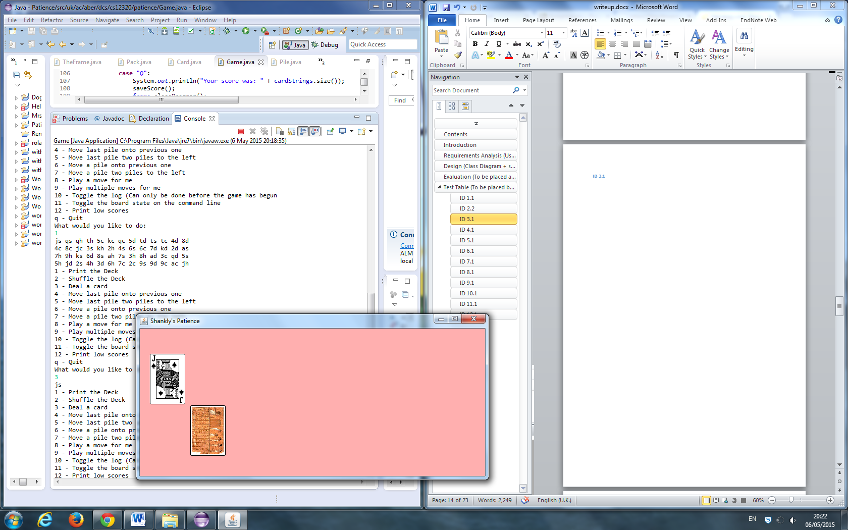

A card is printed (Also shown, a card being printed to the GUI)

SS4

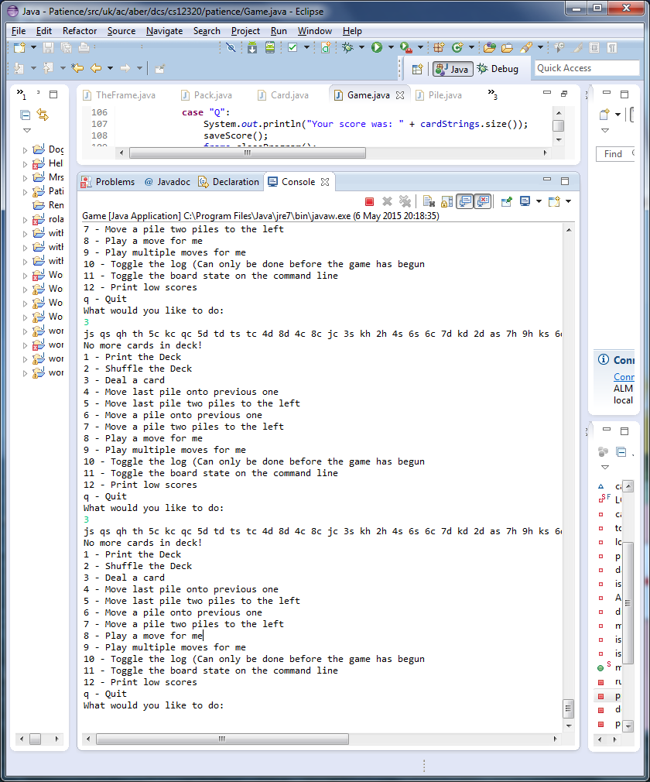

When no more cards are in the deck, no cards are printed

### ID 4.1

SS5

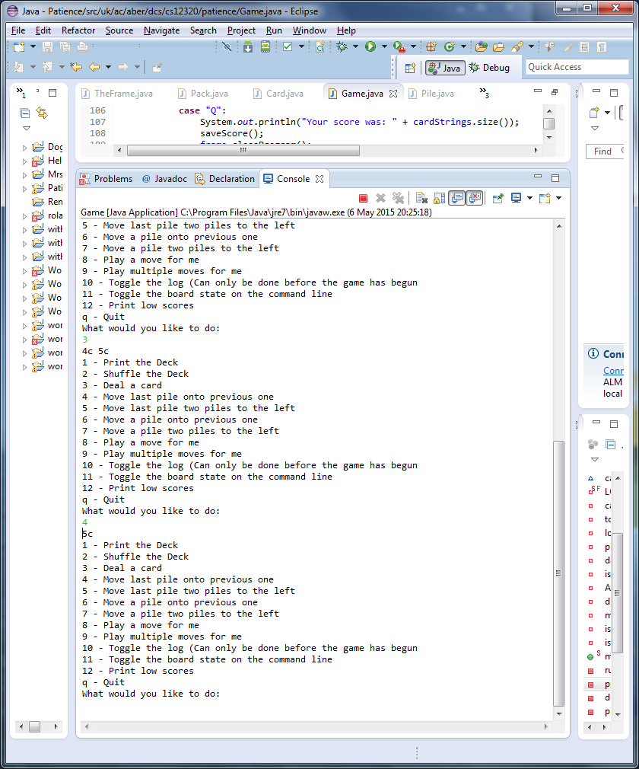

Cards of the same suit are amalgamated

SS6

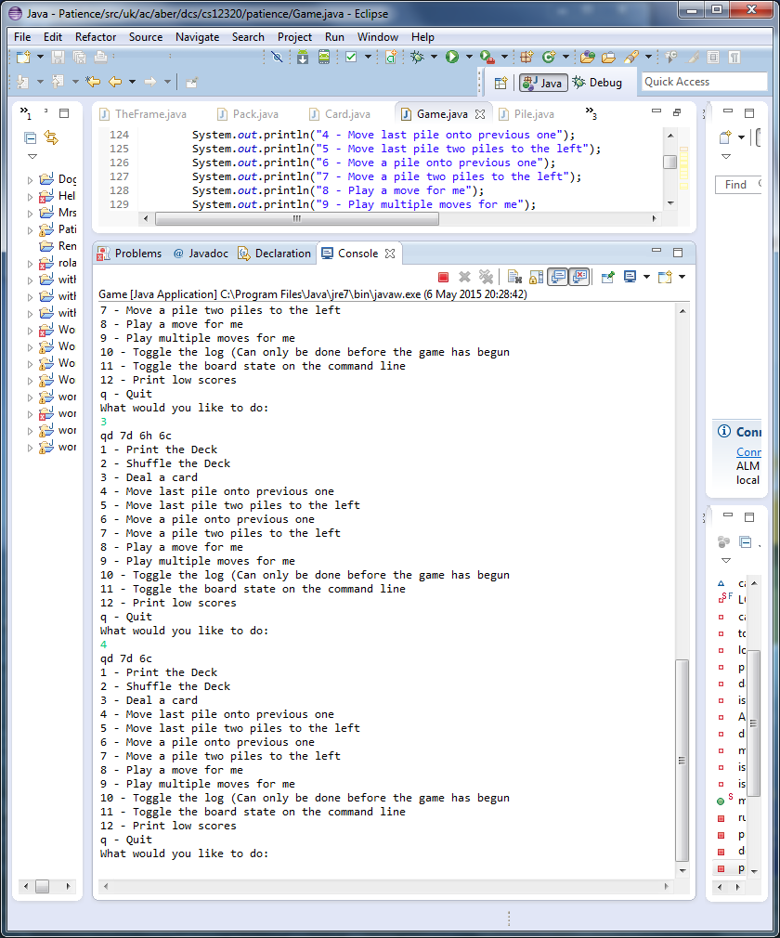

Cards of the same value are amalgamated

SS7

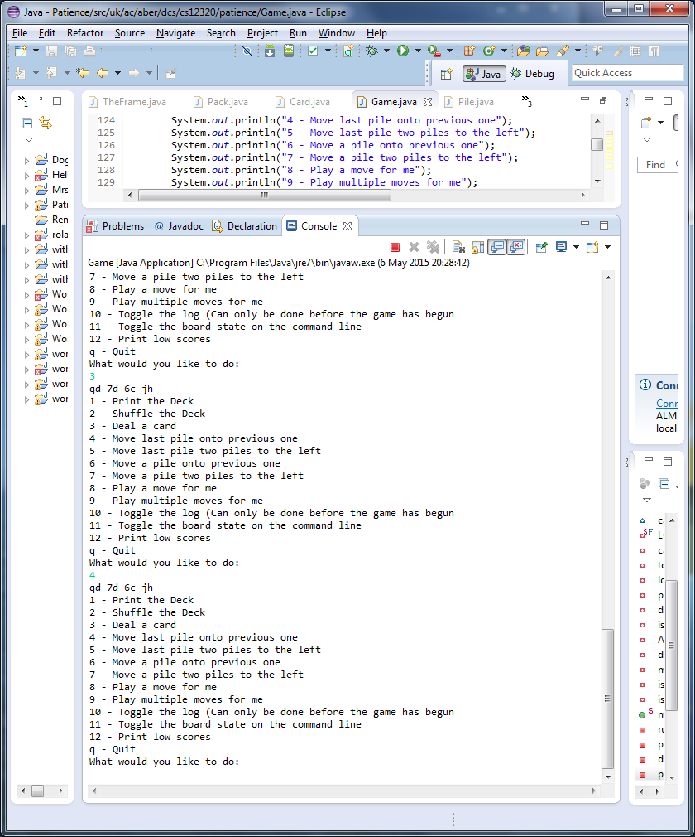

Cards with no shared value are no amalgamated

### ID 5.1

SS8

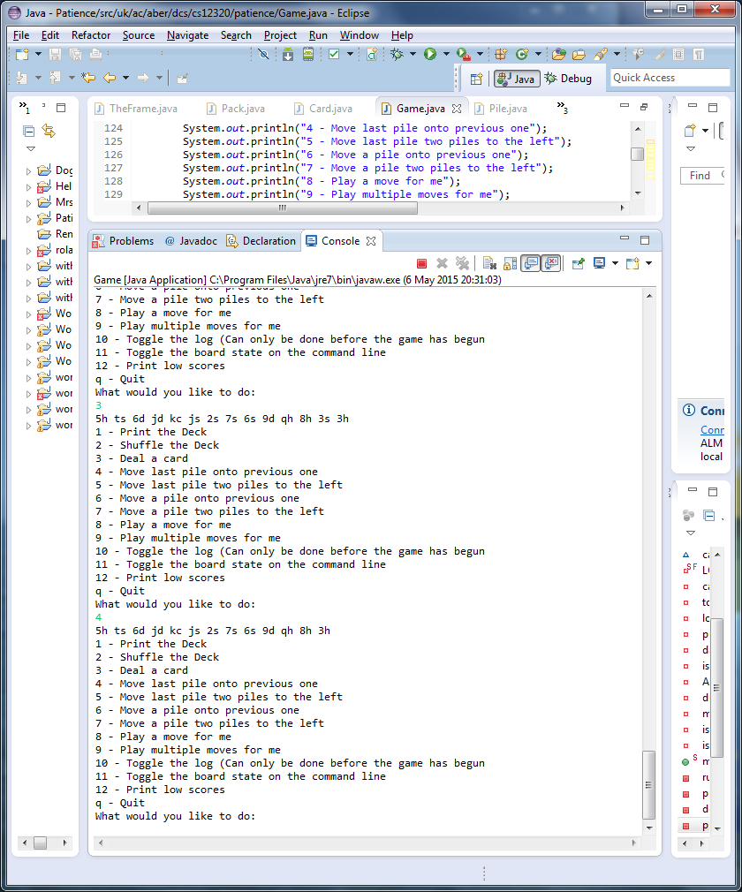

Cards of the same suit are amalgamated

SS9

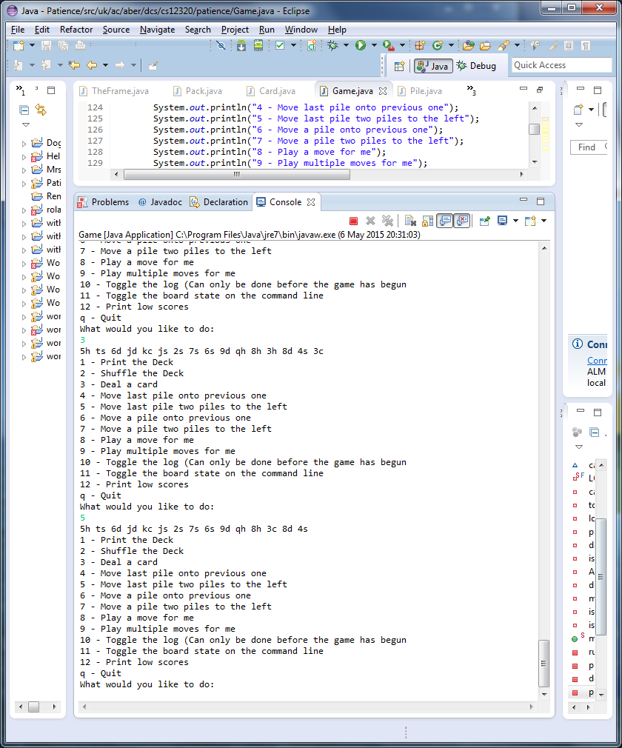

Cards of the same value are amalgamated

SS10

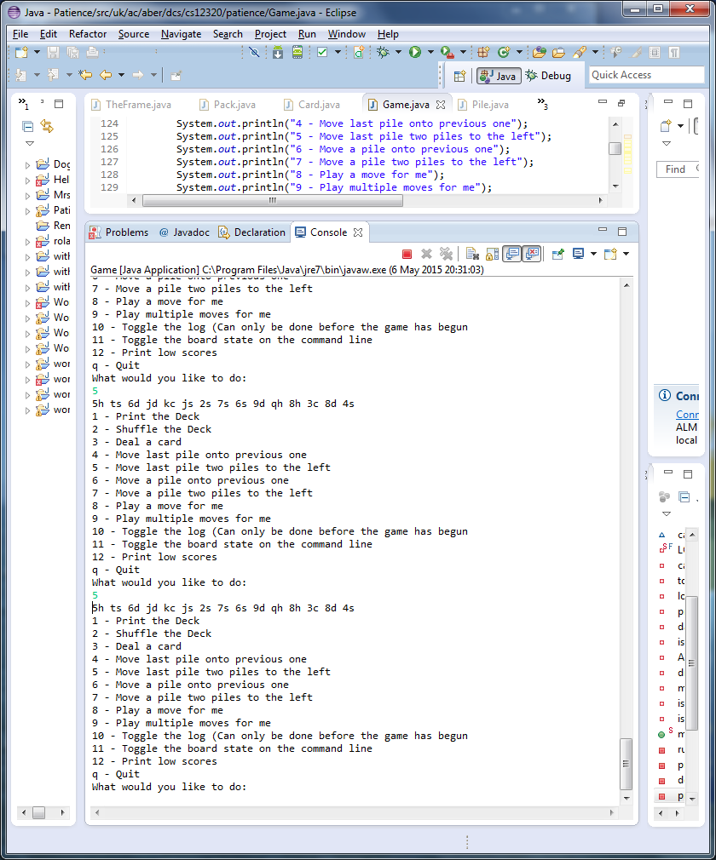

Cards with no shared values are not amalgamated

### ID 6.1

SS11

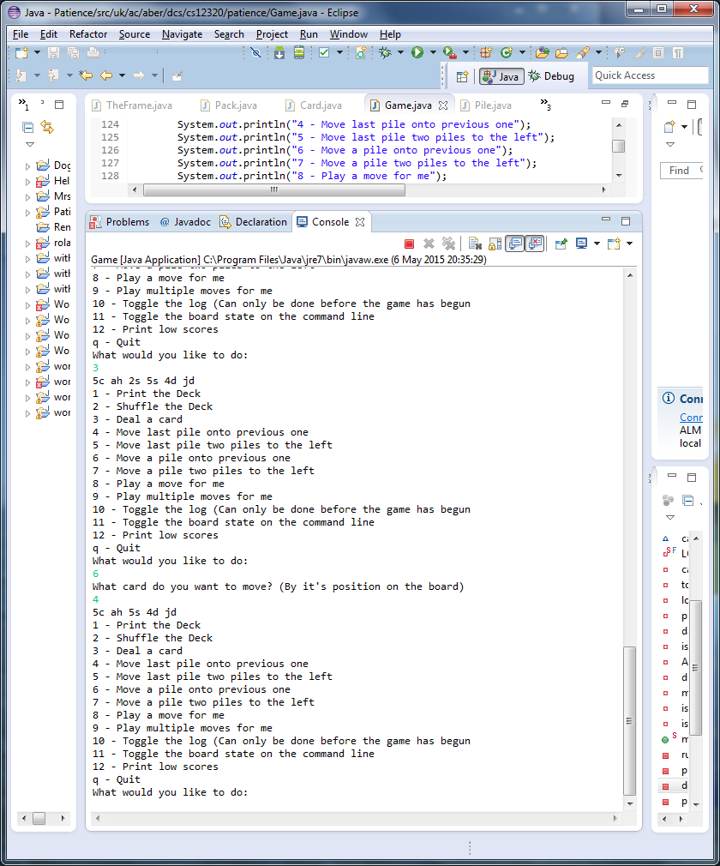

Cards of the same suit are amalgamated

SS12

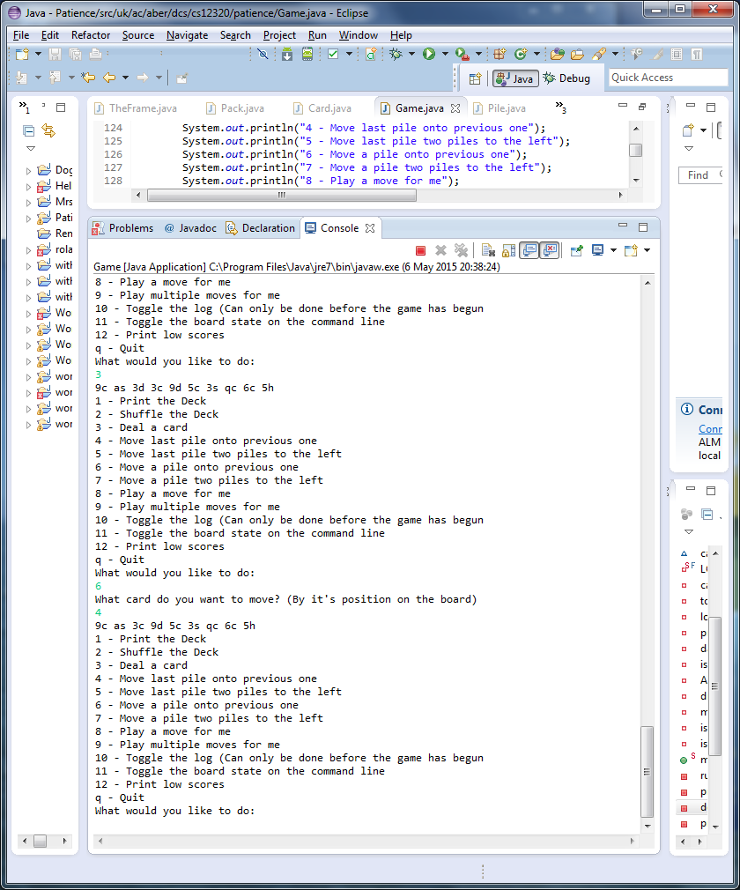

Cards of the same value are amalgamated

SS13

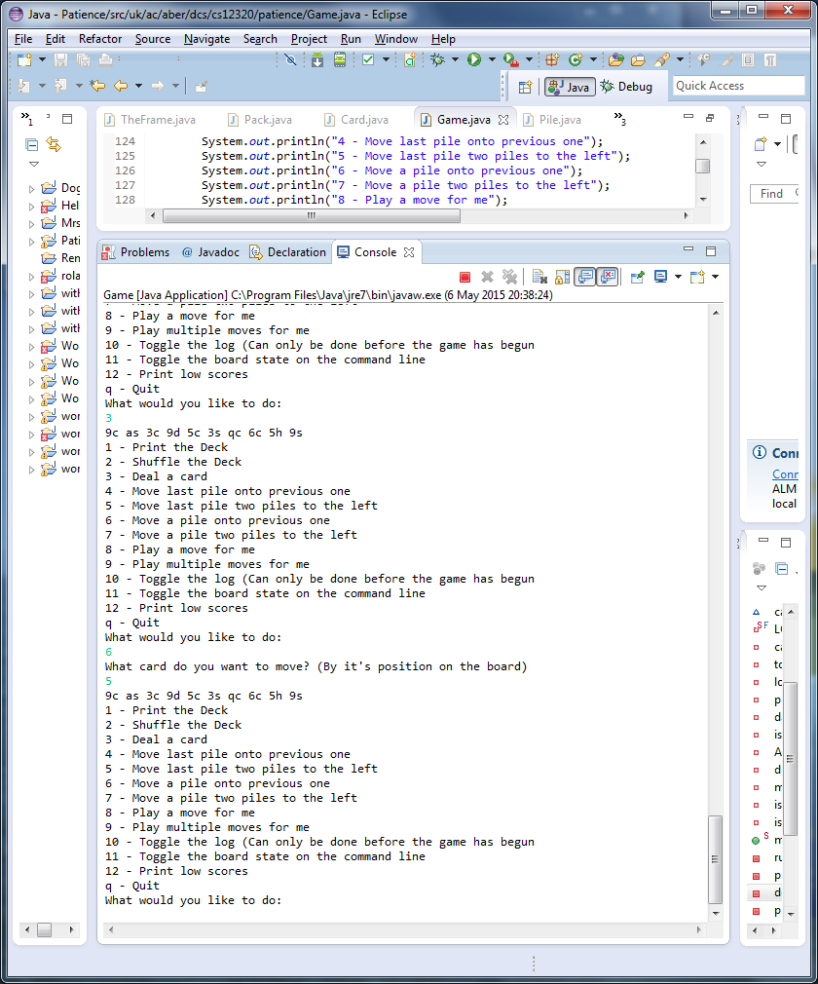

Cards with no shared values are not amalgamated

### ID 7.1

SS14

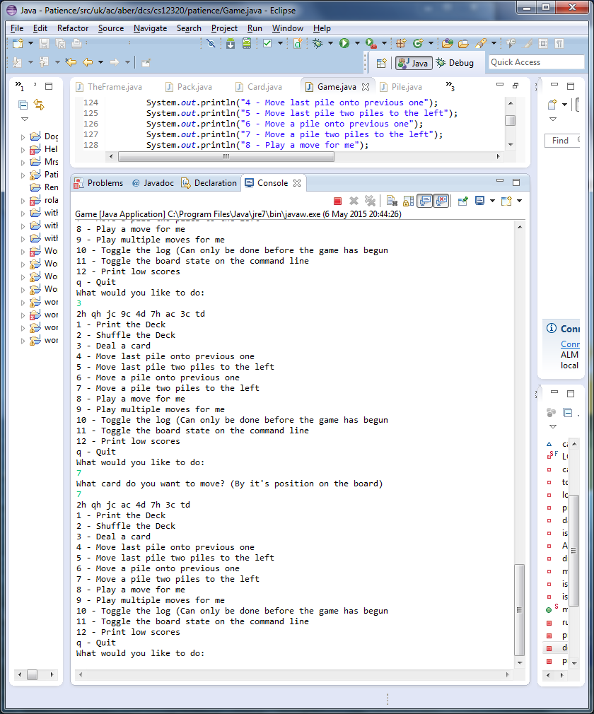

Cards of the same suit are amalgamated

SS15

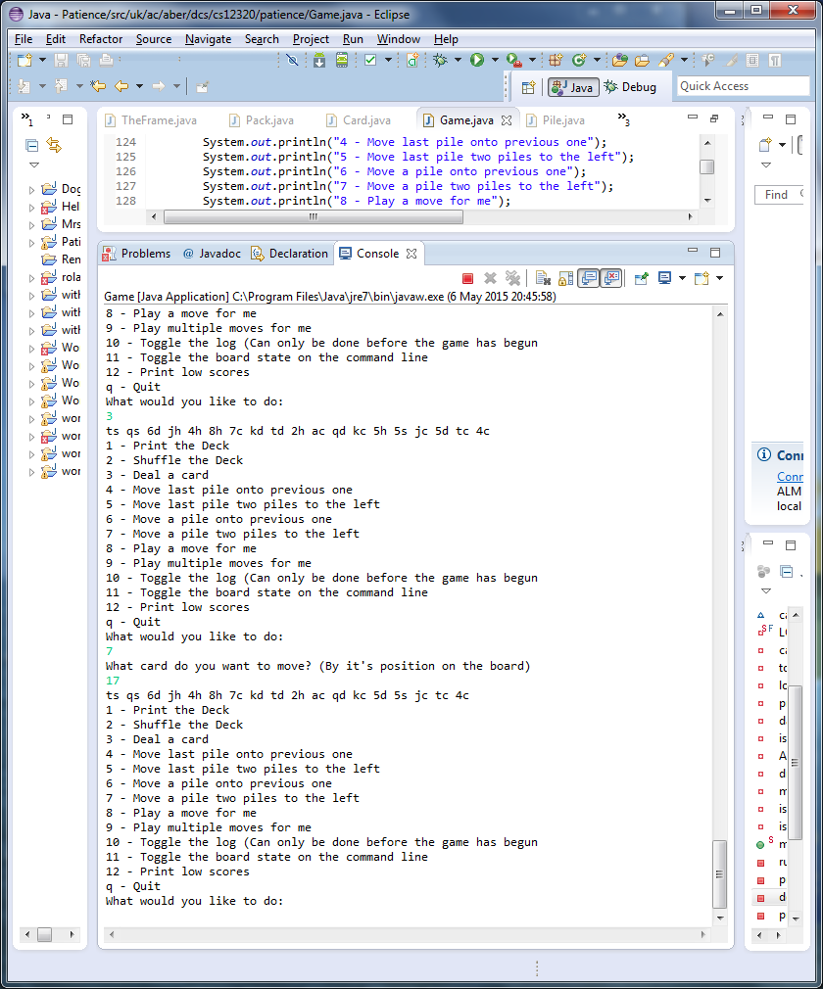

Cards of the same value are amalgamated

SS16

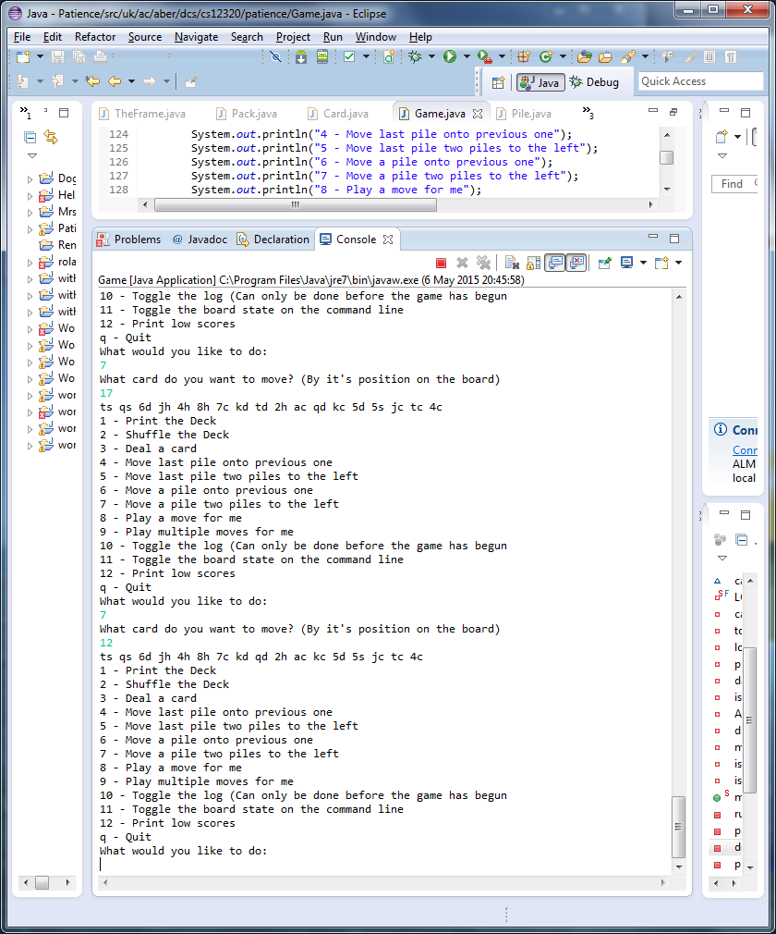

Cards with no shared values are not amalgamated

### ID 8.1

SS17

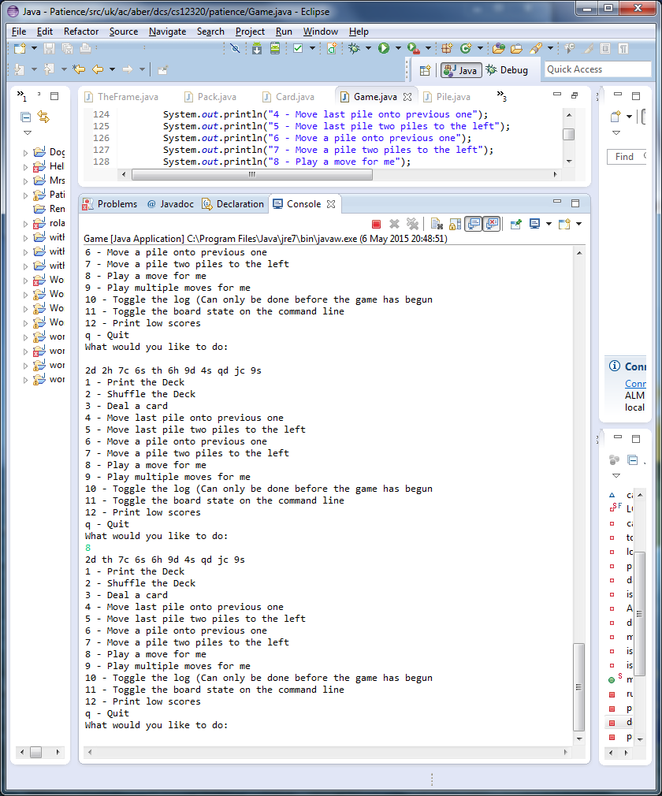

The bot automatically made a move. It favoured the long jump over any short jump options

### ID 9.1

SS18

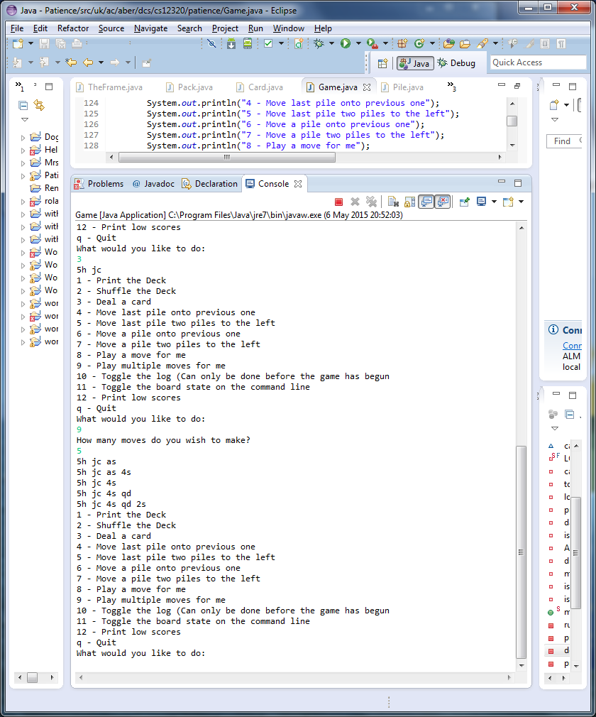

The bot played 5 moves for the user, making a move where possible, and drawing a card if no move was possible.

### ID 10.1

SS19

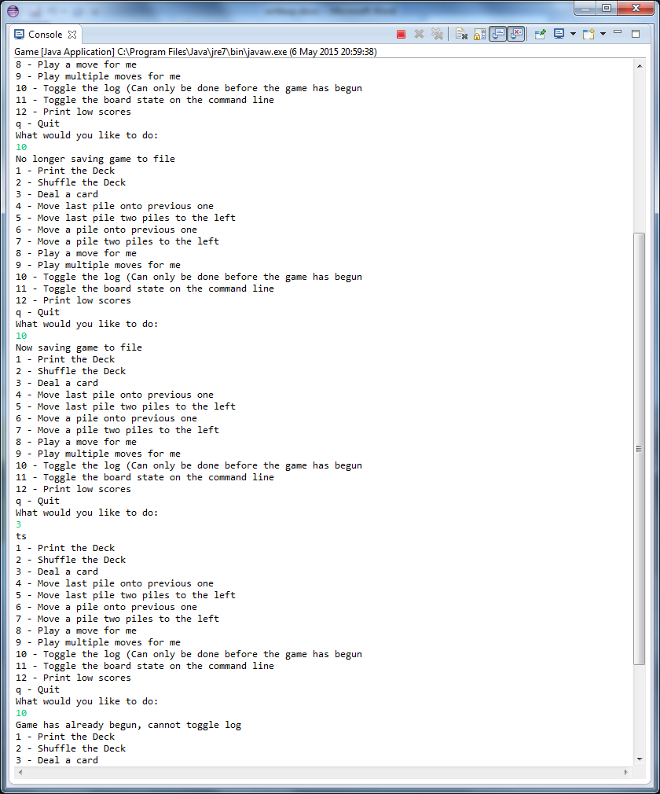

The log is being toggled before the game begins, however, once the game starts, the log cannot be toggled

### ID 11.1

SS20

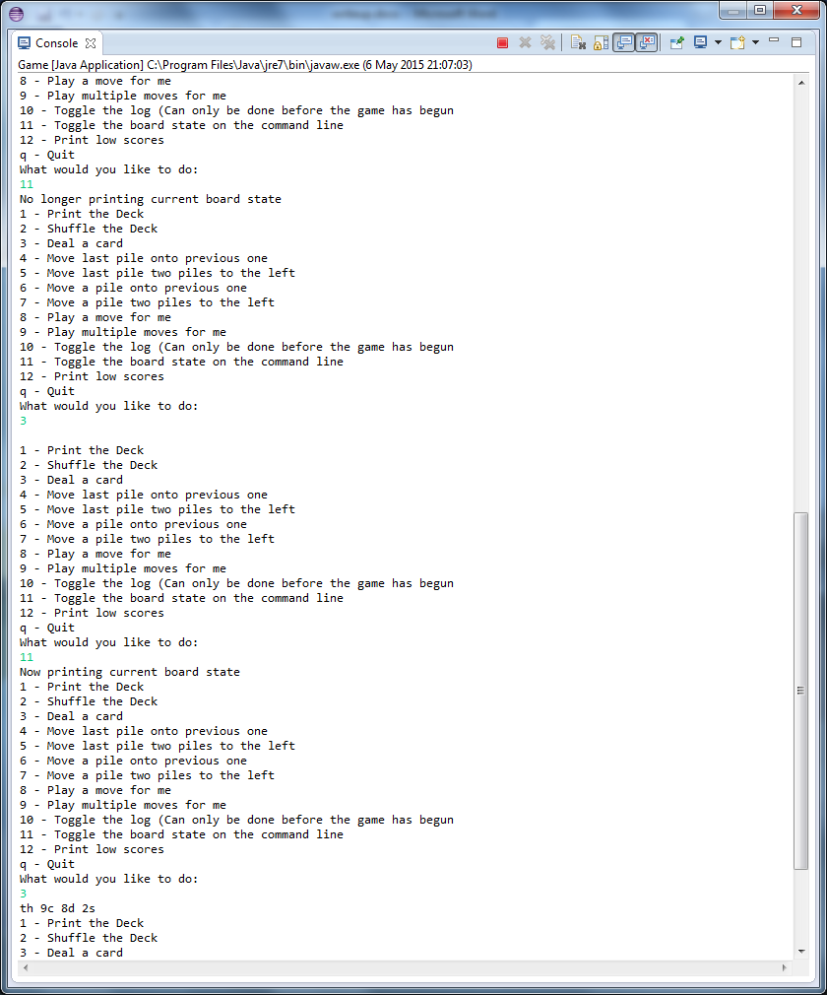

After turning the console updates off, when making a move nothing is added to the console. However when turning it back on, and making a move, the command line shows the current status of the game

### ID 12.1

SS21

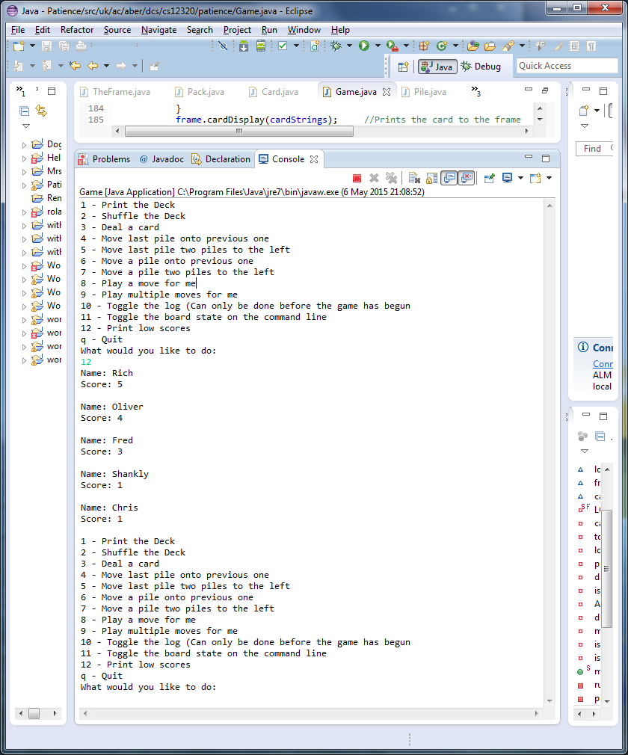

Prints the low scores

# Evaluation

I began by creating my game class, which began with just a small menu and initialise method to load in the cards. To do this I figured I should create a card class, and a pack class to hold these cards in. When loading in this information I noted that everything came in single characters, so it made sense to create the cards with the suit and value as chars. To create the filename associated with each card I made a method to append “.gif” onto the end of the value and suit. This turns reading in any values such as “a” and “h”, and turns it into “ah.gif”. This loading section was not particularly challenging as previous experience from assignments proved very useful.

I started work on the first menu option of printing the deck to the command line. To do this I looped through the arrayList and printed out the toString for a card, which just features the value and suit. To ensure that even when a full pack was printed that it was easy to view, every 13 card I go to the next line. So when printing out the full pack unshuffled it prints every suit on its own line from ace to king. This was done with an “if” statement checking if a multiple of 13 cards have been printed.

Then I wanted to shuffle the deck. I accomplished this using Collections.shuffle. I decided that once a deck had been shuffled it wouldn’t need to be shuffled again. So if you try shuffling and already shuffled deck you get a message saying “You’ve already shuffled the deck!”

Next on the list is dealing a card. I created a “Pile” class I would create when I dealt a card, and I would add this to an arrayList of “piles”. As a pile and a card both share having a suit and value, I make “Pile” the super class for “Card” so it can inherit the char value and char suit from it, including getters.

To deal a card, it required removing it from the pack, creating a pile and adding it to an arrayList of piles, and adding the card image to the cardStrings arrayList which would hold all the filenames to pass into theFrame to be printed to the GUI. Cutting this down into small steps at a time made light work of this task. Learning how to interact with the GUI was the only new thing, but that was explained very well through a help.zip provided with the assignment, and was thus not an issue.

When it came to moving the final card onto the previous one, it was a great introduction to the sort of logic that would be needed for the more complicated parts of this assignment to come. I first got the index of the card by using the size of the arrayList. I create a method in piles to accomplish the moving of a pile to the previous pile. This method gets the index of the other pile to be moved onto. To check if it is possible to make the move, I created a “checkLegality” method in piles, which I pass in the two indexes and compares both the suit and the value of the 2 cards. If the move is possible, it changes a Boolean to “true”, and returns this to the method for moving the last card to the left. If the check came back legal, then I create a moveCard method which does the moving and removing of piles. This was pretty tricky to figure out, as I had to swap the pile into the correct spot and then remove the pile from the arrayList. To accomplish this I did a while loop which only stopped when the index of the card being moved became equal to the index of the card it is being placed onto. After swapping with the card to the left of it to accomplish this, it then removed the pile being covered, which is now placed in its original index plus one. Once this is done, it then updates the GUI through the printFrame method.

The method to move the last pile over 2 piles was almost an exact copy of the move to previous pile method. The only thing that was needed was an extra collections.swap on the cardStrings arrayList which wasn’t needed in the first method due to the dynamic traits of arrayLists. Being able to re-use the methods in pile such as “checkLegality” and “moveCard”. The only differences came in the if statement to check it the move was impossible due to the size of the arrayList, as if there are only 3 cards on the table for example, there is no point seeing if the last card can jump over 2 cards because this would be impossible.

Because of the way I wrote my methods, it made the amalgamate piles in the middle options incredibly simple to implement, the only restriction I have added to my game is that users may only move a card from the right to the left, and not the other way around. This does not change anything about the way the game is played, as if a card can be moved one way, it must therefore be able to move the other as well. This does unfortunately have a negative effect of users being confused when trying to make a move that should be possible, but the option menu makes it quite explicit in that users should enter the card to be moved to the left. I hope this wording will alleviate any possibility of this when running my game.

When calling either of the amalgamate piles options, I have a getInt method that is used to ensure that the user enters and int and nothing else. This avoids any errors of type mismatches being sent into either of the move a card methods.

For the “play for me” parts of the assignment, it took a lot of modifying of other parts of the code to accommodate for all of the bots checks. This is where the most errors came about as well, requiring a lot of added Booleans to ensure the AI didn’t do anything too out of reach. These include not re-calling the checkLegality function from inside the move card functions. The logic of the AI was really basic though thanks to the specification. I knew the AI should prefer long jumps over short ones, so I simply looped though all of the cards on the table, starting from the 4th one over, and checked if it was legal for one of them to do a long jump. If a long jump was possible, I made the move, and broke out of the AI method. If there was no long jump possible, then I start looping through the piles on the table again, starting from one this time, to see if any short jump can be made. This follows the same rules as previous, if a move can be made, make the move and break, else move on to the next option. If no move can be made, the next option is for the AI to draw a card onto the table. If there are no cards left in the deck, then that means every possible option has been exhausted and the AI stops.

The next thing I added was the logging system. This takes every move done and writes it to a file (If the user does not disable logging from one of the menu options). When the first move is made, it prints the date and time before adding the first move to the file. It only prints the date and time once at the very beginning. This can only be toggled on or off before a game starts. As soon as a card is drawn, then the log cannot be turned on/off. The bot is also recorded in the log, however there is no way of knowing what in the log was done by the user or by the bot. This is something in this area that I would like to improve if I were to do the project again.

The last thing I added was the low score system. I first though this would be a very easy thing to add, but it ended up being a bit more difficult than anticipated. It turned out I needed to have the low scores in a certain order so that when checking if a new score was a high score, it would be placed in the correct spot, and remove the worst score there. To achieve this I created a LowScore class, and implemented the comparable interface to the class so I could compare the score of each person who earned it. The system works so that if a low score if the same as the current worst score, it does not get added the low scores, as it favours people who earned that score first. It also only hold 5 users at a time. So if 5 users were to all achieve a low score of 1, then nobody could get a new low score. I also made it so that if the AI was used, then the score would not be added to the low score list, as the user did not “earn” the score during that game. A score may only be added to the low score list if all the cards in the deck have been drawn. This means only finished games get added to the low score list. Adding a low score is completely optional, once you earn a low score, the system asks if you would like to add your score to the list of low scores, if you say no, then the score is discarded, and the low scores are unchanged. To improve this system, I would like to add a time based factor to each score, so that the faster a score was earned, the more that score would be worth. This would continue to give users a reason to improve their score as they play faster and faster to get onto the scoreboard.

For this assignment, I believe I have earned a first. I think this mark is a fair assessment of my work due to meeting all of the specification points given in the assignment. In all my testing I have not been able to crash my program, and everything I tested gave the intended result. There may be bugs in my program, but I am unaware from them if they exist. I do however think the great difficulty I have in designing and creating a plan before I begin coding may hinder my mark somewhat, but I hope to have done at least something satisfactory in that regard.