# Testing

Input is re-written on the input box for clarity of what is being tested

## Translation

### ASCII to ASH (with space and punctuation)

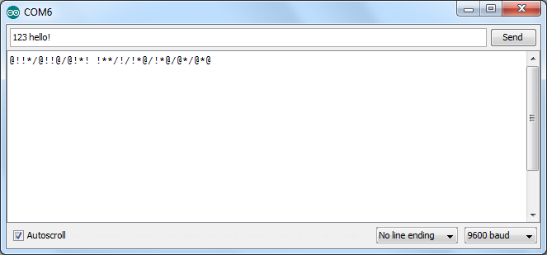

### ASH to ASCII (with space and punctuation)

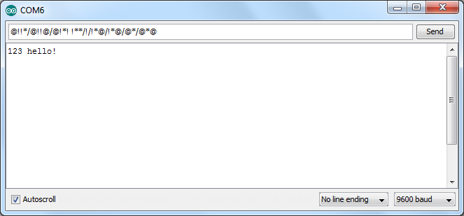

So translating one way and then back to the original works as intended. The translations are correct and there are not “/” characters at the start or end of the ash words.

## Potentiometer

(I have a Serial.print to show the value for demonstration purposes)

### Min Value

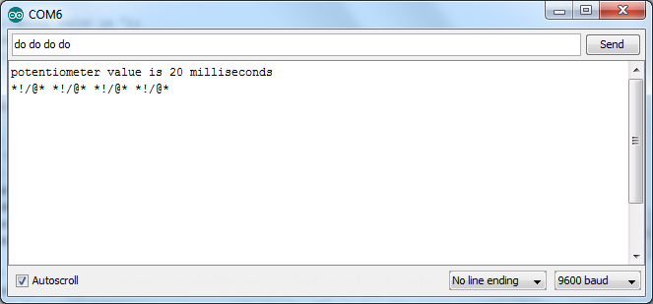

### Random Value

Potentiometer at an arbitrary value in between

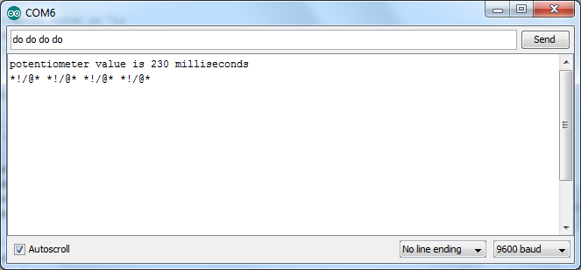

### Max Value

Potentiometer at maximum value

