Testing

1) Ascii to ASH
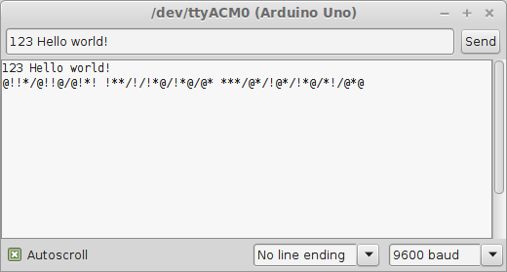

2)ASH to ascii
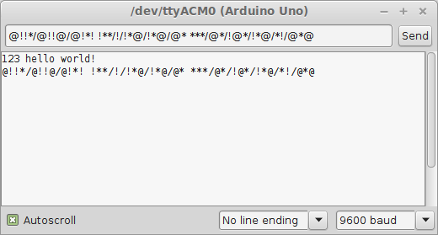

So translating one way and then back to the original works as intended. The translations are correct and there are not “/” characters at the start or end of the ash words.

3) potentiometer at smallest value (I have a Serial.print to print the value for demonstration purposes)
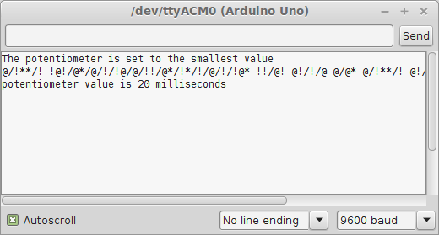

4) potentiometer at a arbitrary value in between

