#create instructor table ?

Sol:

CREATE TABLE instructor_2022260127(

id NUMBER(10),

name VARCHAR2(20),

dept_name VARCHAR2(20),

salary NUMBER(10),

PRIMARY KEY (id)

);



# create course table?

Sol:

CREATE TABLE course_2022260127(

course_id VARCHAR2(30),

title VARCHAR2(30),

dept_name VARCHAR2(30),

credits NUMBER(10)

);



1. Show instructor name only.

Sol:

SELECT name FROM instructor_2022260127;

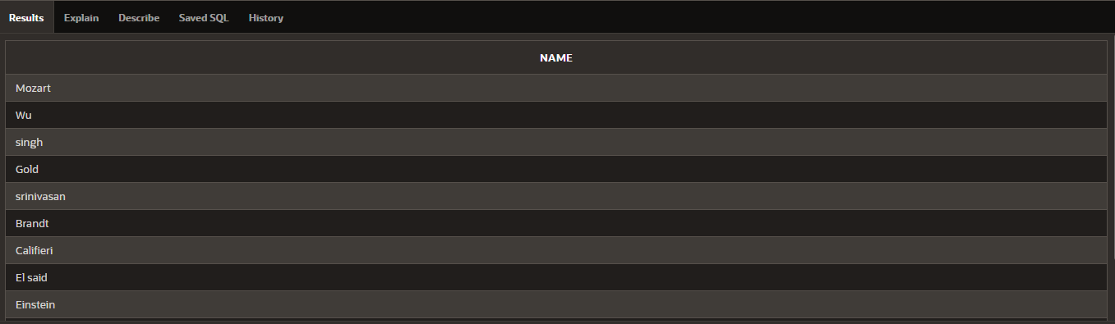

1. Show course id and title only.

Sol:

SELECT course_id,title FROM course_2022260127;

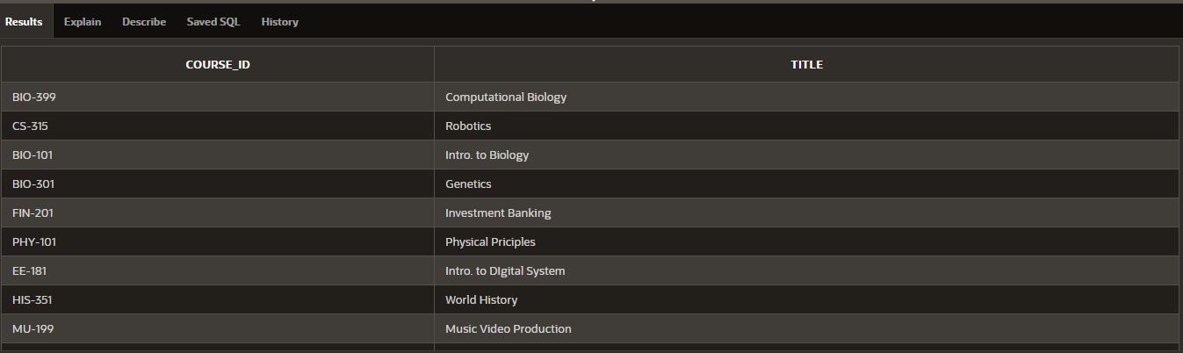

1. Find instructor name and department of the instructor with id = 22222.

Sol:

SELECT name,dept_name,id FROM instructor_2022260127

WHERE id=22222;

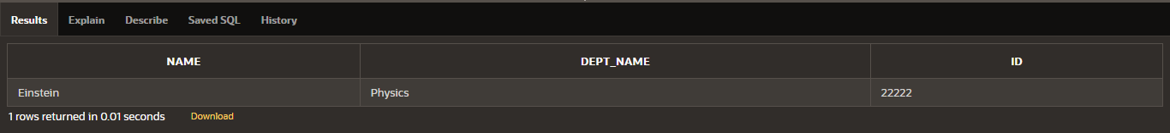

1. Find course title and credits of the courses offered by ‘Comp. Sci.’ department.

Sol:

SELECT title,credits FROM course_2022260127

WHERE dept_name='Comp.Sci';

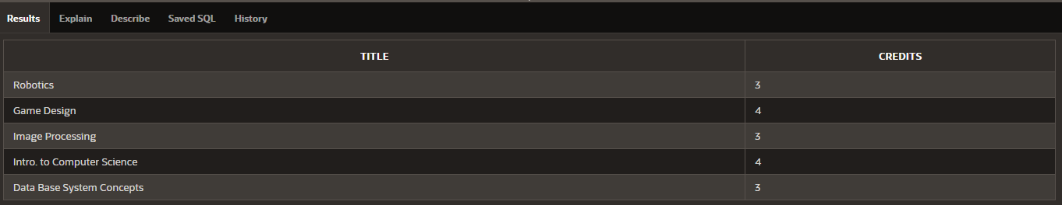

1. Find name and department of instructors who have a salary more than 70000.

Sol:

SELECT name,dept_name FROM instructor_2022260127

WHERE salary>70000;

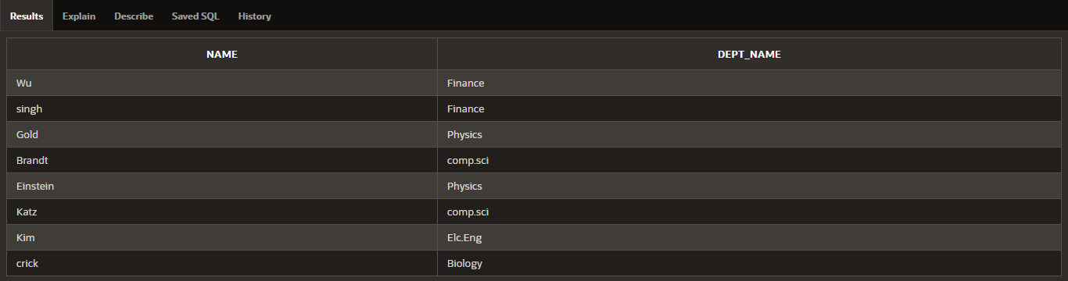

1. Find course title of the courses which are not less than 4 credits.

Sol:

SELECT title FROM course_2022260127

WHERE credits=4;

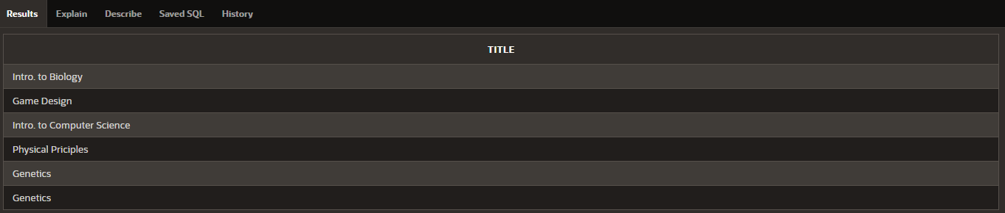

1. Find name and department of instructors who have a salary in between 80000 and 100000 (bounds are inclusive).

Sol:

SELECT name,dept_name FROM instructor_2022260127

WHERE salary>=80000 AND salary<=100000 ;

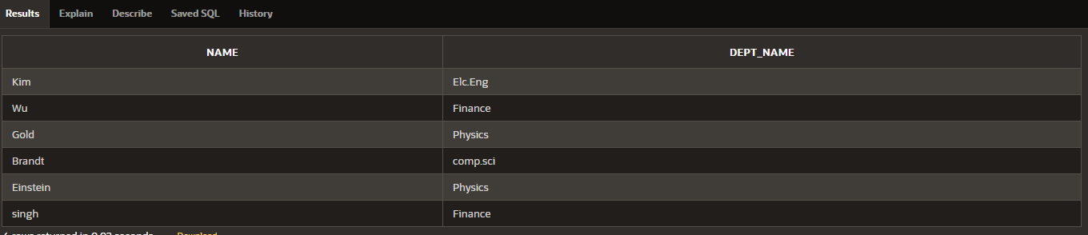

1. Find course titles and credits of the courses not offered by ‘Comp. Sci.’ department.

Sol:

SELECT title,credits FROM course_2022260127

WHERE dept_name!='Comp.Sci';

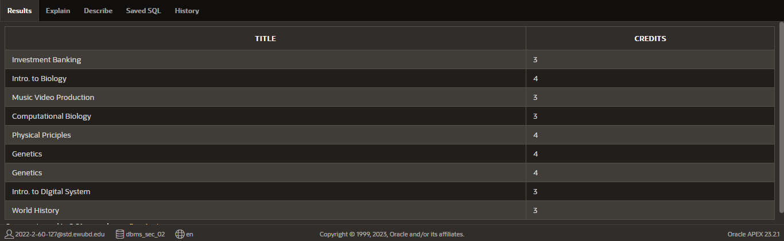

1. Display all records of instructor table.

Sol:

SELECT *FROM instructor_2022260127;

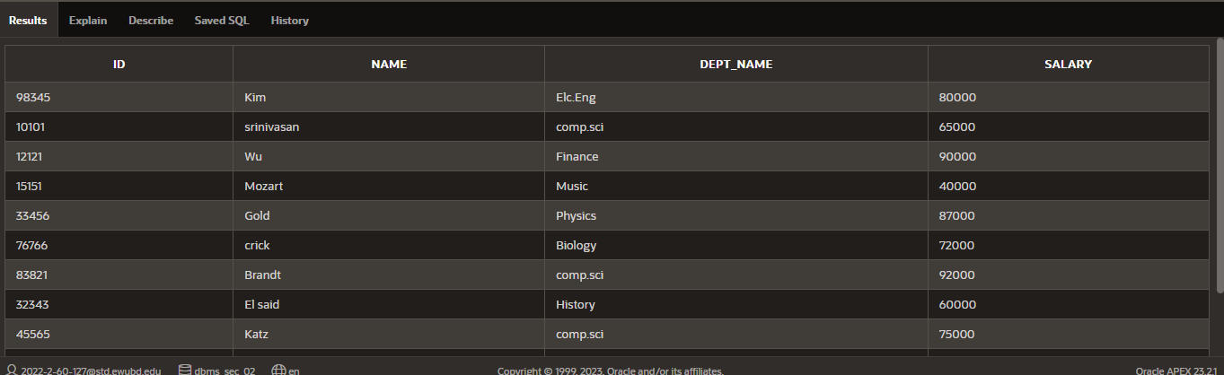

1. Find all courses (display all columns) which are offered by ‘Biology’ department and credits is not 4.

Sol:

SELECT title FROM course_2022260127

WHERE dept_name='Biology' AND credits!=4;

