**LAB TASK 1**

CREATE TABLE account_2022260127(

account_noCHAR(5),

balance NUMBER NOT NULL,

PRIMARY KEY(account_no),

CHECK(balance>0 )

);

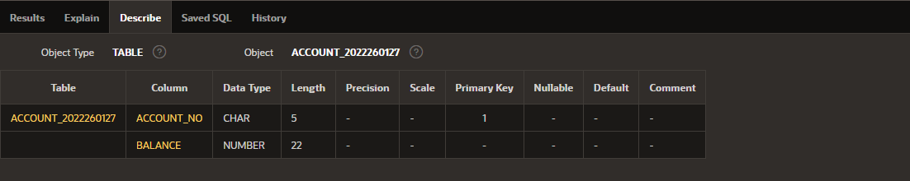

CREATE TABLE customer_2022260127(

customer_noCHAR(5),

customer_name VARCHAR2(20) NOT NULL,

customer_city VARCHAR2(10),

PRIMARY KEY (customer_no)

);

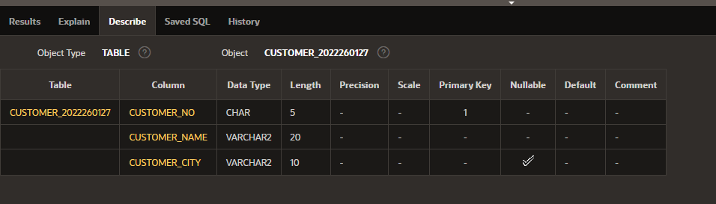

CREATE TABLE depositor_2022260127(

account_noCHAR(5),

customer_noCHAR(5),

PRIMARY KEY (account_no,customer_no)

);

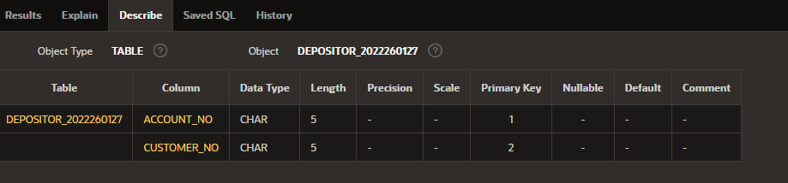

**LAB TASK 2**

1. ALTER TABLE customer_2022260127 ADD DATE_OF_BIRTH DATE;

DESC customer_2022260127;

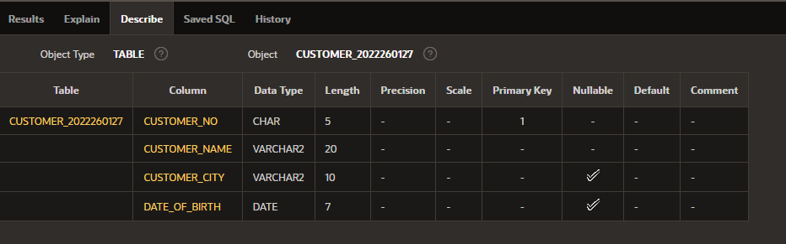

1. ALTER TABLE customer_2022260127 DROP COLUMN DATE_OF_BIRTH;

DESC customer_2022260127;

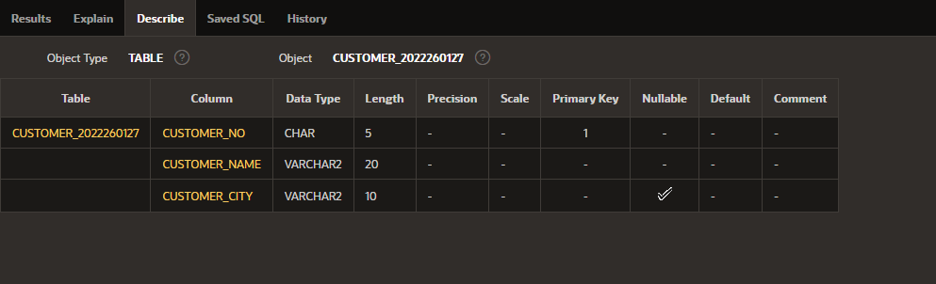

1. ALTER TABLE depositor_2022260127 RENAME COLUMN account_NO TO A_NO;

DESC depositor_2022260127;

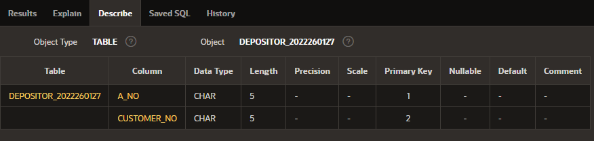

ALTER TABLE depositor_2022260127 RENAME COLUMN customer_NO TO C_NO;

DESC depositor_2022260127;

1. ALTER TABLE depositor_2022260127 ADD CONSTRAINT depositor_fk1

FOREIGN KEY (A_NO)

REFERENCES account_2022260127;

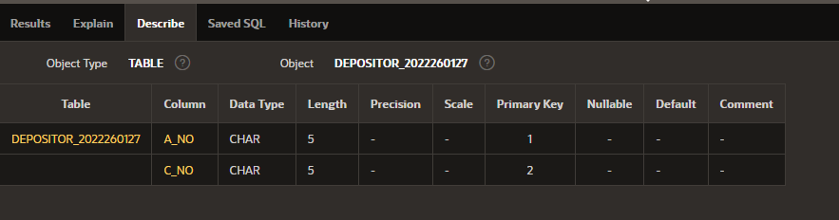

FOREIGN KEY (C_NO)

REFERENCES customer_2022260127;

DESC depositor_2022260127;

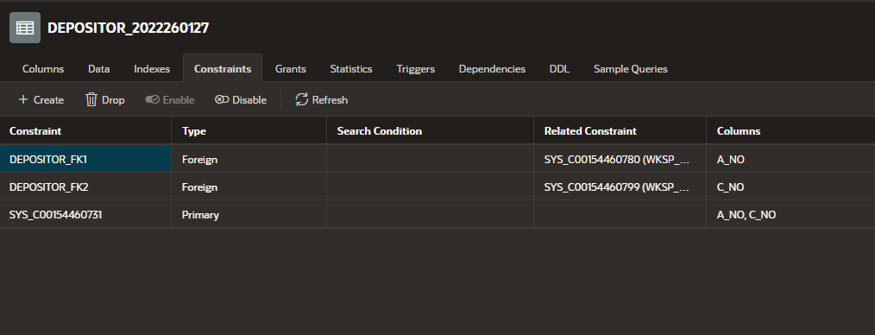

**LAB TASK 3**

INSERT INTO account_2022260127 VALUES ('A-101',12000);

INSERT INTO customer_2022260127 VALUES ('C-101','ALICE','DHAKA');

INSERT INTO depositor_2022260127 VALUES ('A-101','C-101');

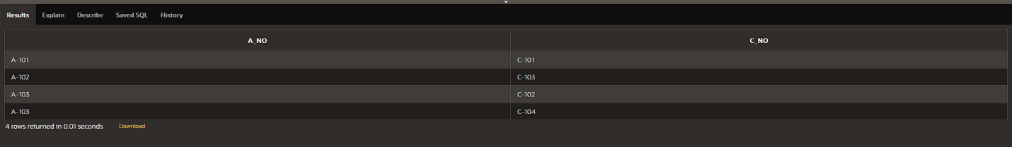

**LAB TASK 4**

1. SELECT customer_name,customer_city

FROM customer_2022260127;

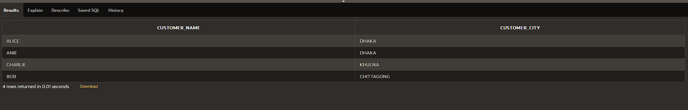

1. SELECT DISTINCT customer_city

FROM customer_2022260127;

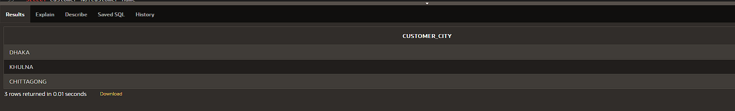

1. SELECT account_NO

FROM account_2022260127

WHERE balance>7000;

1. SELECT customer_no,customer_name

FROM customer_2022260127

WHERE customer_city='KHULNA';

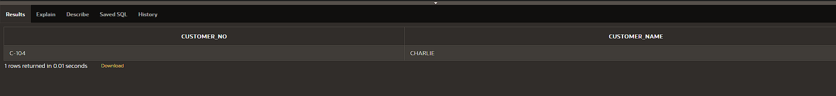

1. SELECT customer_no,customer_name

FROM customer_2022260127

WHERE customer_city!='DHAKA';

1. SELECT c.customer_name, c.customer_city

FROM account_2022260127 a ,customer_2022260127 c ,depositor_2022260127 d

WHERE a.account_no = d.A_NO AND d.C_NO = c.customer_no AND a.balance>7000;

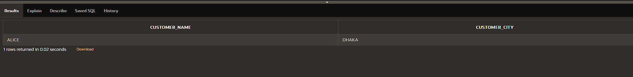

1. SELECT c.customer_name, c.customer_city

FROM account_2022260127 a ,customer_2022260127 c ,depositor_2022260127 d

WHERE a.account_no = d.A_NO AND d.C_NO = c.customer_no AND a.balance>7000 AND c.customer_city!='KHULNA';

1. SELECT a.account_no, balance

FROM account_2022260127 a ,customer_2022260127 c ,depositor_2022260127 d

WHERE a.account_no = d.A_NO AND d.C_NO = c.customer_no AND c.customer_no='C-102';

1. SELECT a.account_no, balance

FROM account_2022260127 a ,customer_2022260127 c ,depositor_2022260127 d

WHERE a.account_no = d.A_NO AND d.C_NO = c.customer_no AND (c.customer_city='DHAKA' OR c.customer_city='KHULNA');

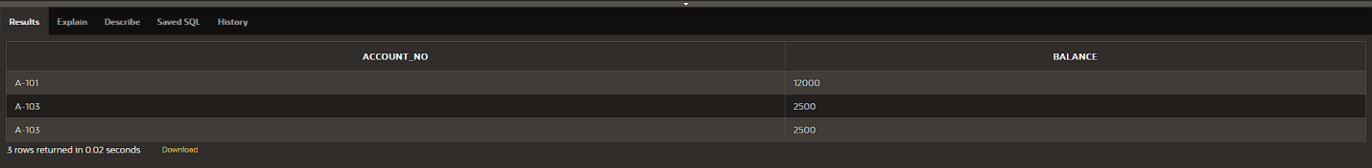

1. SELECT c.customer_name

FROM account_2022260127 a ,customer_2022260127 c ,depositor_2022260127 d

WHERE a.account_no = d.A_NO AND d.C_NO = c.customer_no AND a.account_no IS NULL;

