1. SELECT branch_name,branch_city

FROM Branch

WHERE assets>1000000;

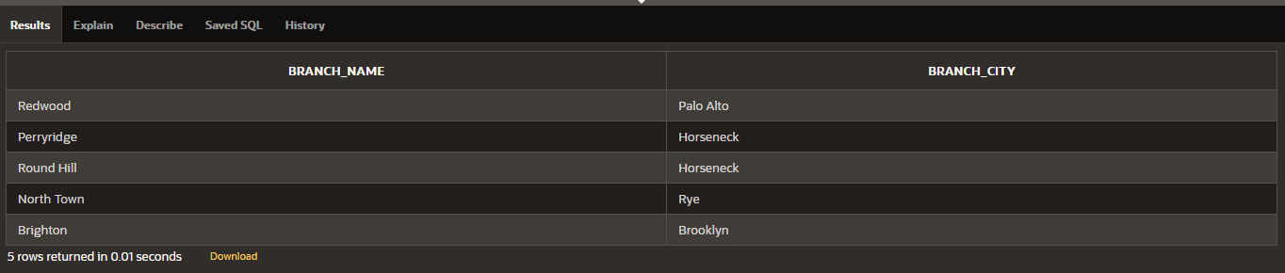

2.

SELECT account_number, balance

FROM Account

WHERE branch_name='Downtown' or balance BETWEEN 600 and 750 ;

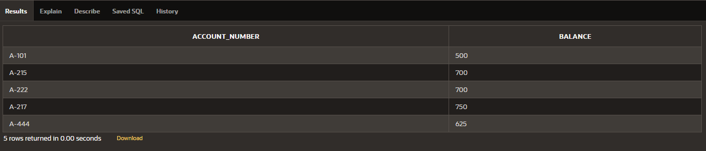

3.

SELECT account_number

FROM Account, Branch

WHERE Account.branch_name=Branch.branch_name AND branch_city='Rye';

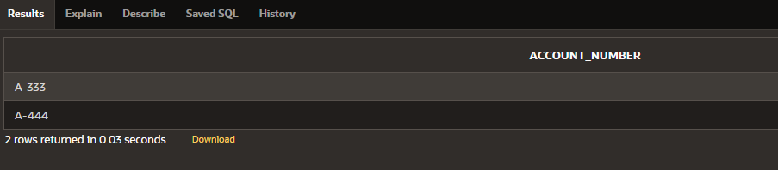

4.

SELECT LOAN.LOAN_NUMBER

FROM LOAN, BORROWER ,CUSTOMER

WHERE LOAN.LOAN_NUMBER = BORROWER.LOAN_NUMBER AND BORROWER.CUSTOMER_NAME= CUSTOMER.CUSTOMER_NAME AND LOAN.AMOUNT >=1000 AND CUSTOMER.CUSTOMER_CITY = 'Harrison';

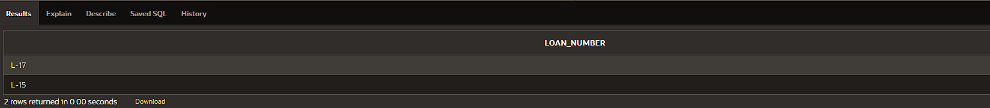

5.

SELECT *

FROM Account

ORDER BY balance DESC ;

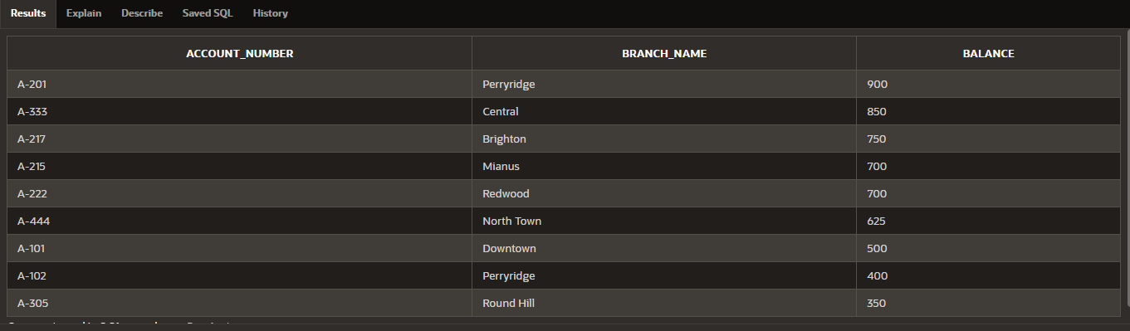

6.

SELECT *

FROM Customer

ORDER BY customer_city ;

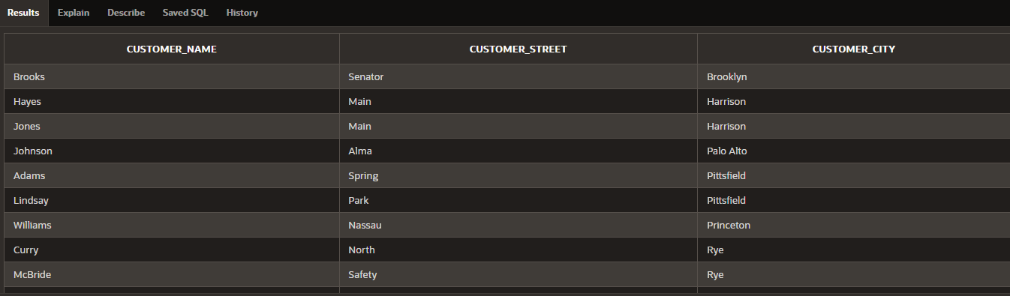

7.

SELECT customer_name

FROM Customer , Account , Branch

WHERE Branch.branch_name=Account.branch_name AND Branch.branch_city=customer_city

INTERSECT

SELECT customer_name

FROM Customer, Loan ,Branch

WHERE Branch.branch_name=Loan.branch_name AND Branch.branch_city=customer_city;

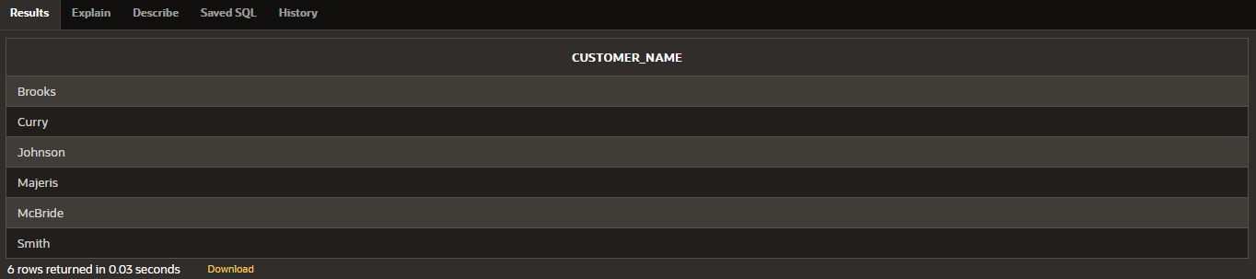

8.

SELECT customer_name,customer_street,customer_city

FROM Customer,Account,Branch

WHERE Branch.branch_name=Account.branch_name And Branch.branch_city=customer_city

UNION

SELECT customer_name,customer_street,customer_city

FROM Customer, Loan,Branch

WHERE Branch.branch_name=Loan.branch_name AND Branch.branch_city=customer_city;

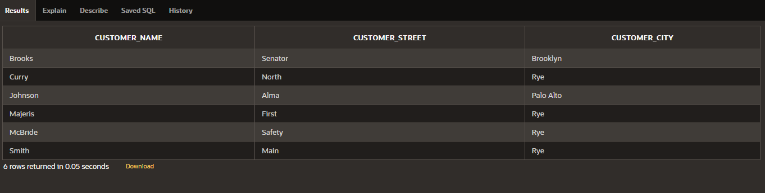

9.

SELECT customer_name,customer_city

FROM Loan,Customer,Branch

WHERE Branch.branch_name=Loan.branch_name AND branch_city=customer_city

MINUS

SELECT customer_name,customer_city

FROM Account,Customer,Branch

WHERE Branch.branch_name=Account.branch_name AND Branch.branch_city=customer_city;

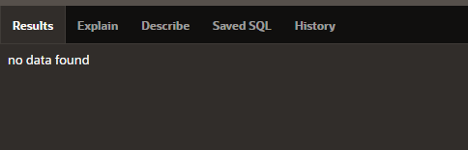

10.

SELECT count(assets)

FROM Branch ;

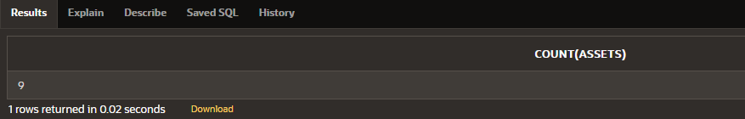

11.

SELECT avg(balance) AS AVG_BALANCE

FROM Account,Branch

WHERE Branch.branch_name=Account.branch_name;

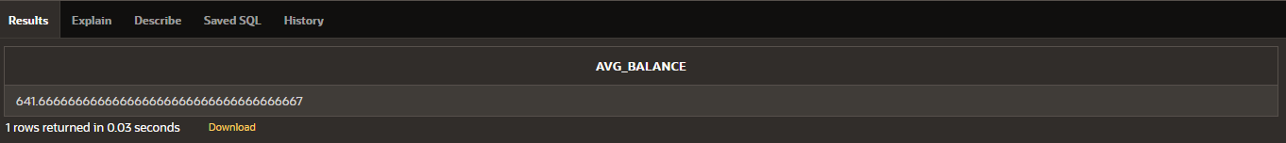

12.

SELECT Round(avg(balance),2) AS AVG_BALANCE

FROM Account,Branch

WHERE Branch.branch_name=Account.branch_name

GROUP BY branch_city ;

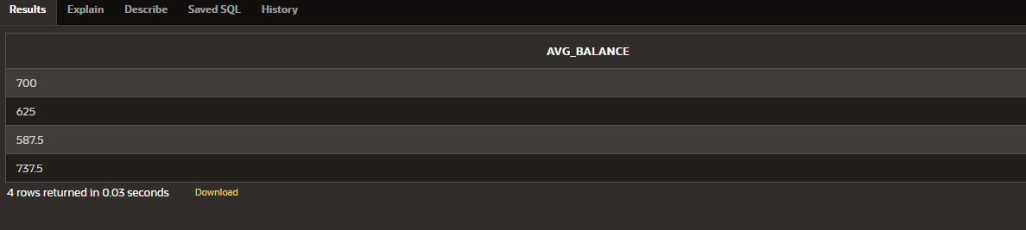

13.

SELECT min(amount) AS MIN_AMOUNT

FROM Loan , Branch

WHERE Loan.branch_name=Branch.branch_name;

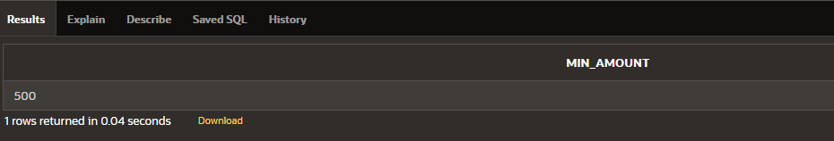

14.

SELECT count(loan_number) AS TOTAL_LOAN_NUMBER

FROM Loan,Branch

WHERE Branch.branch_name=Loan.branch_name;

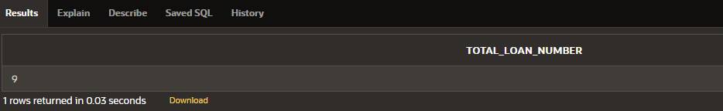

15.

SELECT CUSTOMER_NAME , ACCOUNT_NUMBER

FROM ACCOUNT NATURAL JOIN DEPOSITOR

WHERE BALANCE = (SELECT MAX(BALANCE) FROM ACCOUNT );

