1. Find all customer related information who have an account in a branch, located in the same city as they live. (write this query without using subqueries and then using a subquery)

(without subquery)

SELECT c.*

FROM Customer c, Account a, Branch b, depositor d

WHERE c.customer_city = b.branch_city

AND a.branch_name = b.branch_name

AND c.customer_name = d.customer_name;

(with subquery)

SELECT *

FROM Customer c

WHERE customer_city IN (

SELECT branch_city

FROM Branch b, Account a, depositor d

WHERE a.branch_name = b.branch_name

AND d.customer_name = c.customer_name

);

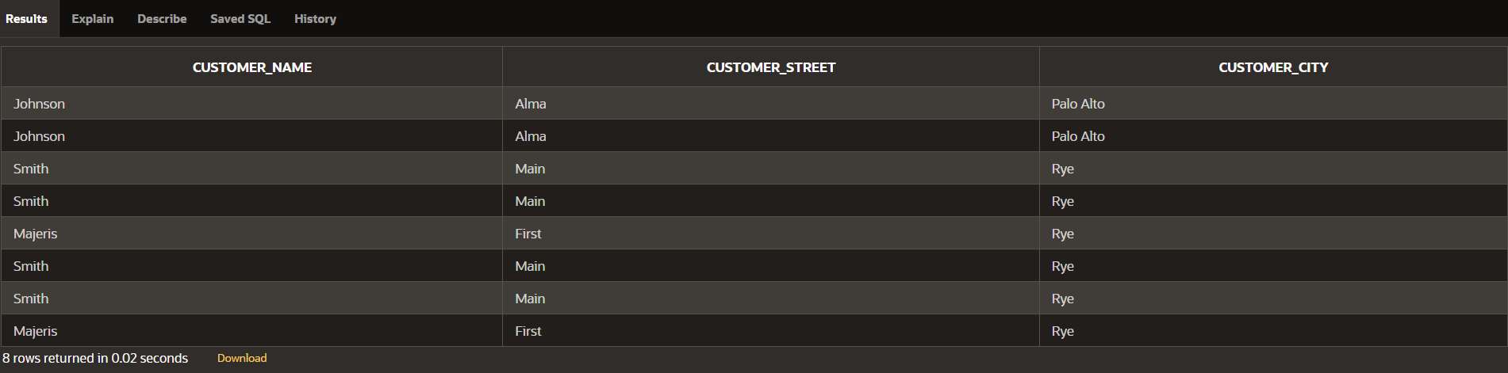

1. Find all customer related information who have a loan in a branch, located in the same city as they live. (write this query without using subqueries and then using a subquery)

(without subqueries)

SELECT c.*

FROM Customer c, Loan l, Branch b, depositor d

WHERE c.customer_city = b.branch_city

AND l.branch_name = b.branch_name

AND c.customer_name = d.customer_name;

(with subqueries)

SELECT *

FROM Customer c

WHERE customer_city IN (

SELECT branch_city

FROM Branch b, Loan l, depositor d

WHERE l.branch_name = b.branch_name

AND d.customer_name = c.customer_name

);

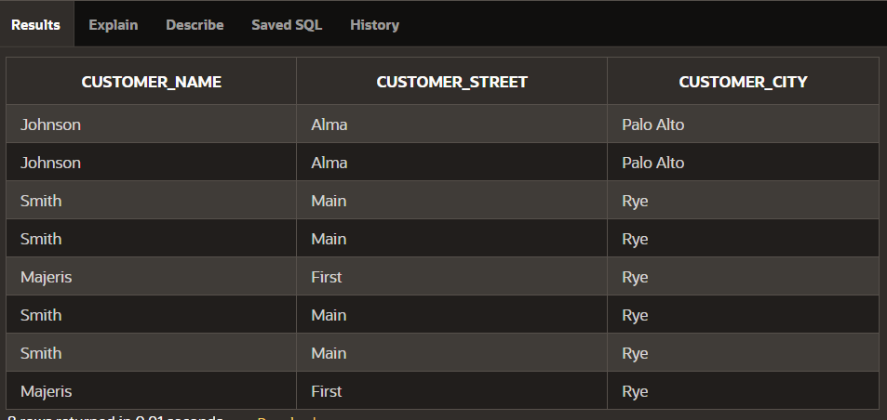

1. For each branch city, find the average balance of all the accounts opened in a branch located in that branch city. Do not include any branch city in the result where the total balance of all accounts opened in a branch located in that city is less than 1000. (Write this query with and without using ‘having’ clause)

i.

SELECT branch_city, AVG(balance) AS avg_balance

FROM Branch b, Account a

WHERE b.branch_name = a.branch_name

GROUP BY branch_city

HAVING SUM(balance) >= 1000;

ii.

SELECT b.branch_city, AVG(a.balance) AS avg_balance

FROM Branch b

JOIN Account a ON b.branch_name = a.branch_name

GROUP BY b.branch_city

HAVING AVG(a.balance) * COUNT(a.account_number) >= 1000;



1. For each branch city, find the average amount of all the loans opened in a branch located in that branch city. Do not include any branch city in the result where the average amount of all loans opened in a branch located in that city is less than 1500. (write this query with and without using ‘having’ clause)

i.

SELECT b.branch_city, AVG(l.amount) AS avg_loan_amount

FROM Branch b

JOIN Loan l ON b.branch_name = l.branch_name

GROUP BY b.branch_city

HAVING AVG(l.amount) >= 1500;

ii.

SELECT branch_city, avg_loan_amount

FROM (

SELECT b.branch_city,

AVG(l.amount) AS avg_loan_amount

FROM

Branch b

JOIN

Loan l ON b.branch_name = l.branch_name

GROUP BY

b.branch_city

) AS sub

WHERE

avg_loan_amount >= 1500;



1. Find the customer name, customer street, customer city of the account which has the highest balance among all the accounts. (Write this query with and without using all keyword)

i. SELECT c.customer_name, c.customer_street, c.customer_city

FROM Customer c, Account a

WHERE (a.balance) >= ALL (SELECT balance FROM Account)

AND c.customer_name IN (SELECT customer_name FROM Depositor WHERE account_number = a.account_number);

ii.SELECT c.customer_name, c.customer_street, c.customer_city

FROM Customer c

JOIN Depositor d ON c.customer_name = d.customer_name

JOIN Account a ON d.account_number = a.account_number

WHERE a.balance = (SELECT MAX(balance) FROM Account);



1. Find the customer name, customer street, customer city of the loan which has the lowest

amount among all the loans. (write this query with and without using all keyword)

i.

SELECT c.customer_name, c.customer_street, c.customer_city

FROM Customer c, Loan l

WHERE (l.amount) <= ALL (SELECT amount FROM Loan)

AND c.customer_name IN (SELECT customer_name FROM Borrower WHERE loan_number = l.loan_number);

ii.

SELECT c.customer_name, c.customer_street, c.customer_city

FROM Customer c

JOIN Borrower b ON c.customer_name = b.customer_name

JOIN Loan l ON b.loan_number = l.loan_number

WHERE l.amount = (SELECT MIN(amount) FROM Loan);



1. Find the distinct branches (name and city) that have opened both accounts and loans. (Write this query using in and exists keyword)

i.

SELECT DISTINCT branch_name, branch_city

FROM Branch

WHERE branch_name IN (

SELECT branch_name

FROM Account

) AND branch_name IN (

SELECT branch_name

FROM Loan

);

ii.

SELECT DISTINCT branch_name, branch_city

FROM Branch b

WHERE EXISTS (

SELECT 1

FROM Account a

WHERE a.branch_name = b.branch_name

) AND EXISTS (

SELECT 1

FROM Loan l

WHERE l.branch_name = b.branch_name

);

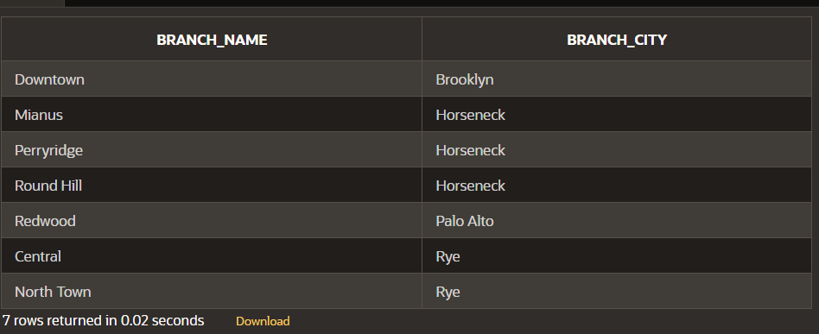

1. Find the distinct customers (name and city) who do not have loans but have accounts. (write this query using not in and not exists keyword)

i.SELECT DISTINCT customer_name, customer_city

FROM Customer

WHERE customer_name NOT IN (

SELECT DISTINCT c.customer_name

FROM Customer c

JOIN Borrower b ON c.customer_name = b.customer_name

);

ii.SELECT DISTINCT customer_name, customer_city

FROM Customer c

WHERE NOT EXISTS (

SELECT 1

FROM Borrower b

WHERE b.customer_name = c.customer_name

);



1. Find those branch names which have total account balance greater than the average of total balance among all the branches. (write this query with and without using with clause)

i.WITH branch_balances AS (

SELECT branch_name, SUM(balance) AS total_balance

FROM Account

GROUP BY branch_name

)

SELECT branch_name

FROM branch_balances

WHERE total_balance > (

SELECT AVG(total_balance)

FROM branch_balances

);

ii.SELECT branch_name

FROM Account

GROUP BY branch_name

HAVING SUM(balance) > (

SELECT AVG(total_balance)

FROM (

SELECT SUM(balance) AS total_balance

FROM Account

GROUP BY branch_name)

AS branch_balances

);



1. Find those branch names which have total loan amount less than the average of total loan

amount among all the branches. (write this query with and without using with clause)

i. WITH branch_loan_amounts AS (

SELECT branch_name, SUM(amount) AS total_amount

FROM Loan

GROUP BY branch_name

)

SELECT branch_name

FROM branch_loan_amounts

WHERE total_amount < (

SELECT AVG(total_amount)

FROM branch_loan_amounts

);

ii.SELECT branch_name

FROM Loan

GROUP BY branch_name

HAVING SUM(amount) < (

SELECT AVG(total_amount)

FROM (

SELECT SUM(amount) AS total_amount

FROM Loan

GROUP BY branch_name

) AS branch_loan_amounts

);

