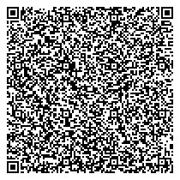

# The certificate is awarded to

Venkatesh J

# for successfully completing the course

Introduction to Cyber Security

# on Friday, February 10th 2023

Issued on: Friday, February 10th 2023

This certificate can be verified by scanning the QR code at https://verify.onwingspan.com