ESP-MDF Installation on Windows

Install Python

Download and Install ESP-IDF Tools Installer

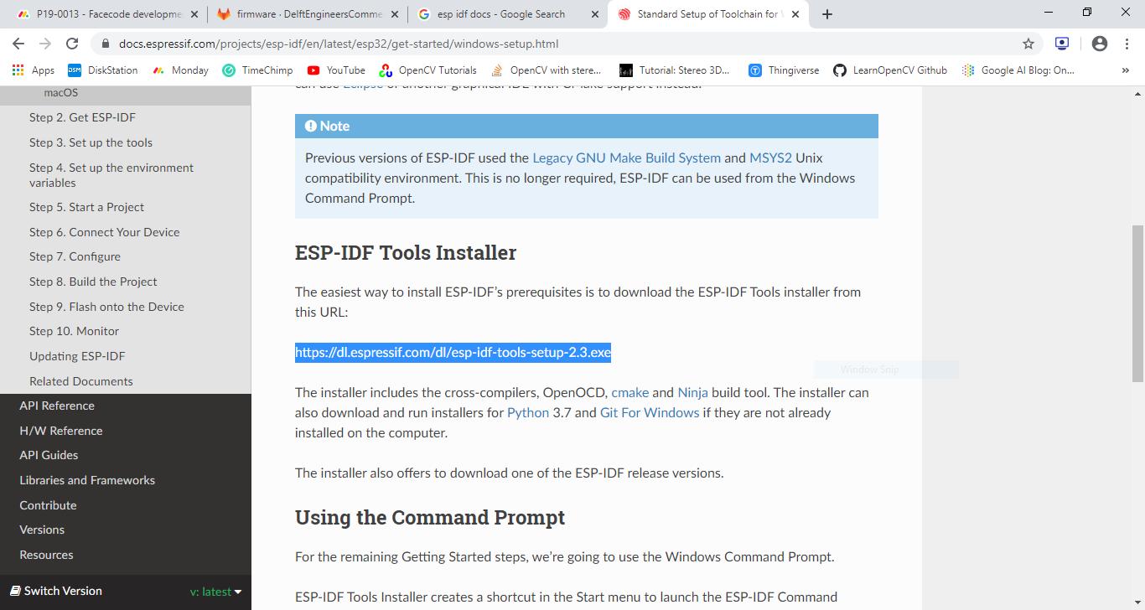

Create directory esp

Clone ESP-MDF:

git clone --recursive <https://github.com/espressif/esp-mdf.git>

Set Environment variables for IDF and ESP:

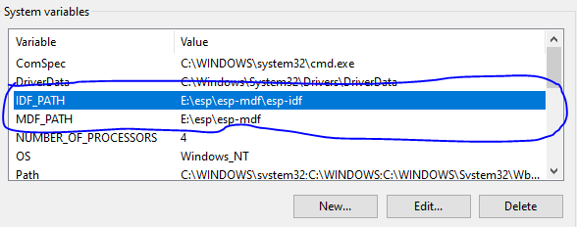

Edit system path variable:

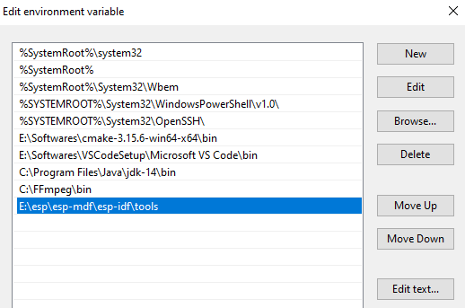

Take backup of E:\esp\esp-idf to E:\esp\old_esp-idf

copy esp-idf folder from E:\esp\esp-mdf\esp-idf

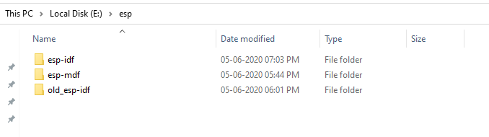

Open ESP-IDF Command prompt. It will tell to install below:

E:\esp\esp-idf\install.bat

Double click to install.

Reopen ESP-IDF Command prompt:

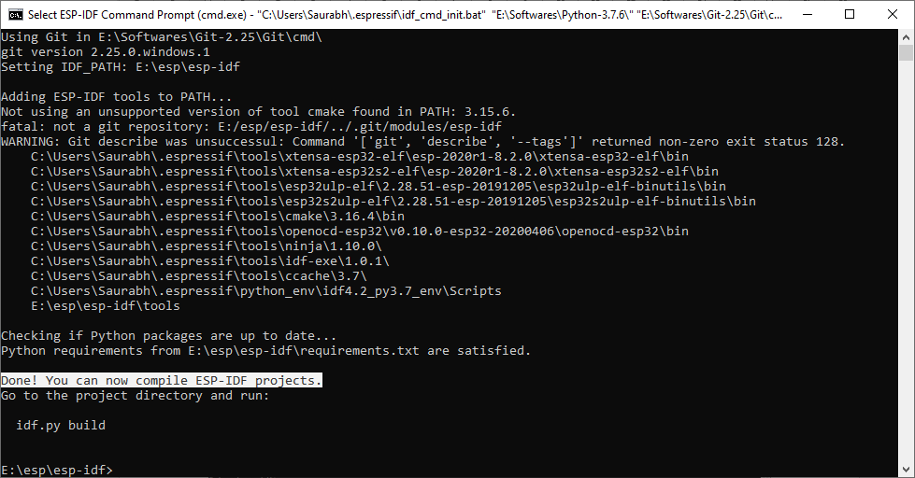

To test, type:

cd E:\esp\esp-mdf\examples\get-started

idf.py menuconfig

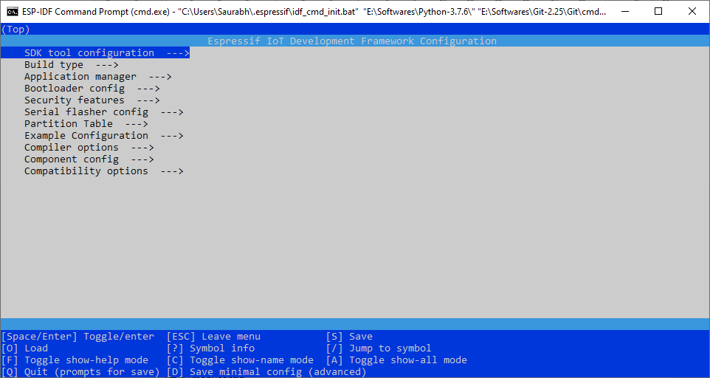

idf.py erase_flash flash

