DATA 260 – Homework 8 Report
Student ID: 018322837 Name: Shashank Ranjan
Section 0 – Personal Configuration and Domain

Name | Definition | Value
SID | Student ID | 018322837
SID4 | Last 4 of Student ID | 2837
PORT_BASE | 8000 + SID mod 900(137) | 8137
prefix | "s" + SID4 | s2837
Seed | SID4 | 2837
verify sid | 260000 + SID4 | 262837
DOMAIN_ID | SID4 MOD 8 | 5
Assigned Domain | Assignment domain | Local restaurant inspections
Repository: https://github.com/ShankySJSU/Data260-2837
Submission Tag: hw8 (how to create tag 😊
Tagged commit hash (hw8):

b087ab45c1d6faf5cfb8deb24c19d83044e40b43
Pleae NOTE this could be different in the WORD document that you find on the repository, as this is source of the PDF file that I will be uploading to Canvas and the Report
( Shashank: always use “git rev-parse HEAD”
Collaborators with access: Sbnikitha, supriyaselvanganesan

Hardware:
Local Windows PC, Python 3.12, VS Code Desktop, i7 CPU, 16GB RAM.
Model Used:
- Embeddings: sentence-transformers/all-MiniLM-L6-v2
- Ollama (qwen2.5:1.5b, qwen3:4b, llama3.2:1b)

Base Directory Structure:
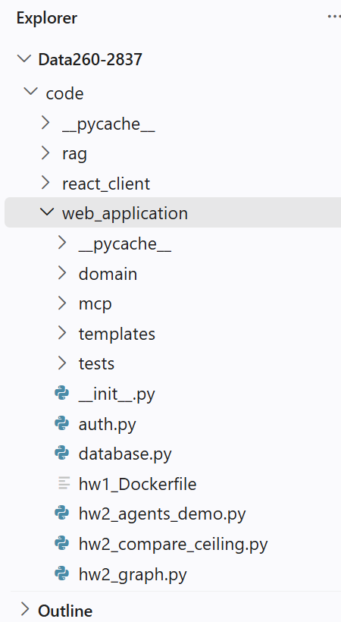 | 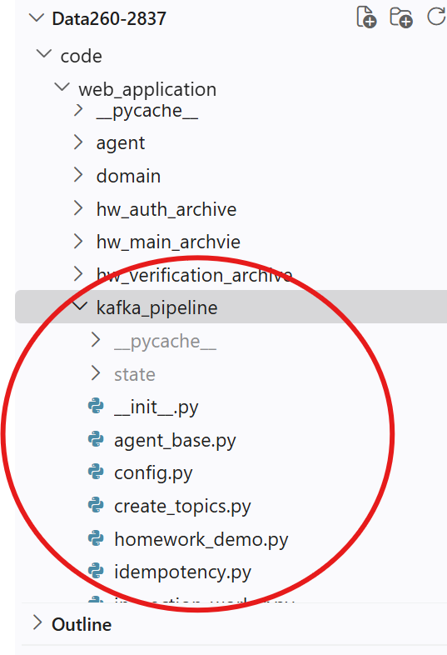
New and changed HW8 files are boxed in red. The code is an extension of the existing HW1–HW7 codebase (no separate copy).

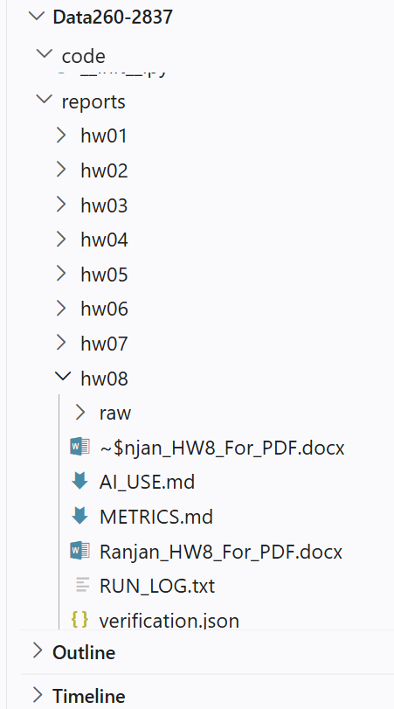 | 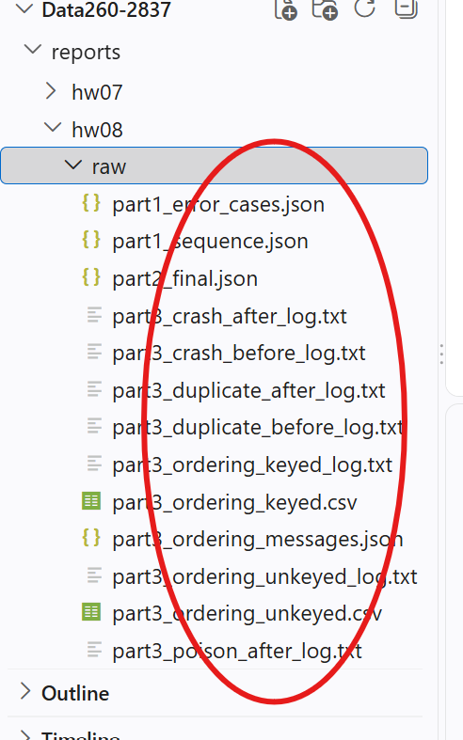

Part 1 - Backend Service Request/Response over Kafka
The domain logic for my primary entity (Inspection) now runs in a separate worker process. The client / FastAPI wrapper and the worker communicate only through two Kafka topics; the worker keeps inspections in a plain Python dictionary and validates input with my existing InspectionCreate Pydantic schema.
1.1 Topics and operations
Topic | Written by | Read by | Partitions
s2837_inspection_requests | client / FastAPI (hw8_main.py) | inspection_worker.py | 1
s2837_inspection_responses | inspection_worker.py (reply_to) | client / FastAPI | 1

Operation | Input data | Success output | Error output
CREATE_INSPECTION | name, inspection_code, inspection_date, status, score, restaurant_id | {"success": true, "inspection_id": "<uuid4>", "message": "Inspection created"} | {"success": false, "error": "Invalid inspection data - ..."}
GET_INSPECTION | {"inspection_id": "<uuid>"} | {"success": true, "inspection": {...}} | {"success": false, "error": "Inspection not found"}
anything else | - | - | {"success": false, "error": "Unknown operation"}

1.2 Request and response message schemas
REQUEST (s2837_inspection_requests)
{
"correlation_id": "81382958-c78b-454f-af44-b8ea73093926",
"reply_to": "s2837_inspection_responses",
"operation": "CREATE_INSPECTION",
"data": {
"name": "Rangoli Indian Cuisine - routine inspection",
"inspection_code": "S2837-INSP-0001",
"inspection_date": "2026-11-02T10:30:00",
"status": "PASS",
"score": 94,
"restaurant_id": 1
}
}

RESPONSE (s2837_inspection_responses)
{
"correlation_id": "81382958-c78b-454f-af44-b8ea73093926",
"operation": "CREATE_INSPECTION",
"success": true,
"inspection_id": "5c72cee2-0d9a-4186-adaa-8705114cde4b",
"message": "Inspection created",
"worker_processed_at": "2026-11-02T07:46:13.879+00:00"
}

1.3 correlation_id flow
- The client (KafkaRequestClient.request / homework_demo.py) creates the correlation_id once with uuid4 and puts it in the request together with reply_to, operation and data.
- FastAPI accepts an X-Correlation-ID header and forwards it unchanged (it only creates one when the caller did not).
- The worker never generates a new id: it copies correlation_id into every response, including error responses, and publishes to the reply_to topic.
- The client's background listener matches the response to the waiting request by correlation_id. A repeated correlation_id returns the stored reply (no second entity).
1.4 Code - worker, client and API wrapper
# inspection_worker.py
def process(request):
"""Validate the envelope and run the operation. Always returns a response dict."""
correlation_id = request.get("correlation_id")
operation = request.get("operation")
if not isinstance(correlation_id, str) or not correlation_id:
body = {"success": False, "error": "Missing correlation_id"}
elif "data" not in request:
body = {"success": False, "error": "Missing data"}
elif operation not in HANDLERS:
body = {"success": False, "error": "Unknown operation"}
else:
body = HANDLERS[operation](request.get("data"))
return {"correlation_id": correlation_id, "operation": operation, **body,
"worker_processed_at": now_iso()}

# request_client.py
def request(self, operation, data, correlation_id=None, timeout=15):
message = self.build_request(operation, data, correlation_id)
correlation_id = message["correlation_id"]
slot = {"event": threading.Event()}
with self._lock:
self._pending[correlation_id] = slot
started = time.perf_counter()
meta = send_json(self.producer, cfg.REQUEST_TOPIC, message, key=correlation_id)
log(self.component, f"SENT to {cfg.REQUEST_TOPIC}[p{meta.partition}@{meta.offset}] "
f"correlation_id={correlation_id} message={short(message)}")
trace(self.component, "CLIENT_SEND", correlation_id, operation=operation,
topic=cfg.REQUEST_TOPIC, partition=meta.partition, offset=meta.offset,
message=message)
try:
if not slot["event"].wait(timeout):
raise TimeoutError(f"no response for correlation_id={correlation_id} "
f"within {timeout}s - is the worker running?")
finally:
with self._lock:
self._pending.pop(correlation_id, None)
response = slot["response"]
elapsed_ms = round((time.perf_counter() - started) * 1000, 1)
# ... (see repository for the rest)

# hw8_main.py
async def create_inspection_kafka(data: dict = Body(...),
x_correlation_id: str | None = Header(default=None)):
return await kafka_call(cfg.OP_CREATE, data, x_correlation_id or str(uuid.uuid4()))

# hw8_main.py
async def kafka_call(operation, data, correlation_id):
log(COMPONENT, f"HTTP -> Kafka operation={operation} correlation_id={correlation_id}")
try:
message, response = await run_in_threadpool(
STATE["client"].request, operation, data, correlation_id)
except TimeoutError as exc:
raise HTTPException(status_code=504, detail=str(exc)) from exc
log(COMPONENT, f"Kafka -> HTTP returning to caller correlation_id="
f"{response.get('correlation_id')} success={response.get('success')}")
return {"request": message, "response": response}

1.5 screenshots
Step 1 : docker compose up -d --build

C:\SJSURepo\Data260\Data260-2837>echo "Shashank -HW 8 - Starting Docker"
"Shashank -HW 8 - Starting Docker"

C:\SJSURepo\Data260\Data260-2837>docker compose up -d --build
[+] Building 27.7s (21/21) FINISHED

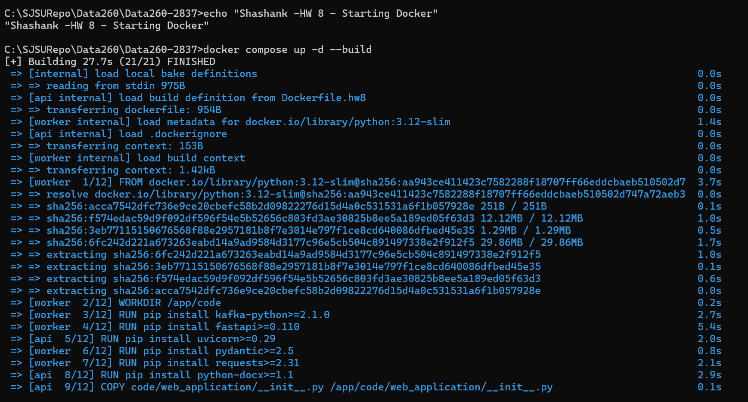
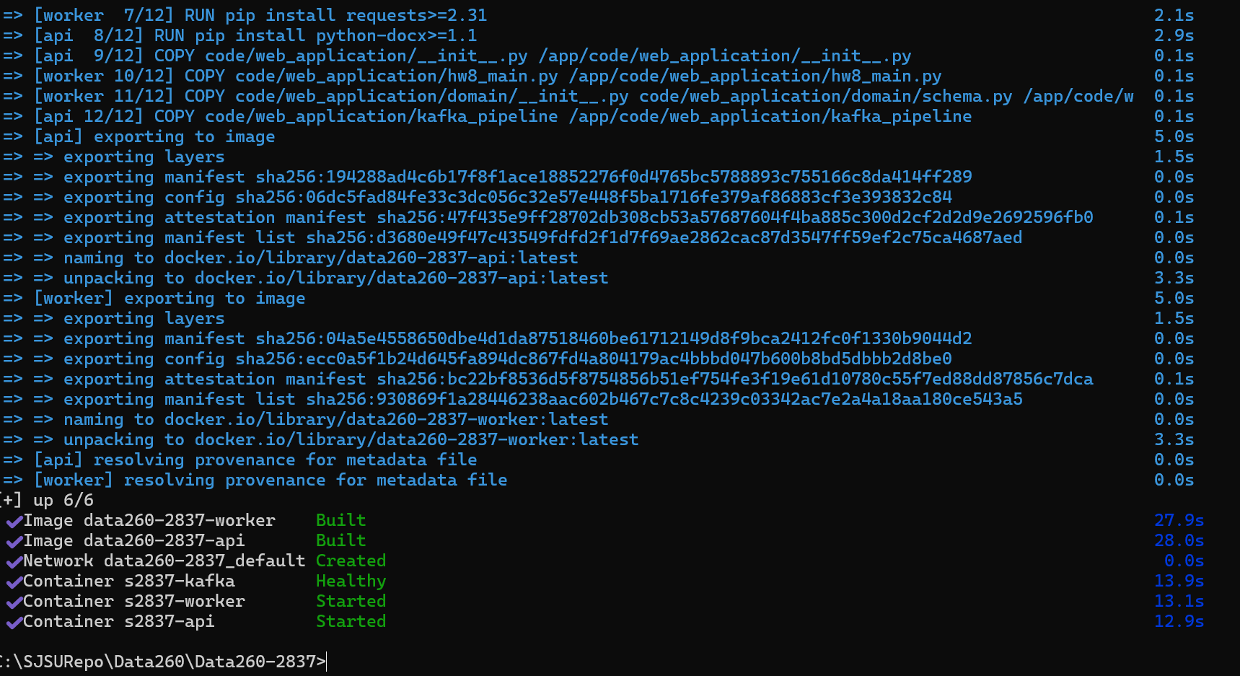

C:\SJSURepo\Data260\Data260-2837>docker ps
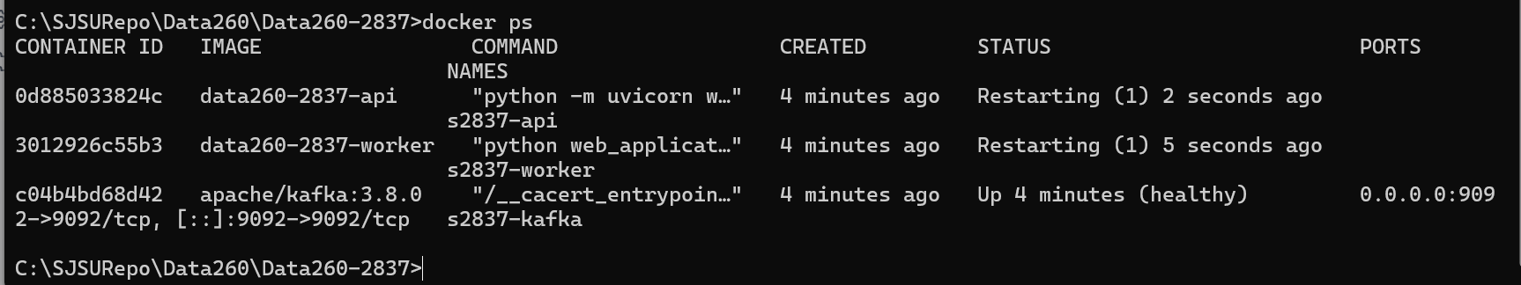
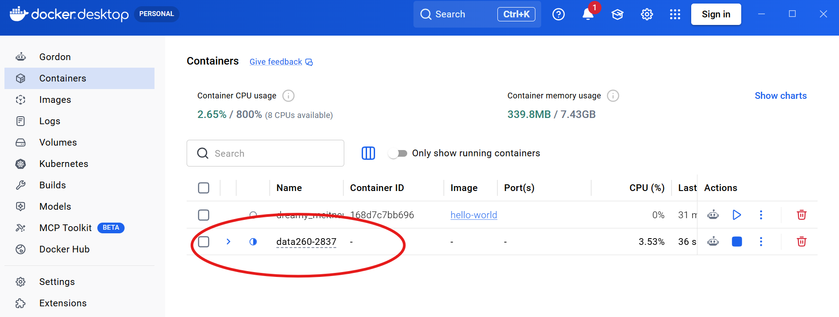

C:\SJSURepo\Data260\Data260-2837>docker logs s2837-worker
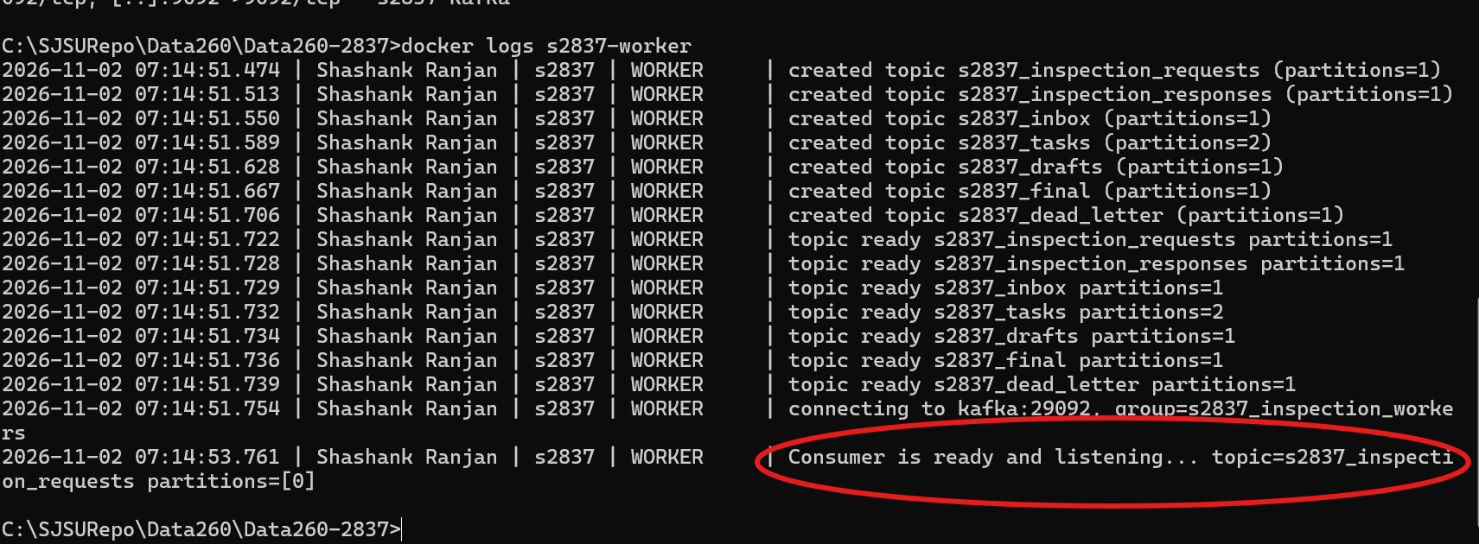
C:\SJSURepo\Data260\Data260-2837>docker logs s2837-api
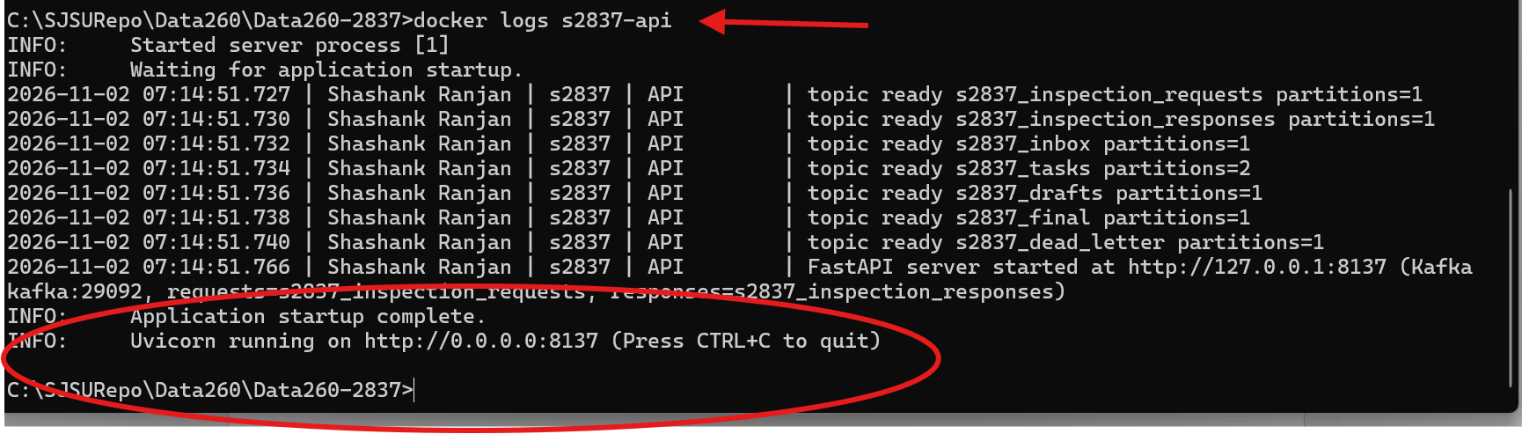
Browser: http://127.0.0.1:8137/docs
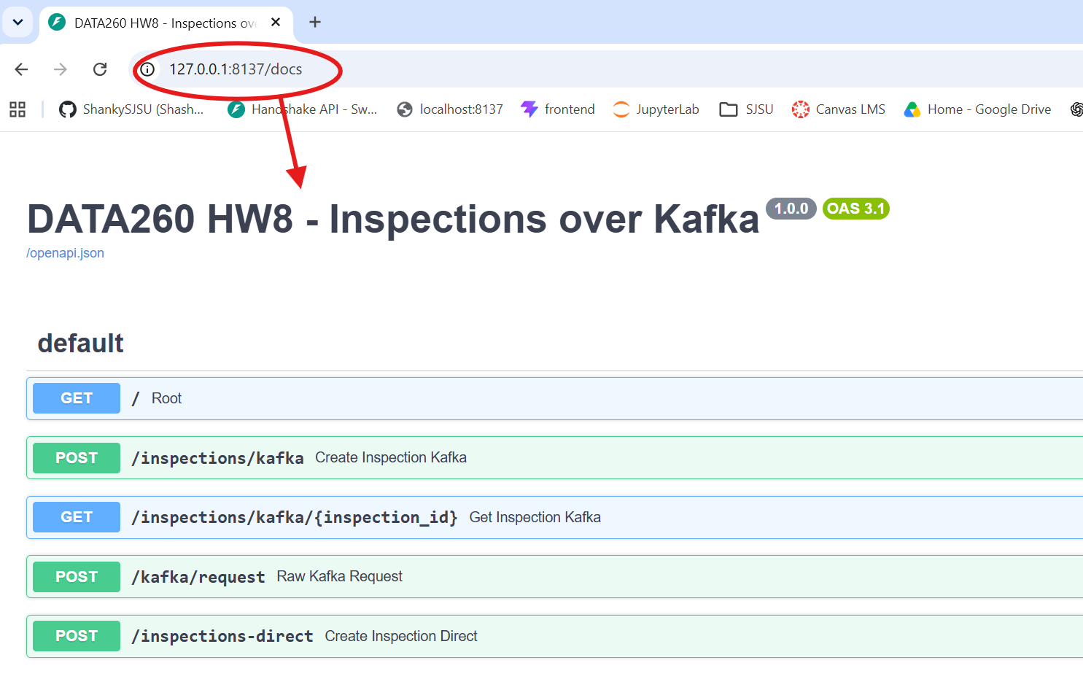

Topics (worker/API already create them; this prints the CLI form and confirms):
C:\SJSURepo\Data260\Data260-2837>cd code

C:\SJSURepo\Data260\Data260-2837\code>python web_application\kafka_pipeline\create_topics.py 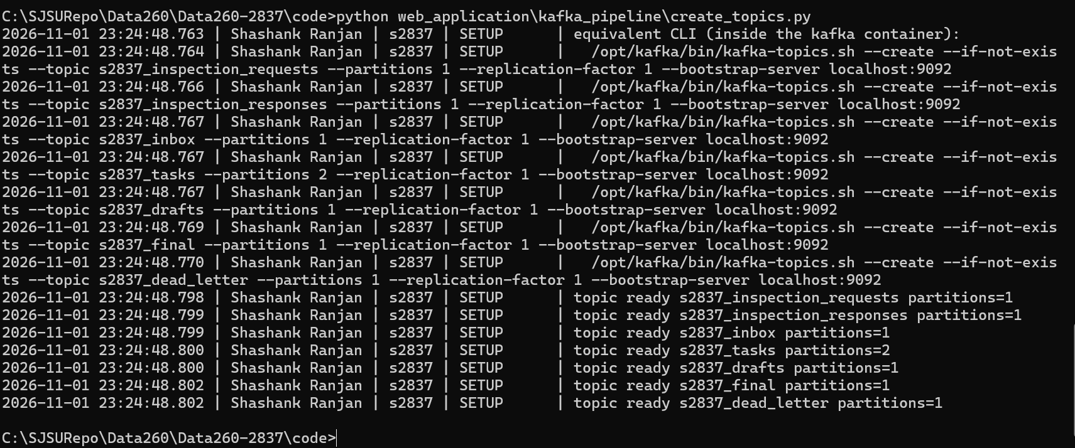
C:\SJSURepo\Data260\Data260-2837\code>echo "Shashank Ranjan -hW 8 - Demo using API"
"Shashank Ranjan -hW 8 - Demo using API"
C:\SJSURepo\Data260\Data260-2837\code>python web_application\kafka_pipeline\homework_demo.py --via-api
2026-11-01 23:41:16.099 | Shashank Ranjan | s2837 | DEMO | ======================================================================
2026-11-01 23:41:16.101 | Shashank Ranjan | s2837 | DEMO | HW8 Part 1 demo - Shashank Ranjan - SID4=2837 PREFIX=s2837 - via FastAPI
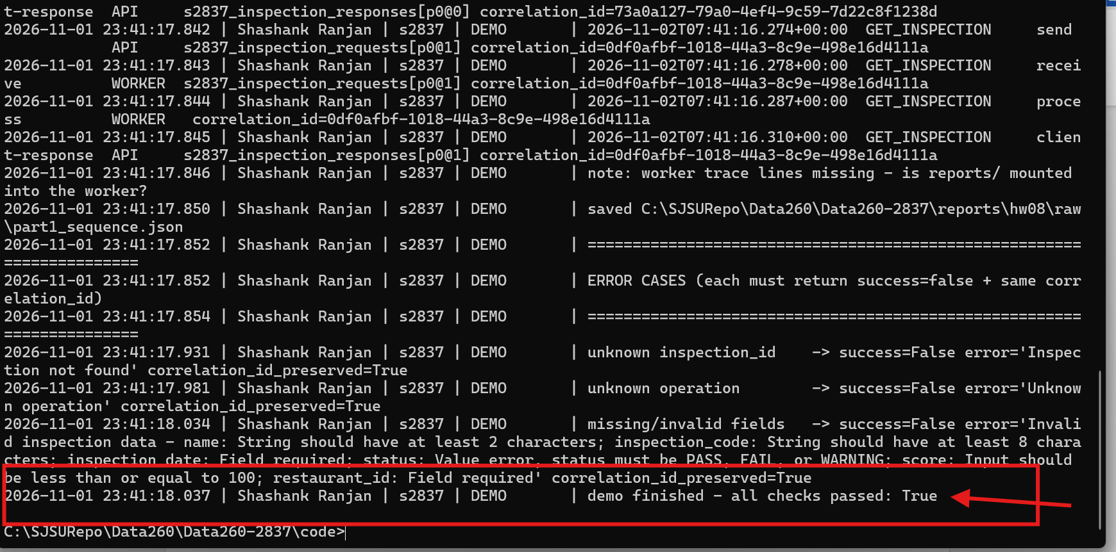
code> python web_application\kafka_pipeline\homework_demo.
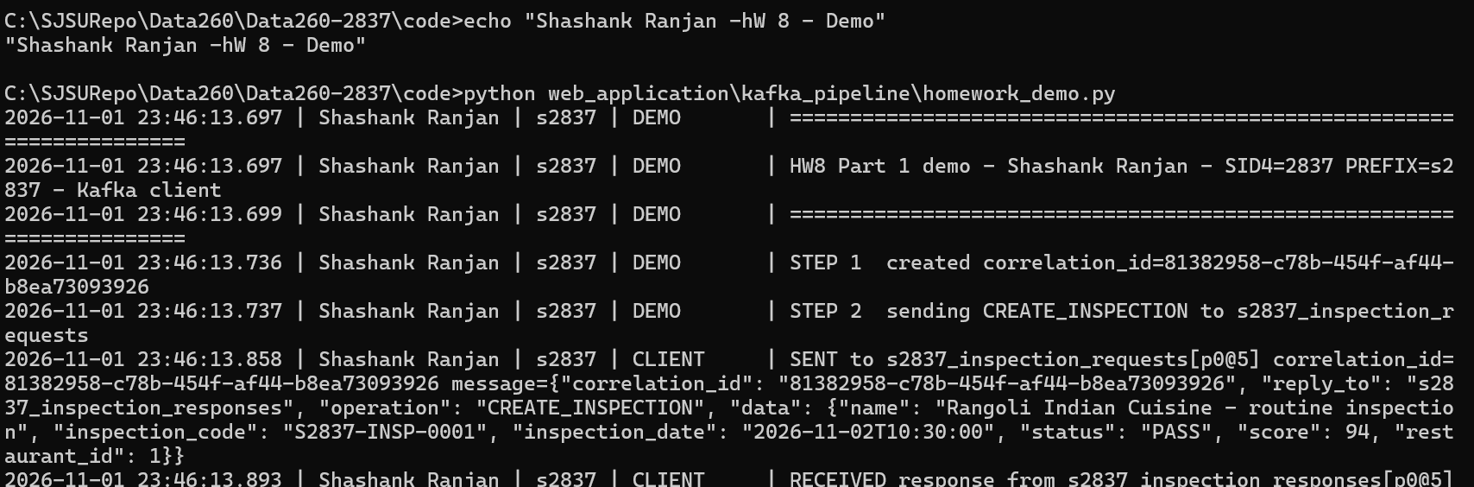

1.6 Full sequence CREATE_INSPECTION -> GET_INSPECTION (from raw/part1_sequence.json)
07:46:13.859 CREATE_INSPECTION CLIENT_SEND CLIENT s2837_inspection_requests[p0@5] cid=81382958
07:46:13.868 CREATE_INSPECTION WORKER_RECEIVE WORKER s2837_inspection_requests[p0@5] cid=81382958
07:46:13.879 CREATE_INSPECTION WORKER_PROCESS WORKER cid=81382958
07:46:13.899 CREATE_INSPECTION WORKER_REPLY WORKER s2837_inspection_responses[p0@5] cid=81382958
07:46:13.895 CREATE_INSPECTION CLIENT_RECEIVE CLIENT s2837_inspection_responses[p0@5] cid=81382958
07:46:13.905 GET_INSPECTION CLIENT_SEND CLIENT s2837_inspection_requests[p0@6] cid=6e6c3788
07:46:13.912 GET_INSPECTION WORKER_RECEIVE WORKER s2837_inspection_requests[p0@6] cid=6e6c3788
07:46:13.922 GET_INSPECTION WORKER_PROCESS WORKER cid=6e6c3788
07:46:13.940 GET_INSPECTION WORKER_REPLY WORKER s2837_inspection_responses[p0@6] cid=6e6c3788
07:46:13.936 GET_INSPECTION CLIENT_RECEIVE CLIENT s2837_inspection_responses[p0@6] cid=6e6c3788

Matching console lines from RUN_LOG.txt (client + worker):
23:46:13.858 CLIENT SENT to s2837_inspection_requests[p0@5] correlation_id=81382958-c78b-454f-af44-b8ea73093926 message={"correlation_id": "81382958-c78b-454f-af4...
07:46:13.858 WORKER RECEIVED from s2837_inspection_requests[p0@5] correlation_id=81382958-c78b-454f-af44-b8ea73093926 operation=CREATE_INSPECTION message={"correl...
07:46:13.874 WORKER PROCESSING CREATE_INSPECTION correlation_id=81382958-c78b-454f-af44-b8ea73093926
07:46:13.884 WORKER PROCESSED CREATE_INSPECTION correlation_id=81382958-c78b-454f-af44-b8ea73093926 success=True inspection_id=5c72cee2-0d9a-4186-adaa-8705114cde4b
23:46:13.893 CLIENT RECEIVED response from s2837_inspection_responses[p0@5] correlation_id=81382958-c78b-454f-af44-b8ea73093926 success=True round_trip_ms=155.5 r...
07:46:13.894 WORKER SENT response to s2837_inspection_responses[p0@5] correlation_id=81382958-c78b-454f-af44-b8ea73093926 response={"correlation_id": "81382958-c7...
23:46:13.904 CLIENT SENT to s2837_inspection_requests[p0@6] correlation_id=6e6c3788-feca-49bc-8d7d-57abf1f3c027 message={"correlation_id": "6e6c3788-feca-49bc-8d7...
07:46:13.908 WORKER RECEIVED from s2837_inspection_requests[p0@6] correlation_id=6e6c3788-feca-49bc-8d7d-57abf1f3c027 operation=GET_INSPECTION message={"correlati...
07:46:13.918 WORKER PROCESSING GET_INSPECTION correlation_id=6e6c3788-feca-49bc-8d7d-57abf1f3c027
07:46:13.926 WORKER PROCESSED GET_INSPECTION correlation_id=6e6c3788-feca-49bc-8d7d-57abf1f3c027 success=True
23:46:13.935 CLIENT RECEIVED response from s2837_inspection_responses[p0@6] correlation_id=6e6c3788-feca-49bc-8d7d-57abf1f3c027 success=True round_trip_ms=34.6 re...
07:46:13.936 WORKER SENT response to s2837_inspection_responses[p0@6] correlation_id=6e6c3788-feca-49bc-8d7d-57abf1f3c027 response={"correlation_id": "6e6c3788-fe...

Result: correlation_id preserved for both requests: True
1.7 Validation and error responses
Case | success | error | correlation_id preserved
unknown inspection_id | False | Inspection not found | True
unknown operation | False | Unknown operation | True
missing/invalid fields | False | Invalid inspection data - name: String should have at least 2 characters; inspection_code: String should have at least 8 characters; inspection_date: Field required; status: Value error, status must be PASS, FAIL, or WARNING; score: Input should be less than or equal to 100; restaurant_id: Field required | True

Part 2 - Three-Agent Kafka Pipeline
Planner, Writer and Reviewer run as separate Python processes. No agent imports or calls another one - each consumes one topic and produces to the next, and every message carries the same correlation_id plus a trace list (stage, agent, pid, topic/partition/offset, timestamps).
2.1 Topics and workflow
Sender | Reads topic | Sends message to
You (send_question.py) | - | s2837_inbox (a question)
Planner (planner.py) | s2837_inbox | s2837_tasks (a plan, 2 partitions)
Writer (writer.py) | s2837_tasks | s2837_drafts (a draft answer)
Reviewer (reviewer.py) | s2837_drafts | s2837_final (approval)

2.2 Topic creation
docker exec s2837-kafka /opt/kafka/bin/kafka-topics.sh --create --if-not-exists --topic s2837_inspection_requests --partitions 1 --replication-factor 1 --bootstrap-server localhost:9092
docker exec s2837-kafka /opt/kafka/bin/kafka-topics.sh --create --if-not-exists --topic s2837_inspection_responses --partitions 1 --replication-factor 1 --bootstrap-server localhost:9092
docker exec s2837-kafka /opt/kafka/bin/kafka-topics.sh --create --if-not-exists --topic s2837_inbox --partitions 1 --replication-factor 1 --bootstrap-server localhost:9092
docker exec s2837-kafka /opt/kafka/bin/kafka-topics.sh --create --if-not-exists --topic s2837_tasks --partitions 2 --replication-factor 1 --bootstrap-server localhost:9092
docker exec s2837-kafka /opt/kafka/bin/kafka-topics.sh --create --if-not-exists --topic s2837_drafts --partitions 1 --replication-factor 1 --bootstrap-server localhost:9092
docker exec s2837-kafka /opt/kafka/bin/kafka-topics.sh --create --if-not-exists --topic s2837_final --partitions 1 --replication-factor 1 --bootstrap-server localhost:9092
docker exec s2837-kafka /opt/kafka/bin/kafka-topics.sh --create --if-not-exists --topic s2837_dead_letter --partitions 1 --replication-factor 1 --bootstrap-server localhost:9092

[SCREENSHOT - kafka-topics.sh --describe / --list showing the s2837_* topics (s2837_tasks with PartitionCount: 2)]
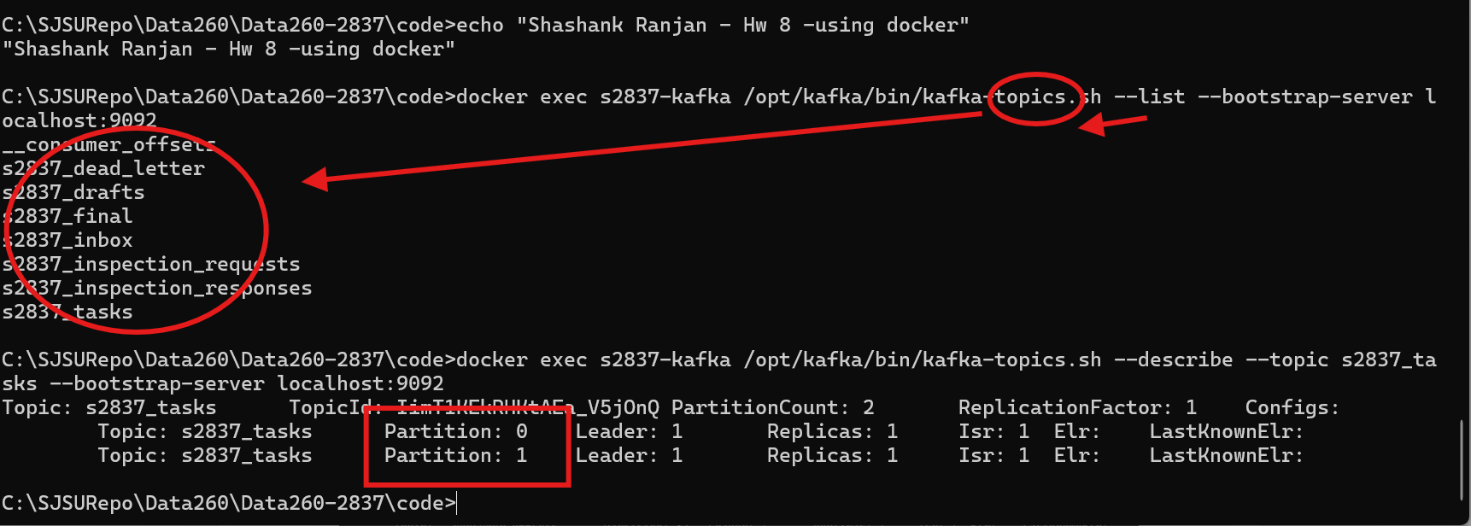
2.3 Agent code
# planner.py
def handle(message, record, runner):
question = require(message, "question")
steps, model = llm.plan(question, runner.component)
log(runner.component, f"PLAN ({model}) steps={steps}")
task = {
"correlation_id": message["correlation_id"],
"test_run": message.get("test_run"),
"kind": "answer_task",
"question": question,
"plan": {"steps": steps, "model": model, "planned_at": now_iso()},
}
# key = correlation_id -> every task of one question lands in the same tasks partition
return [(cfg.TASKS_TOPIC, task, message["correlation_id"])]

# writer.py
def handle(message, record, runner):
kind = message.get("kind", "answer_task")
correlation_id = message["correlation_id"]

if kind == "ordering_event":
entity_id = require(message, "entity_id")
seq = message.get("seq")
if not isinstance(seq, int):
raise PermanentError("ordering_event needs integer seq")
time.sleep(max(0, int(message.get("work_ms", 0))) / 1000)
log(runner.component, f"ORDER entity={entity_id} seq={seq} partition={record.partition}"
f" offset={record.offset}")
draft = {"correlation_id": correlation_id, "test_run": message.get("test_run"),
"kind": "ordering_result",
"run": message.get("run"), "entity_id": entity_id, "seq": seq,
"event": message.get("event"), "global_index": message.get("global_index"),
"partition": record.partition, "offset": record.offset,
"writer": runner.args.instance, "processed_at": now_iso()}
return [(cfg.DRAFTS_TOPIC, draft, entity_id)]

if kind != "answer_task":
raise PermanentError(f"unknown task kind '{kind}'")
# ... (see repository for the rest)

# reviewer.py
def review(draft):
words = len(draft.split())
checks = {
"non_empty": bool(draft.strip()),
"length_40_400_words": 40 <= words <= 400,
"on_domain": bool(re.search(r"inspect|restaurant|food", draft, re.I)),
"no_error_text": not re.search(r"traceback|exception|error:", draft, re.I),
}
return all(checks.values()), checks, words

2.4 Running the agents (4 terminals)
First verify .. ollam is running
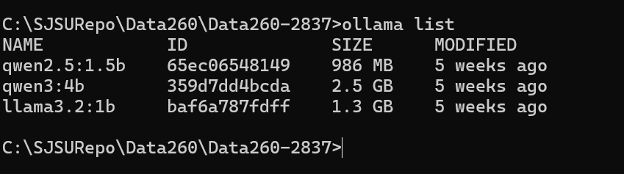
Planner is ready
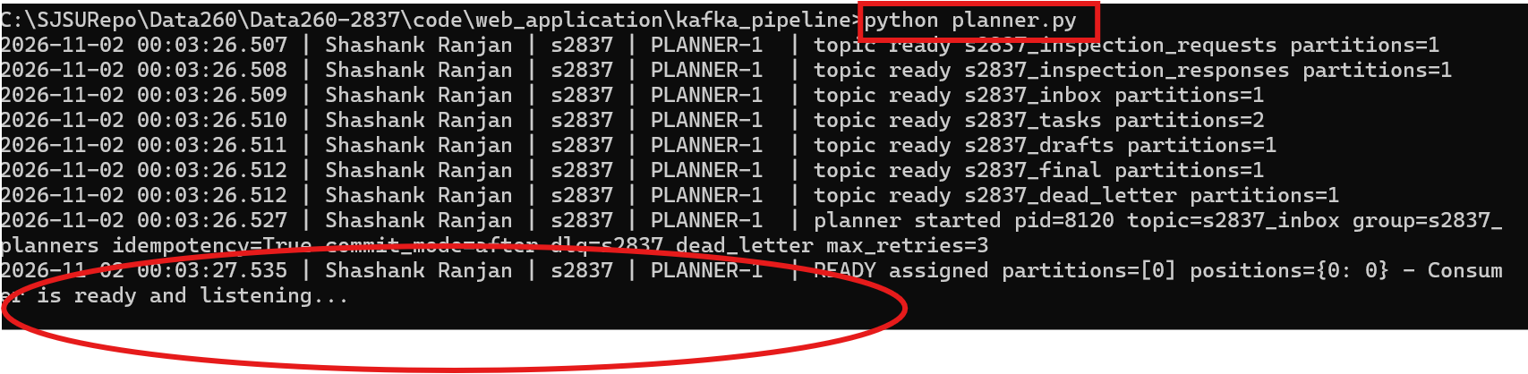
Writer is ready
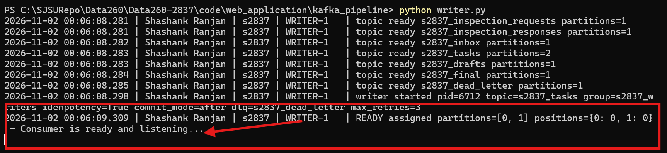
Reviewer is ready
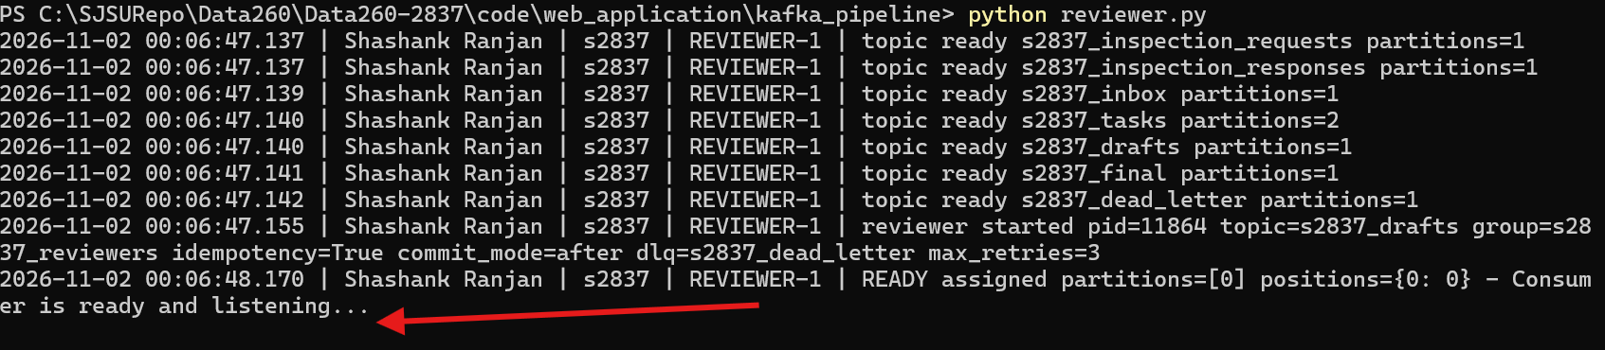
--send questions.py
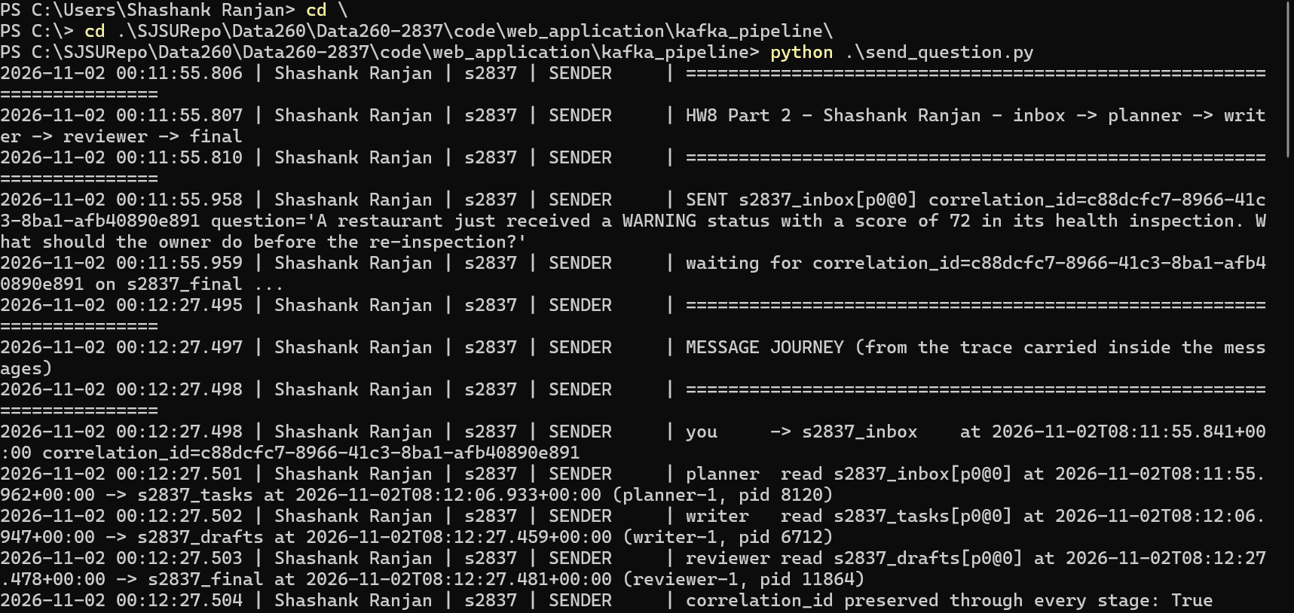
2.5 One complete message journey (inbox -> final)
00:11:55.958 SENDER SENT s2837_inbox[p0@0] correlation_id=c88dcfc7-8966-41c3-8ba1-afb40890e891 question='A restaurant just received a WARNING status with a score ...
00:11:55.959 PLANNER-1 RECEIVED s2837_inbox[p0@0] correlation_id=c88dcfc7-8966-41c3-8ba1-afb40890e891 message={"correlation_id": "c88dcfc7-8966-41c3-8ba1-afb40890e89...
00:11:55.962 PLANNER-1 PROCESSING correlation_id=c88dcfc7-8966-41c3-8ba1-afb40890e891
00:12:06.941 PLANNER-1 SENT s2837_tasks[p0@0] correlation_id=c88dcfc7-8966-41c3-8ba1-afb40890e891 message={"correlation_id": "c88dcfc7-8966-41c3-8ba1-afb40890e891", ...
00:12:06.942 WRITER-1 RECEIVED s2837_tasks[p0@0] correlation_id=c88dcfc7-8966-41c3-8ba1-afb40890e891 message={"correlation_id": "c88dcfc7-8966-41c3-8ba1-afb40890e89...
00:12:27.471 WRITER-1 SENT s2837_drafts[p0@0] correlation_id=c88dcfc7-8966-41c3-8ba1-afb40890e891 message={"correlation_id": "c88dcfc7-8966-41c3-8ba1-afb40890e891",...
00:12:27.473 REVIEWER-1 RECEIVED s2837_drafts[p0@0] correlation_id=c88dcfc7-8966-41c3-8ba1-afb40890e891 message={"correlation_id": "c88dcfc7-8966-41c3-8ba1-afb40890e8...
00:12:27.478 REVIEWER-1 PROCESSING correlation_id=c88dcfc7-8966-41c3-8ba1-afb40890e891
00:12:27.491 REVIEWER-1 SENT s2837_final[p0@0] correlation_id=c88dcfc7-8966-41c3-8ba1-afb40890e891 message={"correlation_id": "c88dcfc7-8966-41c3-8ba1-afb40890e891", ...

Stage | Agent | Read from | Received | Finished
planner | planner-1 | s2837_inbox[p0@0] | 08:11:55.962 | 08:12:06.933
writer | writer-1 | s2837_tasks[p0@0] | 08:12:06.947 | 08:12:27.459
reviewer | reviewer-1 | s2837_drafts[p0@0] | 08:12:27.478 | 08:12:27.481

2.6 Final JSON from s2837_final
{
"correlation_id": "c88dcfc7-8966-41c3-8ba1-afb40890e891",
"status": "approved",
"answer": "Before the re-inspection, the restaurant owner should take the following steps:\n\n1. **Review the Inspection Report and Issues**: Carefully examine the inspection report to understand the specific issues highlighted by the warning. This might include areas such as food safety practices, cleanliness, food handling, and employee health.\n\n2. **Implement Corrective Actions**: Address the identified issues immediately. This could involve:\n - Improving food storage and preparation practices to ensure proper temperature control.\n - Enhancing cleaning procedures to eliminate cross-contamination.\n - Ensuring proper handwashing and glove use by staff.\n - Training staff on food safety protocols and proper handling of food.\n - Implementing a system to monitor and log food temperatures and staff health.\n\n3. **Schedule a Follow-Up Inspection**: Arrange for a follow-up inspection within a reasonable timeframe, typically 1-2 weeks, to ensure the corrective measures are being effectively implemented. This will allow the restaurant to demonstrate that the necessary improvements have been made and that the issues highlighted in the warning have been resolved.\n\nBy following these steps, the restaurant can demonstrate to the health department that it is taking the necessary steps to improve its food safety practices and address the issues highlighted in the warning, thereby potentially reducing the warning status and improving its overall health inspection score.",
"review": {
"checks": {
"non_empty": true,
"length_40_400_words": true,
"on_domain": true,
"no_error_text": true
},
"word_count": 209,
"reviewer": "reviewer-1",
"reviewed_at": "2026-11-02T08:12:27.479+00:00"
},
"writer": {
"instance": "writer-1",
"model": "ollama:qwen2.5:1.5b (temperature 0, seed 2837)",
"written_at": "2026-11-02T08:12:27.459+00:00"
}
}

2.7 How Kafka helped the agents coordinate
Kafka acted as the only contract between the agents: each agent knows just its input topic, its output topic and the JSON shape, so I could start, stop or restart any agent independently and the messages waited in the topic instead of being lost. Consumer groups and committed offsets let every agent resume exactly where it stopped, the two-partition tasks topic lets me add a second Writer without code changes, and the correlation_id plus the trace inside each message gave me an end-to-end audit of one question across three processes. The cost is that the pipeline is asynchronous: send_question.py has to wait on s2837_final and match the correlation_id instead of getting a return value.
Part 3 - Failure Behavior
All experiments are produced by run_hw08_failures.py, which starts the agents as separate processes with their own consumer groups and test_run tag, toggles the safety feature off (before) and on (after), and writes raw/part3_*.json|csv|txt. Agents use the deterministic writer template here so timing reflects Kafka, not the model.
3.I Duplicate delivery - idempotency
# agent_base.py
def _process_once(self, record, where, attempts):
message = decode(record.value) # ValueError -> poison
correlation_id = message.get("correlation_id")
if not isinstance(correlation_id, str) or not correlation_id:
raise PermanentError("missing correlation_id")
if message.get("test_run") != self.args.test_run:
log(self.component, f"IGNORED {where} test_run={message.get('test_run')} "
f"(this agent handles test_run={self.args.test_run})")
return "ignored"
if attempts == 1:
log(self.component, f"RECEIVED {where} correlation_id={correlation_id} "
f"message={short(message, 300)}")
if self.store is not None:
status = self.store.status(correlation_id)
if status == "done":
log(self.component, f"DUPLICATE correlation_id={correlation_id} already "
"processed - skipped, no new output (idempotent)")
trace(self.component, "DUPLICATE_SKIPPED", correlation_id, where=where)
return "duplicate_skipped"
if status == "in_progress" and attempts == 1:
log(self.component, f"REDELIVERY correlation_id={correlation_id} - previous "
"attempt never finished (consumer died); processing again")
self.store.mark_started(correlation_id)

message.setdefault("trace", [])
stage = {"stage": self.name, "agent": self.args.instance, "pid": os.getpid(),
"topic": record.topic, "partition": record.partition, "offset": record.offset,
"received_at": now_iso()}
log(self.component, f"PROCESSING correlation_id={correlation_id}")
outputs = self.handler(message, record, self)
stage["finished_at"] = now_iso()
for topic, value, key in outputs:
# ... (see repository for the rest)

Run | Deliveries | Drafts produced | Finals produced | DUPLICATE skips
before | 2 | 2 | 2 | 0
after | 2 | 1 | 1 | 1

Before fix (--no-idempotency):
00:19:41.815 REVIEWER-DUP-BEFORE reviewer started pid=1672 topic=s2837_drafts group=s2837_dup_r_before_20261102001941 idempotency=False commit_mode=after dlq=s2837_dea...
00:19:41.815 WRITER-DUP-BEFORE writer started pid=13752 topic=s2837_tasks group=s2837_dup_w_before_20261102001941 idempotency=False commit_mode=after dlq=s2837_dead_le...
00:19:44.038 WRITER-DUP-BEFORE RECEIVED s2837_tasks[p0@1] correlation_id=7bd62cad-a1cc-4eb3-beae-ada50482b07c message={"correlation_id": "7bd62cad-a1cc-4eb3-beae-ada50...
00:19:44.051 WRITER-DUP-BEFORE SENT s2837_drafts[p0@1] correlation_id=7bd62cad-a1cc-4eb3-beae-ada50482b07c message={"correlation_id": "7bd62cad-a1cc-4eb3-beae-ada50482...
00:19:44.052 REVIEWER-DUP-BEFORE RECEIVED s2837_drafts[p0@1] correlation_id=7bd62cad-a1cc-4eb3-beae-ada50482b07c message={"correlation_id": "7bd62cad-a1cc-4eb3-beae-ad...
00:19:44.057 WRITER-DUP-BEFORE COMMITTED offset 2 on p0 after success
00:19:44.067 REVIEWER-DUP-BEFORE SENT s2837_final[p0@1] correlation_id=7bd62cad-a1cc-4eb3-beae-ada50482b07c message={"correlation_id": "7bd62cad-a1cc-4eb3-beae-ada5048...
00:19:44.071 REVIEWER-DUP-BEFORE COMMITTED offset 2 on p0 after success
00:19:45.149 WRITER-DUP-BEFORE RECEIVED s2837_tasks[p0@2] correlation_id=7bd62cad-a1cc-4eb3-beae-ada50482b07c message={"correlation_id": "7bd62cad-a1cc-4eb3-beae-ada50...
00:19:45.184 WRITER-DUP-BEFORE SENT s2837_drafts[p0@2] correlation_id=7bd62cad-a1cc-4eb3-beae-ada50482b07c message={"correlation_id": "7bd62cad-a1cc-4eb3-beae-ada50482...
00:19:45.185 REVIEWER-DUP-BEFORE RECEIVED s2837_drafts[p0@2] correlation_id=7bd62cad-a1cc-4eb3-beae-ada50482b07c message={"correlation_id": "7bd62cad-a1cc-4eb3-beae-ad...
00:19:45.191 WRITER-DUP-BEFORE COMMITTED offset 3 on p0 after success
00:19:45.203 REVIEWER-DUP-BEFORE SENT s2837_final[p0@2] correlation_id=7bd62cad-a1cc-4eb3-beae-ada50482b07c message={"correlation_id": "7bd62cad-a1cc-4eb3-beae-ada5048...
00:19:45.208 REVIEWER-DUP-BEFORE COMMITTED offset 3 on p0 after success

After fix (SQLite idempotency store keyed by correlation_id):
00:19:55.625 WRITER-DUP-AFTER writer started pid=6620 topic=s2837_tasks group=s2837_dup_w_after_20261102001941 idempotency=True commit_mode=after dlq=s2837_dead_letter...
00:19:55.628 REVIEWER-DUP-AFTER reviewer started pid=20912 topic=s2837_drafts group=s2837_dup_r_after_20261102001941 idempotency=True commit_mode=after dlq=s2837_dead_...
00:19:57.736 WRITER-DUP-AFTER RECEIVED s2837_tasks[p1@0] correlation_id=952a972d-2171-4704-a484-ba8e6f5d210b message={"correlation_id": "952a972d-2171-4704-a484-ba8e6f...
00:19:57.747 REVIEWER-DUP-AFTER RECEIVED s2837_drafts[p0@3] correlation_id=952a972d-2171-4704-a484-ba8e6f5d210b message={"correlation_id": "952a972d-2171-4704-a484-ba8...
00:19:57.747 WRITER-DUP-AFTER SENT s2837_drafts[p0@3] correlation_id=952a972d-2171-4704-a484-ba8e6f5d210b message={"correlation_id": "952a972d-2171-4704-a484-ba8e6f5d2...
00:19:57.754 WRITER-DUP-AFTER COMMITTED offset 1 on p1 after success
00:19:57.760 REVIEWER-DUP-AFTER SENT s2837_final[p0@3] correlation_id=952a972d-2171-4704-a484-ba8e6f5d210b message={"correlation_id": "952a972d-2171-4704-a484-ba8e6f5d...
00:19:57.765 REVIEWER-DUP-AFTER COMMITTED offset 4 on p0 after success
00:19:58.852 WRITER-DUP-AFTER RECEIVED s2837_tasks[p1@1] correlation_id=952a972d-2171-4704-a484-ba8e6f5d210b message={"correlation_id": "952a972d-2171-4704-a484-ba8e6f...
00:19:58.856 WRITER-DUP-AFTER DUPLICATE correlation_id=952a972d-2171-4704-a484-ba8e6f5d210b already processed - skipped, no new output (idempotent)
00:19:58.864 WRITER-DUP-AFTER COMMITTED offset 2 on p1 after duplicate_skipped

3.II Consumer death - commit offsets only after successful processing
# agent_base.py
def _handle(self, record):
where = f"{record.topic}[p{record.partition}@{record.offset}]"
if self.args.commit_mode == "early":
self.consumer.commit()
log(self.component, f"COMMITTED offset {record.offset + 1} on p{record.partition} "
"BEFORE processing (unsafe early-commit mode)")
attempts = 0
while True:
attempts += 1
try:
outcome = self._process_once(record, where, attempts)
break
except Exception as exc: # retry / dead-letter
permanent = isinstance(exc, (PermanentError, ValueError, UnicodeDecodeError))
log(self.component, f"ERROR attempt {attempts}"
f"{'' if self.args.no_dlq else '/' + str(self.args.max_retries)}"
f" at {where}: {type(exc).__name__}: {exc}")
if not self.args.no_dlq and attempts >= self.args.max_retries:
self._dead_letter(record, exc, attempts, permanent)
outcome = "dead_letter"
break
backoff = 1.0 if self.args.no_dlq else min(0.5 * 2 ** (attempts - 1), 4)
log(self.component, f"RETRY in {backoff:.1f}s (message blocks this partition "
"until it succeeds" + (")" if self.args.no_dlq
else " or reaches the limit)"))
time.sleep(backoff)
if self.args.commit_mode == "after":
self.consumer.commit()
log(self.component, f"COMMITTED offset {record.offset + 1} on p{record.partition} "
f"after {outcome}")

Run | commit mode | msg offset | committed at kill | after restart | redelivered | lost
before | early | p1@3 | {'1': 4, '0': 3} | {'1': 4, '0': 3} | False | True
after | after | p1@5 | {'1': 5, '0': 3} | {'1': 6, '0': 3} | True | False

Before fix (--commit-mode early, offset committed on receipt):
00:20:09.289 WRITER-CRASH-BEFORE writer started pid=8676 topic=s2837_tasks group=s2837_crash_before_20261102001941 idempotency=True commit_mode=early dlq=s2837_dead_le...
00:20:10.298 WRITER-CRASH-BEFORE READY assigned partitions=[0, 1] positions={0: 3, 1: 2} - Consumer is ready and listening...
00:20:11.393 WRITER-CRASH-BEFORE COMMITTED offset 3 on p1 BEFORE processing (unsafe early-commit mode)
00:20:11.394 WRITER-CRASH-BEFORE RECEIVED s2837_tasks[p1@2] correlation_id=9655658f-b946-4f06-a55b-13526eecc60b message={"correlation_id": "9655658f-b946-4f06-a55b-135...
00:20:11.408 WRITER-CRASH-BEFORE SENT s2837_drafts[p0@4] correlation_id=9655658f-b946-4f06-a55b-13526eecc60b message={"correlation_id": "9655658f-b946-4f06-a55b-13526e...
00:20:11.504 WRITER-CRASH-BEFORE COMMITTED offset 4 on p1 BEFORE processing (unsafe early-commit mode)
00:20:11.506 WRITER-CRASH-BEFORE RECEIVED s2837_tasks[p1@3] correlation_id=8f9990cc-95db-49df-a697-707ba1616398 message={"correlation_id": "8f9990cc-95db-49df-a697-707...
00:20:11.511 WRITER-CRASH-BEFORE WORKING slowly for 8s on correlation_id=8f9990cc-95db-49df-a697-707ba1616398 (offset not committed yet - kill me now)
00:20:16.078 WRITER-CRASH-BEFORE-RESTART writer started pid=21408 topic=s2837_tasks group=s2837_crash_before_20261102001941 idempotency=True commit_mode=early dlq=s283...
00:20:17.082 WRITER-CRASH-BEFORE-RESTART READY assigned partitions=[] positions={} - Consumer is ready and listening...
00:20:23.117 WRITER-CRASH-BEFORE-RESTART READY assigned partitions=[0, 1] positions={0: 3, 1: 4} - Consumer is ready and listening...

After fix (commit after the draft is acked):
00:21:05.181 WRITER-CRASH-AFTER writer started pid=8244 topic=s2837_tasks group=s2837_crash_after_20261102001941 idempotency=True commit_mode=after dlq=s2837_dead_lett...
00:21:06.191 WRITER-CRASH-AFTER READY assigned partitions=[0, 1] positions={0: 3, 1: 4} - Consumer is ready and listening...
00:21:07.267 WRITER-CRASH-AFTER RECEIVED s2837_tasks[p1@4] correlation_id=ef5d7b46-f974-4042-bccc-586ee9904950 message={"correlation_id": "ef5d7b46-f974-4042-bccc-586e...
00:21:07.281 WRITER-CRASH-AFTER SENT s2837_drafts[p0@5] correlation_id=ef5d7b46-f974-4042-bccc-586ee9904950 message={"correlation_id": "ef5d7b46-f974-4042-bccc-586ee99...
00:21:07.287 WRITER-CRASH-AFTER COMMITTED offset 5 on p1 after success
00:21:07.377 WRITER-CRASH-AFTER RECEIVED s2837_tasks[p1@5] correlation_id=c2d41f18-3aba-4060-b2d0-8de80dd3349d message={"correlation_id": "c2d41f18-3aba-4060-b2d0-8de8...
00:21:07.385 WRITER-CRASH-AFTER WORKING slowly for 8s on correlation_id=c2d41f18-3aba-4060-b2d0-8de80dd3349d (offset not committed yet - kill me now)
00:21:11.913 WRITER-CRASH-AFTER-RESTART writer started pid=22656 topic=s2837_tasks group=s2837_crash_after_20261102001941 idempotency=True commit_mode=after dlq=s2837_...
00:21:12.914 WRITER-CRASH-AFTER-RESTART READY assigned partitions=[] positions={} - Consumer is ready and listening...
00:21:18.437 WRITER-CRASH-AFTER-RESTART READY assigned partitions=[0, 1] positions={0: 3, 1: 5} - Consumer is ready and listening...
00:21:18.439 WRITER-CRASH-AFTER-RESTART RECEIVED s2837_tasks[p1@5] correlation_id=c2d41f18-3aba-4060-b2d0-8de80dd3349d message={"correlation_id": "c2d41f18-3aba-4060-b...
00:21:18.440 WRITER-CRASH-AFTER-RESTART REDELIVERY correlation_id=c2d41f18-3aba-4060-b2d0-8de80dd3349d - previous attempt never finished (consumer died); processing again
00:21:18.445 WRITER-CRASH-AFTER-RESTART WORKING slowly for 8s on correlation_id=c2d41f18-3aba-4060-b2d0-8de80dd3349d (offset not committed yet - kill me now)
00:21:26.461 WRITER-CRASH-AFTER-RESTART SENT s2837_drafts[p0@6] correlation_id=c2d41f18-3aba-4060-b2d0-8de80dd3349d message={"correlation_id": "c2d41f18-3aba-4060-b2d0...
00:21:26.467 WRITER-CRASH-AFTER-RESTART COMMITTED offset 6 on p1 after success

3.III Poison message - bounded retries and s2837_dead_letter
# agent_base.py
def _dead_letter(self, record, exc, attempts, permanent):
raw = record.value.decode("utf-8", "replace") if record.value else None
try:
correlation_id = decode(record.value).get("correlation_id")
except Exception:
correlation_id = None
letter = {
"correlation_id": correlation_id,
"failed_stage": self.name,
"failed_agent": self.args.instance,
"source_topic": record.topic, "source_partition": record.partition,
"source_offset": record.offset,
"error_type": type(exc).__name__, "error": str(exc),
"permanent": permanent, "attempts": attempts,
"raw_value": raw, "dead_lettered_at": now_iso(),
"traceback_tail": traceback.format_exception_only(type(exc), exc)[-1].strip(),
}
meta = send_json(self.producer, cfg.DEAD_LETTER_TOPIC, letter, key=correlation_id)
log(self.component, f"DEAD-LETTER after {attempts} attempts -> "
f"{cfg.DEAD_LETTER_TOPIC}[p{meta.partition}@{meta.offset}] "
f"source={record.topic}[p{record.partition}@{record.offset}]")
trace(self.component, "DEAD_LETTER", correlation_id, offset=record.offset)

Run | Attempts | Good msgs processed | Dead-letter records
before | 18 | 0/3 | 0
after | 3 | 3/3 | 1

Record in s2837_dead_letter:
{
"correlation_id": "dc3877fa-137d-4c63-ad8b-0a96fee03cbc",
"failed_stage": "writer",
"failed_agent": "writer-poison-after",
"source_topic": "s2837_tasks",
"source_partition": 1,
"source_offset": 10,
"error_type": "PermanentError",
"error": "plan.steps must be a non-empty list of strings",
"permanent": true,
"attempts": 3,
"raw_value": "{\"correlation_id\": \"dc3877fa-137d-4c63-ad8b-0a96fee03cbc\", \"test_run\": \"poison-after-20261102001941\", \"kind\": \"answer_task\", \"question\": \"poison\", \"plan\": \"THIS-IS-NOT-A-LIST\"}",
"dead_lettered_at": "2026-11-02T08:21:50.120+00:00",
"traceback_tail": "web_application.kafka_pipeline.agent_base.PermanentError: plan.steps must be a non-empty list of strings"
}

Before fix (--no-dlq, retries forever):
00:21:28.965 WRITER-POISON-BEFORE RECEIVED s2837_tasks[p1@6] correlation_id=9484baec-c2d7-49f2-88c2-d4e572c3abf4 message={"correlation_id": "9484baec-c2d7-49f2-88c2-d4...
00:21:28.969 WRITER-POISON-BEFORE ERROR attempt 1 at s2837_tasks[p1@6]: PermanentError: plan.steps must be a non-empty list of strings
00:21:28.969 WRITER-POISON-BEFORE RETRY in 1.0s (message blocks this partition until it succeeds)
00:21:29.976 WRITER-POISON-BEFORE ERROR attempt 2 at s2837_tasks[p1@6]: PermanentError: plan.steps must be a non-empty list of strings
00:21:29.979 WRITER-POISON-BEFORE RETRY in 1.0s (message blocks this partition until it succeeds)
00:21:30.988 WRITER-POISON-BEFORE ERROR attempt 3 at s2837_tasks[p1@6]: PermanentError: plan.steps must be a non-empty list of strings
00:21:30.990 WRITER-POISON-BEFORE RETRY in 1.0s (message blocks this partition until it succeeds)
00:21:31.996 WRITER-POISON-BEFORE ERROR attempt 4 at s2837_tasks[p1@6]: PermanentError: plan.steps must be a non-empty list of strings
00:21:31.999 WRITER-POISON-BEFORE RETRY in 1.0s (message blocks this partition until it succeeds)
00:21:33.006 WRITER-POISON-BEFORE ERROR attempt 5 at s2837_tasks[p1@6]: PermanentError: plan.steps must be a non-empty list of strings
00:21:33.008 WRITER-POISON-BEFORE RETRY in 1.0s (message blocks this partition until it succeeds)
00:21:34.018 WRITER-POISON-BEFORE ERROR attempt 6 at s2837_tasks[p1@6]: PermanentError: plan.steps must be a non-empty list of strings
00:21:34.020 WRITER-POISON-BEFORE RETRY in 1.0s (message blocks this partition until it succeeds)
00:21:35.032 WRITER-POISON-BEFORE ERROR attempt 7 at s2837_tasks[p1@6]: PermanentError: plan.steps must be a non-empty list of strings

After fix:
00:21:48.599 WRITER-POISON-AFTER RECEIVED s2837_tasks[p1@10] correlation_id=dc3877fa-137d-4c63-ad8b-0a96fee03cbc message={"correlation_id": "dc3877fa-137d-4c63-ad8b-0a...
00:21:48.604 WRITER-POISON-AFTER ERROR attempt 1/3 at s2837_tasks[p1@10]: PermanentError: plan.steps must be a non-empty list of strings
00:21:48.605 WRITER-POISON-AFTER RETRY in 0.5s (message blocks this partition until it succeeds or reaches the limit)
00:21:49.109 WRITER-POISON-AFTER ERROR attempt 2/3 at s2837_tasks[p1@10]: PermanentError: plan.steps must be a non-empty list of strings
00:21:49.110 WRITER-POISON-AFTER RETRY in 1.0s (message blocks this partition until it succeeds or reaches the limit)
00:21:50.117 WRITER-POISON-AFTER ERROR attempt 3/3 at s2837_tasks[p1@10]: PermanentError: plan.steps must be a non-empty list of strings
00:21:50.140 WRITER-POISON-AFTER DEAD-LETTER after 3 attempts -> s2837_dead_letter[p0@0] source=s2837_tasks[p1@10]
00:21:50.148 WRITER-POISON-AFTER COMMITTED offset 11 on p1 after dead_letter
00:21:50.151 WRITER-POISON-AFTER RECEIVED s2837_tasks[p1@11] correlation_id=3943cfc8-03d1-4150-8965-fa8cd17cb558 message={"correlation_id": "3943cfc8-03d1-4150-8965-fa...
00:21:50.264 WRITER-POISON-AFTER SENT s2837_drafts[p0@7] correlation_id=3943cfc8-03d1-4150-8965-fa8cd17cb558 message={"correlation_id": "3943cfc8-03d1-4150-8965-fa8cd1...
00:21:50.278 WRITER-POISON-AFTER COMMITTED offset 12 on p1 after success
00:21:50.281 WRITER-POISON-AFTER RECEIVED s2837_tasks[p1@12] correlation_id=7ce400f7-a796-46c5-bff1-2c76344dc23e message={"correlation_id": "7ce400f7-a796-46c5-bff1-2c...
00:21:50.292 WRITER-POISON-AFTER SENT s2837_drafts[p0@8] correlation_id=7ce400f7-a796-46c5-bff1-2c76344dc23e message={"correlation_id": "7ce400f7-a796-46c5-bff1-2c7634...
00:21:50.300 WRITER-POISON-AFTER COMMITTED offset 13 on p1 after success
00:21:50.301 WRITER-POISON-AFTER RECEIVED s2837_tasks[p1@13] correlation_id=7f24831e-3276-42d7-881c-5e6de06cb43d message={"correlation_id": "7f24831e-3276-42d7-881c-5e...
00:21:50.308 WRITER-POISON-AFTER SENT s2837_drafts[p0@9] correlation_id=7f24831e-3276-42d7-881c-5e6de06cb43d message={"correlation_id": "7f24831e-3276-42d7-881c-5e6de0...
00:21:50.315 WRITER-POISON-AFTER COMMITTED offset 14 on p1 after success

3.IV Ordering - 2 partitions, 2 Writers in one group, VERIFY_SEED messages
# run_hw08_failures.py
def ordering_messages():
rng = random.Random(cfg.VERIFY_SEED)
entities = [f"INSP-{cfg.SID4}-{c}" for c in "ABCD"]
lifecycle = ["SCHEDULED", "STARTED", "VIOLATION_RECORDED", "SCORE_UPDATED",
"STATUS_CHANGED", "REINSPECTION_BOOKED", "CLOSED", "NOTE_ADDED"]
seq = {e: 0 for e in entities}
out = []
for i in range(20):
entity = rng.choice(entities)
seq[entity] += 1
out.append({"global_index": i, "entity_id": entity, "seq": seq[entity],
"event": lifecycle[(seq[entity] - 1) % len(lifecycle)],
"work_ms": rng.randint(30, 900)})
return out

# partition key:
meta = send_json(producer, cfg.TASKS_TOPIC, body, key=msg['entity_id']) # keyed run

Run - unkeyed (no key):
Entity | Processed seq order | Partitions | In order
INSP-2837-A | [2, 1, 3] | [0, 1] | False
INSP-2837-B | [1, 3, 2, 4, 5, 6, 7, 8] | [0, 1] | False
INSP-2837-C | [1, 2, 3, 4, 5] | [0, 1] | True
INSP-2837-D | [1, 2, 3, 4] | [0, 1] | True

00:21:53.794 WRITER-ORDER-1-UNKEYED READY assigned partitions=[0] positions={0: 3} - Consumer is ready and listening...
00:21:53.794 WRITER-ORDER-2-UNKEYED READY assigned partitions=[1] positions={1: 14} - Consumer is ready and listening...
00:21:54.949 WRITER-ORDER-1-UNKEYED ORDER entity=INSP-2837-D seq=1 partition=0 offset=3
00:21:54.983 WRITER-ORDER-2-UNKEYED ORDER entity=INSP-2837-C seq=1 partition=1 offset=14
00:21:55.708 WRITER-ORDER-1-UNKEYED ORDER entity=INSP-2837-B seq=1 partition=0 offset=4
00:21:55.736 WRITER-ORDER-2-UNKEYED ORDER entity=INSP-2837-D seq=2 partition=1 offset=15
00:21:55.820 WRITER-ORDER-1-UNKEYED ORDER entity=INSP-2837-D seq=3 partition=0 offset=5
00:21:55.905 WRITER-ORDER-1-UNKEYED ORDER entity=INSP-2837-B seq=3 partition=0 offset=6
00:21:55.954 WRITER-ORDER-2-UNKEYED ORDER entity=INSP-2837-B seq=2 partition=1 offset=16
00:21:56.685 WRITER-ORDER-2-UNKEYED ORDER entity=INSP-2837-B seq=4 partition=1 offset=17
00:21:56.697 WRITER-ORDER-1-UNKEYED ORDER entity=INSP-2837-B seq=5 partition=0 offset=7
00:21:56.731 WRITER-ORDER-2-UNKEYED ORDER entity=INSP-2837-C seq=2 partition=1 offset=18
00:21:57.365 WRITER-ORDER-2-UNKEYED ORDER entity=INSP-2837-B seq=6 partition=1 offset=19
00:21:57.449 WRITER-ORDER-2-UNKEYED ORDER entity=INSP-2837-A seq=2 partition=1 offset=20
00:21:57.581 WRITER-ORDER-1-UNKEYED ORDER entity=INSP-2837-C seq=3 partition=0 offset=8
00:21:58.050 WRITER-ORDER-2-UNKEYED ORDER entity=INSP-2837-B seq=7 partition=1 offset=21
00:21:58.167 WRITER-ORDER-1-UNKEYED ORDER entity=INSP-2837-A seq=1 partition=0 offset=9
00:21:58.371 WRITER-ORDER-2-UNKEYED ORDER entity=INSP-2837-D seq=4 partition=1 offset=22
00:21:58.459 WRITER-ORDER-1-UNKEYED ORDER entity=INSP-2837-C seq=4 partition=0 offset=10
00:21:58.688 WRITER-ORDER-1-UNKEYED ORDER entity=INSP-2837-A seq=3 partition=0 offset=11
00:21:58.991 WRITER-ORDER-2-UNKEYED ORDER entity=INSP-2837-B seq=8 partition=1 offset=23
00:21:59.075 WRITER-ORDER-1-UNKEYED ORDER entity=INSP-2837-C seq=5 partition=0 offset=12

Run - keyed (key = entity_id):
Entity | Processed seq order | Partitions | In order
INSP-2837-A | [1, 2, 3] | [1] | True
INSP-2837-B | [1, 2, 3, 4, 5, 6, 7, 8] | [0] | True
INSP-2837-C | [1, 2, 3, 4, 5] | [0] | True
INSP-2837-D | [1, 2, 3, 4] | [1] | True

00:22:00.596 WRITER-ORDER-1-KEYED READY assigned partitions=[0] positions={0: 13} - Consumer is ready and listening...
00:22:00.596 WRITER-ORDER-2-KEYED READY assigned partitions=[1] positions={1: 24} - Consumer is ready and listening...
00:22:01.852 WRITER-ORDER-2-KEYED ORDER entity=INSP-2837-D seq=1 partition=1 offset=24
00:22:01.886 WRITER-ORDER-1-KEYED ORDER entity=INSP-2837-C seq=1 partition=0 offset=13
00:22:02.608 WRITER-ORDER-2-KEYED ORDER entity=INSP-2837-D seq=2 partition=1 offset=25
00:22:02.643 WRITER-ORDER-1-KEYED ORDER entity=INSP-2837-B seq=1 partition=0 offset=14
00:22:02.720 WRITER-ORDER-2-KEYED ORDER entity=INSP-2837-D seq=3 partition=1 offset=26
00:22:02.860 WRITER-ORDER-1-KEYED ORDER entity=INSP-2837-B seq=2 partition=0 offset=15
00:22:02.966 WRITER-ORDER-1-KEYED ORDER entity=INSP-2837-B seq=3 partition=0 offset=16
00:22:03.293 WRITER-ORDER-2-KEYED ORDER entity=INSP-2837-A seq=1 partition=1 offset=27
00:22:03.375 WRITER-ORDER-2-KEYED ORDER entity=INSP-2837-A seq=2 partition=1 offset=28
00:22:03.609 WRITER-ORDER-2-KEYED ORDER entity=INSP-2837-A seq=3 partition=1 offset=29
00:22:03.715 WRITER-ORDER-1-KEYED ORDER entity=INSP-2837-B seq=4 partition=0 offset=17
00:22:03.951 WRITER-ORDER-2-KEYED ORDER entity=INSP-2837-D seq=4 partition=1 offset=30
00:22:04.507 WRITER-ORDER-1-KEYED ORDER entity=INSP-2837-B seq=5 partition=0 offset=18
00:22:04.561 WRITER-ORDER-1-KEYED ORDER entity=INSP-2837-C seq=2 partition=0 offset=19
00:22:05.453 WRITER-ORDER-1-KEYED ORDER entity=INSP-2837-C seq=3 partition=0 offset=20
00:22:06.107 WRITER-ORDER-1-KEYED ORDER entity=INSP-2837-B seq=6 partition=0 offset=21
00:22:06.379 WRITER-ORDER-1-KEYED ORDER entity=INSP-2837-C seq=4 partition=0 offset=22
00:22:06.992 WRITER-ORDER-1-KEYED ORDER entity=INSP-2837-B seq=7 partition=0 offset=23
00:22:07.360 WRITER-ORDER-1-KEYED ORDER entity=INSP-2837-C seq=5 partition=0 offset=24
00:22:07.978 WRITER-ORDER-1-KEYED ORDER entity=INSP-2837-B seq=8 partition=0 offset=25

3.V Failure table
Failure scenario | Before fix | After fix
Duplicate delivery | same correlation_id delivered twice -> 2 drafts, 2 finals (extra side effect) | idempotency store -> 1 draft, 1 final, 1 DUPLICATE skips
Consumer killed mid-work | commit-before-processing: offset already {1: 4, 0: 3} at kill -> after restart message_lost=True | commit-after-success: committed {1: 5, 0: 3} at kill -> redelivered, REDELIVERY detected=True, draft completed=True, committed now {1: 6, 0: 3}
Poison message | unbounded retry: 18 attempts in 15s, good messages processed 0/3 (partition blocked) | 3 attempts (limit 3) -> 1 record in s2837_dead_letter, good messages processed 3/3
Two partitions/two consumers | no key: 4/4 entities split across partitions, 2/4 processed out of order (2 inversions) | key=entity_id: 0/4 split, 0/4 out of order (0 inversions)

3.VI Comparison with the HW2 in-process graph
In HW2 my LangGraph Planner -> Reviewer -> Supervisor graph ran as function calls in one Python process: each node returned its state directly to the next node.
Benefits gained by moving to Kafka:
- Independent scaling - a second Writer joined the same consumer group and took one of the two s2837_tasks partitions with no code change (Part 3.IV).
- Decoupled failure - when the Writer was killed, the Planner and Reviewer kept running and the unfinished task stayed in Kafka until the restarted Writer finished it (Part 3.II); in HW2 an exception in one node stopped the whole graph run.
New responsibilities I now handle myself:
- Duplicate delivery - Kafka is at-least-once, so the same correlation_id can arrive twice; I added an idempotency store and offset commits after success (Part 3.I/II).
- Ordering and poison messages - order is only guaranteed inside one partition, so I had to choose entity_id as the message key; and a bad message would block a partition forever, so I added bounded retries and s2837_dead_letter (Part 3.III/IV).
verification.json (make verify-hw08)
---Final Verifiction (All 18 of 18 passed)
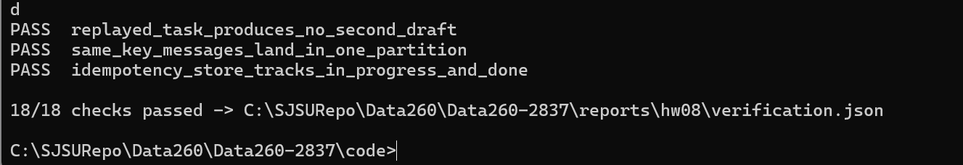
"checks": [
{
"check": "kafka_reachable",
"status": "PASS"
},
{
"check": "all_prefix_topics_exist_with_partitions",
"status": "PASS"
},
{
"check": "create_then_get_roundtrip_through_kafka",
"status": "PASS"
},
{
"check": "correlation_id_preserved_request_to_response",
"status": "PASS"
},
{
"check": "request_has_required_envelope_fields",
"status": "PASS"
},
{
"check": "get_unknown_id_returns_error_with_correlation_id",
"status": "PASS"
},
{
"check": "unknown_operation_returns_error",
"status": "PASS"
},
{
"check": "invalid_or_missing_fields_rejected",
"status": "PASS"
},
{
"check": "duplicate_request_same_correlation_id_creates_no_second_entity",
"status": "PASS"
},
{
"check": "fastapi_running_on_port_base",
"status": "PASS"
},
{
"check": "fastapi_create_get_via_kafka",
"status": "PASS"
},
{
"check": "pipeline_inbox_to_final_with_status_and_answer",
"status": "PASS"
},
{
"check": "pipeline_correlation_id_preserved_all_stages",
"status": "PASS"
},
{
"check": "poison_message_retried_then_dead_lettered",
"status": "PASS"
},
{
"check": "message_after_poison_still_processed",
"status": "PASS"
},
{
"check": "replayed_task_produces_no_second_draft",
"status": "PASS"
},
{
"check": "same_key_messages_land_in_one_partition",
"status": "PASS"
},
{
"check": "idempotency_store_tracks_in_progress_and_done",
"status": "PASS"
}
],
"summary": {
"passed": 18,
"total": 18
}
}

AI Use
1. What I used an AI assistant for and what I did myself: I used Claude to draft the Kafka code for this homework (worker, request client, FastAPI wrapper, Planner/Writer/Reviewer agents, the failure-test runner, docker-compose, the smoke test and the report builder) on top of my existing HW1-HW7 repository. I did myself: computing my configuration (SID4 2837, PREFIX s2837, PORT_BASE 8137, VERIFY_SEED 262837), choosing Inspection as the primary entity and reusing my InspectionCreate schema, running Docker/Kafka and every experiment on my machine, taking the screenshots, checking each log and table against the raw files, and the final review of the report.
2. One AI-produced output that was wrong: the first version of the duplicate-delivery experiment reported 3 drafts for one replayed correlation_id instead of 2, which would have overstated the duplicate problem in the failure table.
3. How I detected it: I read every record on s2837_drafts with its writer instance and test tag. The extra draft came from my normal Part 2 writer (group s2837_writers), which was still running and also consumed the test message, because each consumer group receives every message on the topic.
4. What I changed and why it works now: every Part 3 test message now carries a test_run tag. Agents only handle messages whose tag matches their --test-run value and log IGNORED for everything else, and the runner counts only tagged outputs. Each experiment also uses its own consumer group. A rerun gave exactly 2 drafts before the fix and 1 after it. The same check (replayed_task_produces_no_second_draft) is part of verify_hw08.py.

