Homework 1
StudentID : 018322837
Name: Shashank Ranjan Data 260
Name | Definition | Value
SID | Student ID | 018322837
SID4 | Last 4 of Student ID | 2837
PORT_BASE | 8000 + SID mod 900 | 8137 | 137
prefix | "s" + SID4 | s2837
Seed | SID4 | 2837
verify sid | 260000 + SID4 | 262837
DOMAIN_ID | SID4 MOD 8 | 5
Assigned Domain |  | 5 |  | Local restaurant inspections

Questions: (Part 1) HTML
Ans:
Created an HTML Pages and executed in my localhost and posted all the information/output.
The page running in localhost
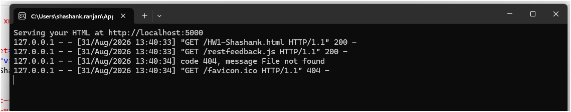
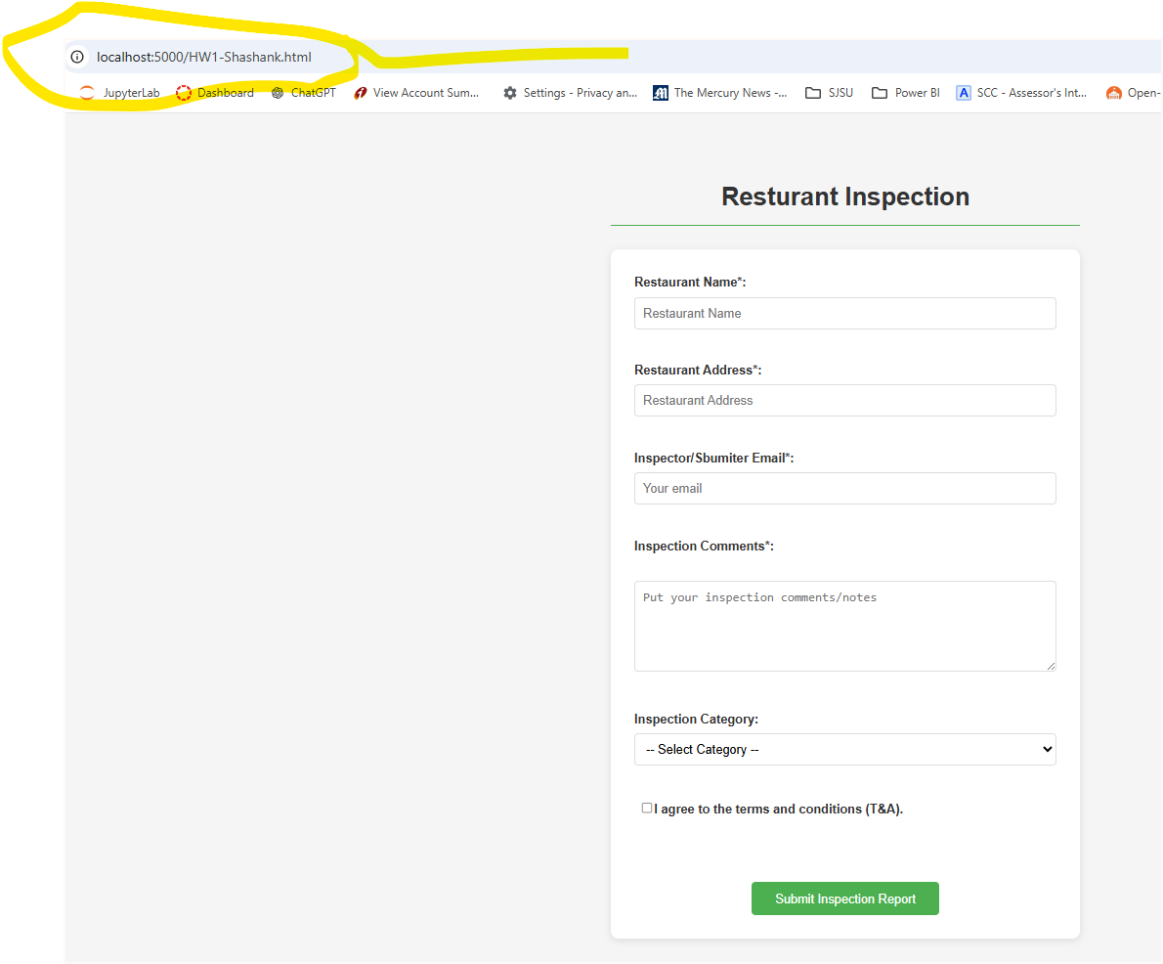

Since my work/office environment did not allow me to execute using “docker” due to govt security policy, hence I used my “python run time” server to execute this page. The details are also in the app.py and my visual studio information.
import http.server
import socketserver

PORT = 5000

# Tell Python to serve files straight from your current project directory
Handler = http.server.SimpleHTTPRequestHandler

with socketserver.TCPServer(("", PORT), Handler) as httpd:
print(f"Serving your HTML at http://localhost:{PORT}")
httpd.serve_forever()

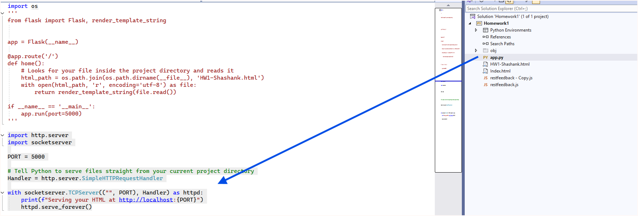
Questions: (Part 1) Javascript
Ans: All the parts of the JavaScript’s requirements were met. Here is the output
Here is the full console.log report that I saved and generated using javascript (my javascript file name is restfeedback.js.
log:Inspection Form Submission with following values: {"restName":"Rangoli Sweets","restAdr":"130 El Camion Real","email":"shanky@gmail.com","comments":"Everything looks good in this resturant with proper seating place and drinking facilities with hygine","inspectionCat":"OverAllCondition","termsChecked":true,"submittedAt":"8/31/2026, 2:44:47 AM"}
restfeedback.js:55 Primary Field -->(Restaurant Name): Rangoli Sweets
restfeedback.js:56 Email Field-->(Inspector email): shanky@gmail.com
restfeedback.js:64 Log:Submiited form values with submission date and time: Object
restfeedback.js:69 Count of Successfull submission till now: 1
restfeedback.js:47 log:Inspection Form Submission with following values: {"restName":"China Town","restAdr":"123 Freont Street","email":"ranjan@inspection.com","comments":"Problem in condtion at this resturant with traces of infection due to rodent","inspectionCat":"PestAndDisposal","termsChecked":true,"submittedAt":"8/31/2026, 2:46:26 AM"}
restfeedback.js:55 Primary Field -->(Restaurant Name): China Town
restfeedback.js:56 Email Field-->(Inspector email): ranjan@inspection.com
restfeedback.js:64 Log:Submiited form values with submission date and time: {restName: 'China Town', restAdr: '123 Freont Street', email: 'ranjan@inspection.com', comments: 'Problem in condtion at this resturant with traces of infection due to rodent', inspectionCat: 'PestAndDisposal', …}
restfeedback.js:69 Count of Successfull submission till now: 2
restfeedback.js:47 log:Inspection Form Submission with following values: {"restName":"Mc Donald inc","restAdr":"23 Main Street San Jose","email":"raj@sjcity.com","comments":"All Good . No issues found at this location . Employees were using hygienic practice in serving food","inspectionCat":"HygineicCondition","termsChecked":true,"submittedAt":"8/31/2026, 2:48:07 AM"}
restfeedback.js:55 Primary Field -->(Restaurant Name): Mc Donald inc
restfeedback.js:56 Email Field-->(Inspector email): raj@sjcity.com
restfeedback.js:64 Log:Submiited form values with submission date and time: {restName: 'Mc Donald inc', restAdr: '23 Main Street San Jose', email: 'raj@sjcity.com', comments: 'All Good . No issues found at this location . Employees were using hygienic practice in serving food', inspectionCat: 'HygineicCondition', …}
restfeedback.js:69 Count of Successfull submission till now: 3

Deployment:
I got issues due to docker at my work environment, hence I have to use “github” repositories.
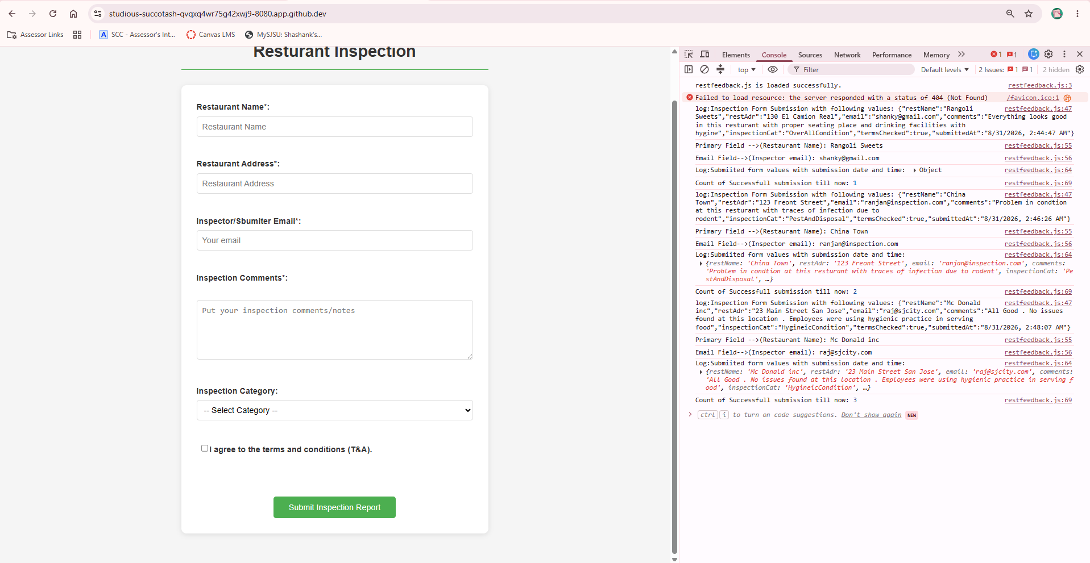
Agentic AI (Part 2)
I have explicitly qwen3:4b instead of qwen3:8b because it was taking lots of time at my laptop and hence decided to use the lower version of the model.

Q1: Command used:
The command I used was
“python agents_demo.py --input nondeterminism_input.json”
This has default temperature of 0.7
And for running with specific temperature of 0.0, I used
python agents_demo.py --input nondeterminism_input.json --temperature 0.0 > reports/hw01/raw/run_00_test.txt
this created report in “reports/hw01/raw/” folder
Questions 2: Console screenshots
Ans:
Here is the screenshot for executing the python file for the agent with final output
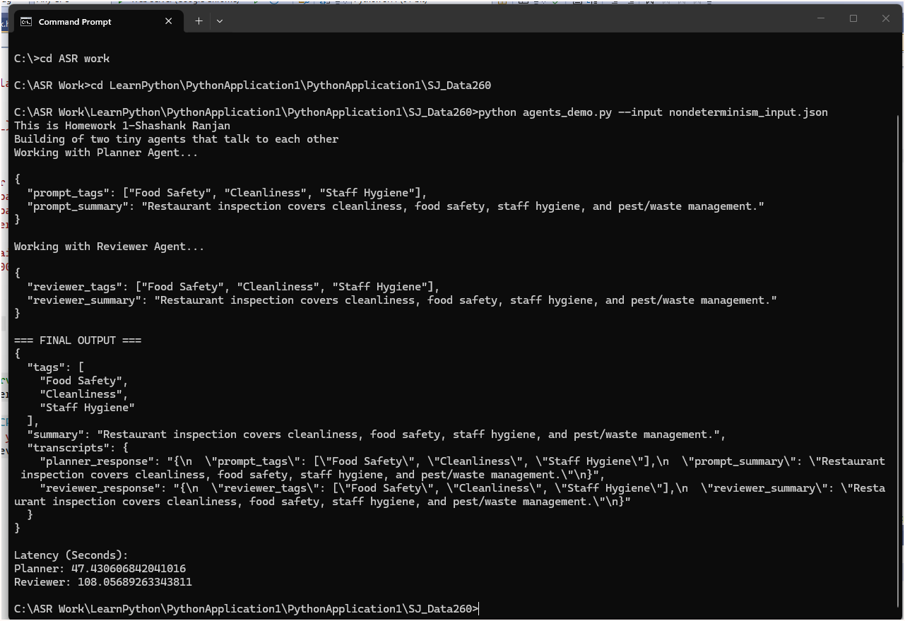
Question 3: Short Ansers (1-2 lines each).
I have executed the above command multiple times, and hence finally printing from the last run
Q1. The 3 final tags you obtained
- Food Safety
- Premises Cleanliness
- Staff Hygiene
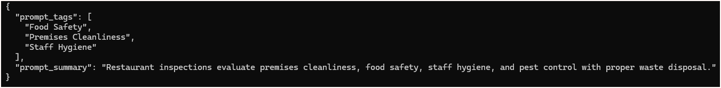
Q2. The final summary (≤ 25 words)
Here is the final summary that I got and I am also showing the screen shot:
“Restaurant inspections evaluate food safety, premises cleanliness, and staff hygiene.”
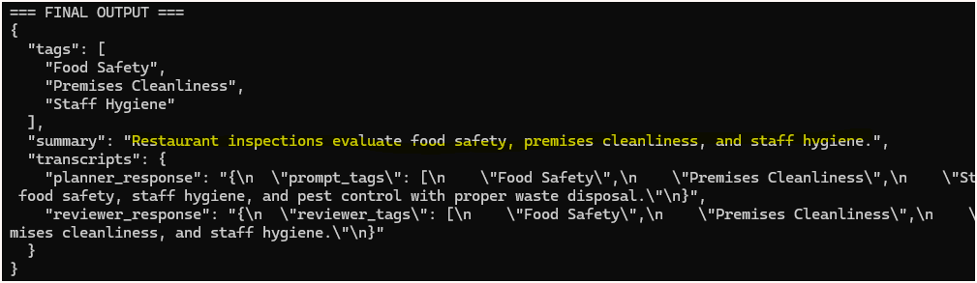
Q3. Did the Reviewer agent change anything?
Yes, the reviewer change the prompt summary though it did not change the tags. The same tags were listed.
Prompt said “"Restaurant inspections evaluate premises cleanliness, food safety, staff hygiene, and pest control with proper waste disposal.”
Reviewer modified it slightly and shortened it to meet the 25 words limit.
Restaurant inspections evaluate food safety, premises cleanliness, and staff hygiene.

Deliverable 4 — Explanation of Each Step (1–2 sentences per step)
Planner Step
The planner agent read my json file with the title and content and generated three domain related tags and provided a summary based on the content.
Reviewer Step
The reviewer parsed the planner’s output and validated the output (now the reviewer’s input) for tags and also the summary’s total length restrictions. It corrected it.
Finalizer Step
The finalizer combined both the Planner and Reviewer’s output (with the correct version based on the requirement) and printed the full transcripts.

Model Client and Token Accounting (Part 4)
In your Report and README,
Q : why is prior conversation context resent with everyturn?
Ans: LLMs are stateless and they don’t remember history. Hence full context is needed to resent to understand continuity.
Q: How is a system prompt different from a user message?
Ans: The system prompt is used for rules for model but user message is to set tasks or questions.
Q: Why do input tokens grow over a conversation?
Ans: Since each inputs are once again fed for continuity and context understanding hence tokens grow over a conversation.

Q What eventually limits that growth?
Ans :The model’s maximm content window is reached, messages must be truncated.

