Hands_on_7:
Task-1:

96. Inspect the generated file in migrations/versions/ — confirm it contains the upgrade() and downgrade() functions.

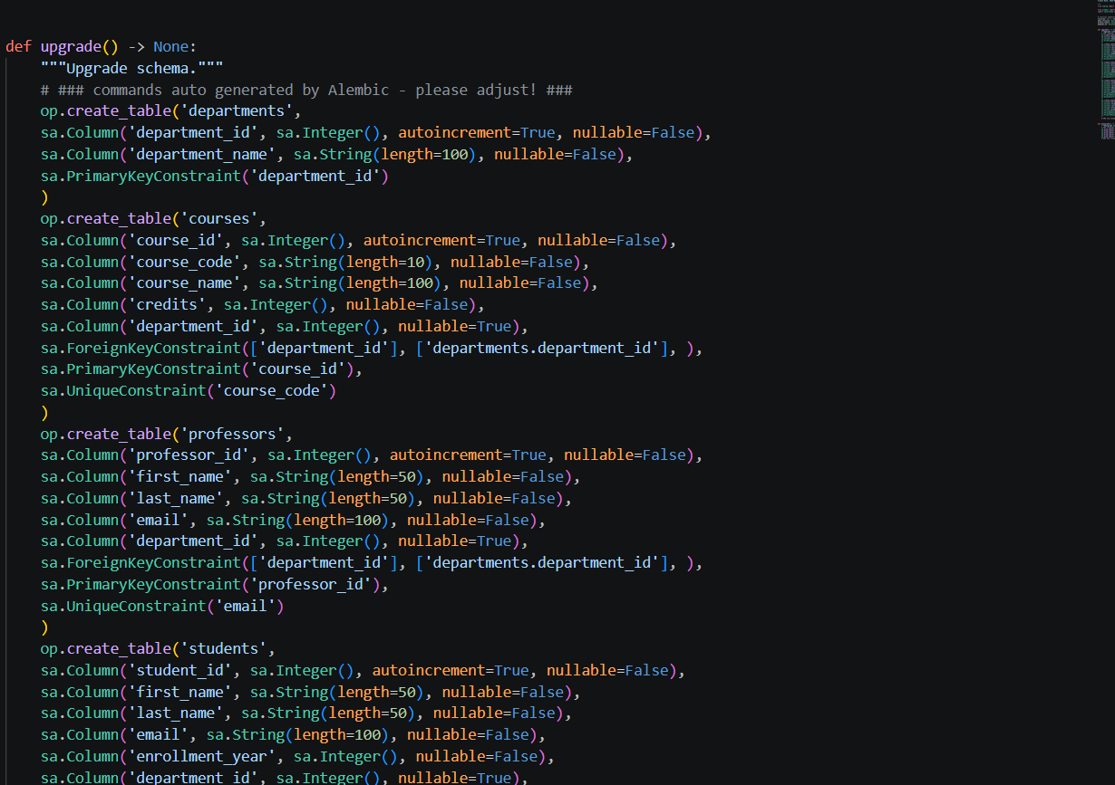

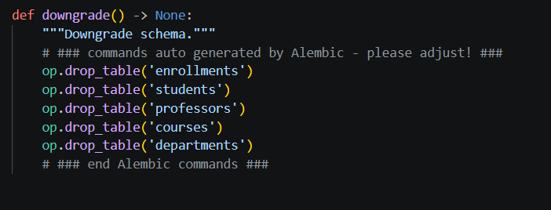

97. Run alembic upgrade head to apply the migration. Verify the alembic_version table is created in your database.

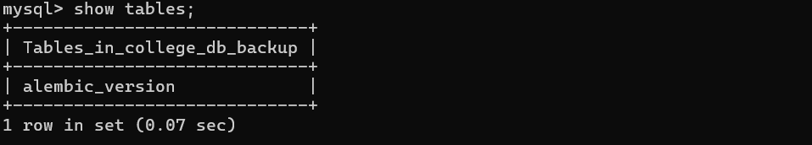

Task 2:

98. In models.py, add a new column is_active BOOLEAN DEFAULT TRUE to the Student model.
99. Run alembic revision --autogenerate -m 'add is_active to students'.
100. Inspect the generated migration — confirm upgrade() adds the column and downgrade() drops it.
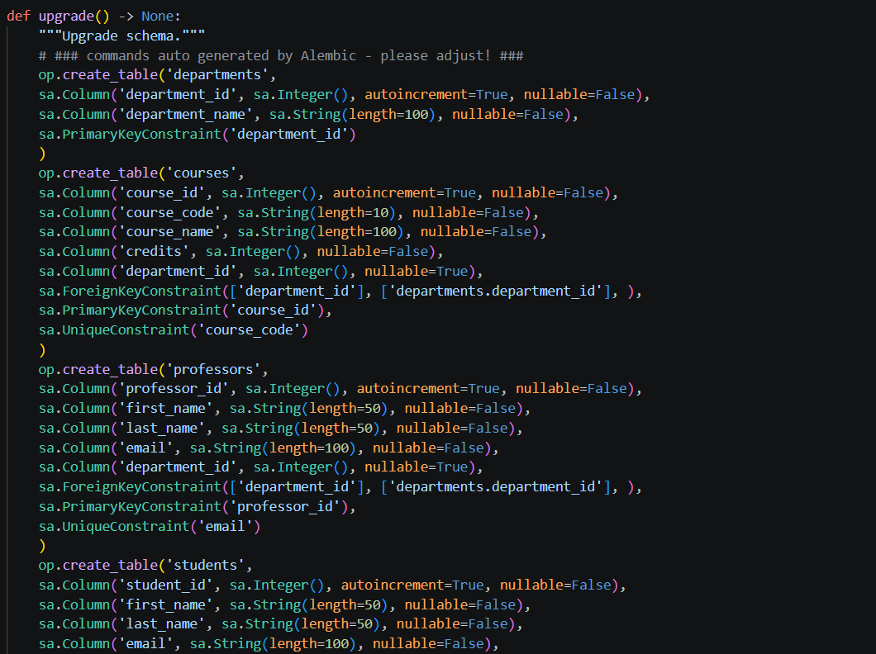

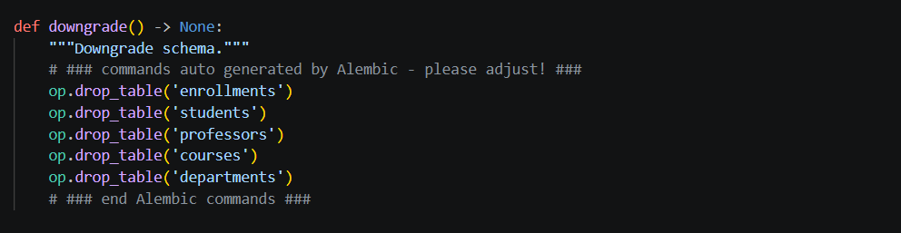

101. Apply with alembic upgrade head. Verify the column exists using your SQL client.

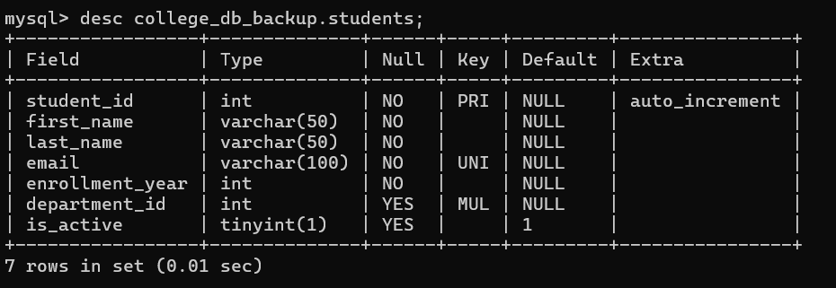

102. Add a new table CourseSchedule with columns: schedule_id, course_id (FK), day_of_week, start_time, end_time. Create the model, generate the migration, and apply it.

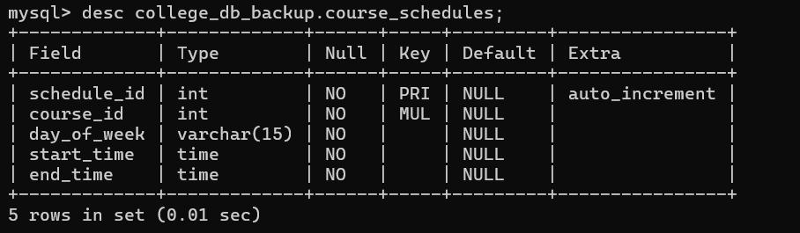

103. Run alembic history --verbose to see the full migration chain.

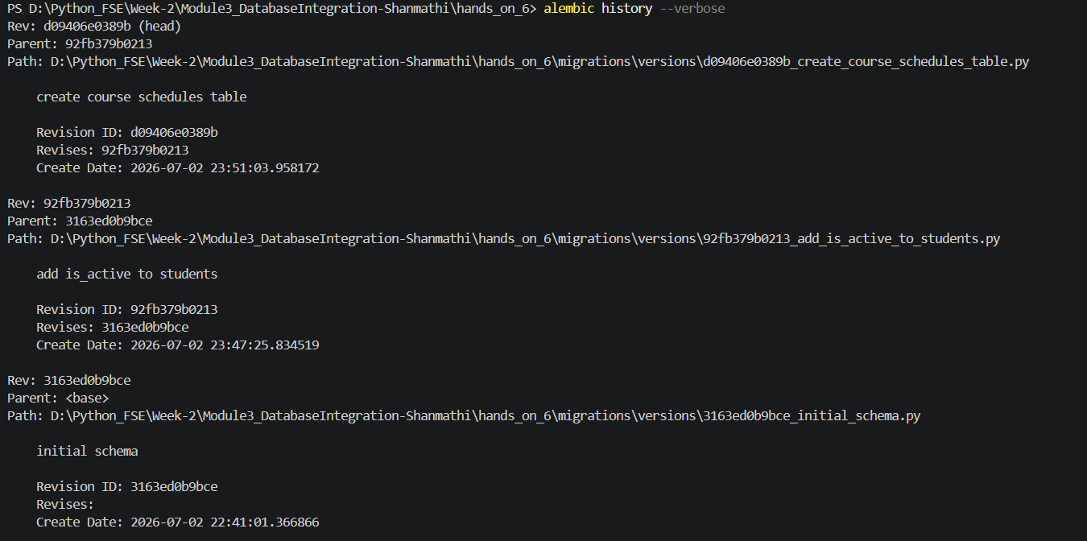

Hands_on_7:
Task-3:

104. Note the current alembic head revision hash using alembic current.

105. Roll back one step using alembic downgrade -1. Confirm the is_active column is dropped.

106. Roll back to the very first revision using alembic downgrade base (this undoes all migrations).
107. Re-apply all migrations with alembic upgrade head and confirm you are back to the latest state.

