Hands_on_5
Task-1

60. In MongoDB Compass or mongosh, create a database named college_nosql.
61. Create a collection named feedback.
62. Insert at least 10 feedback documents following the schema above. Vary ratings (1–5), tags, and
semesters. Include at least 3 documents for CS101 and 2 for CS102.
63. Insert one document that intentionally omits the attachments field.

Inserted document:

db.feedback.insertMany([
{
"course_id": "CS101",
"student_id": "STU001",
"rating": 5,
"comments": "Absolutely loved the practical lab sessions!",
"tags": ["Lab", "Practical"],
"semester": "Fall 2025",
"attachments": ["lab1_submission.pdf"]
},
{
"course_id": "CS101",
"student_id": "STU002",
"rating": 4,
"comments": "Great foundational content, but assignments were quite lengthy.",
"tags": ["Assignments"],
"semester": "Fall 2025",
"attachments": []
},
{
"course_id": "CS101",
"student_id": null, // Anonymous feedback
"rating": 2,
"comments": "The pacing of the lecture loop was much too fast for beginners.",
"tags": ["Pacing", "Lectures"],
"semester": "Spring 2026",
"attachments": ["syllabus_feedback.docx"]
},
{
"course_id": "CS102",
"student_id": "STU003",
"rating": 5,
"comments": "Excellent continuation of CS101. The final project was amazing.",
"tags": ["Project", "Practical"],
"semester": "Spring 2026",
"attachments": ["project_proposal.pdf"]
},
{
"course_id": "CS102",
"student_id": "STU004",
"rating": 3,
"comments": "Good material, but exams did not match up well with homework sets.",
"tags": ["Exams"],
"semester": "Spring 2026",
"attachments": []
},
{
"course_id": "MATH201",
"student_id": "STU001",
"rating": 1,
"comments": "Professor was disorganized and grades were posted incredibly late.",
"tags": ["Grading", "Organization"],
"semester": "Fall 2025",
"attachments": ["grade_appeal.pdf"]
},
{
"course_id": "MATH201",
"student_id": "STU005",
"rating": 4,
"comments": "Difficult content but excellent office hours support.",
"tags": ["Support", "Difficult"],
"semester": "Fall 2025",
"attachments": []
},
{
"course_id": "PHY101",
"student_id": "STU006",
"rating": 4,
"comments": "The virtual simulations helped make abstract concepts clear.",
"tags": ["Simulations", "Lab"],
"semester": "Fall 2025",
"attachments": ["sim_screenshot.png"]
},
{
"course_id": "PHY101",
"student_id": null,
"rating": 3,
"comments": "Midterm was exceptionally brutal, but curve helped out.",
"tags": ["Exams", "Grading"],
"semester": "Spring 2026",
"attachments": []
},
{
// 63. Intentionally omitting the attachments field completely
"course_id": "ENG101",
"student_id": "STU007",
"rating": 5,
"comments": "Fantastic essay reading selections and structured group peer reviews.",
"tags": ["Reading", "Essays"],
"semester": "Spring 2026"
}
]);

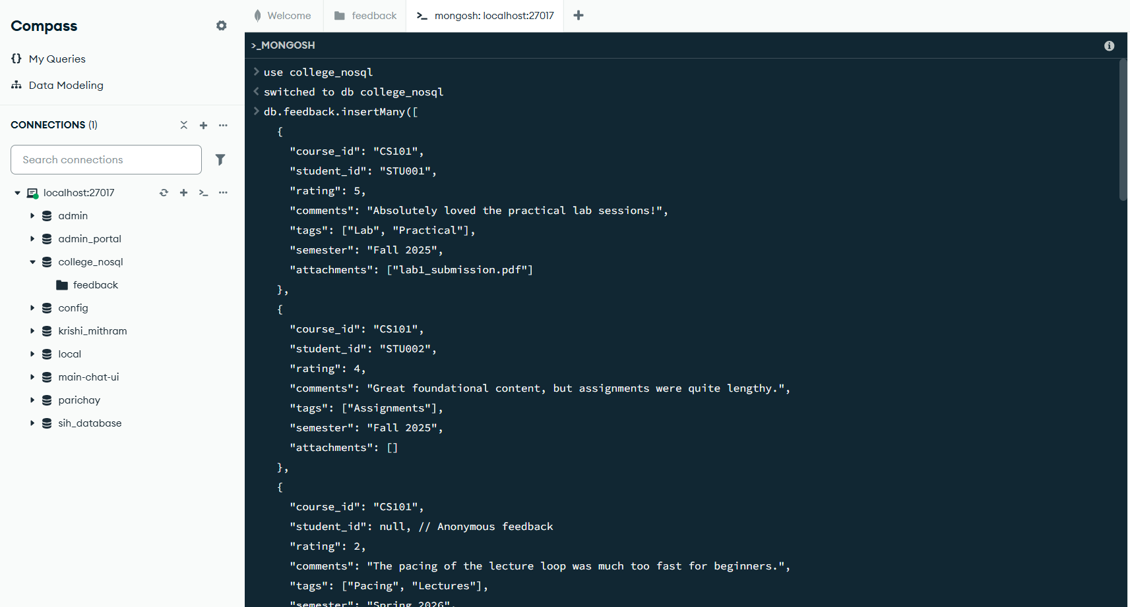

64. Verify the inserts using db.feedback.countDocuments()

db.feedback.countDocuments();
< 10

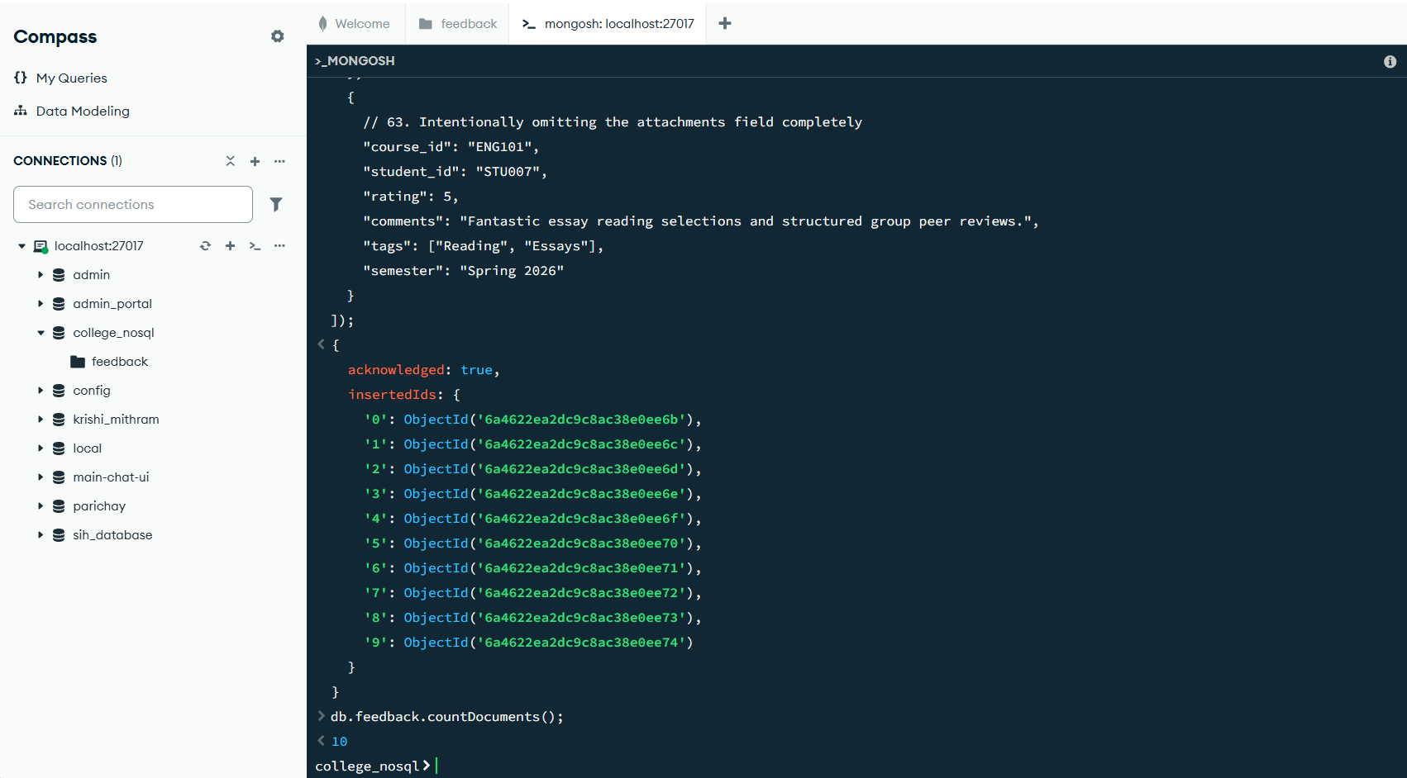

Task-2

65. READ: Find all feedback documents where rating is 5
db.feedback.find({ rating: 5 });

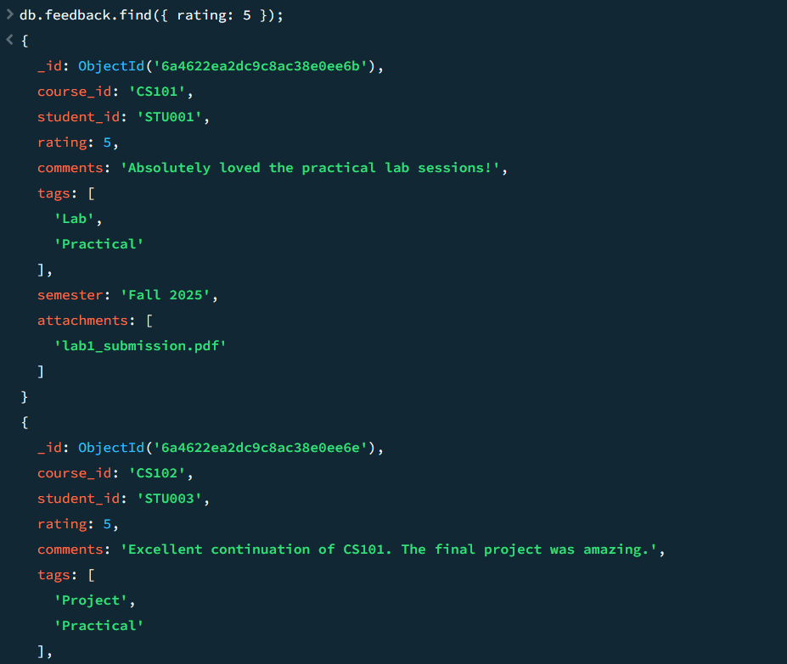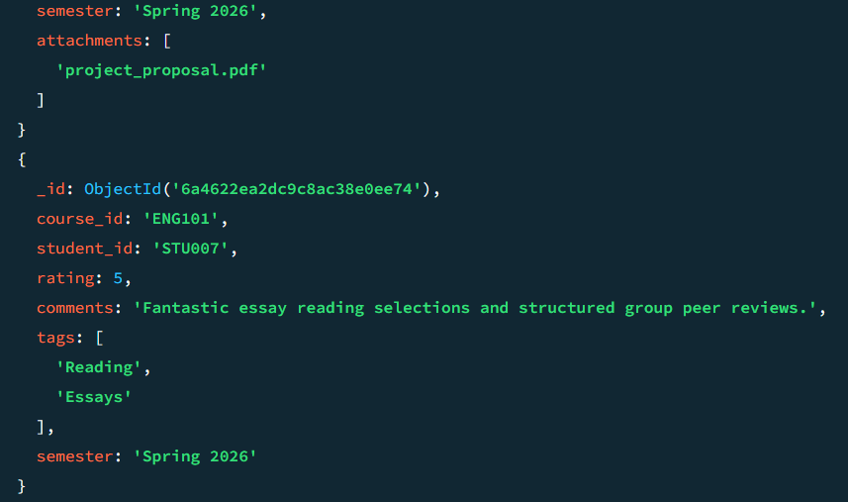
66. READ: Find feedback for course CS101 where the tags array contains 'challenging'
db.feedback.find({ course_id: "CS101", tags: "challenging" });

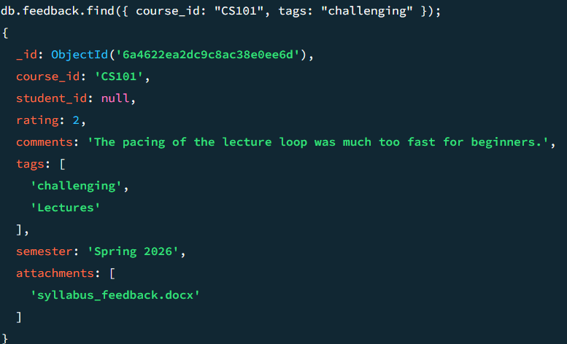

67. READ: Retrieve only the student_id, course_code, and rating fields (projection) for all documents — exclude _id.
db.feedback.find({}, { student_id: 1, course_id: 1, rating: 1, _id: 0 });

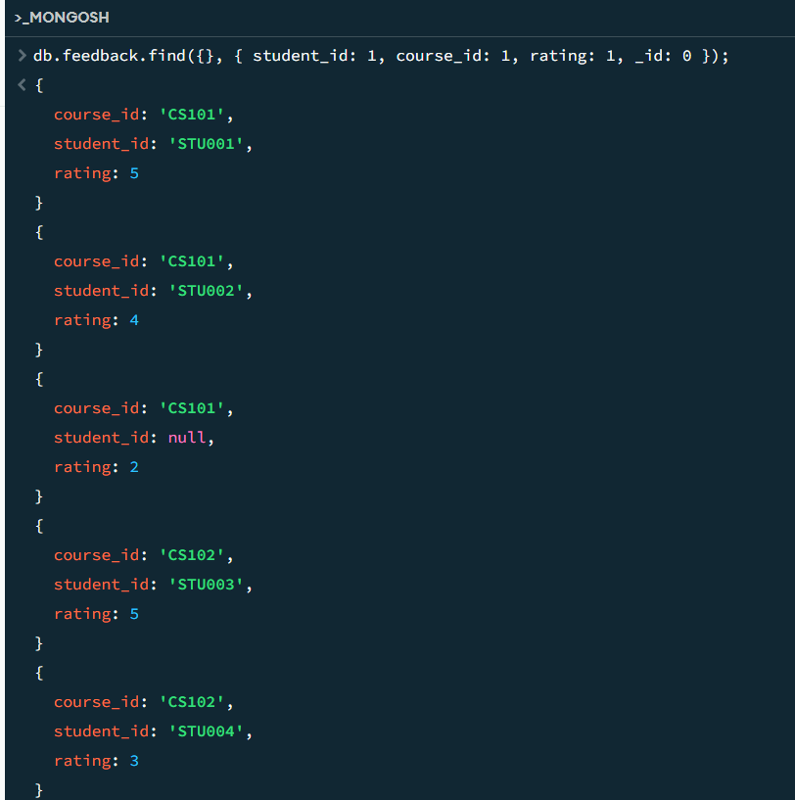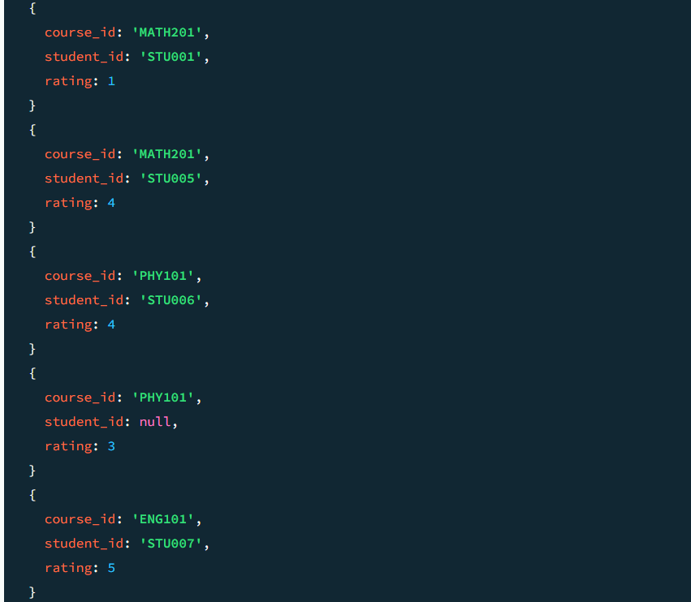

68. UPDATE: For all feedback documents with rating < 3, add a field needs_review: true using updateMany and $set.
db.feedback.updateMany({ rating: { $lt: 3 } }, { $set: { needs_review: true } });

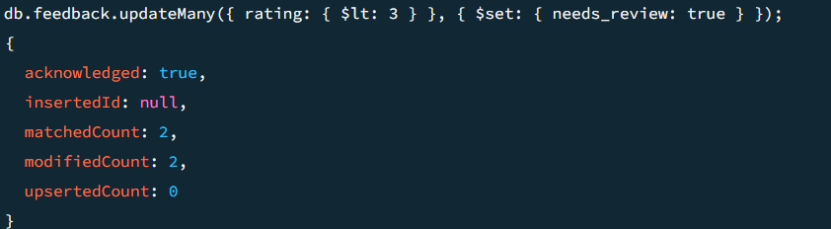

69. UPDATE: Push a new tag 'reviewed' into the tags array of all documents where needs_review is true, using $push.
db.feedback.updateMany({ needs_review: true }, { $push: { tags: "reviewed" } });

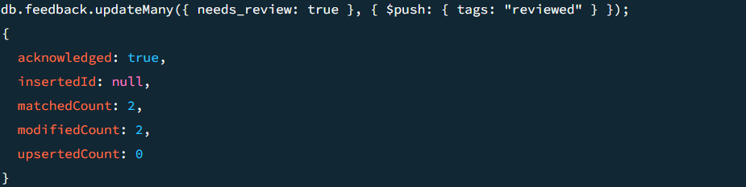

70. DELETE: Delete all feedback documents where the semester is '2021-EVEN'.
db.feedback.deleteMany({ semester: "2021-EVEN" });

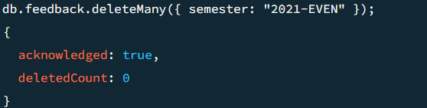

Task-3

71. Write a pipeline that: (Stage 1) filters to semester '2022-ODD'; (Stage 2) groups by course_code calculating average rating and total feedback count; (Stage 3) sorts by average rating descending.
72. Extend the pipeline with a $project stage to rename avg_rating to average_rating and round it to 1 decimal place using $round

db.feedback.aggregate([
// Stage 1
{
$match: { semester: "2022-ODD" }
},

// Stage 2
{
$group: {
_id: "$course_id",
avg_rating: { $avg: "$rating" },
total_feedback: { $sum: 1 }
}
},

// Stage 3 Sort by average rating descending
{
$sort: { avg_rating: -1 }
},

// Stage 4 (72): Project, rename, and round to 1 decimal place
{
$project: {
_id: 0,
course_code: "$_id",
total_feedback: 1,
average_rating: { $round: ["$avg_rating", 1] }
}
}
]);

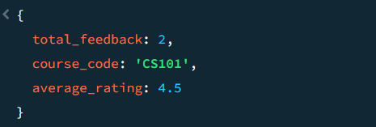

73. Write a pipeline that uses $unwind on the tags array, then $group by tag to count how many times each tag appears. Sort by count descending — a tag frequency leaderboard.
db.feedback.aggregate([
// Stage 1
{
$unwind: "$tags"
},
// Stage 2
{
$group: {
_id: "$tags",
count: { $sum: 1 }
}
},
// Stage 3
{
$sort: { count: -1 }
}
]);

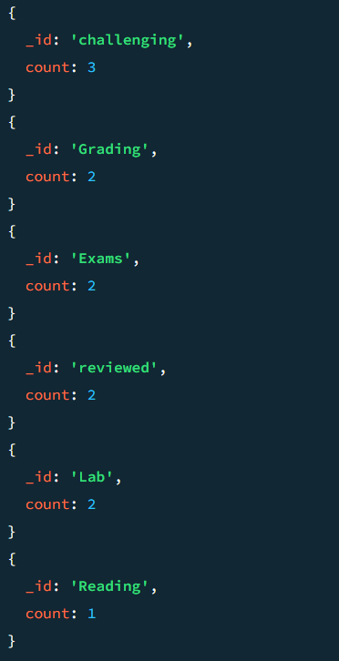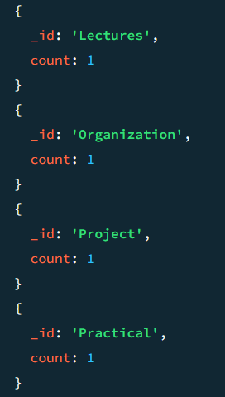

74. Add an index on course_code and verify its usage with
db.feedback.find({course_code:'CS101'}).explain('executionStats') — confirm the stage shows IXSCAN not COLLSCAN.

db.feedback.createIndex({ course_code: 1 });
db.feedback.find({ course_id: "CS101" }).explain("executionStats");

OUTPUT:
{
explainVersion: '1',
queryPlanner: {
namespace: 'college_nosql.feedback',
parsedQuery: {
course_id: {
'$eq': 'CS101'
}
},
indexFilterSet: false,
queryHash: '26E65F6E',
planCacheShapeHash: '26E65F6E',
planCacheKey: '2F0FAD36',
optimizationTimeMillis: 1,
maxIndexedOrSolutionsReached: false,
maxIndexedAndSolutionsReached: false,
maxScansToExplodeReached: false,
prunedSimilarIndexes: false,
winningPlan: {
isCached: false,
stage: 'FETCH',
inputStage: {
stage: 'IXSCAN',
keyPattern: {
course_id: 1
},
indexName: 'course_id_1',
isMultiKey: false,
multiKeyPaths: {
course_id: []
},
isUnique: false,
isSparse: false,
isPartial: false,
indexVersion: 2,
direction: 'forward',
indexBounds: {
course_id: [
'["CS101", "CS101"]'
]
}
}
},
rejectedPlans: []
},
executionStats: {
executionSuccess: true,
nReturned: 3,
executionTimeMillis: 8,
totalKeysExamined: 3,
totalDocsExamined: 3,
executionStages: {
isCached: false,
stage: 'FETCH',
nReturned: 3,
executionTimeMillisEstimate: 0,
works: 4,
advanced: 3,
needTime: 0,
needYield: 0,
saveState: 0,
restoreState: 0,
isEOF: 1,
docsExamined: 3,
alreadyHasObj: 0,
inputStage: {
stage: 'IXSCAN',
nReturned: 3,
executionTimeMillisEstimate: 0,
works: 4,
advanced: 3,
needTime: 0,
needYield: 0,
saveState: 0,
restoreState: 0,
isEOF: 1,
keyPattern: {
course_id: 1
},
indexName: 'course_id_1',
isMultiKey: false,
multiKeyPaths: {
course_id: []
},
isUnique: false,
isSparse: false,
isPartial: false,
indexVersion: 2,
direction: 'forward',
indexBounds: {
course_id: [
'["CS101", "CS101"]'
]
},
keysExamined: 3,
seeks: 1,
dupsTested: 0,
dupsDropped: 0
}
}
},
queryShapeHash: '2880AC1D64C04EF3593124E36E50AF025E3EFFA1E66C1E5F665A7519E6A67ABC',
command: {
find: 'feedback',
filter: {
course_id: 'CS101'
},
'$db': 'college_nosql'
},
serverInfo: {
host: 'LAPTOP-TMIMLNA7',
port: 27017,
version: '8.0.8',
gitVersion: '7f52660c14217ed2c8d3240f823a2291a4fe6abd'
},
serverParameters: {
internalQueryFacetBufferSizeBytes: 104857600,
internalQueryFacetMaxOutputDocSizeBytes: 104857600,
internalLookupStageIntermediateDocumentMaxSizeBytes: 104857600,
internalDocumentSourceGroupMaxMemoryBytes: 104857600,
internalQueryMaxBlockingSortMemoryUsageBytes: 104857600,
internalQueryProhibitBlockingMergeOnMongoS: 0,
internalQueryMaxAddToSetBytes: 104857600,
internalDocumentSourceSetWindowFieldsMaxMemoryBytes: 104857600,
internalQueryFrameworkControl: 'trySbeRestricted',
internalQueryPlannerIgnoreIndexWithCollationForRegex: 1
},
ok: 1
}

