**Test Case 1**

Input: [2,3,6,6,5]

Result:

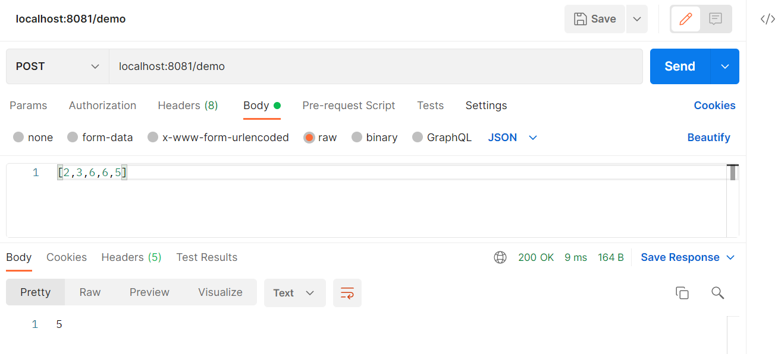

**Test Case 2**

Input: [5,6,23,456,56,478]

Result:

