
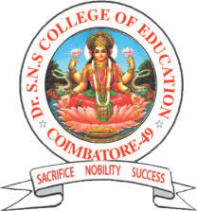
Dr. SNS COLLEGE OF EDUCATION
Accredited by NAAC-UGC with 'A' Grade
Affiliated to Tamil Nadu Teachers Education University
COIMBATORE-641049

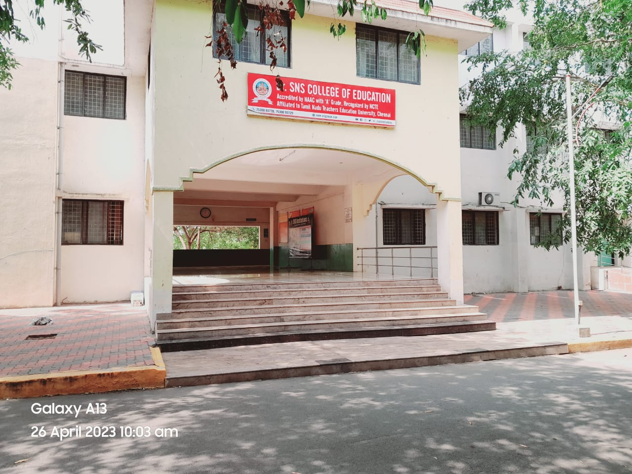

Handbook & Academic Calendar
2025- 2026

Dr. SNS COLLEGE OF EDUCATION
Accredited by NAAC UGC with 'A' Grade
Affiliated to Tamil Nadu Teachers Education University

487, Thudiyalur - Saravanampatti Road, Chinnavedampatti post,
Coimbatore – 641049

Contact us: +91 75300 93728, +91 75300 93729
Website: www.drsnsce.edu.in

PERSONAL INFORMATION
Name : __________________________________

Course : ______________________ Dept. :____________

Date of Birth : _____________________ Age : ____________

Height : ______________________. Weight: ___________

Blood Group : ______________________

Home Address :________________________________________________________
______________________________________________________________________________________________________________________________________________________________________________________________________________
Ph. No. : ______________________ Cell No: _________________

Any other particulars : ______________________________________________________

Guardian/Parent Signature Student Signature

PREFACE

Coimbatore region has been deprived of higher training educational facilities for several decades for rural students; with a sole motto to provide Quality Teacher Education to the students. Many generous persons motivated by their philanthropic urge formed a trust called “Sri SNS Charitable Trust” on 20th Jan 1997 which runs this Institution. The Endeavour of the trust is to provide equal opportunities to the rich and the poor without any discrimination

The trust after careful consideration decided to establish “Dr.SNS College of Education” and submitted the application to the National Council for Teacher Education (NCTE), Bangalore on 2007, requesting approval for the establishment of a new Educational College in the name of Dr.SNS College of Education (Dr.SNSCE) from the academic year 2007 –2008 with one year B.Ed., Programme. With a sanctioned intake of 100 students and 8 faculty members, the college had a steady growth and today it offers a Two Year B.Ed Programme with the intake of two units (100 students) and 16 faculty members.

Dr. SNS College of Education is one of the best Co-Educational Self- financing Colleges affiliated to Tamil Nadu Teachers Education University, Chennai -05. It has been recognized by the NCTE, Bangalore and accredited with NAAC ‘A ’Grade by UGC, obtained (2f) Status by UGC.

Excellence in Leadership

The Sri SNS Charitable Trust boasts of highly educated and qualified members who are at the helm of affairs. The Founder Chairman of the Trust, Deiva Thiru Dr. S. N. Subbramanian is a dynamic Industrialist cum Educationist with very high qualifications and an IITian too. His qualifications are B.Tech.,M.Tech., Ph.D., MBA., M.Phil, PhD., who is also the Chairman of the Governing Council of the College constituted.
Dr. S. Rajalakshmi, B.Sc., M.B.B.S. DGO is the Chairman/Correspondent of the Sri SNS Charitable Trust and takes care of the entire finance, administration of the Trust, addresses all the infrastructural needs of the College and supports the leaders in achieving their goals. She is also a member of the College Governing Council.
Dr. S. Nalin VimalKumar., B.E., M.S., (USA) PhD (USA) facilitates the role of Technical Director, who guides the team to set inspirational vision for the Institute by globally exploring emerging trends.

Our College
Dr. SNS College of Education, started in the academic year 2007-2008 is one of the best Co-Educational self-financing Colleges affiliated to Tamil Nadu Teachers Education University, Chennai -05. It has been recognized by the NCTE, Bangalore, Accredited with NAAC ‘A ’Grade by UGC, obtained (2f) Status by UGC. It is located on the Thudiyalur- Saravanampatti Road, a few kilometers away from Coimbatore city. It is housed in a majestic and imposing building with all infrastructural facilities.
MOTTO
Sacrifice Nobility Success
VISION
To be an excellent Institution to mould noble teachers with high thinking, sound knowledge and healthy virtues to be a beacon light to the learners.
MISSION
- To teach the learners to realize their potentialities and power within them
- To teach the student teachers that learning is an endless process and curiosity leads one to learn new things
- To teach the student teachers that knowledge is a valuable treasure to be shared by all
- To inculcate among the learner’s humanism, perseverance, tolerance, ethical and moral values
- To mould the student teachers into worthy citizens and upright leaders

VALUES
- Accepting the importance of learning
- Encouraging curiosity and the questioning mind
- Motivating and rewarding effort and achievement
- Promoting logical and critical thinking based on evidence
- Recognizing the partnership between school, home and community in education
- Seeing education as a lifelong process

OBJECTIVES
To Maintain Quality Enhancement in terms of Teaching, Learning,
EXTENSION ACTIVITIES AND RESEARCH
To promote among the students, the spirit of serving the Society/Country

Rules and Regulations for Students
Attendance
Attendance in the college is compulsory. A student must put in a minimum of 85% attendance to be eligible for the TNTEU degree examinations. The absence of a student for any single hour in a session in a day would result in the loss of attendance for half a day.
The duration of the B.Ed. Course shall be for one academic year consisting of 200 working days /curriculum transaction days. It is strictly instructed that the students who do not earn required attendance will not be permitted to write the university examination. Internal marks will not be given for students who have shortage of attendance. Such students have to repeat the course by rejoining afresh at the succeeding years, if they wish to complete the B.Ed degree course.
Conduct
Every student should be dressed modestly and decently. Students are required to help in keeping the college campus and the classroom clean and tidy. With a view to bring about intimate association between students and teachers, each student is assigned to a member of the teaching staff who will be her tutor for guidance and counseling..
Campus facilities and student amenities
In order to facilitate better learning the college has provision for Multi Media Projectors. The classrooms are provided with LCD Projectors,. To facilitate the young teachers to the modern trends in teaching, annual seminars and workshops in each subject are arranged and eminent scholars and experts in each field participate in them. The college is proud of its state of the Multipurpose hall fitted with the latest electronic systems.

Library
- Perfect silence should be observed in the library.
- Except on Sunday and other Public holidays library would be kept open on all the other days from 9.00 a.m to 5.30 p.m
- Students will be allowed to borrow two books at a time for a period of two week.
- If the book is not returned on due date, a fine of Rs. 1/-is collected per day.
- Marking in books or writing in them is strictly forbidden.
- A book lost or damaged shall be replaced by a new copy of the same book within a month from the due date by the borrower.
- A book may be renewed for a second time provided no other application for the book is pending.
- Reference books can be consulted only in the library.
- All books must be returned for annual stock taking Students are advised to contact the Librarian for any assistance.
- A Suggestion Book is available with the Librarian and students may write their suggestions for improvement.

Dr. SNS COLLEGE OF EDUCATION, COIMBATORE – 641 049
List of Working Days for the Academic Year 2025- 2026

JULY -2025
Date | Day | Event | No. of working days
 |  |  | II Year | I Year
1 | TUE
2 | WED
3 | THU | International Plastic Bag Free Day
4 | FRI
5 | SAT
6 | SUN | Muharram Holiday
7 | MON
8 | TUE
9 | WED
10 | THU
11 | FRI
12 | SAT
13 | SUN | Holiday Martyrs' Day
14 | MON | Holiday
15 | TUE | World Youth Skill Day
16 | WED
17 | THU
18 | FRI
19 | SAT
20 | SUN | Holiday
21 | MON
22 | TUE
23 | WED
24 | THU
25 | FRI
26 | SAT
27 | SUN | Holiday
28 | MON | World National Conversation Day
29 | TUE
30 | WED
31 | THU

"The art of teaching is the art of assisting discovery."
— Mark Van Doren

AUGUST -2025
Date | Day | Event | No. of working days
 |  |  | II Year | I Year
1 | FRI | II Year School Internship Begins
2 | SAT
3 | SUN | Holiday
4 | MON
5 | TUE
6 | WED
7 | THU
8 | FRI
9 | SAT
10 | SUN | Holiday
11 | MON
12 | TUE | International Youth Day
13 | WED
14 | THU
15 | FRI | INDEPENDENCE DAY
16 | SAT | Krishna Jayanthi
17 | SUN | Holiday
18 | MON
19 | TUE
20 | WED
21 | THU
22 | FRI
23 | SAT
24 | SUN | Holiday
25 | MON
26 | TUE
27 | WED | Vinayakar Chathurthi
28 | THU
29 | FRI | National Sports Day
30 | SAT
31 | SUN | Holiday

"Teaching is the one profession that creates all other professions."
— Unknown (widely quoted in teacher education)

SEPTEMBER -2025
Date | Day | Event | No. of working days
 |  |  | II Year | I Year
1 | MON
2 | TUE | National Nutrition Week
3 | WED
4 | THU
5 | FRI | Milad-un-Nabi ,Teachers Day
6 | SAT
7 | SUN | Holiday
8 | MON | World Literacy Day-Holiday
9 | TUE
10 | WED
11 | THU
12 | FRI
13 | SAT
14 | SUN | Holiday
15 | MON
16 | TUE
17 | WED
18 | THU
19 | FRI
20 | SAT
21 | SUN | Holiday
22 | MON
23 | TUE
24 | WED
25 | THU
26 | FRI | World Environmental Health Day
27 | SAT
28 | SUN | Holiday
29 | MON
30 | TUE

"It is the supreme art of the teacher to awaken joy in creative expression and knowledge."
— Albert Einstein

OCTOBER -2025
Date | Day | Event | No. of working days
 |  |  | II Year | I Year
1 | WED | Ayutha Pooja
2 | THU | Gandhi Jayanthi, Vijaya Dasami
3 | FRI
4 | SAT
5 | SUN | Holiday
6 | MON
7 | TUE
8 | WED
9 | THU
10 | FRI
11 | SAT | International Girl Child Day
12 | SUN | Holiday
13 | MON
14 | TUE
15 | WED
16 | THU | World Food Day
17 | FRI
18 | SAT
19 | SUN | Holiday
20 | MON | Diwali
21 | TUE
22 | WED
23 | THU
24 | FRI
25 | SAT
26 | SUN | Holiday
27 | MON | Test No. 1 Begins- I Year
28 | TUE
29 | WED
30 | THU
31 | FRI | Test No. 1 Ends - I Year

"Tell me and I forget, teach me and I may remember, involve me and I learn."
— Benjamin Franklin

NOVEMBER -2025
Date | Day | Event | No. of working days
 |  |  | II Year | I Year
1 | SAT
2 | SUN | Holiday
3 | MON
4 | TUE
5 | WED
6 | THU
7 | FRI | World Cancer Awareness Day
8 | SAT | State Level Workshop
9 | SUN | Holiday
10 | MON
11 | TUE | National Education Day
12 | WED
13 | THU
14 | FRI | Children’s Day & World Diabetes Day
15 | SAT
16 | SUN | Holiday
17 | MON | Test No. 2 Begins - I Year
18 | TUE
19 | WED
20 | THU
21 | FRI | Test No. 2 Ends - I Year
22 | SAT
23 | SUN | Holiday
24 | MON
25 | TUE
26 | WED
27 | THU
28 | FRI
29 | SAT
30 | SUN | Holiday Flag Day

"Education is not the filling of a pail, but the lighting of a fire."
— William Butler Yeats

DECEMBER -2025
Date | Day | Event | No. of working days
 |  |  | II Year | I Year
1 | MON | World AIDS Day-Holiday
2 | TUE
3 | WED
4 | THU
5 | FRI
6 | SAT
7 | SUN | Holiday
8 | MON
9 | TUE
10 | WED | Human Rights Day
11 | THU | Bharathiar Birthday
12 | FRI
13 | SAT
14 | SUN | International Energy conservation Day  Holiday
15 | MON
16 | TUE
17 | WED
18 | THU
19 | FRI
20 | SAT
21 | SUN | Holiday
22 | MON
23 | TUE
24 | WED | National Consumer Rights Day
25 | THU | CHRISTMAS
26 | FRI
27 | SAT
28 | SUN | Holiday
29 | MON
30 | TUE
31 | WED

"A good teacher can inspire hope, ignite the imagination, and instill a love of learning."
— Brad Henry

JANUARY -2026
Date | Day | Event | No. of working days
 |  |  | II Year | I Year
1 | THU | NEW YEAR
2 | FRI
3 | SAT
4 | SUN
5 | MON | I Internal Exam Begins- I Year
6 | TUE
7 | WED
8 | THU
9 | FRI | I Internal Exam Ends - I Year
10 | SAT
11 | SUN
12 | MON
13 | TUE | -
14 | WED | Pongal
15 | THU | Thiruvalluvar Day
16 | FRI
17 | SAT
18 | SUN
19 | MON | II Internal Exam Begins- I Year
20 | TUE
21 | WED
22 | THU
23 | FRI | II Internal Exam Ends- I Year
24 | SAT
25 | SUN | -
26 | MON | Republic Day
27 | TUE | -
28 | WED
29 | THU
30 | FRI
31 | SAT

"What the teacher is, is more important than what he teaches."
— Karl Menninger

FEBRUARY -2026
Date | Day | Event | No. of working days
 |  |  | II Year | I Year
1 | SUN | Holiday
2 | MON | Model Exam Begins- I Year
3 | TUE
4 | WED
5 | THU
6 | FRI | Model Exam Ends - I Year
7 | SAT
8 | SUN | Holiday
9 | MON | Test No. 1 begins for II Year ,
10 | TUE | World Pulses Day
11 | WED
12 | THU
13 | FRI | Test No. 1 Ends for II Year
14 | SAT
15 | SUN | Holiday
16 | MON
17 | TUE
18 | WED
19 | THU
20 | FRI
21 | SAT | World Mother Tongue day
22 | SUN | Holiday
23 | MON
24 | TUE
25 | WED
26 | THU
27 | FRI
28 | SAT

"Education is the most powerful weapon which you can use to change the world."
— Nelson Mandela

MARCH -2026
Date | Day | Event | No. of working days
 |  |  | II Year | I Year
1 | SUN | Holiday
2 | MON | Test No. 2 begins for II Year
3 | TUE
4 | WED | National Safety Day
5 | THU
6 | FRI | Test No. 2 Ends for II Year
7 | SAT
8 | SUN | Holiday ,Women’s Day
9 | MON
10 | TUE
11 | WED
12 | THU
13 | FRI | National Level Conference
14 | SAT | Pi Day
15 | SUN | Holiday, World Consumer Rights Day
16 | MON
17 | TUE | Holiday
18 | WED
19 | THU | Ugadi
20 | FRI
21 | SAT | Ramazan
22 | SUN | Holiday
23 | MON
24 | TUE
25 | WED
26 | THU
27 | FRI
28 | SAT | National Science Day
29 | SUN
30 | MON
31 | TUE | Holiday

"The roots of education are bitter, but the fruit is sweet."
— Aristotle

APRIL -2026
Date | Day | Event | No. of working days
 |  |  | II Year | I Year
1 | WED
2 | THU | World Autism Awareness Day
3 | FRI | Good Friday
4 | SAT
5 | SUN | Holiday
6 | MON | I Internal Exam Begins for II Year
7 | TUE | World Health Day
8 | WED
9 | THU
10 | FRI | I Internal Exam Ends for II Year
11 | SAT
12 | SUN | Holiday
13 | MON
14 | TUE
15 | WED
16 | THU
17 | FRI
18 | SAT | World Heritage Day
19 | SUN | Holiday
20 | MON
21 | TUE | II Internal Exam Begins for II Year
22 | WED | World Earth Day
23 | THU
24 | FRI
25 | SAT | II Internal Exam Ends for II Year
26 | SUN | Holiday
27 | MON
28 | TUE
29 | WED
30 | THU | Annual Day

- "An investment in knowledge pays the best interest."
— Benjamin Franklin

MAY -2026
Date | Day | Event | No. of working days
 |  |  | II Year | I Year
1 | FRI | International Workers Day
2 | SAT
3 | SUN | Holiday
4 | MON
5 | TUE
6 | WED
7 | THU
8 | FRI | World Red Cross Day
9 | SAT
10 | SUN | Holiday
11 | MON | Model Exam Begins for II Year
12 | TUE
13 | WED
14 | THU
15 | FRI | Model Exam Ends for II Year
16 | SAT
17 | SUN | Holiday
18 | MON
19 | TUE
20 | WED
21 | THU
22 | FRI | International Day for Biological Diversity
23 | SAT
24 | SUN | Holiday
25 | MON
26 | TUE
27 | WED
28 | THU
29 | FRI
30 | SAT
31 | SUN | Holiday ,World Anti-Tobacco Day

- "The aim of education is the knowledge not of facts but of values."
— William Ralph Inge

JUNE -2026
Date | Day | Event | No. of working days
 |  |  | II Year | I Year
1 | MON
2 | TUE
3 | WED
4 | THU
5 | FRI
6 | SAT
7 | SUN | Holiday
8 | MON
9 | TUE
10 | WED
11 | THU
12 | FRI
13 | SAT
14 | SUN | Holiday
15 | MON
16 | TUE
17 | WED
18 | THU
19 | FRI
20 | SAT
21 | SUN | Holiday
22 | MON
23 | TUE
24 | WED
25 | THU
26 | FRI
27 | SAT
28 | SUN | Holiday
29 | MON
30 | TUE

“Develop a passion for learning. If you do, you will never cease to grow.” – Anthony J. D’Angelo

