# Swag Labs Test Automation Framework

## Overview

This project automates the testing of the Swag Labs e-commerce website. The framework is developed using **Selenium WebDriver**, **Java**, and **TestNG**, and the project is managed using **Maven**.

# Using GitHub and Git bash:

* GitHub repository url - <https://github.com/ShanmugaPriyaAlagarsamy/swaglab.git>

## Prerequisites

Before you proceed, ensure that the following are installed on your system:

1. **Java Development Kit (JDK 8 or later)**: Make sure JAVA_HOME is set correctly.
2. **JRE version 1.8 or higher.**
3. **Maven**: To manage dependencies and run the tests.
4. **Git**: To clone the project repository.
5. **Browser Driver**: Chrome Driver,
6. **To run cross browser testing:** Firefox Driver, Edge Driver

## Cloning the Project from GitHub

To clone the project repository, follow these steps:

1. Open **Git Bash** on your system.
2. Navigate to the directory where you want to clone the project:

* cd path/to/your/directory

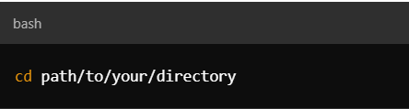

1. Clone the GitHub repository:

* git clone <https://github.com/ShanmugaPriyaAlagarsamy/swaglab.git>

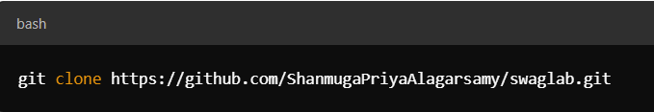

1. Navigate into the project directory:

* cd swaglab

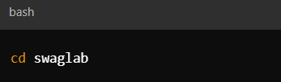

## Installing Dependencies

Once the project is cloned, install the dependencies using **Maven**:

1. In **Git Bash**, run the following command to clean and install dependencies:

* mvn clean install

This will download all the required dependencies and build the project.

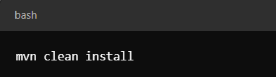

## Running the Tests

To execute the automated test cases using **Maven** and **Git Bash**, follow these steps:

1. **Run all tests**:

* mvn test

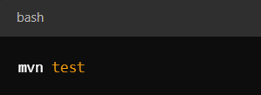

1. **Run specific test cases**:

* mvn -Dtest=TestClassName test

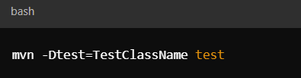

Example:

* mvn -Dtest=TC001_VerifyLoginFunctionalityWithAcceptedUsernamesAndPassword test

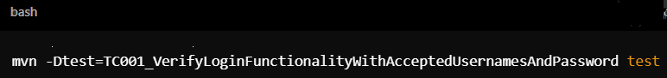

## Viewing Test Reports

* After the test execution, the test report will automatically open on your desktop for review.
* After the test execution, You can also view the detailed test report in swaglab/reports folder.

**in the project directory.**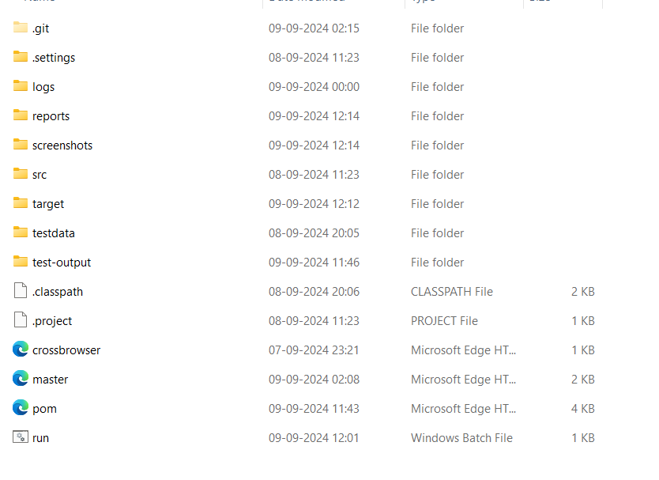

* Open the generated HTML Test reports to view detailed test results.

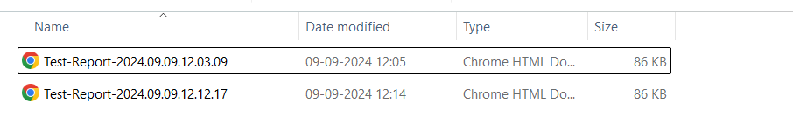

## Configuring the Browser Driver

Ensure that you have the correct browser driver installed for running the tests.

For example:

* **ChromeDriver**: Download from ChromeDriver Downloads.
* **GeckoDriver**: Download from [GeckoDriver Releases](https://github.com/mozilla/geckodriver/releases).

Update the driver path in the config.properties file or add it to your system environment path.

## Troubleshooting

If you encounter any issues with running the tests, ensure that:

* The **Java** and **Maven** paths are correctly set in the environment variables.
* The browser driver is set up correctly and matches the browser version

# **2.Using Eclipse:**

## Prerequisites

Before you proceed, ensure that the following are installed on your system:

1. **Java Development Kit (JDK 8 or later)**: Make sure JAVA_HOME is set correctly.
2. **Maven**: To manage dependencies and run the tests.
3. **Git**: To clone the project repository.
4. **Eclipse IDE**: Set up with **TestNG** plugin.
5. **Browser Driver**: ChromeDriver, GeckoDriver, EdgeDriver,FireFox Driver

## Cloning the Project from GitHub

To clone the project repository, follow these steps:

1. Open **Git Bash** on your system.

1. Navigate to the directory where you want to clone the project:

* cd path/to/your/directory



1. Clone the GitHub repository:

* git clone <https://github.com/ShanmugaPriyaAlagarsamy/swaglab.git>



1. Navigate into the project directory:

* cd swaglab

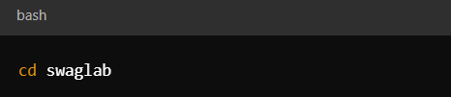

## Importing the Project into Eclipse

1. Open **Eclipse IDE**.
2. Go to **File** > **Import** > **Maven** > **Existing Maven Projects**.
3. In the **Root Directory**, browse to the location where you cloned the project and click **Finish**.
4. **Maven** will automatically download the required dependencies and build the project.

## Installing TestNG Plugin in Eclipse

1. In **Eclipse**, go to **Help** > **Eclipse Marketplace**.
2. In the search box, type **TestNG** and install the TestNG plugin.
3. After installation, restart **Eclipse** to apply the changes.

## Running the Test Cases Using TestNG XML in Eclipse

1. After importing the project, navigate to the **master.xml** file located in the project directory.
2. Right-click on the **master.xml file** and select **Run As** > **TestNG Suite**.
3. The TestNG framework will execute the test cases defined in the master.xml file.
4. You can view the results in the **TestNG** tab and the **Console** output.

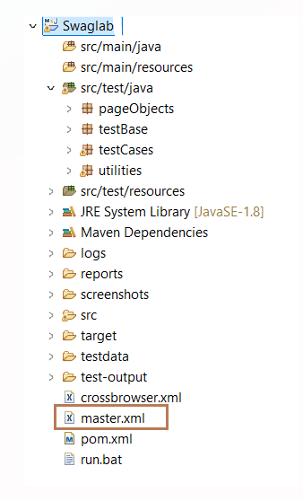

## Viewing Test Reports

* After the test execution, the test report will automatically open on your desktop for review.
* After the test execution, You can view the detailed test report in the swaglab/extent-reports folder the test reports are generated in the swaglab/reports folder.

