Course: CS634 - 002

Professor: Jason Wang

Student: Shanmuga Sankar Balamurugan

UCID: sb387

Email: [sb387@njit.edu](mailto:sb387@njit.edu)

Subject: Mid-Term Project Report

Topic: Association Rule Mining

**ASSOCIATION RULE MINING ALGORITHMS**



Contents

1. Introduction 4

2. Description 4

2.1. Apriori Algorithm 4

2.2. Brute Force Algorithm 4

2.3. Database 4

3. Input Databases 4

3.1. Database 1 4

3.2. Database 2 5

3.3. Database 3 5

3.4. Database 4 6

3.5. Database 5 6

4. Apriori Algorithm 7

4.1. Import Libraries 7

4.2. Read Data Function 7

4.3. Frequency Function 7

4.4. Support Function 8

4.5. Confidence Function 9

4.6. Apriori Algorithm Function 9

5. Brute Force Algorithm 11

5.1. Import Libraries 11

5.2. Read Data Function 11

5.3. Frequency Function 11

5.4. Support Function 12

5.5. Confidence Function 13

5.6. Brute Force Algorithm Function 14

6. Results 15

6.1. Apriori vs. Brute Force – Database 1 15

6.1.1. Apriori Results 15

6.1.2. Brute Force Results 16

6.2. Apriori vs Brute Force – Database 2 17

6.2.1. Apriori Results 17

6.2.2. Brute Force Results 18

6.3. Apriori vs. Brute Force – Database 3 19

6.3.1. Apriori Results 19

6.3.2. Brute Force Results 20

6.4. Apriori vs. Brute Force – Database 4 21

6.4.1. Apriori Results 21

6.4.2. Brute Force Results 22

6.5. Apriori vs Brute Force – Database 5 23

6.5.1. Apriori Results 23

6.5.2. Brute Force Results 24

7. Conclusion 24

# Introduction

The goal of the project is to apply and compare association rule technique such as Apriori algorithm against Brute Force algorithm, to determine efficiency as a matter of time, i.e., how much faster is Apriori to Brute Force algorithm.

# Description

## Apriori Algorithm

Find the sets which meet minimum support requirement, starting from 1-itemsets to k-itemsets; if j-itemset is not frequent we do not need to consider any of its supersets. The identified frequent sets are used to generate association rules.

## Brute Force Algorithm

Generate all 1-itemsets and 2-itemsets and check if they are frequent. Then generate 3-itemsets; follow this procedure to generate k-itemsets, and flag all that meets the minimum support requirement during the entire process. These frequent sets are used to generate association rules.

## Database

We create five databases in a csv file format, each with 20 transactions containing between 15-20 items (overall 30 unique items), commonly seen on platforms such as Amazon, K-Mart, etc. This transaction data is used as input on which our algorithms are applied. We limit the no. items per database as execution of Brute Force algorithm is not feasible; we are more interested in executing Apriori and comparing their efficiencies.

# Input Databases

The images of the five databases with 20 transactions with 15-20 items will be found below.

## Database 1

## Database 2

## Database 3

## Database 4

## Database 5

# Apriori Algorithm

The code written for the executing Apriori Algorithm.

## Import Libraries

List of packages used in the program

|  |
| --- |
| **import** pandas **as** pd  **import** numpy **as** np  **from** itertools **import** chain**,**combinations  **import** time |

## Read Data Function

Function to read the csv file containing transaction data

|  |
| --- |
| **def** readData**(**path**):**  '''  Function to read csv file containing the transactions    Parameters:-  path - Location of the input file    '''  transactionData **=** pd**.**read_csv**(**path**,** header **=** **None)**  **return** transactionData |

## Frequency Function

Function to identify the frequent 1-itemsets in the data

|  |
| --- |
| **def** frequency**(**transactionData**,**support**):**  '''Fucntion to determine the frequent items in the transaction database    Parameters:-  transactionData - Single column dataframe containing all the transactions  support - User determined support level for generating itemsets    '''    ## Extract transaction information from dataframe to a list  Transactions **=** **[]**  **for** i **in** **range(len(**transactionData**)):**  Transactions**.**append**(**transactionData**[**0**][**i**].**split**(**","**))**    ## Initialize dictionaries to store frequent itemsets  FrequentItemSets **=** **{}**  AprioriResults **=** **{}**    ## Calculate total no. of occurrences of items among all transactions  **for** i**,**items **in** **enumerate(**Transactions**):**  **for** j **in** **range(len(**items**)):**  **if** items**[**j**]** **in** FrequentItemSets**:**  FrequentItemSets**[**items**[**j**]]** **+=** 1  **else:**  FrequentItemSets**[**items**[**j**]]** **=** 1  association **=** **[]**  nonFrequent **=** **[]**    ## Assign items to the lists depending on whether they meet the minimum support  **for** i **in** FrequentItemSets**:**  **if** FrequentItemSets**[**i**]/len(**Transactions**)** **>=** support**:**  association**.**append**(**i**)**  **else:**  nonFrequent**.**append**(**i**)**    ## Delete all items which do not meet the minimum support requirement  **for** i **in** nonFrequent**:**  **del** FrequentItemSets**[**i**]**  n_combinations **=** **list(**combinations**(**association**,**2**))**  **return** n_combinations**,**Transactions**,**FrequentItemSets**,**AprioriResults |

## Support Function

Function to get all frequent itemsets which meet minimum support level, and break when no superset can be created based on existing frequent itemsets

|  |
| --- |
| **def** support_level**(**n_combinations**,**support**,**Transactions**,**AprioriResults**):**  '''  Function to determine all itemset combinations which meet the minimum support    Parameters:-  n_combinations - List of all itemset combinations meeting the support requirement  support - User determined support level for generating itemsets  Transaction - List containing all transactions  AprioriResults - Dictionary containing all itemsets meeting support level    '''    ## Loop to generate itemsets as long as they meet support requirements  **while** **len(**n_combinations**)** **>** 0**:**  itemSets **=** **[]**  **for** i **in** n_combinations**:**  count **=** 0  **for** j **in** **range(len(**Transactions**)):**  **if** **set(**i**).**issubset**(**Transactions**[**j**])** **==** **True:** ## for itemsets present in transactions, increase count  count **+=** 1  **if** count**/len(**Transactions**)** **>=** support**:** ## if itemset meets minimum support add it to dictionary  itemSets**.**append**(**i**)**  AprioriResults**[tuple(sorted(**i**))]** **=** count    addition **=** **[]**    ## Loop to generate (n+1)th itemset  **for** i **in** **range(len(**itemSets**)):**  j **=** **len(**itemSets**)** **-** 1  **while** j **>** i**:** ## Generating (n+1)th itemset, eg. (A,B),(A,C) => (A,B,C)  **if** **len(list(set(**itemSets**[**i**])** **-** **set(**itemSets**[**j**])))** **==** 1 **and** **set(**itemSets**[**i**]).**intersection**(set(**itemSets**[**j**]))** **!=** **set():**  addition**.**append**(tuple(sorted(set(**itemSets**[**i**]).**intersection**(set(**itemSets**[**j**])).**union**(set(**itemSets**[**i**]).**symmetric_difference**(set(**itemSets**[**j**]))))))**  j **-=** 1  ## List of new itemsets for which support levels need to be checked  n_combinations **=** **list(frozenset(sorted(**sub**))** **for** sub **in** **set(sorted(**addition**)))**    **return** AprioriResults |

## Confidence Function

Function to print association rules of frequent itemsets which meet the minimum confidence level

|  |
| --- |
| **def** confidence_level**(**AprioriResults**,**FrequentItemSets**,**Transactions**,**confidence**,**support**):**  '''  Function to generate the support and confidence levels of itemsets which meet user defined requirements    Parameters:-  ApriroiResults - Dictionary containing frequent itemsets  FrequentItemSets - Dictionary containing frequent items  Transactions - List containing all transactions  confidence - User determined confidence level for generating itemsets  support - User determined support level for generating itemsets    '''  ## iterate over itemsets which are greater than minimum support level  **for** i**,**combination **in** **enumerate(**AprioriResults**):**  ## iterate to get association of 1 item to the rest of the set  **for** j **in** combination**:**  ## for 2-itemsets  **if** **len(set(**combination**)** **-** **set((**j**,)))** **==** 1**:**  BaseGroup **=** **list(set(**combination**)** **-** **set((**j**,)),)[**0**]**  ## calculate support and confidence level  confidenceCalculation **=** AprioriResults**.**get**(**combination**)/**FrequentItemSets**.**get**(**BaseGroup**)**  supportLevel **=** AprioriResults**.**get**(**combination**)/len(**Transactions**)**  ## print valid associations  **if** confidenceCalculation **>=** confidence **and** supportLevel **>=** support**:**  **print(set((**BaseGroup**,)),**"=>"**,**"{"**,**j**,**"}"**,**"("**,**supportLevel**\***100**,**"%,"**,**confidenceCalculation**\***100**,**"%"**,**")"**)**  ## for n-itemsets, where n > 2  **else:**  BaseGroup **=** **tuple(set(**combination**)** **-** **set((**j**,)))**  ## calculate support and confidence level  confidenceCalculation **=** AprioriResults**.**get**(**combination**)/**AprioriResults**.**get**(tuple(sorted(**BaseGroup**)))**  supportLevel **=** AprioriResults**.**get**(**combination**)/len(**Transactions**)**  ## print valid associations  **if** confidenceCalculation **>=** confidence **and** supportLevel **>=** support**:**  **print(set(**BaseGroup**),**"=>"**,**"{"**,**j**,**"}"**,**"("**,**supportLevel**\***100**,**"%,"**,**confidenceCalculation**\***100**,**"%"**,**")"**)**    FrequentItemSets**[**combination**]** **=** AprioriResults**.**get**(**combination**)** |

## Apriori Algorithm Function

Function which takes user input of support and confidence level for transaction data, on which Apriori Algorithm is executed.

|  |
| --- |
| **def** Apriori**(**support**,**confidence**,**path**):**  '''  Function to execute Apriori Algorithim    Parameters:-  support - User determined support level for generating itemsets  confidence - User determined confidence level for generating itemsets  path - Location of the input file    '''    transactionData **=** readData**(**path**)**  n_combinations**,**Transactions**,**FrequentItemSets**,**AprioriResults **=** frequency**(**transactionData**,**support**)**  AprioriResults **=** support_level**(**n_combinations**,**support**,**Transactions**,**AprioriResults**)**  **return** confidence_level**(**AprioriResults**,**FrequentItemSets**,**Transactions**,**confidence**,**support**)** |

# Brute Force Algorithm

Code written for executing Brute Force Algorithm

## Import Libraries

List of packages used in the program

|  |
| --- |
| **import** pandas **as** pd  **import** numpy **as** np  **from** itertools **import** chain**,**combinations  **import** time |

## Read Data Function

Function to read the csv file containing transaction data

|  |
| --- |
| **def** readData**(**path**):**  '''  Function to read csv file containing the transactions    Parameters:-  path - Location of the input file    '''  transactionData **=** pd**.**read_csv**(**path**,** header **=** **None)**  **return** transactionData |

## Frequency Function

Function to identify the frequent 1-itemsets in the data

|  |
| --- |
| **def** frequency**(**transactionData**,**support**):**  '''Fucntion to determine the frequent items in the transaction database    Parameters:-  transactionData - Single column dataframe containing all the transactions  support - User determined support level for generating itemsets    '''    ## Extract transaction information from dataframe to a list  Transactions **=** **[]**  **for** i **in** **range(len(**transactionData**)):**  Transactions**.**append**(**transactionData**[**0**][**i**].**split**(**","**))**    ## Initialize dictionaries to store frequent itemsets  FrequentItemSets **=** **{}**  BruteForce **=** **{}**    ## Calculate total no. of occurrences of items among all transactions  **for** i**,**items **in** **enumerate(**Transactions**):**  **for** j **in** **range(len(**items**)):**  **if** items**[**j**]** **in** FrequentItemSets**:**  FrequentItemSets**[**items**[**j**]]** **+=** 1  **else:**  FrequentItemSets**[**items**[**j**]]** **=** 1  association **=** **[]**  nonFrequent **=** **[]**    ## Assign items to the lists depending on whether they meet the minimum support  **for** i **in** FrequentItemSets**:**  **if** FrequentItemSets**[**i**]/len(**Transactions**)** **>=** support**:**  association**.**append**(**i**)**  **else:**  nonFrequent**.**append**(**i**)**    ## List of all items  **for** x **in** nonFrequent**:**  association**.**append**(**x**)**    ## Delete all items which do not meet the minimum support requirement  **for** i **in** nonFrequent**:**  **del** FrequentItemSets**[**i**]**  n_combinations **=** **list(**combinations**(**association**,**2**))**  **return** n_combinations**,**Transactions**,**FrequentItemSets**,**BruteForce |

## Support Function

Function to enumerate all possible itemsets and give all frequent itemsets which meet minimum support level

|  |
| --- |
| **def** support_level**(**n_combinations**,**support**,**Transactions**,**BruteForce**):**  '''  Function to determine all itemset combinations which meet the minimum support    Parameters:-  n_combinations - List of all itemset combinations meeting the support requirement  support - User determined support level for generating itemsets  Transaction - List containing all transactions  BruteForce - Dictionary containing all itemsets meeting support level    '''    ## Loop to generate itemsets as long as they meet support requirements  **while** **len(**n_combinations**)** **>** 0**:**  itemSets **=** **[]**  **for** i **in** n_combinations**:**  count **=** 0  **for** j **in** **range(len(**Transactions**)):**  **if** **set(**i**).**issubset**(**Transactions**[**j**])** **==** **True:** ## for itemsets present in transactions, increase count  count **+=** 1  **if** count**/len(**Transactions**)** **>=** support**:** ## if itemset meets minimum support add it to dictionary  itemSets**.**append**(**i**)**  BruteForce**[tuple(sorted(**i**))]** **=** count    itemSets **=** n_combinations    addition **=** **[]**    ## Loop to generate (n+1)th itemset  **for** i **in** **range(len(**itemSets**)):**  j **=** **len(**itemSets**)** **-** 1  **while** j **>** i**:** ## Generating (n+1)th itemset, eg. (A,B),(A,C) => (A,B,C)  **if** **len(list(set(**itemSets**[**i**])** **-** **set(**itemSets**[**j**])))** **==** 1 **and** **set(**itemSets**[**i**]).**intersection**(set(**itemSets**[**j**]))** **!=** **set():**  addition**.**append**(tuple(sorted(set(**itemSets**[**i**]).**intersection**(set(**itemSets**[**j**])).**union**(set(**itemSets**[**i**]).**symmetric_difference**(set(**itemSets**[**j**]))))))**  j **-=** 1  ## List of new itemsets for which support levels need to be checked  n_combinations **=** **list(frozenset(sorted(**sub**))** **for** sub **in** **set(sorted(**addition**)))**    **return** BruteForce |

## Confidence Function

Function to print association rules of frequent itemsets which meet the minimum confidence level

|  |
| --- |
| **def** confidence_level**(**BruteForce**,**FrequentItemSets**,**Transactions**,**confidence**,**support**):**  '''  Function to generate the support and confidence levels of itemsets which meet user defined requirements    Parameters:-  BruteForce - Dictionary containing frequent itemsets  FrequentItemSets - Dictionary containing frequent items  Transactions - List containing all transactions  confidence - User determined confidence level for generating itemsets  support - User determined support level for generating itemsets    '''  ## iterate over itemsets which are greater than minimum support level  **for** i**,**combination **in** **enumerate(**BruteForce**):**  ## iterate to get association of 1 item to the rest of the set  **for** j **in** combination**:**  ## for 2-itemsets  **if** **len(set(**combination**)** **-** **set((**j**,)))** **==** 1**:**  BaseGroup **=** **list(set(**combination**)** **-** **set((**j**,)),)[**0**]**  ## calculate support and confidence level  confidenceCalculation **=** BruteForce**.**get**(**combination**)/**FrequentItemSets**.**get**(**BaseGroup**)**  supportLevel **=** BruteForce**.**get**(**combination**)/len(**Transactions**)**  ## print valid associations  **if** confidenceCalculation **>=** confidence **and** supportLevel **>=** support**:**  **print(set((**BaseGroup**,)),**"=>"**,**"{"**,**j**,**"}"**,**"("**,**supportLevel**\***100**,**"%,"**,**confidenceCalculation**\***100**,**"%"**,**")"**)**  ## for n-itemsets, where n > 2  **else:**  BaseGroup **=** **tuple(set(**combination**)** **-** **set((**j**,)))**  ## calculate support and confidence level  confidenceCalculation **=** BruteForce**.**get**(**combination**)/**BruteForce**.**get**(tuple(sorted(**BaseGroup**)))**  supportLevel **=** BruteForce**.**get**(**combination**)/len(**Transactions**)**  ## print valid associations  **if** confidenceCalculation **>=** confidence **and** supportLevel **>=** support**:**  **print(set(**BaseGroup**),**"=>"**,**"{"**,**j**,**"}"**,**"("**,**supportLevel**\***100**,**"%,"**,**confidenceCalculation**\***100**,**"%"**,**")"**)**    FrequentItemSets**[**combination**]** **=** BruteForce**.**get**(**combination**)** |

## Brute Force Algorithm Function

Function which takes user input of support and confidence level for transaction data, on which Brute Force Algorithm is executed.

|  |
| --- |
| **def** BruteForce**(**support**,**confidence**,**path**):**  '''  Function to execute Brute Force Algorithim    Parameters:-  support - User determined support level for generating itemsets  confidence - User determined confidence level for generating itemsets  path - Location of the input file    '''    transactionData **=** readData**(**path**)**  n_combinations**,**Transactions**,**FrequentItemSets**,**AprioriResults **=** frequency**(**transactionData**,**support**)**  AprioriResults **=** support_level**(**n_combinations**,**support**,**Transactions**,**AprioriResults**)**  **return** confidence_level**(**AprioriResults**,**FrequentItemSets**,**Transactions**,**confidence**,**support**)** |

# Results

The association rule and time taken to execute both algorithms at various support and confidence levels.

## Apriori vs. Brute Force – Database 1

At 15% support and 70% confidence Apriori and Brute Force execute at 0.0089s and 1629.50s respectively. At 10% support and 70% confidence Apriori and Brute Force execute at 0.04587s and 1770.33s respectively.

### Apriori Results

### Brute Force Results

## Apriori vs Brute Force – Database 2

At 15% support and 65% confidence Apriori and Brute Force execute at 0.01499s and 401.06s respectively. At 15% support and 70% confidence Apriori and Brute Force execute at 0.0159s and 437.49s respectively.

### Apriori Results

### Brute Force Results

## Apriori vs. Brute Force – Database 3

At 15% support and 75% confidence Apriori and Brute Force execute at 0.0219s and 99.77s respectively. At 10% support and 90% confidence Apriori and Brute Force execute at 0.0229s and 105.38s respectively.

### Apriori Results

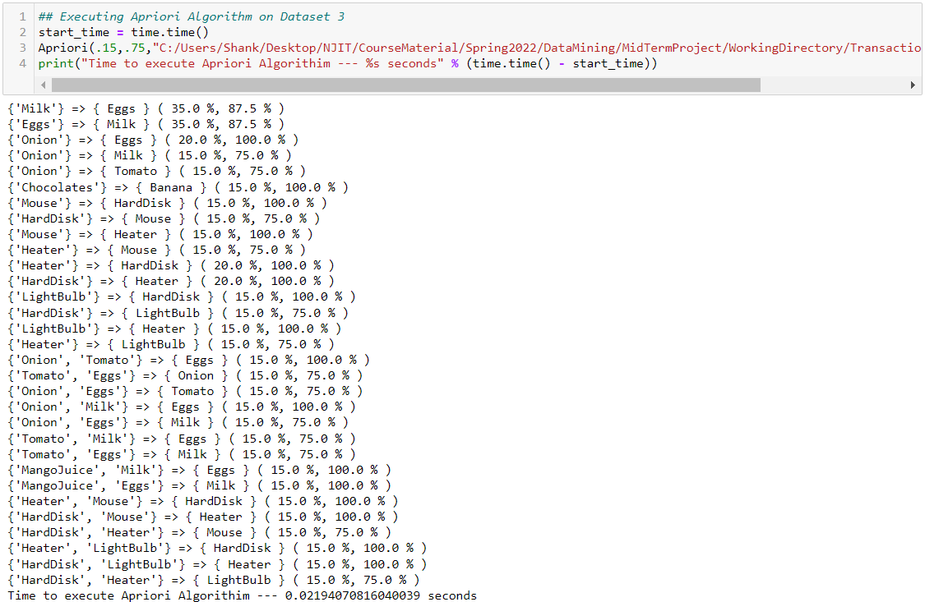

### Brute Force Results

## Apriori vs. Brute Force – Database 4

At 15% support and 60% confidence Apriori and Brute Force execute at 0.0139s and 1572.45s respectively. At 10% support and 85% confidence Apriori and Brute Force execute at 0.0269s and 1694.82s respectively.

### Apriori Results

### Brute Force Results

## Apriori vs Brute Force – Database 5

At 15% support and 65% confidence Apriori and Brute Force execute at 0.01399s and 98.03srespectively. At 10% support and 83% confidence Apriori and Brute Force execute at 0.0759s and 106.19s respectively.

### Apriori Results

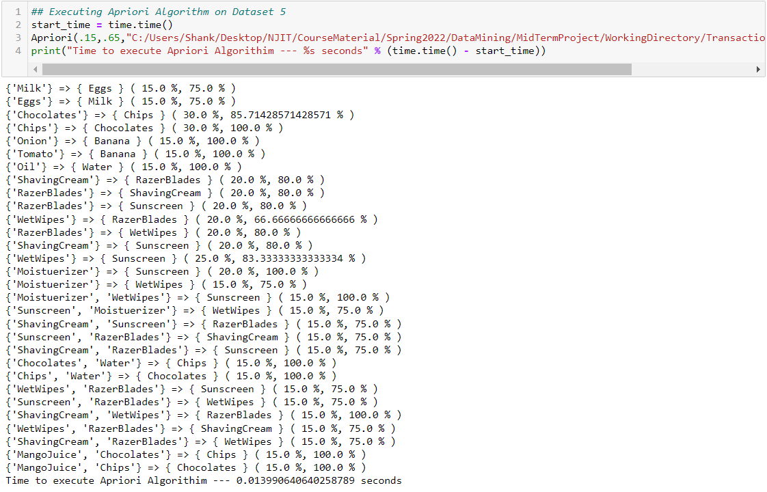

### Brute Force Results

# Conclusion

We have conducted two different types of association rule mining algorithms on 5 different databases, and in each case, across different support and confidence level combinations, we have determined that Apriori algorithm is faster than the Brute Force algorithm by a considerable margin.