NAME: Shanmuga Bharath M

ROLL NO: 713322AD095

DEPT: AI&DS

TASK 2

RELATIONSHIP DIAGRAM BETWEEN AI, MACHINE LEARNING AND DEEP LEARNING

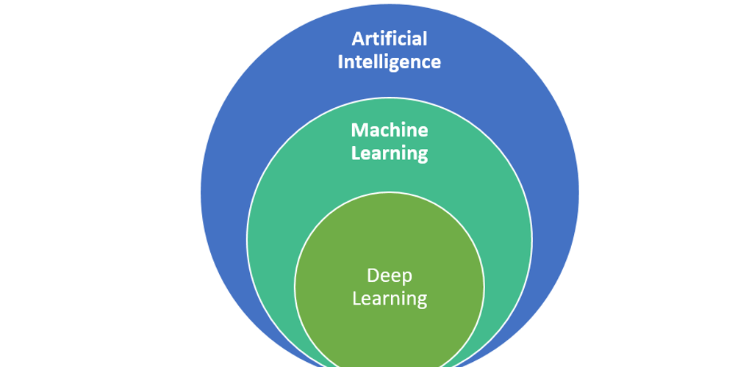

ARTIFICIAL INTELLIGENCE:

Artificial Intelligence is used to classify machines that mimic human intelligence and human cognitive functions like problem-solving and learning. AI uses predictions and automation to optimize and solve complex tasks that humans have historically done, such as facial and speech recognition, decision-making.

* Artificial Narrow Intelligence
* Artificial General Intelligence
* Artificial Super Intelligence

MACHINE LEARNING:

Machine learning is a subset of AI . It helps you make predictions that minimize the errors that arise from merely guessing. For example, companies like Amazon use machine learning to recommend products to a specific customer based on what they’ve looked at and bought before.

DEEP LEARNING:

Deep learning is a subset of machine learning. The primary difference between machine learning and deep learning is how each algorithm learns and how much data each type of algorithm uses.