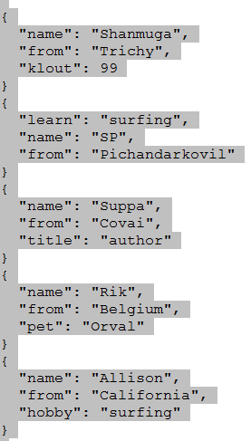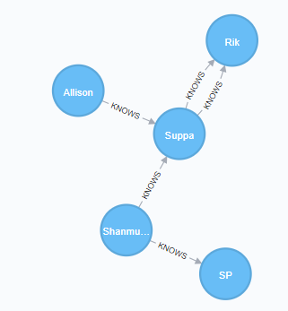

CREATE (ee:Person { name: "Shanmuga", from: "Trichy", klout: 99 })

MATCH (ee:Person) WHERE ee.name = "Shanmuga" RETURN ee;

MATCH (n:Person) RETURN n LIMIT 100

MATCH (ee:Person)-[:KNOWS]-(friends)  
WHERE ee.name = "Shanmuga" RETURN ee, friends

MATCH (js:Person)-[:KNOWS]-(surfer)  
WHERE js.name = "Shanmuga" AND surfer.from = "Pichandarkovil"  
RETURN DISTINCT surfer

----------  
SP  
------

MATCH (js:Person)-[:KNOWS]-(surfer)  
WHERE js.name = "Allison" AND surfer.from = "Pichandarkovil"  
RETURN DISTINCT surfer

----------  
No Records  
---------

MATCH (js:Person)-[\*]-(surfer)  
WHERE js.name = "Allison" AND surfer.from = "Pichandarkovil"  
RETURN DISTINCT surfer  
  
----------  
SP  
------