**Task 1:** Create an RDS instance in your AWS account and upload the data to the RDS instance (Note: Instructions on how to work with RDS can be found[**here.)**](https://cdn.upgrad.com/uploads/production/08f82196-b083-426a-ab25-1eb052c43683/Documentation%2B-%2BWorking%2Bwith%2BRDS.pdf)

Since the dataset is huge, you need to upload the data from only two files (i.e. **yellow_tripdata_2017-01.csv & yellow_tripdata_2017-02.csv)**from the dataset.

**Note: You will need to create an appropriate schema for the data sets to upload them to RDS (you can find the data dictionary in the previous segments. The steps to work with RDS in given in the Additional Resource).**

**EMR creation:**

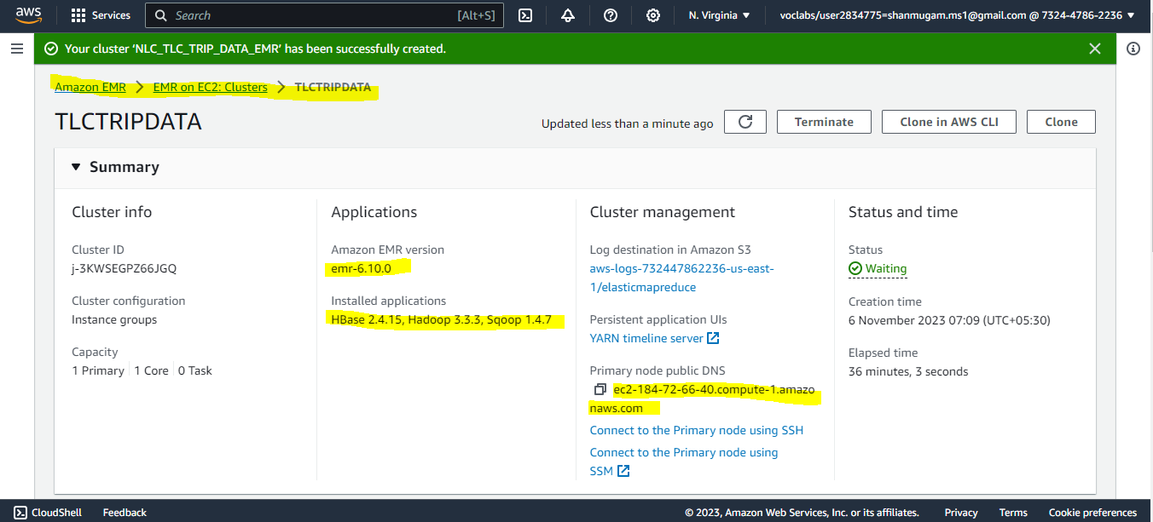

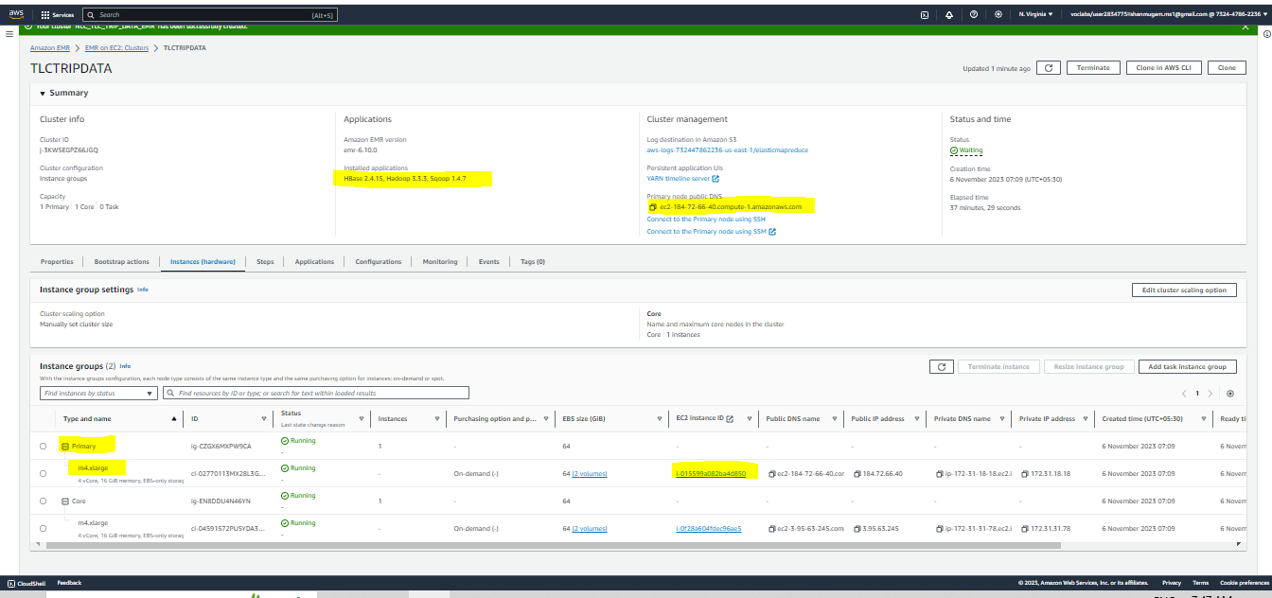

**RDS Instance creation:**

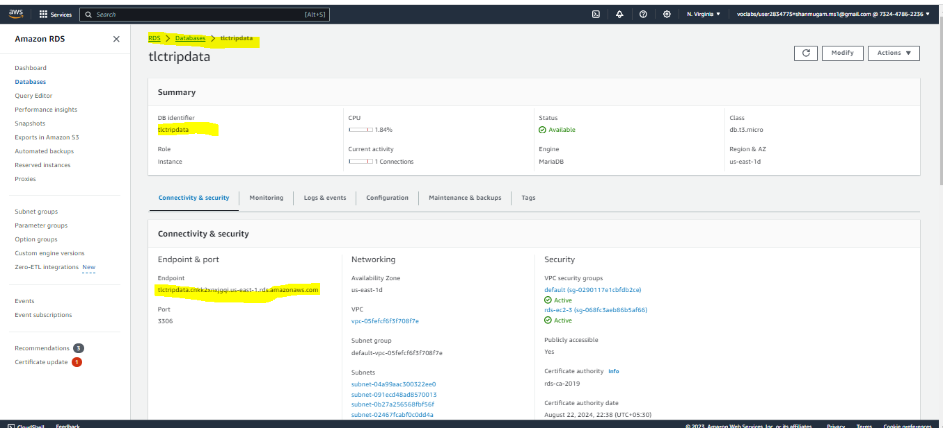

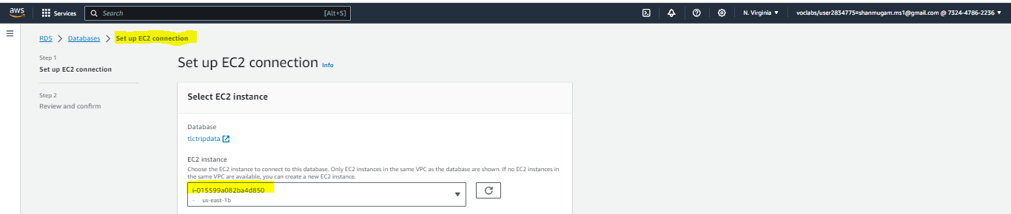

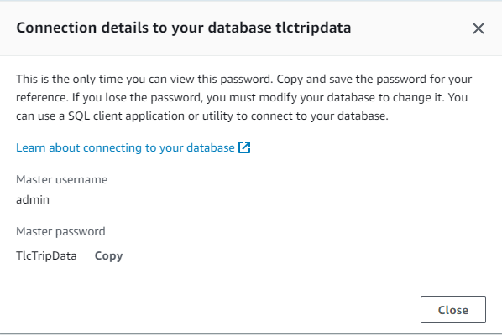

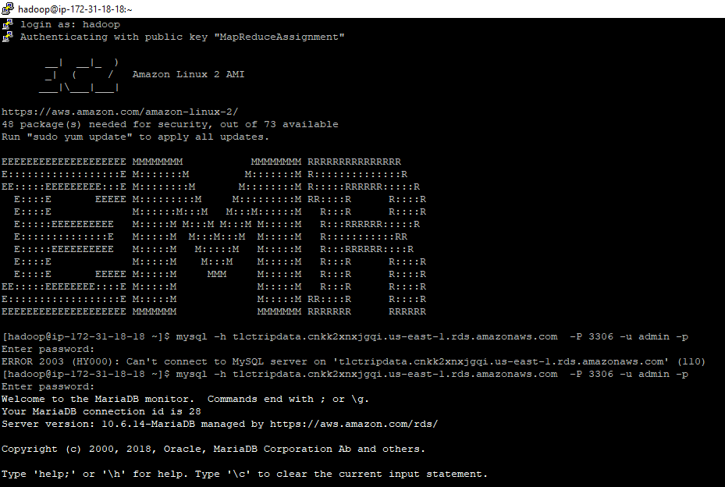

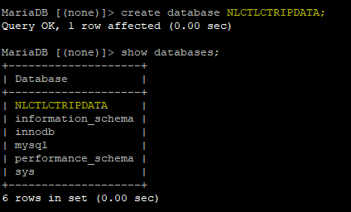

create database NLCTLCTRIPDATA;

use NLCTLCTRIPDATA;

CREATE TABLE yellow_taxi_trip_data( VendorID INT, tpep_pickup_datetime VARCHAR(50), tpep_dropoff_datetime VARCHAR(50), Passenger_count INT, Trip_distance FLOAT, PULocationID INT, DOLocationID INT, RateCodeID INT, Store_and_fwd_flag VARCHAR(2), payment_type INT, Fare_amount FLOAT, Extra FLOAT, MTA_tax FLOAT, improvement_surcharge FLOAT, Tip_amount FLOAT, Tolls_amount FLOAT, total_amount FLOAT, Congestion_Surcharge FLOAT, Airport_fee FLOAT );

wget https://nyc-tlc-upgrad.s3.amazonaws.com/yellow_tripdata_2017-01.csv;

wget https://nyc-tlc-upgrad.s3.amazonaws.com/yellow_tripdata_2017-02.csv;

LOAD DATA LOCAL INFILE '/home/hadoop/yellow_tripdata_2017-01.csv' INTO TABLE yellow_taxi_trip_data FIELDS TERMINATED BY ',' LINES TERMINATED BY '\n' IGNORE 1 LINES;

LOAD DATA LOCAL INFILE '/home/hadoop/yellow_tripdata_2017-02.csv' INTO TABLE yellow_taxi_trip_data FIELDS TERMINATED BY ',' LINES TERMINATED BY '\n' IGNORE 1 LINES;

select count(*) from yellow_taxi_trip_data;

