CLASS EXERCISE DAY - 3

CLASS EXERCISE NO : 1

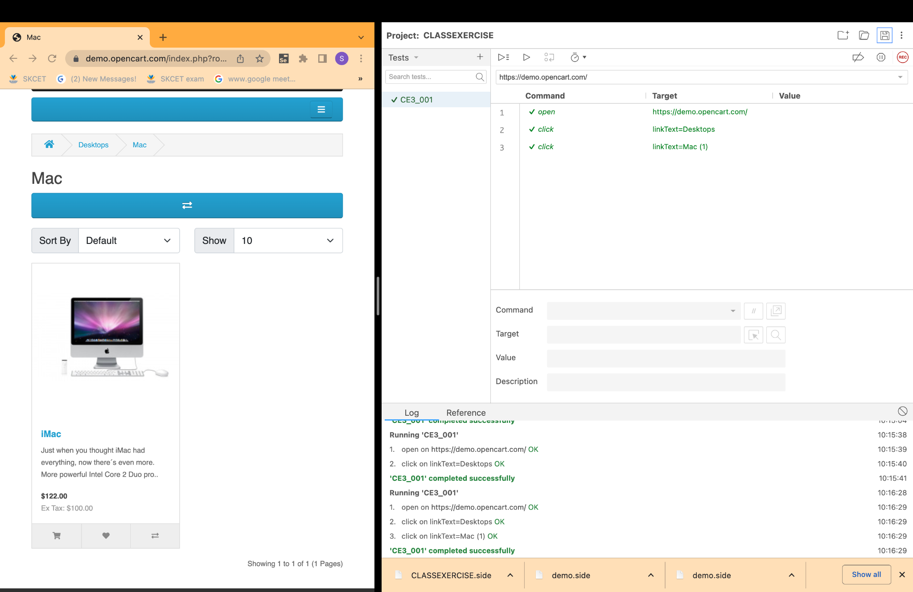

CLASS EXERCISE NO : 2

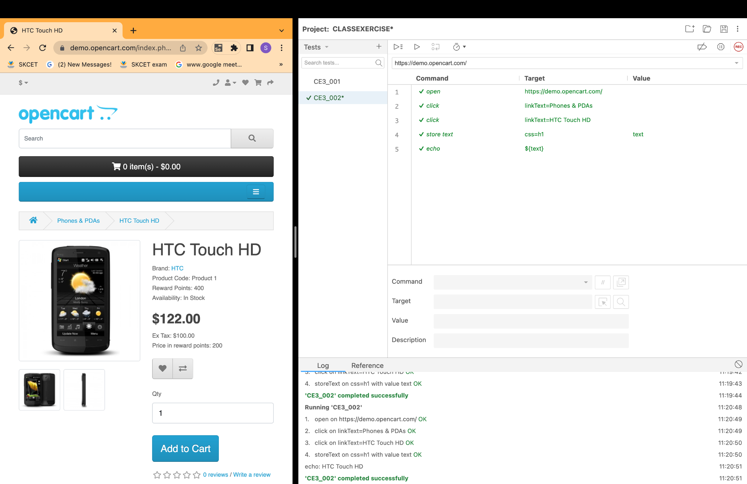

CLASS EXERCISE NO : 3

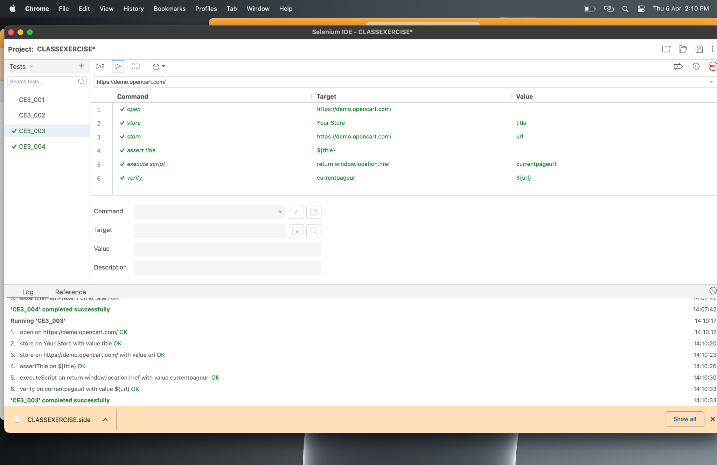

CLASS EXERCISE NO : 4

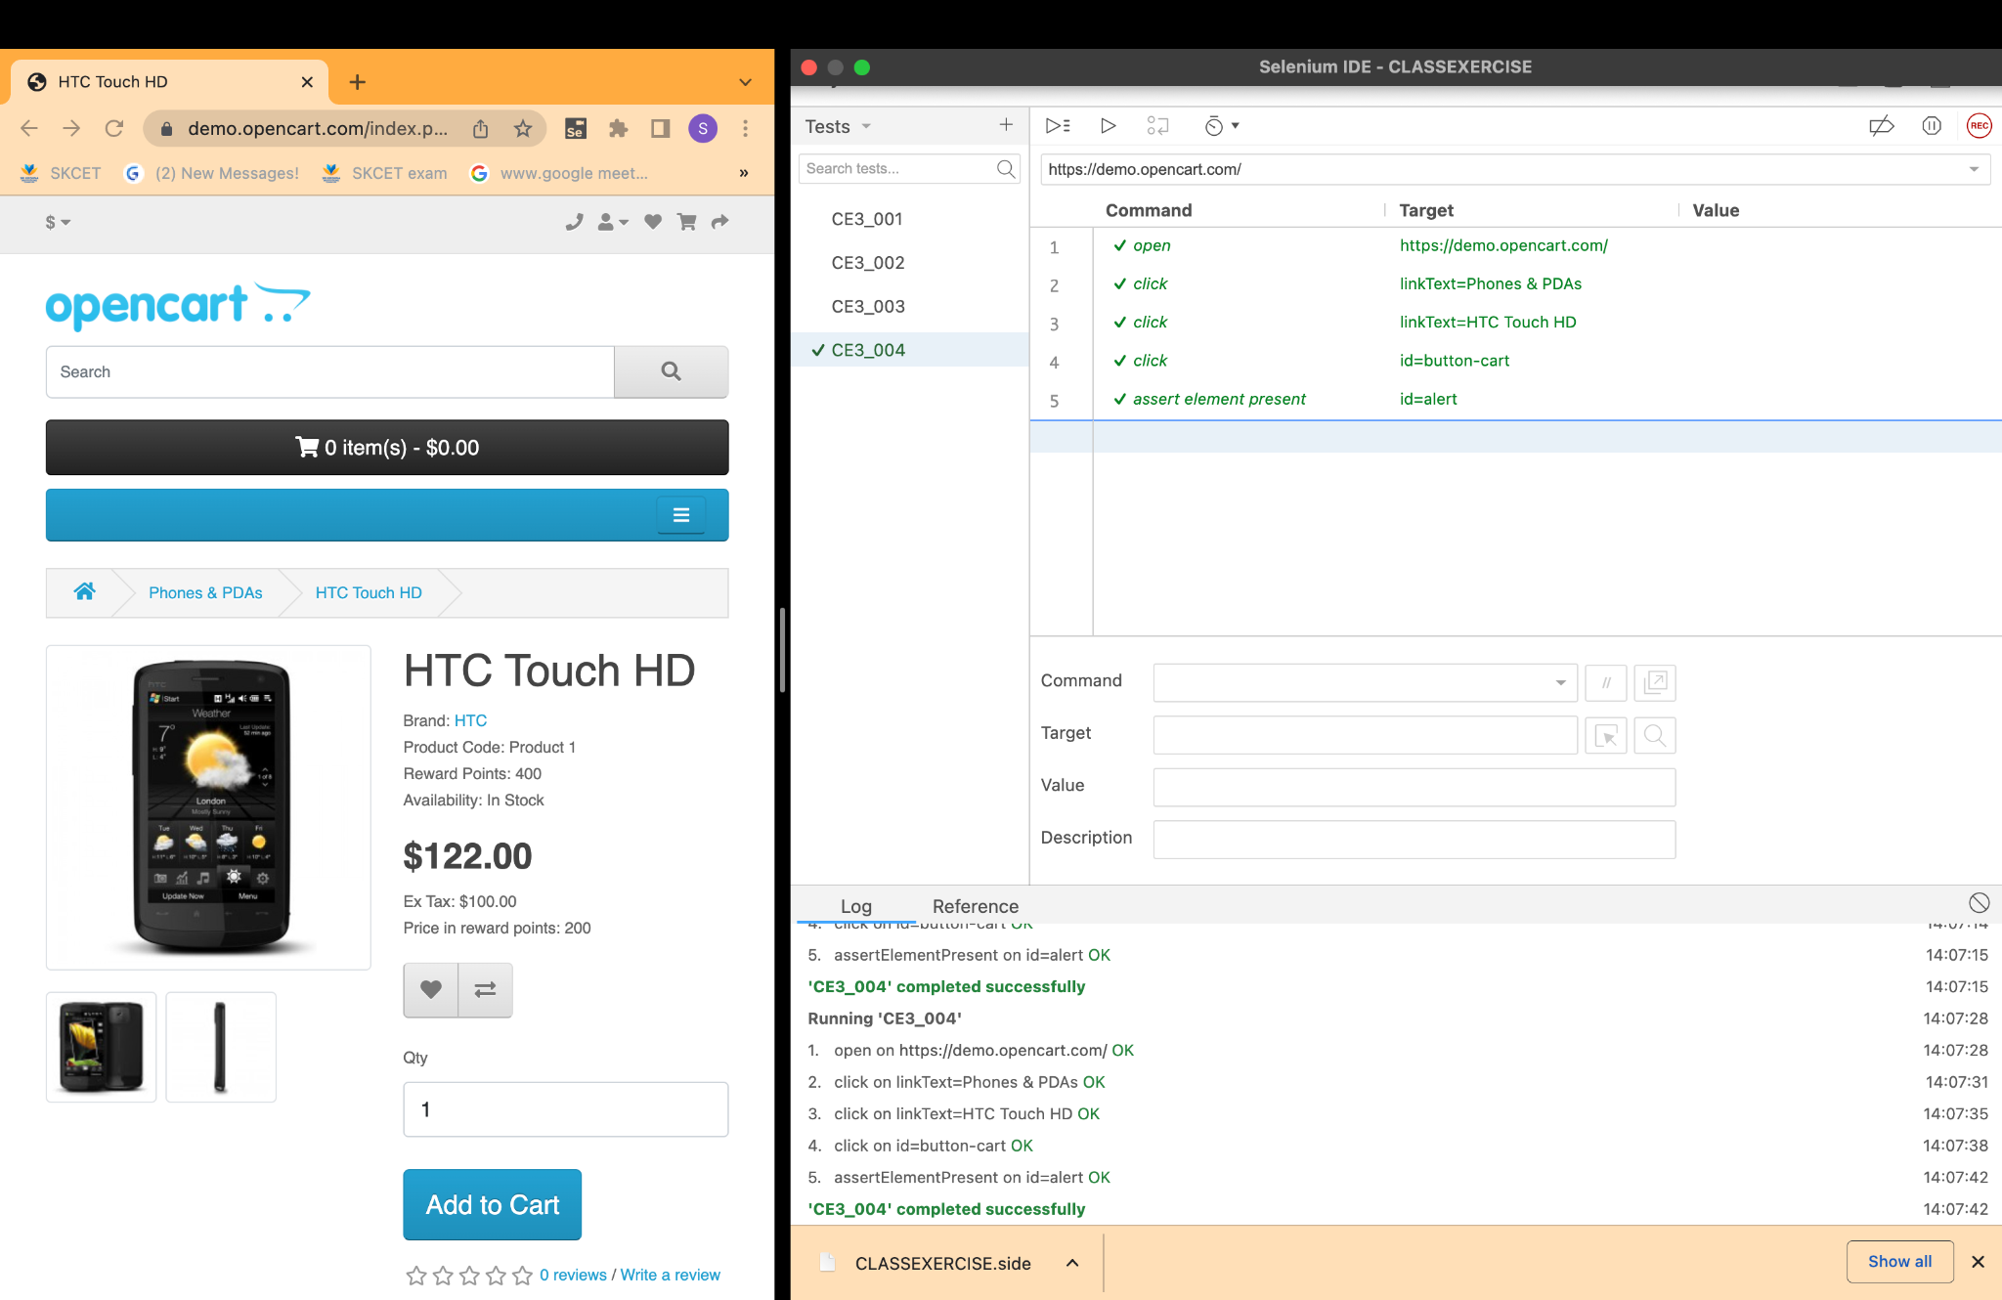

CLASS EXERCISE NO : 5

