Day 23 – Assignment 2: S3 Bucket Implementation for E-commerce Platform

Create S3 Buckets: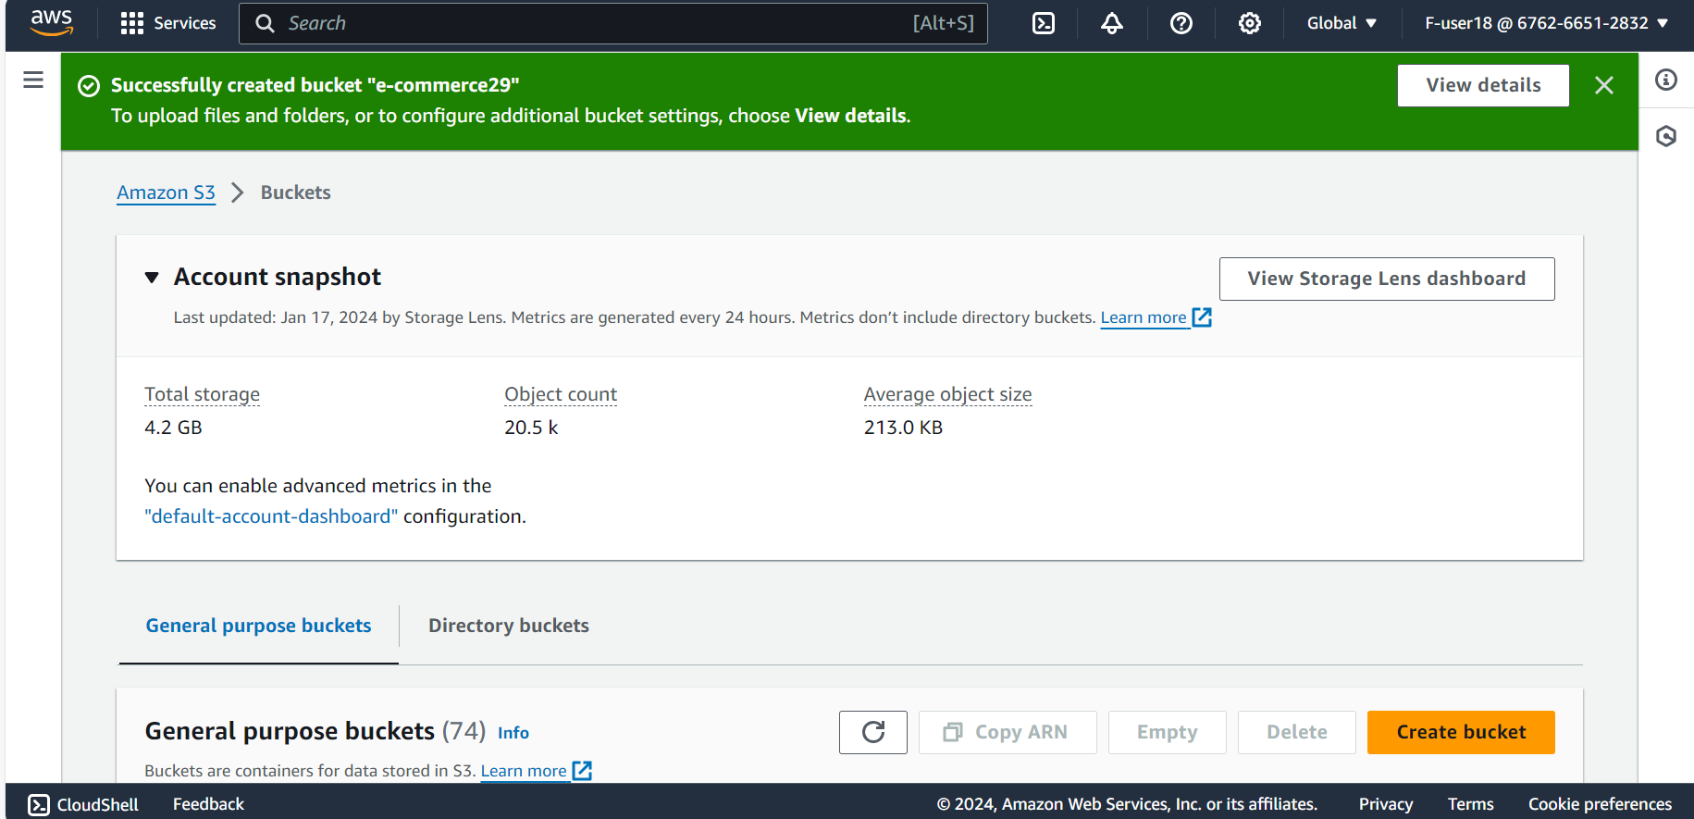

Upload files to the S3 bucket:

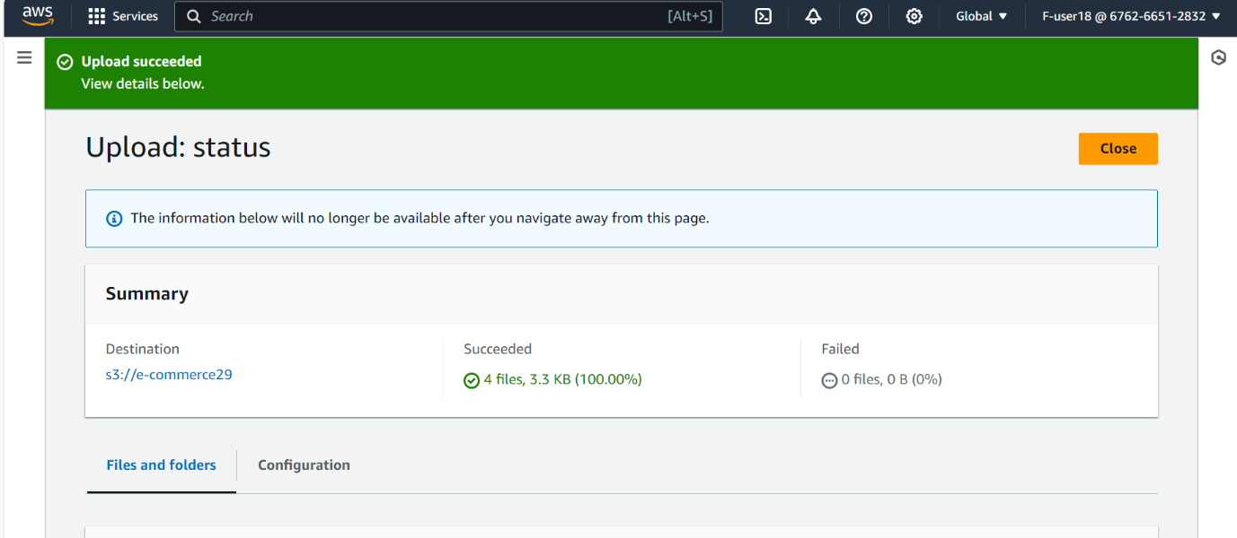

Enable static website hosting and set the index document to index.html:

Integrate the S3 buckets with a CDN:

Website:

