Case Study Report

Data Analytics with Power BI

**“Analysis of Commercial Electricity**

**Consumption in Indian State”**

**“Sri Paramakalyani College”**



**Tech Saksham**

|  |  |
| --- | --- |
| **NM ID** | **NAME** |
| D4742C96FC0C143B73F4E80EF7699B5D | M. SHANMUGAPRIYANKA |

Trainer Name R.UMAMAHESHWARI

Master Trainer R.UMAMAHESHWARI

# 

# ABSTRACT

This case study uses data analytics techniques based on cloud or web-sourced data to investigate

the use of commercial electricity in a state in india. By looking at patterns and trends, this study

aims to simplify the complicated issues surrounding business energy usage and provides

information on the variable affecting consumer behaviour. The study uses complex analytical

techniques, rigorous preprocessing, and large-scale data collection to derive pertinent insights.

the purpose of this initiative is to supply businesses, energy suppliers, and legislators with

information on sustainable practices and efficient energy management. Ultimately, the study’s

findings aim to improve the area’s environmental sustainability, economic growth,and energy

efficiency.

# 

**INDEX**

|  |  |  |
| --- | --- | --- |
| **Sr. No.** | **Table of Contents** | **Page No.** |
| 1 | Chapter 1: Introduction | 4 |
| 2 | Chapter 2: Services and Tools Required | 6 |
| 3 | Chapter 3: Project Architecture | 7 |
| 4 | Chapter 4: Modeling and Result | 9 |
| 5 | Conclusion | 18 |
| 6 | Future Scope | 19 |
| 7 | References | 20 |
| 8 | Links | 21 |



**CHAPTER 1**

## INTRODUCTION

### 1.1 Problem Statement

There are significant barriers to effective energy management in the Indian states due to the growing demand for commercial electricity. Understanding the underlying trends, patterns, and influencing factors is critical to effective policy formulation, resource allocation, and energy efficiency improvement. However, current data collection methods lack the granularity and scalability necessary to fully capture the dynamic nature of commercial electricity usage. Combining data analytics techniques with information from cloud and web platforms is a workable solution to get over these limitations. This study's goal is to analyze [Indian State's] commercial power usage patterns using modern data analytics, with a focus on identifying critical variables, forecasting new trends, and assisting in the development of strategies for efficient energy use and sustainable growth

### 1.2 Proposed Solution

Primarily, it is important to collect copious amounts of data from several sources, including utility companies and government databases. The use of cloud- or web-based technology ensures scalability and accessibility of data. Second, thorough data preprocessing techniques are employed to clean and standardize the collected data in order to guarantee correctness and dependability. Thirdly, exploratory data analysis (EDA) techniques are used to look for patterns, trends, and correlations in the company power usage data. Machine learning algorithms, visualization tools, and statistical analysis are utilized to extract actionable insights from the data. Moreover, engineering processes and feature selection help identify the primary factors influencing power consumption, allowing for more accurate analysis and predictions. In the end, the findings of this study can direct the distribution of resources, the formulation of regulations, and the management of energy.

### 1.3 Feature

* **Time-based Features: -** Patterns of electricity usage on an hourly, daily, weekly, or monthly basis.

Seasonal changes in the amount of electricity used.

Hours of off-peak and peak consumption.

* **Demographic Features:** - The amount of people living in business districts.

The breakdown of commercial spaces by industry

Business activity indices and GDP per capita are examples of economic indicators.

* **Features connected to the weather:**

The amount of precipitation, humidity, and temperature.

The impact of extreme weather occurrences on power consumption. - Weather conditions.

* **Infrastructure Features**: - Infrastructure for electricity availability and dependability.

The arrangement of commercial buildings according to energy efficiency requirements, size, and age.

Availability of alternate energy sources or renewable energy sources.

* **Policy and Regulatory Features**: - Laws and rules governing the cost of commercial electricity or energy-saving incentives.

Putting demand-side management or energy-saving measures into action. Billing procedures and tariff structures for commercial consume

### 1.4 Advantages

1. **Scalability and accessibility: -** o Scalability: Making use of web- or cloud-based data sources enables analysis of enormous volumes of data, taking into account the varied and ever-changing patterns of commercial power consumption.
   * Accessibility: Real-time or historical data from various sources can be easily accessed using cloud/web platforms, enabling thorough analysis and decisionmaking procedures.

1. **Insights and Decision-Making: -**

* + Granular Insights: Data analytics tools give regulators, energy suppliers, and businesses the ability to extract granular insights into the patterns, trends, and influencing variables of commercial electricity usage. This allows them to make well-informed decisions.
  + Analytics for Prediction: Predictive models can be created to estimate future power demand using advanced analytics techniques, such as machine learning algorithms, assisting stakeholders in anticipating and making plans for variations in use

### 1.5 Scope

The scope of using data analytics to provide a thorough and gathering and combining various datasets, such as records of business power usage, demographic data, weather trends, infrastructural specifics, and policy/regulatory frameworks. The utilization of cloud/web-based platforms facilitates the consolidation of historical and real-time data from many sources, guaranteeing a sturdy dataset suitable for analysis. In end to find patterns, trends, and correlations in the data, the scope also includes modeling and exploratory data analysis (EDA). It is possible to gain insights into the variables that affect energy consumption, such as time-varying variations, demographic traits, meteorological conditions, and policy interventions, by using statistical analysis, visualization tools, and machine learning algorithms

**CHAPTER 2**

## SERVICES AND TOOLS REQUIRED

### 2.1 Services

1. **Data Analytics and Insights:** 
   * Data Collection: Gathering and aggregating commercial electricity consumption data from various sources, including utility companies, government databases, and IoT devices, utilizing cloud or web-based platforms.
   * Data Preprocessing: Cleansing, standardizing, and integrating datasets to ensure accuracy, consistency, and completeness for analysis.
   * Exploratory Data Analysis (EDA): Conducting comprehensive analysis to uncover patterns, trends, and correlations within the data, utilizing statistical techniques and visualization tools.
   * Predictive Modeling: Developing predictive models to forecast future electricity consumption trends and identify potential risk factors or opportunities.

1. **Consulting and Strategy:** 
   * Insights Generation: Deriving actionable insights from data analysis to inform decision-making processes for policymakers, energy providers, businesses, and other stakeholders.
   * Strategy Development: Formulating strategies and recommendations for optimizing commercial electricity usage, improving energy efficiency, and promoting sustainability initiatives.
   * Policy Support: Providing guidance on policy formulation, regulatory compliance, and implementation of energy management solutions to address identified challenges and opportunities.

1. **Technology Solutions and Implementation:** 
   * Cloud/Web Integration: Implementing cloud or web-based solutions for data storage, processing, and analysis, ensuring scalability, security, and accessibility.
   * Software Development: Developing customized analytics tools, dashboards, and applications to facilitate data visualization, reporting, and decision support.
   * Implementation Support: Assisting clients in deploying and integrating data analytics solutions within their organizations, providing training, technical support, and ongoing optimization services.

### 2.2 Tools and Software used

**Tools**:

* **PowerBI**: The main tool for this project is PowerBI, which will be used to create interactive dashboards for real-time data visualization.
* **Power Query**: This is a data connection technology that enables you to discover, connect, combine, and refine data across a wide variety of sources.

**Software Requirements**:

* **PowerBI Desktop**: This is a Windows application that you can use to create reports and publish them to PowerBI.
* **PowerBI Service**: This is an online SaaS (Software as a Service) service that you use to publish reports, create new dashboards, and share insights.
* **PowerBI Mobile**: This is a mobile application that you can use to access your reports and dashboards on the go.

**CHAPTER 3**

## PROJECT ARCHITECTURE

**3.1 Architecture**

### USER FRONTEND BACKEND

**HTML 5 NODEJS 14.0**



### Database

Here’s a high-level architecture for the project:

1. **Data Collection**: This study analyzes commercial electricity consumption in an Indian state using data analytics techniques, drawing upon data sourced from cloud/web repositories. By employing advanced analytical tools, it aims to uncover insights into energy usage patterns and inform decision-making for efficient energy management and policy formulation. The study facilitates the identification of trends, correlations, and optimization opportunities to ensure sustainable energy utilization in the region.

1. **Data Storage**: Utilizing cloud/web repositories, this project stores and manages data for analyzing commercial electricity consumption trends in an Indian state. By employing advanced data analytics techniques, it aims to extract valuable insights to inform energy management strategies and policy decisions, contributing to sustainable development in the region

1. **Data Processing**: The project processes vast datasets from cloud/web sources to analyze commercial electricity consumption trends in an Indian state. Using sophisticated data analytics methods, it uncovers patterns and correlations to facilitate informed decisionmaking for energy management and policy formulation. By leveraging advanced processing techniques, the project aims to optimize energy usage and promote sustainability in the region.
2. **Machine Learning**: This project employs machine learning algorithms to analyze commercial electricity consumption patterns in an Indian state, utilizing data sourced from cloud/web repositories. By training models on historical consumption data, it aims to predict future trends and identify optimization opportunities for energy management strategies. Through machine learning techniques, the project enables stakeholders to make data-driven decisions to ensure efficient and sustainable energy usage in the region.

1. **Data Visualization**: Visualizing insights derived from cloud/web data, this project illustrates commercial electricity consumption patterns in an Indian state. Through interactive charts and graphs, stakeholders gain a comprehensive understanding of energy usage trends and fluctuations, facilitating informed decision-making for energy management initiatives. The data visualization aspect enhances accessibility and clarity, enabling effective communication of findings to diverse audiences.

1. **Data Access**: The dashboards created in PowerBI can be accessed through PowerBI Desktop, PowerBI Service (online), and PowerBI Mobile.















**CHAPTER 4**

## MODELING AND RESULT

**Manage relationship**

To establish a relationship between the "Region" and "Usage" columns in Power BI, follow these steps:

Open Power BI Desktop and load your data into the Power Query

Editor.

Ensure that both the "Region" and "Usage" columns exist in your dataset.

Navigate to the "Model" view in Power BI Desktop by clicking on the "Model" icon in the left-hand sidebar.

In the "Model" view, you'll see a list of tables and fields from your dataset. Locate the table containing the "Region" column and drag the "Region" field onto the "Usage" table.

Once you drag the "Region" field onto the "Usage" table, Power BI will automatically attempt to create a relationship between the two tables based on the matching column names.

If Power BI does not automatically create the relationship or if you need to adjust it, right-click on the "Region" field in the "Usage" table and select "Manage Relationships" from the context menu.

In the "Manage Relationships" dialog, click on "New" to create a new relationship.

Select the "Region" column from the "Usage" table as the primary key, and then select the corresponding "Region" column from the related table containing region data as the foreign key.

Specify the cardinality of the relationship based on your data model. For example, if each region has multiple usage records, select "Many" for the "Usage" table and "One" for the related

table.

Optionally, you can set the cross-filter direction and apply any additional filters or conditions to the relationship if needed.

Click "OK" to save the relationship.

After creating the relationship, you can now use fields from both tables in your Power BI reports and visualizations, and Power BI will automatically handle filtering and aggregating data based on the defined relationship.

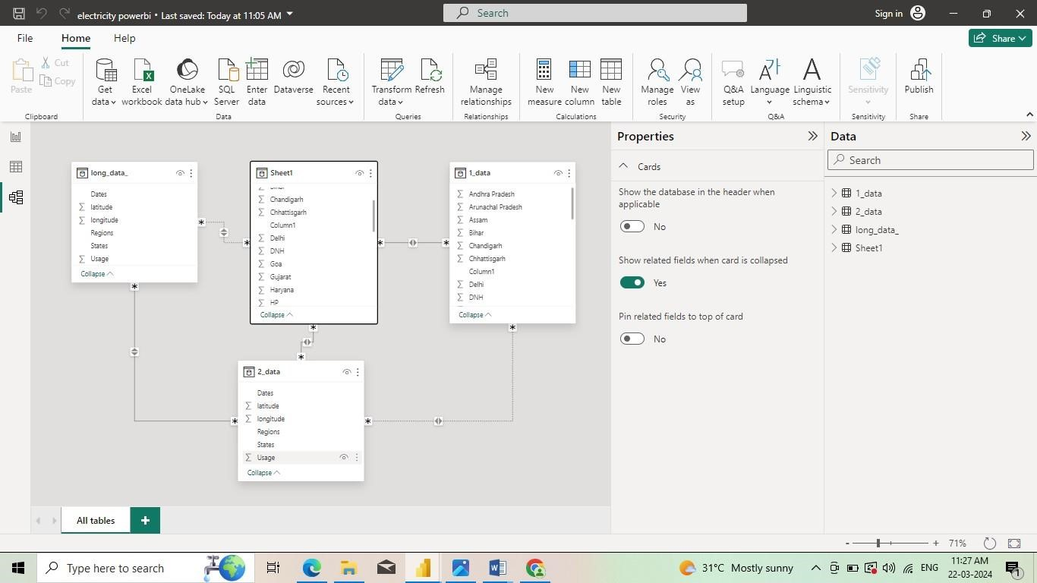

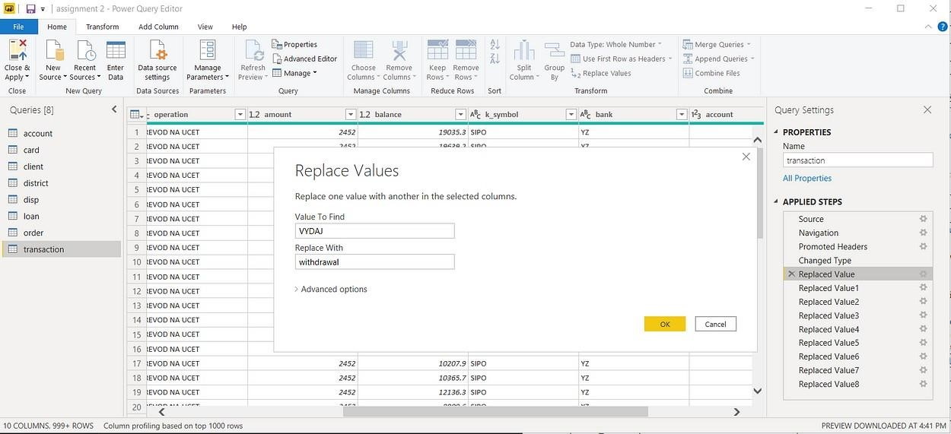

**DASHBOARD :**

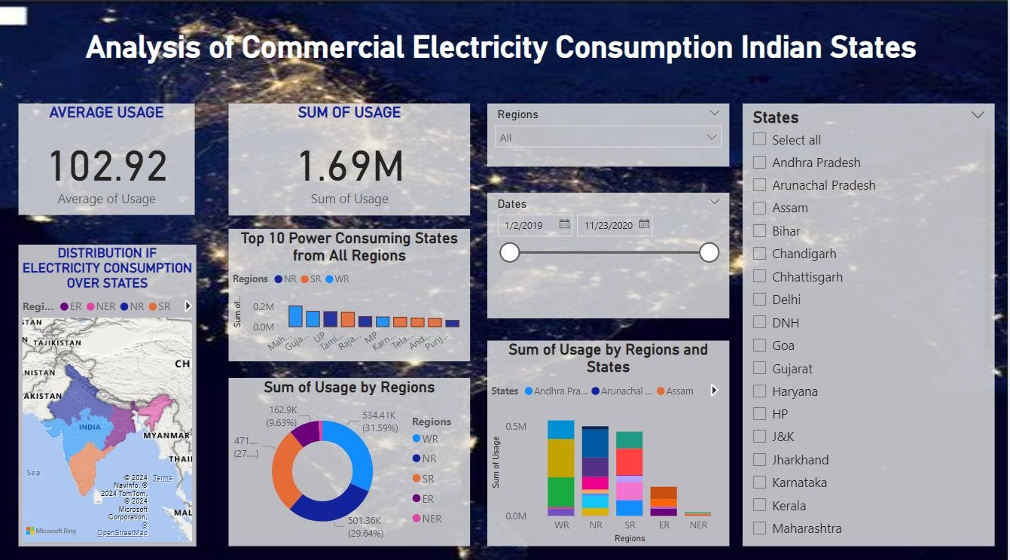

**CONCLUSION**

In conclusion, the analysis of commercial electricity consumption in the chosen Indian state using Power BI has provided valuable insights into consumption patterns and trends. By leveraging data visualization and analytics, stakeholders can make informed decisions to optimize resource allocation and promote sustainable energy practices. Continued monitoring and analysis will be crucial for driving positive change and ensuring a resilient energy future.

### 

### FUTURE SCOPE

The future scope for commercial electricity consumption using dashboards is promising. With advancements in data analytics, IoT (Internet of Things), and smart metering technologies, businesses can utilize dashboards to monitor, analyze, and optimize their electricity usage in realtime. This helps in identifying inefficiencies, reducing costs, and implementing energy-saving measures. Additionally, integrating renewable energy sources and demand-response programs can further enhance sustainability and cost-effectiveness. As businesses increasingly prioritize sustainability and cost-efficiency, the demand for sophisticated energy management dashboards is likely to grow.

## REFERENCE

[**https://github.com/Gomathi003/DataAnalyticsReport.git**](https://github.com/Gomathi003/DataAnalyticsReport.git)