Hadoop-2.7.3 Version:

Did not face any issues during installation. Ran the cmds given in Hadoop.apache.org website

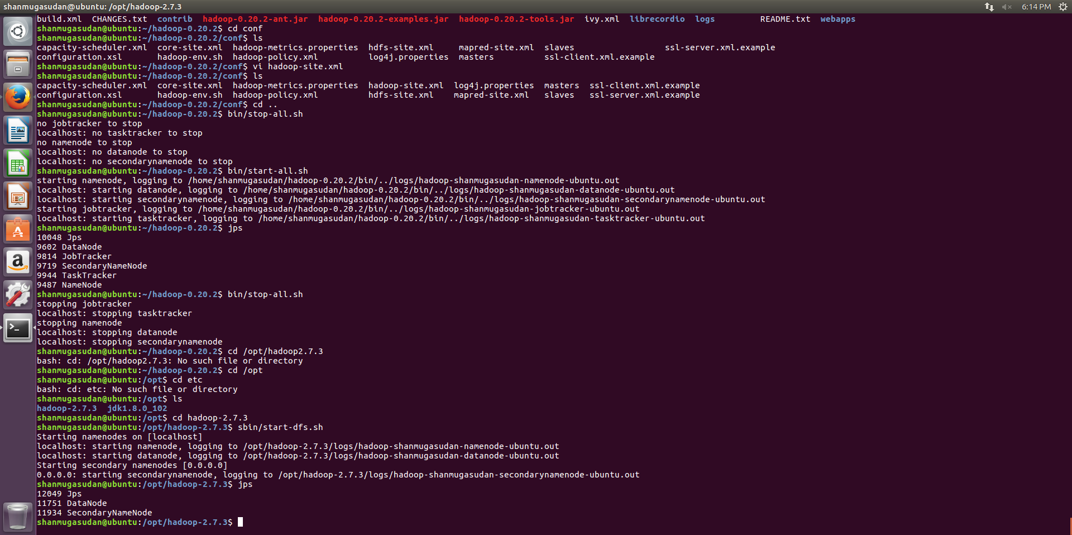

Single Node Installation in Latest version:



MapReduce Monitoring Web App-Hadoop Latest:

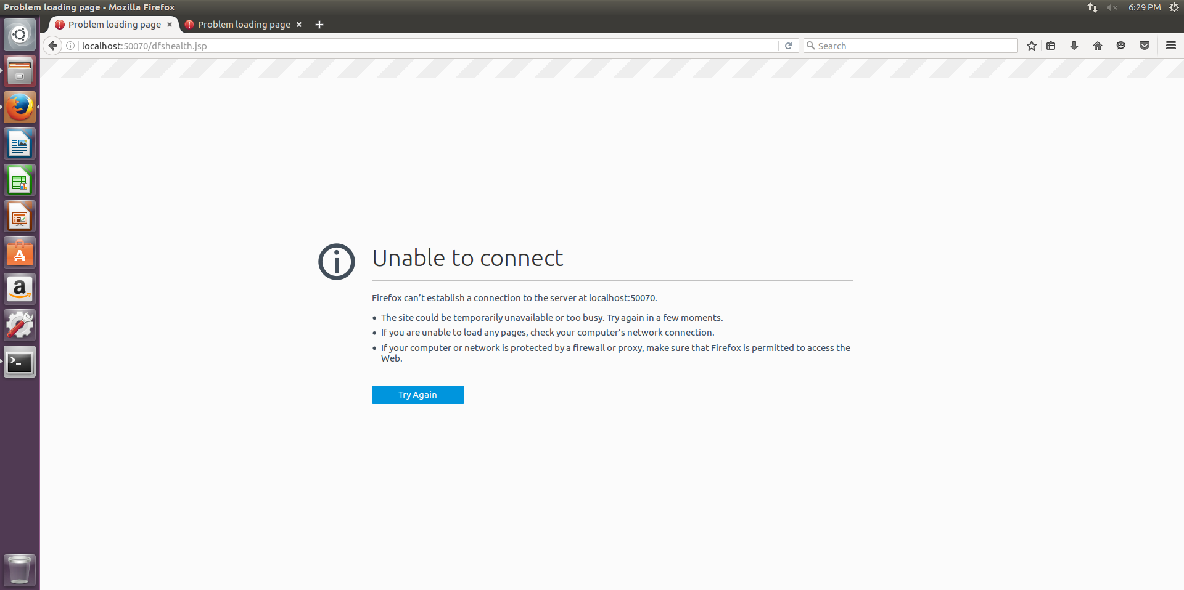

Hadoop 0.20.2:

Faced issues with starting Hadoop processes. Moved the Hadoop file to /home/username folder and did the installation.

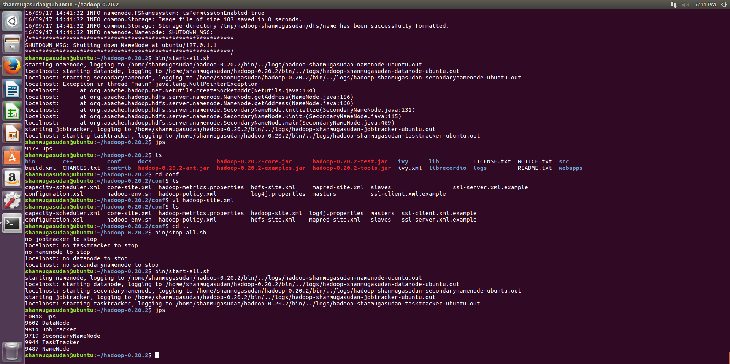

MapReduce Monitoring Web app- Hadoop Old:

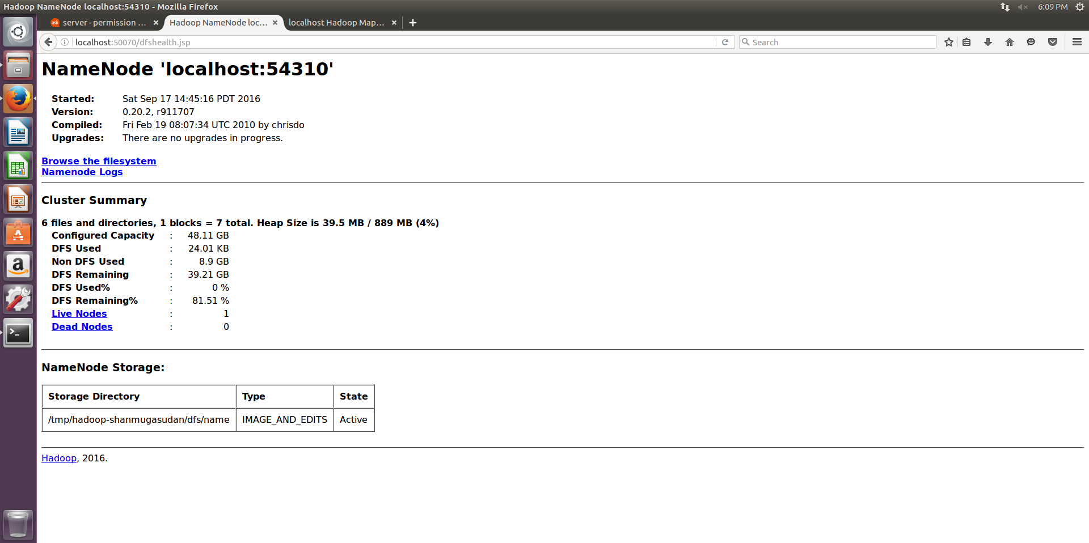

Single Node Installation in Hadoop Old Version:

