**Assignment-5: Running Page Rank code on a multi node cluster**

1. **Setting up a multi node cluster:**

I created three virtual machines, One master and two slaves.

I edited /etc/hosts and /etc/hostname files to customize my hostnames as “master, slave1, slave2” respectively.

Then, I installed Java 8 on all the VMs’ followed by Hadoop installations.

After installing Hadoop, I configured master slave communication, by overwriting the hosts files on both the files mentioned above.

I made configuration changes (replace localhost as master) on mapred-site.xml and core-site.xml.

I confirmed that my Hadoop cluster was up and running by checking the browser results at master:50070.

Screenshots below:

Hadoop started at master: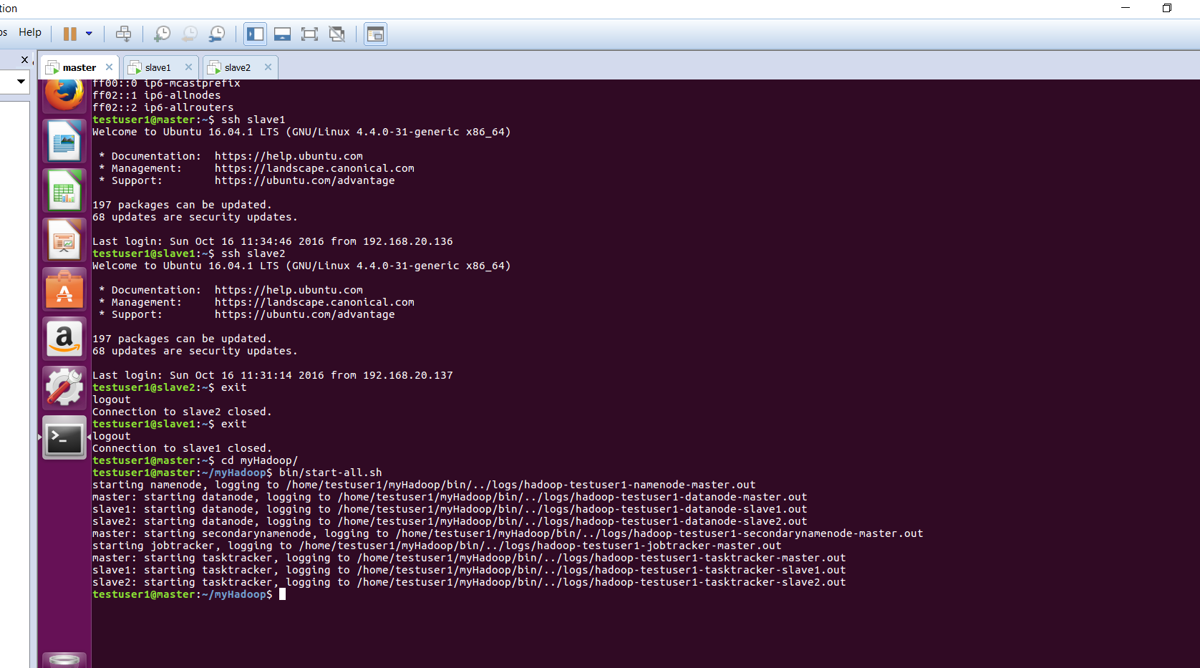

Master hosts file :

Ssh master outputs :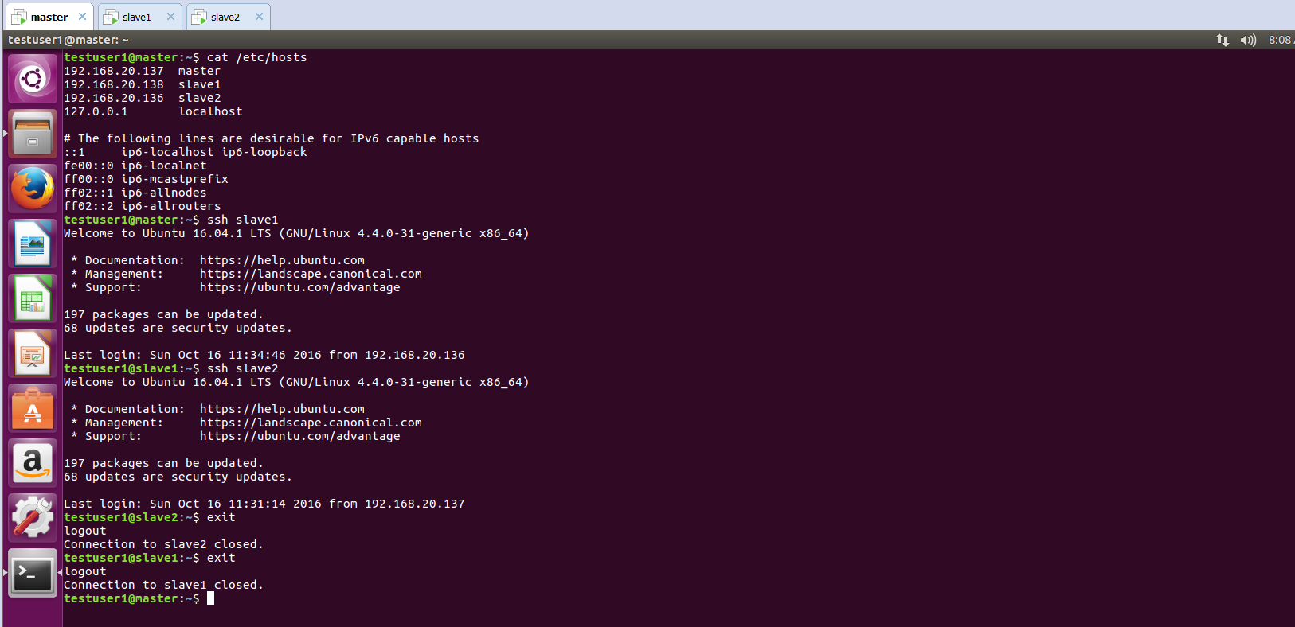

slave-1 hosts :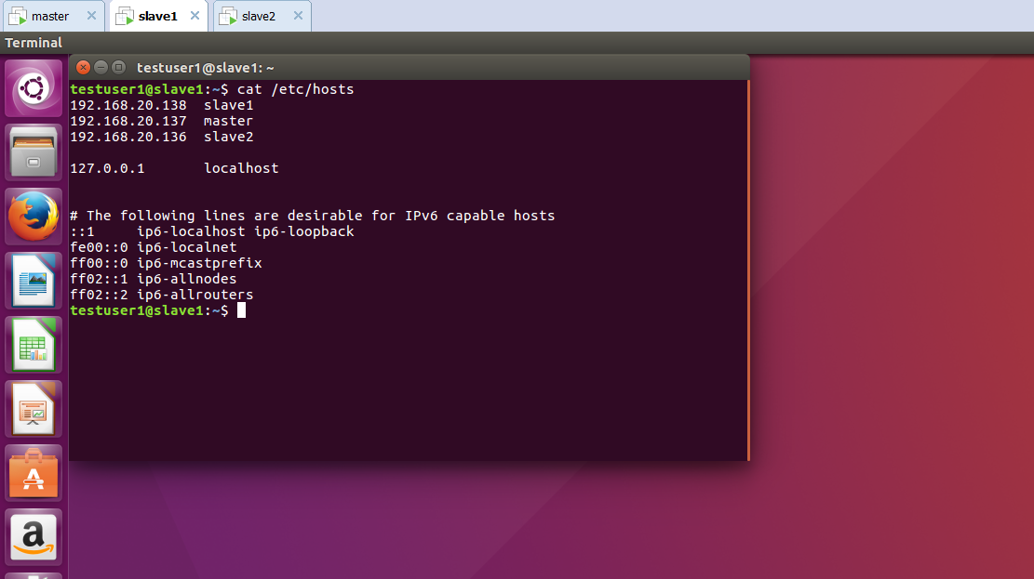

ssh at slave-1:

slave -2 - hosts: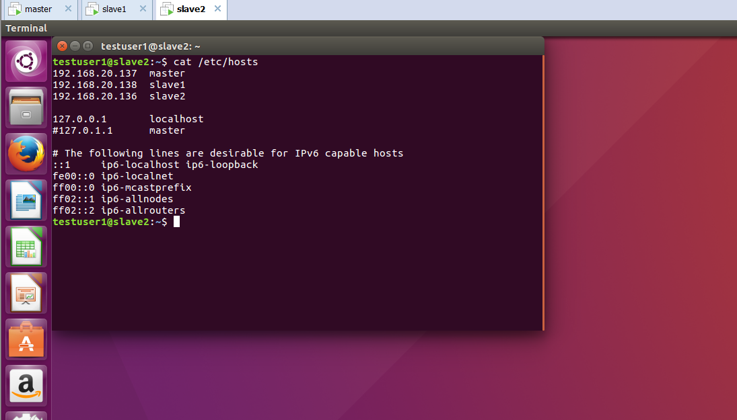

ssh at slave 2: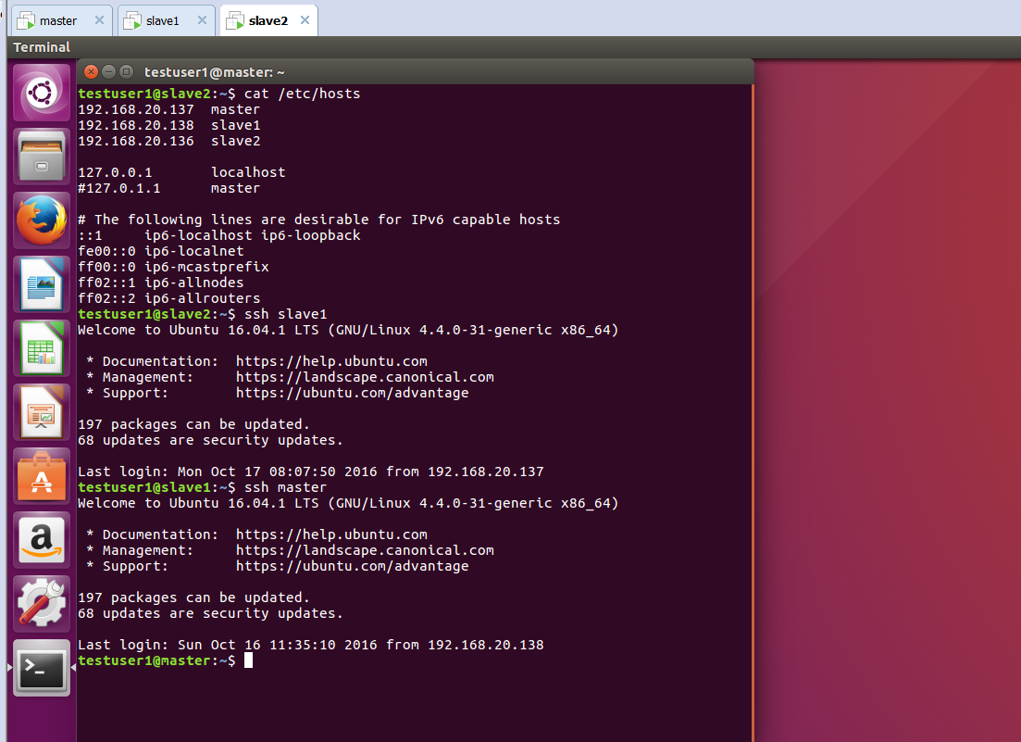

Job tracker at master:

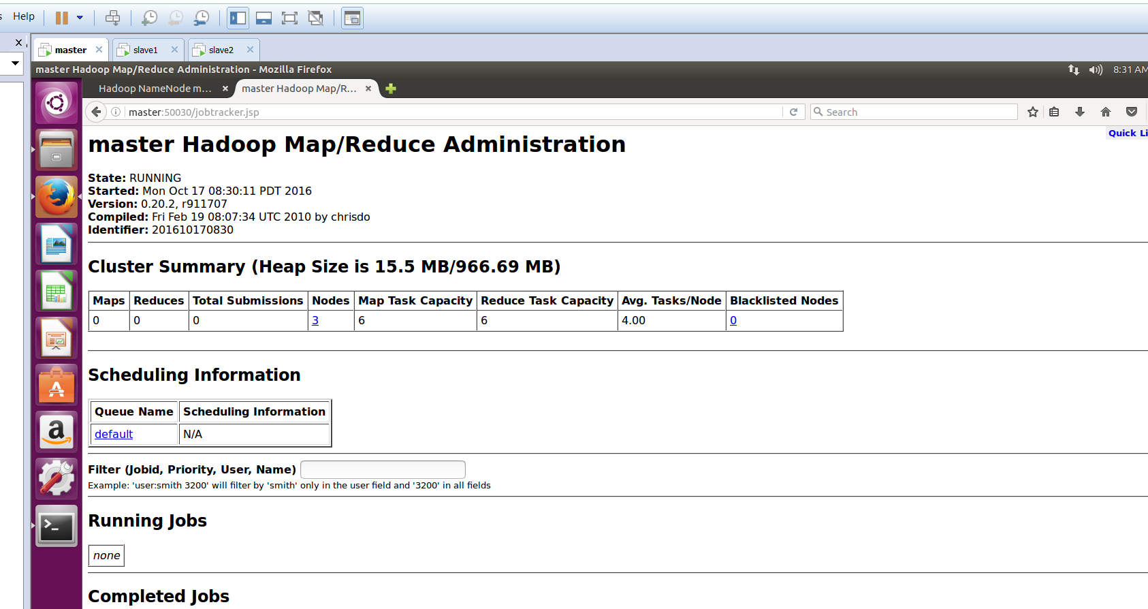

Browse master: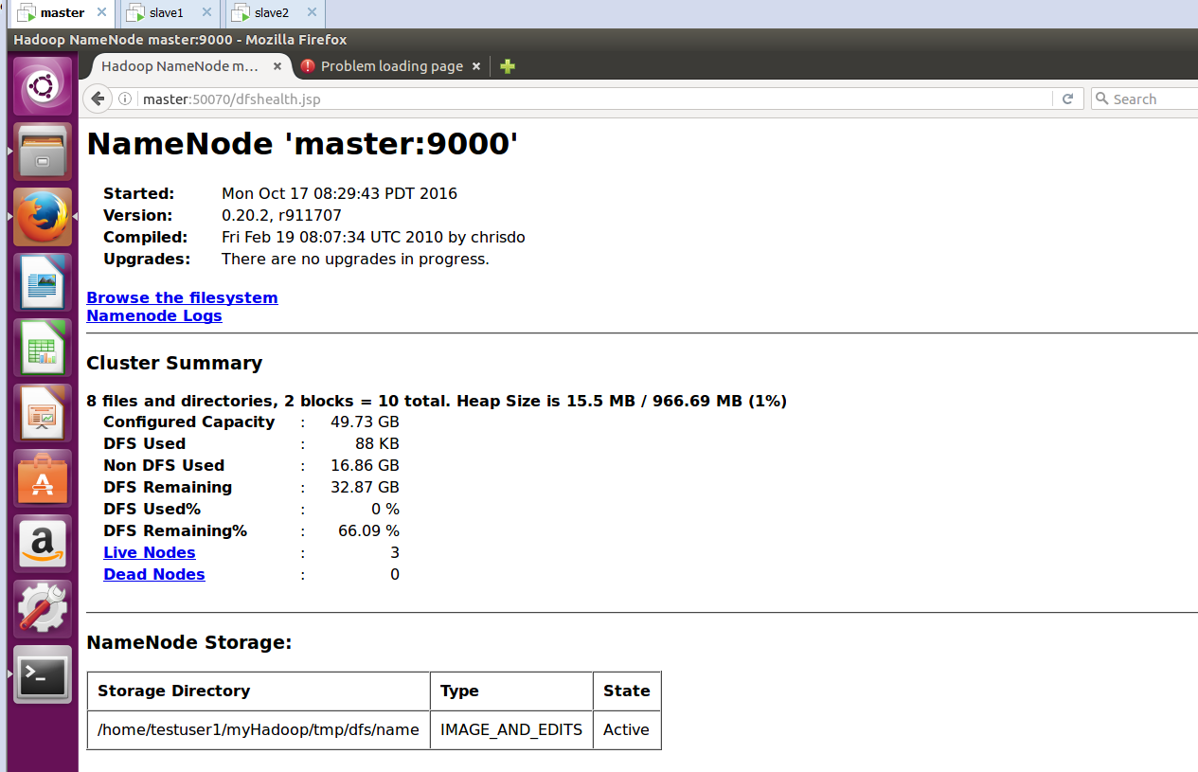

**2.PageRank Code:**

Following are the code changes I have performed to arrive at the results.

Steps taken:

1. Cleaned a lot of junk value on builder reducer.
2. Changed the damping factor difference in the emit value of iterator reducer to 0.0015 for a factor of 0.85.

From the code results,

1. The range is converging.
2. Totally 254 unique species in the result.
3. The convergence is seen after 10 iterations approximately, for a factor of 0.85.

Output-4: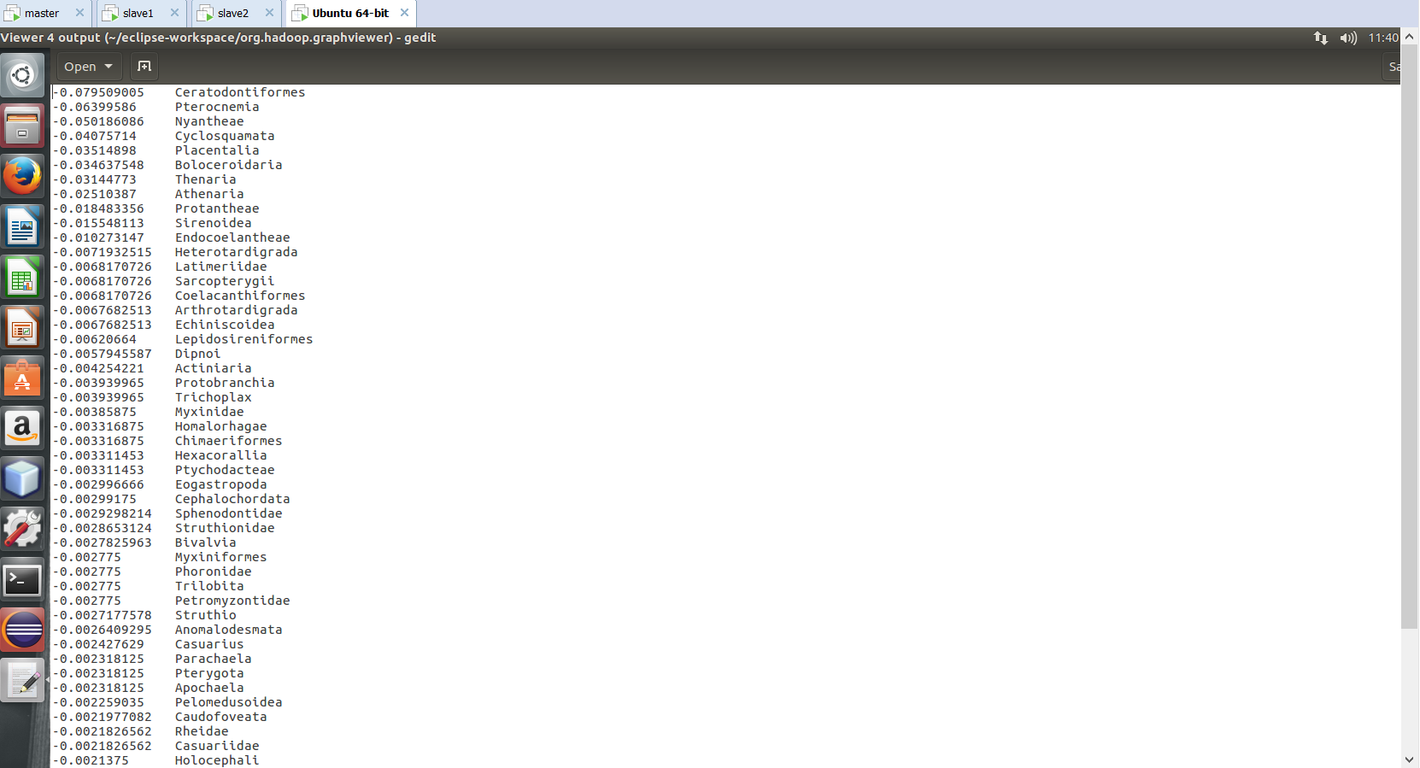

Output -14: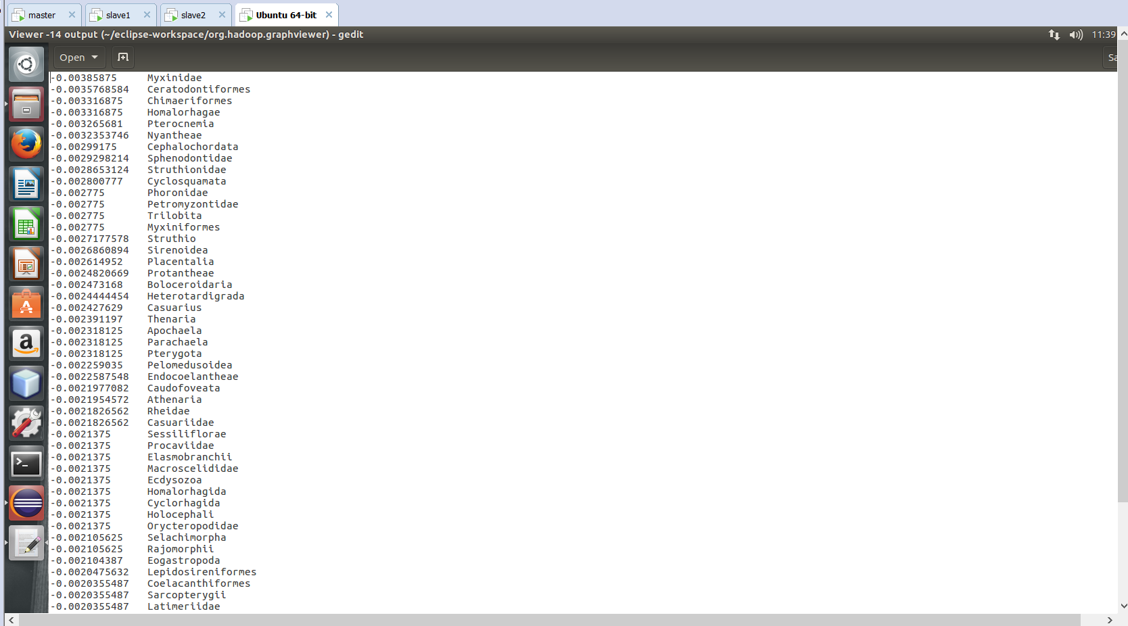

Output-20:



Output 14:

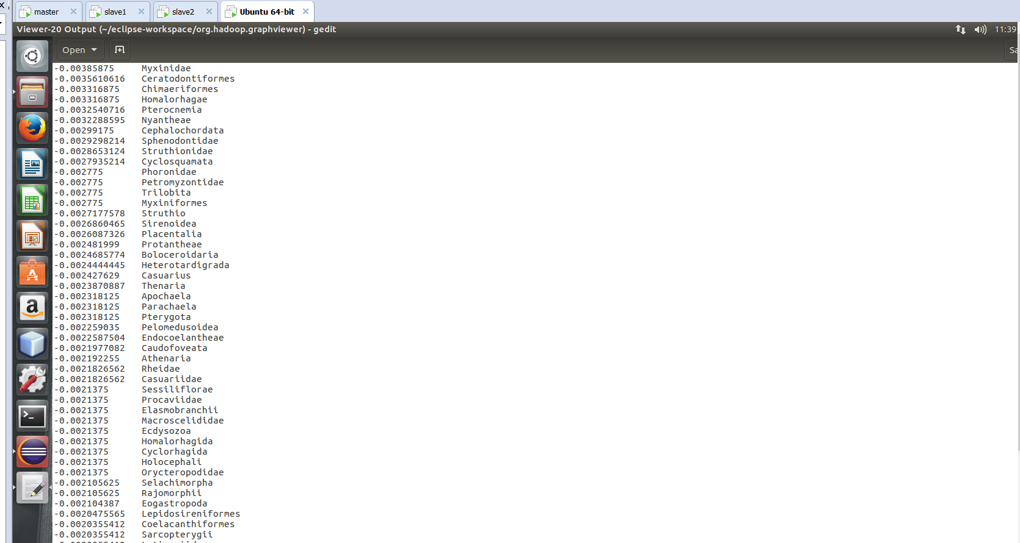

Data cleansing:

