**Question:** To compute the dataset considered for Winnow and Logistic algorithms this time using “Genetic Algorithm”.

**Answer:**

I complied the code given along with the lecture material. I extracted the input dataset I used for previous algorithms to a text file initially and placed it in the project folder.

**Screenshot of the results:**

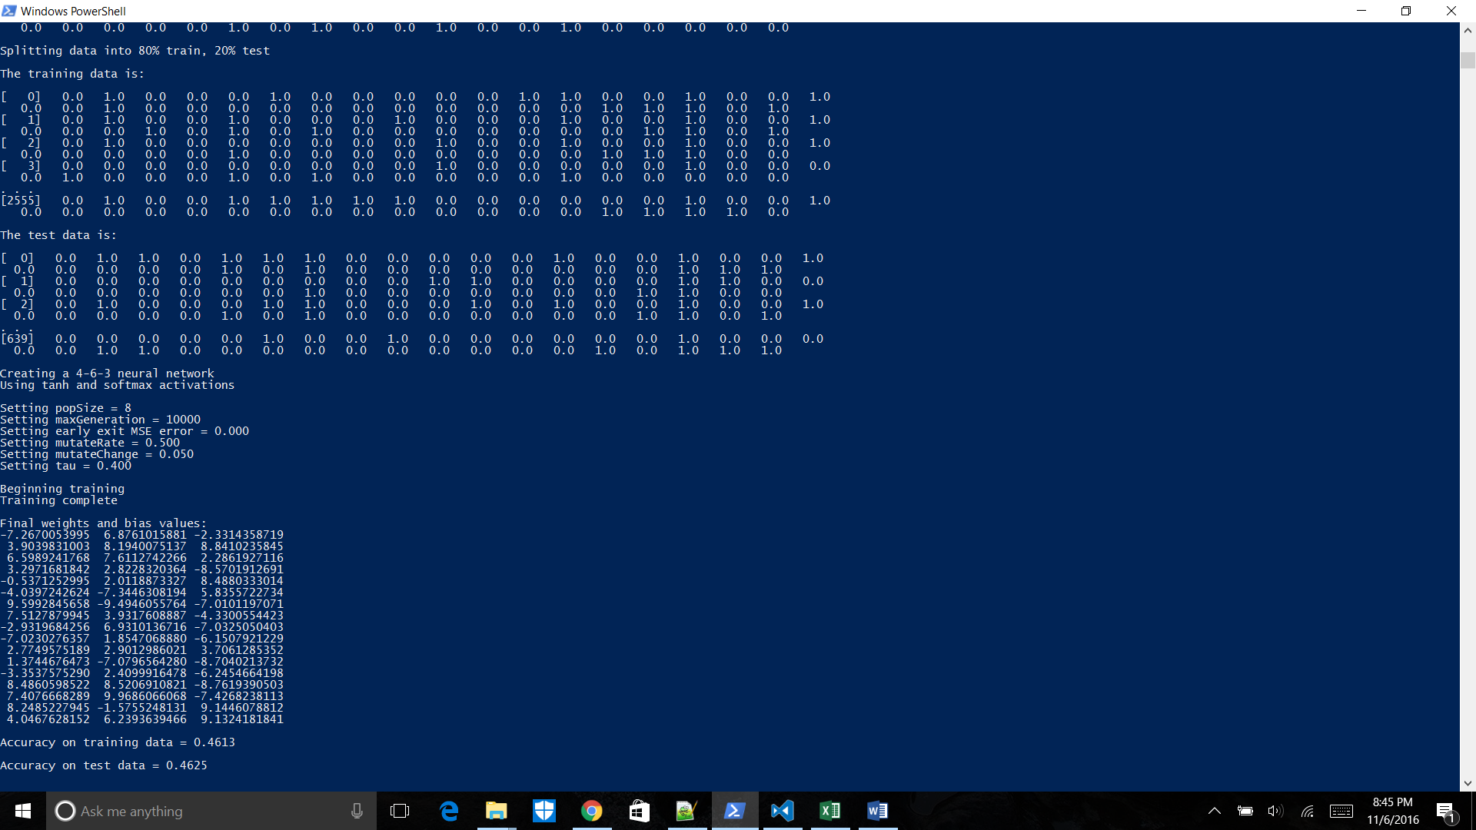

**Varying the population Size:**

I varied the population size and got a lesser accuracy on my test data.

Screenshot of the output:

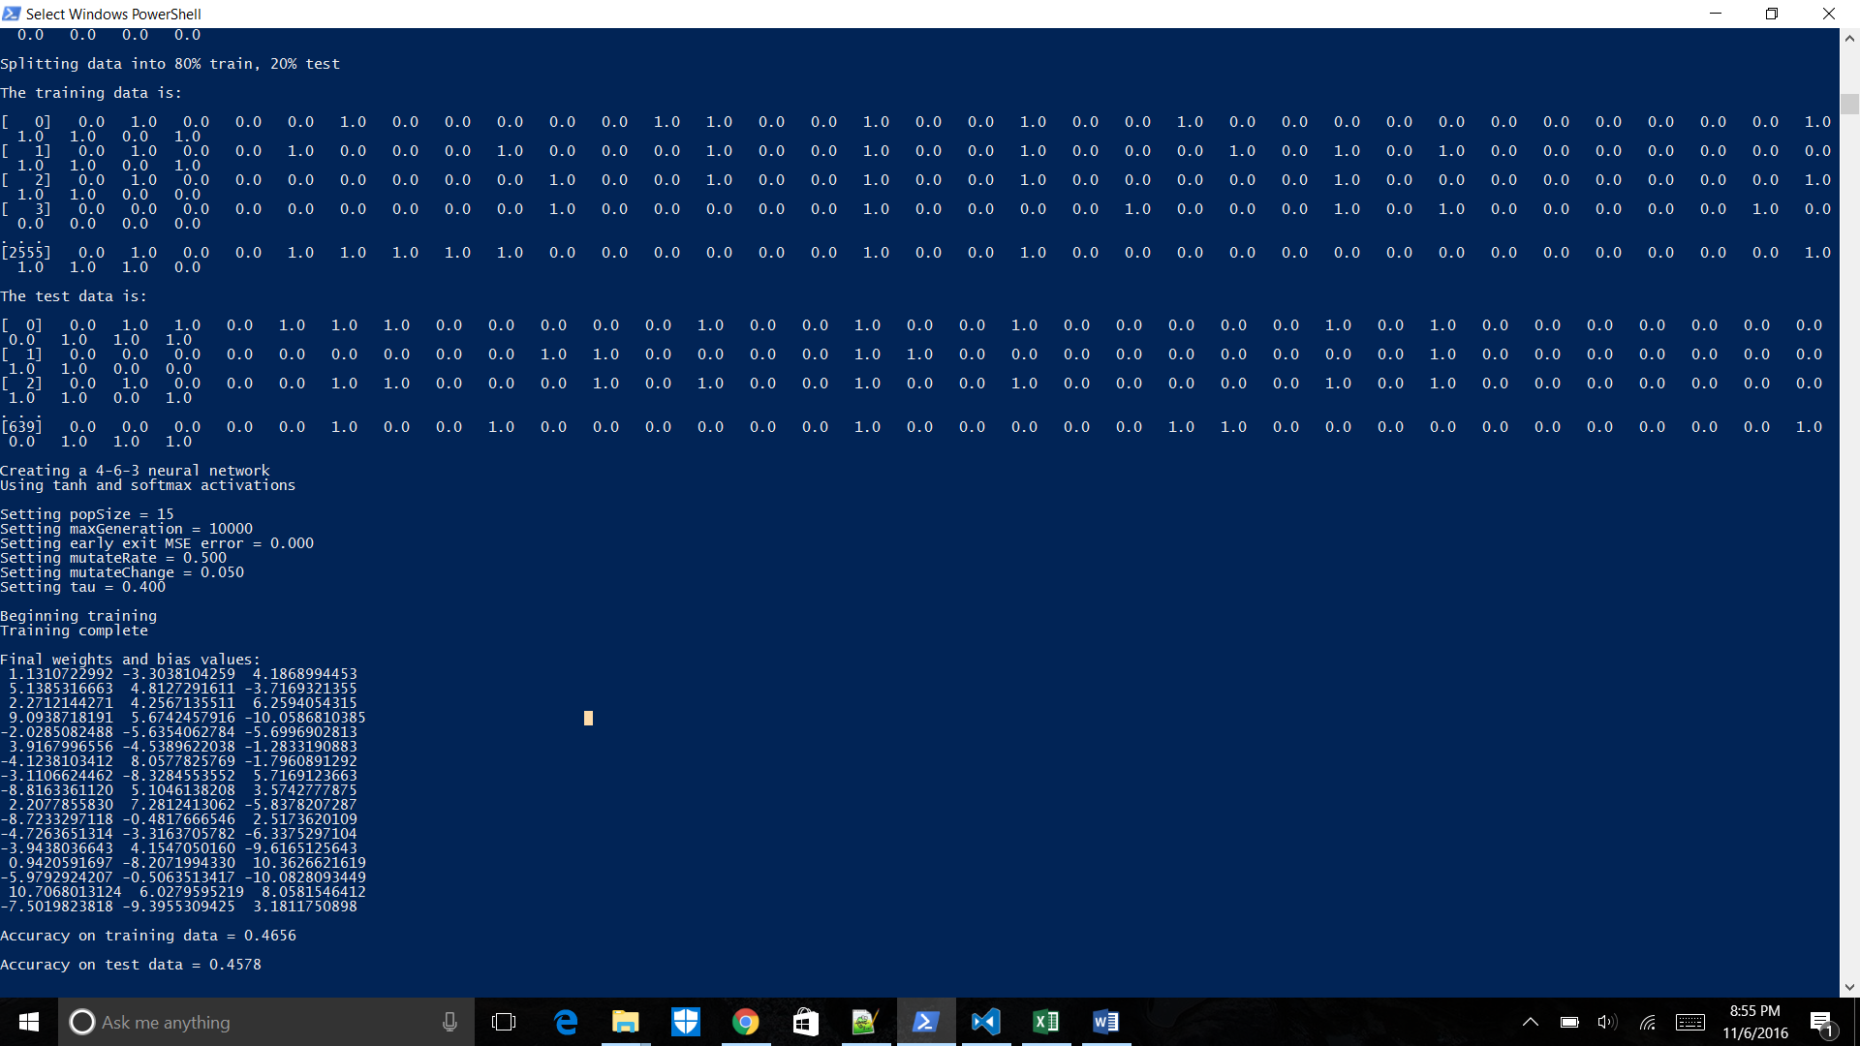

**Changing the number of Inputs:**

I gave the number of inputs as 15 and population size as 15. I have achieved an accuracy of 80% on test data.

**Screenshot of my result:**

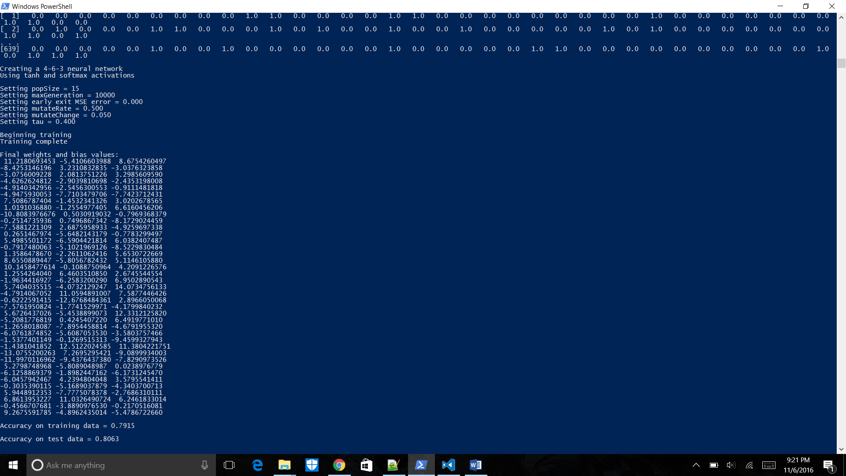

I ran into an exception by increasing the number of inputs to 100.

**Screenshot of Error output:**

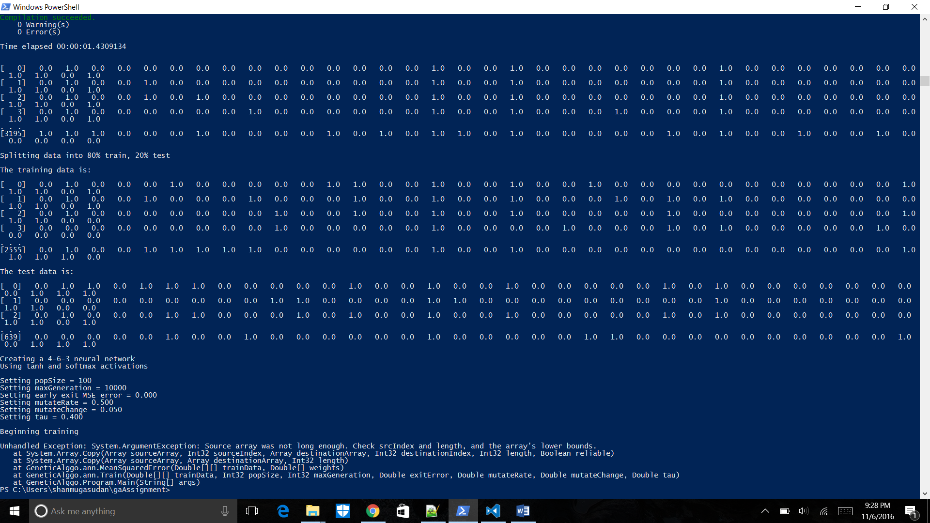

**Output for Input and Population size to 10:**

I have achieved an accuracy of 42% on running the number of inputs and population size 42.8%.

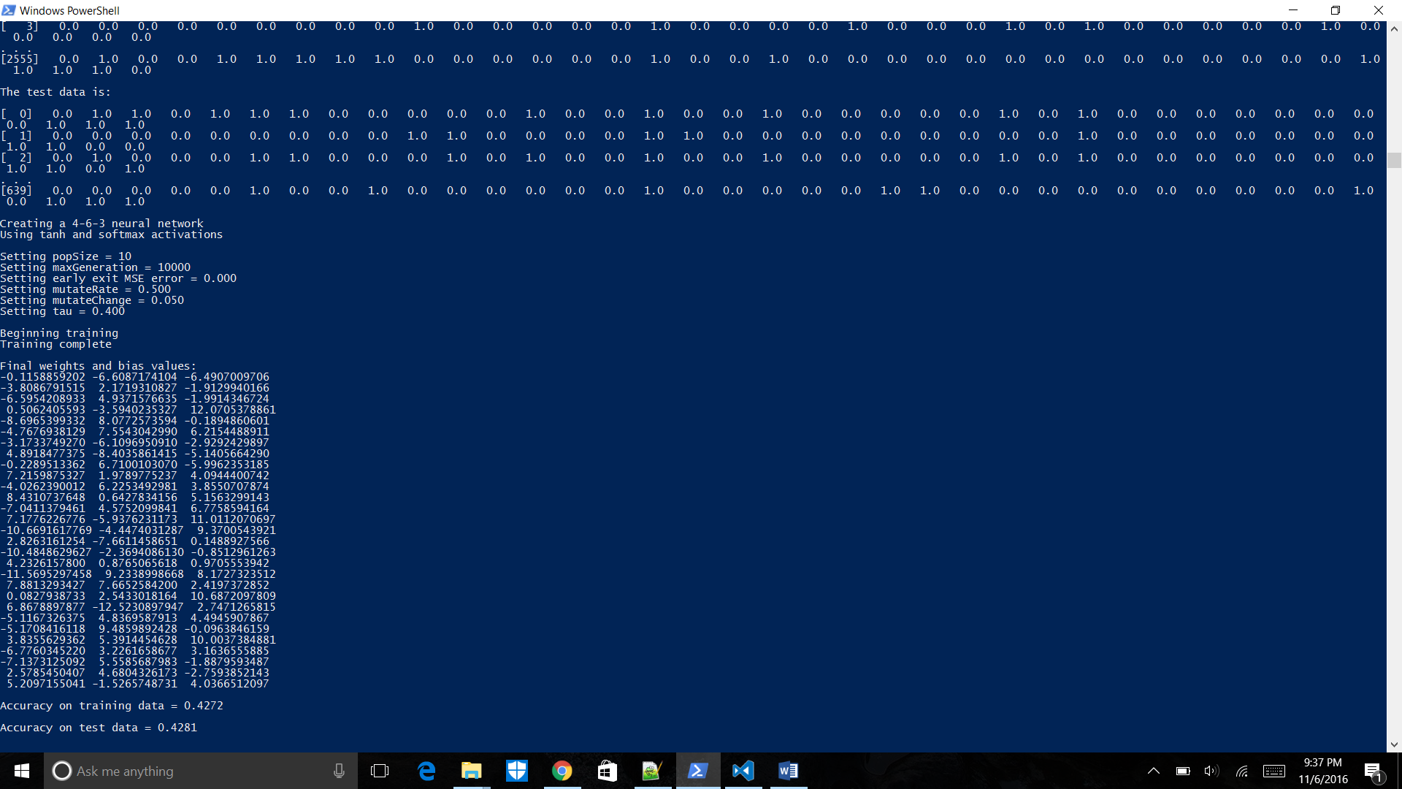

**Inference:** The Population size and number of inputs play a crucial role in Evolutionary Optimization.

Population size determines the neural network weights considered for the algorithm. Changing the population size impacts the solutions. My best accuracy was 80% on test data for population size as 15 and number of inputs 15.