- Header Images

- Navbar affixed with multi-level menus and menu on right(login)

- Carousel

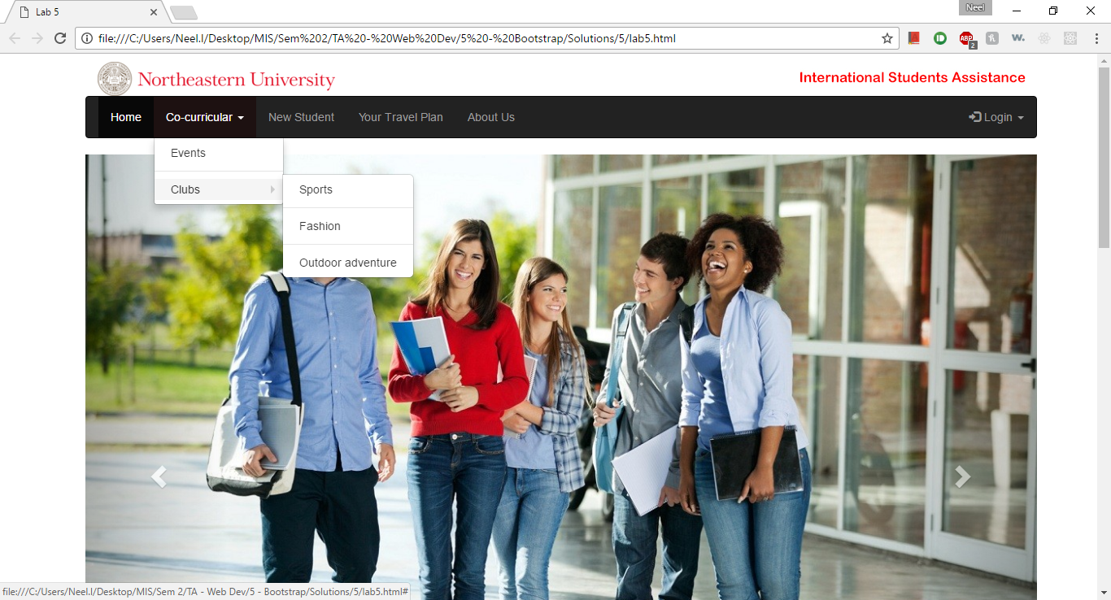

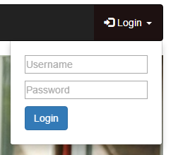

* Media elements (Image and video)

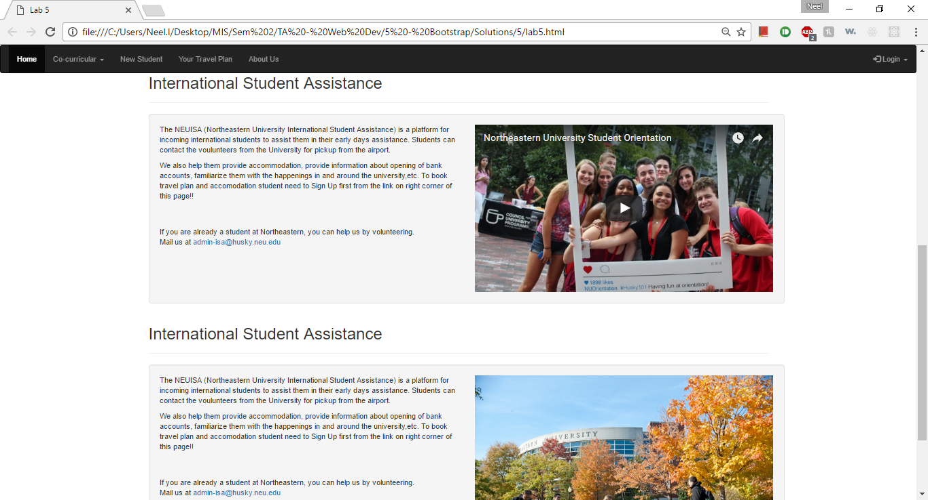

* Media Elements on tablet and phone views : (video pulled on top, image hidden)

