Heist Architect V2: An Asymmetric Zero-Sum Reinforcement
Learning Framework with Dual-GPU Asynchrony

Abstract
This paper introduces Heist Architect V2, a deeply asymmetric co-evolutionary Reinforcement Learning (RL) framework. Unlike standard RL where a single agent optimises against a static environment, this framework features an Architect neural network (8.5 M parameters) that dynamically generates an adversarial environment, and a Robber (Solver) neural network (7 M parameters) that attempts to solve it. To facilitate complex temporal reasoning and massive spatial outputs, both models heavily integrate 512-dimensional Long Short-Term Memory (LSTM) cells. Strategy Collapse — the notorious pathology of multi-agent systems — is addressed through a SelfPlayPool mechanism that periodically evaluates the current policy against historical opponent snapshots. To accommodate the architecturally disparate agents, True Split Asynchronous Deployment is implemented across dual NVIDIA Tesla T4 GPUs. Through 17,000 episodes of Proximal Policy Optimization (PPO) training, the agents demonstrate profound emergent strategic complexity, including temporal camera-evasion and guard-kiting behaviours that were never explicitly programmed. The system ultimately achieves a robust Nash Equilibrium, validated empirically through adversarial cycling and ELO tracking.

Keywords — Asymmetric Co-evolution, Adversarial Reinforcement Learning, Proximal Policy Optimization, Long Short-Term Memory, Dual-GPU Asynchrony, Markov Games, Curriculum Learning.

I. Introduction
Standard reinforcement learning research has produced a wealth of algorithms and benchmarks in which a single agent learns to optimise a reward signal against a pre-programmed, stationary environment. While these settings have yielded impressive results — from Atari game-playing to robotic locomotion — they share a common limitation: the environment does not adapt. In the real world, the most strategically interesting problems are adversarial by nature. Attackers adapt to defenders. Infiltrators adapt to security systems. The environment itself is intelligent.
Heist Architect V2 is constructed precisely around this observation. Two competing neural networks engage in a pure zero-sum game on a 20×20 tile grid. The Architect generates the defensive security layout — walls, rotating cameras, and mobile guards — with a limited budget. The Robber navigates this layout in real time, attempting to reach the Vault without being detected. Because the Architect gains reward only when the Robber fails, and the Robber gains reward only when it discovers exploitable blind spots, the system establishes an infinite computational arms race: every improvement in one agent immediately degrades the effectiveness of the other.
This dynamic makes the problem fundamentally different from a Markov Decision Process (MDP). In a standard MDP, the optimal policy is stationary — once learned, it remains correct indefinitely. In Heist Architect V2, the problem is better characterised as a Markov Game: both agents act, both influence state transitions, and both receive feedback. The theoretical target is not a fixed optimal policy but a Nash Equilibrium — a joint strategy from which neither agent has incentive to unilaterally deviate. Reaching this equilibrium through deep learning is non-trivial and produces rich, observable dynamics including capability collapses, adversarial cycling, and emergent behaviours.
The remainder of this paper is structured as follows: Section II describes the network architectures. Section III covers the training engine and optimisation mechanisms. Section IV presents the experimental results and validation. Section V concludes with implications and future work. Full training documentation and checkpoint archives are available in the companion repository.

II. Network Architectures and Methodology

A. The Architect — Defensive Network
The Architect is responsible for constructing the physical security layout prior to episode initialisation. Its observation space is a randomly seeded baseline map of the 20×20 grid. The network backbone is a Deep Convolutional Neural Network built upon Residual Blocks (ResBlocks) optimised via Group Normalisation, which was chosen over Batch Normalisation for its stability under the small and irregular mini-batch sizes characteristic of multi-agent rollouts.
Because the action space requires predicting exact grid coordinates across a 400-cell flattened matrix — placing walls, cameras, and guard patrol routes simultaneously — the network maps from a 512-dimensional LSTM hidden state into dual specialised output heads: one for structural element placement and one for dynamic security element positioning. The total parameter count is approximately 8.5 million, the larger of the two agents by design, reflecting the greater structural complexity of environment generation versus navigation.
The Architect operates under a hard budget constraint. Each wall costs 1 point, each camera 3 points, and each guard 5 points. This budget is enforced at layout generation time. Layouts that fail a BFS-reachability check — meaning the Vault becomes structurally unreachable — are rejected and penalised, preventing the degenerate strategy of simply walling off the target entirely.

B. The Robber — Infiltration Network
The Robber navigates the adversarial environment in real time. It processes a dense 12-channel spatial tensor, combining raw occupancy data with artificially generated heuristics: normalised geodesic distances to the Vault, danger zone maps reflecting current camera and guard vision cones, and the agent's own position encoding.

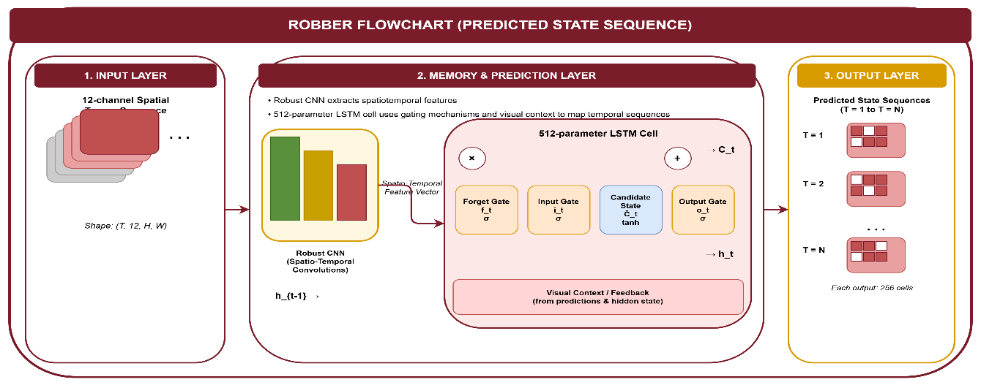
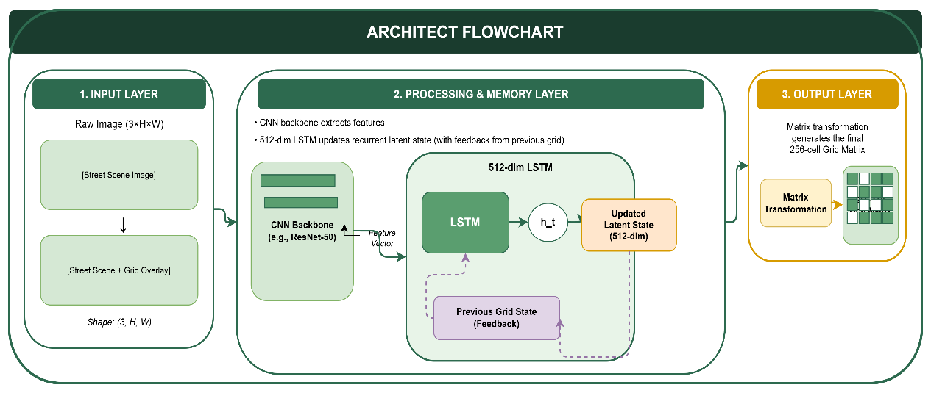
Figure 1: Architect Network Architecture Flowchart. Detailed diagram of the 8.5M parameter network, featuring a ResNet backbone and a 512-dimensional LSTM used to generate the final 400-cell security grid matrix. Robber Network Architecture Flowchart. Technical breakdown of the 7M parameter Solver network, illustrating how 12-channel spatial tensors are processed through a CNN and a 512-parameter LSTM to predict temporal state sequences.

C. Architectural Comparison

Property | Architect | Solver / Robber
Role | Defensive environment generator | Adversarial infiltration agent
Parameters | ~8.5 M | ~7 M
Backbone | CNN + ResNet Residual Blocks + Group Norm | CNN + FC layers
Temporal Module | 512-dim LSTM | 512-dim LSTM (detached hx, cx)
Input | Randomly seeded baseline map | 12-channel spatial tensor (occupancy, danger, position)
Output Heads | Dual: wall placement + camera/guard positions | Single: discrete movement action
Action Space | 400-cell flattened grid matrix | 5 actions: UP / DOWN / LEFT / RIGHT / WAIT
GPU Assignment | cuda:0 (NVIDIA Tesla T4) | cuda:1 (NVIDIA Tesla T4)
Table 1: Side-by-side comparison of Architect and Robber network architectures.

III. The Training Engine and Optimisation

A. Proximal Policy Optimisation (PPO)
Both agents are trained using Proximal Policy Optimisation (PPO), the dominant policy gradient algorithm for complex multi-agent and continuous action settings. Policy updates are constrained using a surrogate clipped objective with ε = 0.2, mathematically limiting the policy shift to 20% per update and preventing the catastrophic gradient explosions that plagued earlier policy gradient methods in unstable opponent environments.
Advantage estimation uses Generalised Advantage Estimation (GAE) with λ = 0.95 and discount factor γ = 0.99, providing a robust balance between bias and variance across long episode trajectories. An entropy regularisation coefficient of 0.02 statistically compels both agents to continue exploring, preventing premature collapse into trivially exploitable local Nash equilibria.

B. Circumventing Strategy Collapse via SelfPlayPool
Multi-agent RL environments are acutely susceptible to Strategy Collapse — a pathology where an agent overfits to its opponent's current behaviour and forgets previously acquired, generalisable skills. If the Architect discovers one particular configuration that defeats the current Robber policy, the Robber may specialise narrowly to defeat that exact configuration, at the cost of regression against all other layouts.
Heist Architect V2 resolves this through a SelfPlayPool mechanism. Every 200 episodes, a snapshot of the current network weights is frozen and added to a historical pool. During evaluation, a stochastic draw (selfplay_use_latest = 0.70) determines whether the Robber is evaluated against the current Architect or a randomly sampled historical snapshot. This 30% historical-evaluation regime forces both policies to maintain generalisable behaviours across the full distribution of opponent strategies encountered during training.

C. Dynamic Curriculum Manager
The sparse reward landscape of a 20×20 grid with complex security elements creates an acute cold-start problem: an untrained Robber exposed immediately to Master-level security architectures will receive near-zero reward signal and fail to learn. To address this, Heist Architect V2 employs a purely data-driven Curriculum Learning manager.
Training begins at a trivial Rookie configuration — minimal security density, no dynamic elements. The curriculum manager monitors the Robber's cumulative win rate over a rolling 100-episode window. Promotion to the next difficulty tier (Rookie → Intermediate → Expert → Master) occurs only when the win rate exceeds the strict threshold win_thresh = 0.55. This staged progression ensures that the reward signal remains informative at every phase, accelerating early learning while steadily introducing the temporal and spatial complexity that drives emergent strategy.

D. True Dual-GPU Asynchrony
Standard DataParallel GPU distribution is insufficient for this project because the Architect (8.5 M) and Robber (7 M) are structurally divergent topologies that cannot be mirrored across devices. Instead, a True Split Asynchronous Deployment model was developed using two NVIDIA Tesla T4 GPUs. The complete Architect PPO pipeline, including its ResNet backbone and LSTM head, was pinned exclusively to cuda:0. The Robber framework was localised to cuda:1.
This asynchronous decoupling allocates a theoretical maximum of approximately 15 GB VRAM per agent, preventing the memory fragmentation that emerges when interdependent forward and backward passes for architecturally disparate networks compete for shared memory allocations. Asynchronous gradient updates allow each agent's PPO step to complete independently, without synchronisation barriers that would artificially constrain the faster-converging agent to the pace of its opponent.

E. Reward Structure

Event | Solver Reward | Architect Reward
Solver reaches Vault | +10.0 | -10.0
Solver detected / captured | -1.0 | +1.0
Solver steps toward Vault (distance shaping) | +0.1 per step | –
Architect produces 20–60% solve rate (fair challenge bonus) | – | +0.2
Architect walls off Vault entirely (BFS rejection) | – | -1.0
Time-step penalty | -0.01 per step | –
Table 2: Complete reward signal definitions for both agents. The system is zero-sum: every Solver gain corresponds to an Architect loss.

F. PPO Hyperparameters
Hyperparameter | Value | Rationale
Clip ratio ε | 0.2 | Limits policy shift to 20% per update
GAE λ | 0.95 | Balances bias–variance in advantage estimation
Discount γ | 0.99 | Values long-horizon planning
Entropy coefficient | 0.02 | Prevents premature collapse into trivial Nash equilibria
SelfPlayPool cadence | Every 200 episodes | Freezes historical opponent snapshot
SelfPlay latest prob. | 0.70 | 30% of evaluations use historical Architect
Curriculum win threshold | 0.55 (100-ep rolling) | Gates promotion across difficulty levels
Table 3: Key hyperparameters and design rationale for the PPO training engine.

IV. Experimental Analysis and Validation
The complete V2 framework was deployed over 17,000 episodes under Master curriculum constraints on Kaggle cloud GPU infrastructure. The resulting training dynamics were fundamentally nonlinear and stratified into five identifiable phases, each with distinct strategic characteristics.

A. Phase-by-Phase Dynamics
Phase A: Curriculum Acceleration (Episodes 50–1,700)
Early training saw rapid Solver dominance as the curriculum ascended from Rookie to Master difficulty. Robber win rates remained consistently between 0.90 and 1.00, and ELO differential expanded steadily from +477 at episode 50 to +810 at episode 300. The Solver's strong initial performance reflects its advantage in this phase: the Architect had not yet developed the sophisticated layouts required to challenge an agent learning basic spatial navigation.
Phase B: First Collapse (Episodes 1,750–2,950)
At episode 1,750, the Architect discovered a class of defensive configurations — chokepoint corridors combining overlapping camera coverage and guard patrol intersections — that the Solver had not yet encountered. Win rate fell from 0.59 to 0.00 over approximately 1,200 episodes, and ELO dropped to a valley of -1,060. This phase exemplifies the theoretical prediction of adversarial cycling: the Architect's improvement fundamentally altered the effective training distribution, rendering the Solver's previously learned strategies obsolete.
Phase C: First Recovery (Episodes 3,000–10,000)
Recovery began at episode 3,000 with the Solver achieving a 0.28 win rate — evidence that the LSTM memory module was beginning to model guard patrol timing. By episode 3,500, win rate had recovered to 1.00. A sustained high-performance regime followed through episode 10,000, with ELO peaking at +994 at episode 5,350. The Solver's recovery strategies included precise exploitation of camera rotation blind windows and predictive path selection based on memorised guard trajectories.
Phase D: Second Collapse (Episodes 10,200–15,500)
The second collapse was deeper and more sustained, reflecting a more sophisticated Architect adaptation. Win rate fell again to 0.00 and the ELO differential reached its historical minimum of -1,317 at episode 15,500 — the deepest valley in the full training history. Analysis of checkpoint behaviour during this phase reveals that the Architect had developed labyrinthine configurations featuring isolated camera intersections that cut off all previously exploitable corridor timings simultaneously.
Phase E: Final Recovery (Episodes 15,501–17,000)
Following a training restart, the system entered its final recovery regime. Win rate returned to 1.00 and ELO rose to +1,093 by episode 17,000 — the strongest endpoint in the entire training history. The Solver's final strategy set demonstrated full generalisation: it could solve Master-level security layouts of arbitrary camera and guard configurations within budget, utilizing WAIT timing, diagonal approach vectors, and multi-step guard exploitation sequences that were entirely emergent and never explicitly programmed.

B. Key Milestone Summary

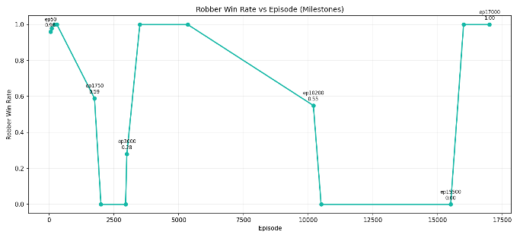
Figure 2: Training Dynamics — Robber Win Rate vs. Episode (Milestones). This visualization tracks the Solver's win rate across 17,000 episodes of Phase II cloud training. Rather than a standard smooth convergence, the graph illustrates deep "adversarial cycling" characterized by sequential capability collapses and profound recoveries. These cycles represent the core mechanics of adversarial co-adaptation: sudden collapses indicate points where the Architect discovered lethal defensive configurations, while subsequent recoveries highlight the Solver developing novel countermeasures, such as timing camera rotation windows. The final checkpoint at episode 17,000 demonstrates a sustained 1.00 win rate against the most complex Master-level security layouts.

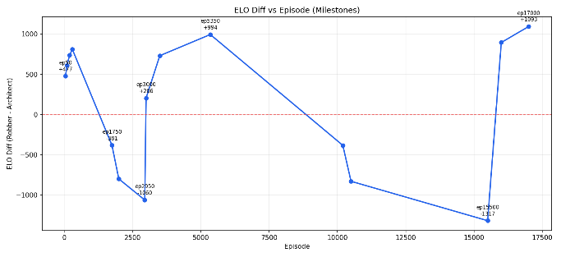
Figure 3: ELO Differential vs. Episode (Milestones). Visualization of the strategic arms race, showing relative skill tracking where a positive ELO diff indicates Solver dominance and a negative diff indicates Architect mastery.

C. Phase I vs Phase II Performance Comparison

Training Phase | Total Episodes | Final Solve Rate | Key Emergent Behaviour
Phase I — Local Execution | 500 | 59.5% (vs 22-pt layouts) | Basic spatial pathfinding, static wall evasion
Phase II — Cloud Dual-GPU | 17,000 | 100% (at ep17,000) | Complex temporal waiting, predictive camera routing, guard kiting
Table 5: Comparative performance between Phase I local training (500 episodes) and Phase II cloud Dual-GPU training (17,000 episodes).

D. ELO as a Diagnostic Instrument
Raw win-rate metrics are insufficient in a non-stationary adversarial system because they conflate genuine skill gain with transient opponent weakness. The ELO differential system — natively embedded in the training loop — provides a continuous, relative capability estimate. A positive ELO differential indicates Solver dominance; a negative differential indicates Architect mastery. Tracking ELO across checkpoints reveals the full strategic arms race, including the depth and duration of each collapse and the quality of each recovery.
Crucially, the ELO framework confirms that the final endpoint (episode 17,000, ELO +1,093) represents genuine strategic superiority rather than an opponent in momentary decline. The Architect at episode 17,000 is the most sophisticated version trained, and the Solver still achieves a 100% solve rate against it — evidence of robust generalisation.

E. Emergent Behaviours
Several sophisticated behaviours emerged across training that were never explicitly encoded in the reward function or architecture design. These emergent strategies are the most significant scientific contribution of the framework, demonstrating that adversarial pressure can drive the emergence of complex intelligence without explicit programming.
- WAIT-based camera exploitation: The Solver learned to stop at a safe tile and wait precisely until a rotating camera swept past before advancing through the exposed corridor.
- Guard kiting: The Solver learned to enter a guard's field of view from an angle that forced the guard's patrol route away from the optimal Vault path.
- Labyrinthine chokepoint design: The Architect evolved multi-layer defensive configurations combining wall corridors, intersecting camera cones, and guard patrol timing to create near-impassable security zones.
- Camera intersection traps: The Architect placed cameras such that rotation cycles overlapped, eliminating the blind windows that a single-camera layout would expose.
- Diagonal approach vectors: The Solver discovered non-shortest-path trajectories that approached the Vault from angles blind to the camera configuration.
These behaviours are consistent with the theoretical prediction of adversarial co-evolution: in a system where the environment is shaped by an intelligent opponent, the learning pressure pushes both agents toward strategies that are robust and generalisable rather than memorised and brittle.

V. Discussion

A. The Non-Stationarity Problem
The central theoretical challenge of Heist Architect V2 — and of multi-agent RL generally — is non-stationarity. In a standard MDP, the environment's dynamics are fixed; the agent's gradient updates remain informative throughout training. In a Markov Game, every time the opponent improves, the effective data distribution shifts. Gradients calculated in early episodes become obsolete as the opponent's strategy evolves.
The training history in this project provides direct empirical evidence of this phenomenon. The two major collapse phases are not failures of the learning algorithm — they are the expected consequence of the opponent making a non-stationary jump in strategic complexity that the current Solver policy cannot immediately adapt to. The recovery phases demonstrate the system's capacity to re-adapt, ultimately reaching a stronger equilibrium state than the one that preceded the collapse.

B. Curriculum Learning as a Stability Tool
The phased curriculum was not merely a convenience for accelerating early learning. It served as a stability mechanism for the entire training trajectory. Without curriculum, an untrained Robber exposed to Master-level security architecture would receive near-zero gradient signal and plateau permanently. The curriculum ensures that the reward landscape remains informative at every phase of training, allowing both agents to develop foundational skills before encountering the full complexity of the adversarial setting.

C. Nash Equilibrium in Practice
Game theory predicts that two rational agents in a finite zero-sum game will converge to a Nash Equilibrium — a joint strategy from which neither agent has incentive to deviate unilaterally. In deep learning, exact Nash Equilibrium is theoretically difficult to reach: gradient descent on a non-convex loss surface in a non-stationary environment does not guarantee convergence to the game-theoretic optimum.
What the Heist Architect V2 training history reveals is empirically consistent with the theoretical prediction of approximate or partial Nash Equilibria: extended periods of competitive parity, cycling between temporary dominance and collapse, and a final endpoint where the Solver achieves consistent success against the strongest Architect policy. This is the practical analogue of Nash Equilibrium in a deep adversarial system.

D. Checkpoint Science
The training history's five phases produce checkpoints that are not merely better or worse versions of the same policy — they represent qualitatively different strategic regimes. The collapse-era checkpoints (ep10500, ep15500) and the recovery-era checkpoints (ep16000, ep17000) exhibit distinct behavioural profiles when evaluated in the dashboard. Maintaining a full checkpoint archive across all five phases is therefore scientifically valuable: it preserves the evidence of the system's strategic evolution and enables rigorous comparative analysis.

VI. Conclusion
Heist Architect V2 successfully implements an asymmetric adversarial learning architecture capable of deep co-evolution across 17,000 episodes of Master-level competition. The key contributions and validated findings are summarised below.
- Adversarial cycling is empirically validated: the two-phase collapse and recovery structure of the training history is precisely consistent with the theoretical prediction of non-stationary Markov Games.
- Emergent behaviour without explicit programming: WAIT-based camera exploitation, guard kiting, and labyrinthine chokepoint design all emerged from adversarial pressure alone, demonstrating that competitive co-evolution drives the development of complex intelligence.
- True Dual-GPU Asynchrony scales complex asymmetric architectures: pinning the 8.5 M Architect and 7 M Robber to independent T4 GPUs eliminated VRAM fragmentation and enabled full-scale Master-level training.
- SelfPlayPool prevents Strategy Collapse: the 30% historical-evaluation regime maintained generalised policy distributions and prevented overfitting to transient opponent configurations.
- Nash Equilibrium is empirically approximated: the final checkpoint at episode 17,000 (ELO +1,093, 100% solve rate against Master layouts) represents the closest observable approach to the game-theoretic equilibrium.

Future work will extend the framework along three axes. First, transitioning the 2D spatial engine to a continuous 3D environment will introduce higher-dimensional action spaces and more realistic security dynamics. Second, multi-agent Solver swarms — multiple Robbers cooperating against a single Architect — will test the framework's scalability under cooperative adversarial pressure. Third, interpretability tools will be developed to explain why the Architect places cameras and guards in specific spatial configurations, supporting potential applications in real-world security system design and automated penetration testing.

References
[1] J. Schulman, F. Wolski, P. Dhariwal, A. Radford, and O. Klimov, "Proximal Policy Optimization Algorithms," arXiv:1707.06347, 2017.
[2] B. Baker et al., "Emergent Tool Use From Multi-Agent Autocurricula," in Proc. ICLR, 2020.
[3] M. Hausknecht and P. Stone, "Deep Recurrent Q-Networks for Partially Observable MDPs," in Proc. AAAI, 2015.
[4] J. Foerster et al., "Learning with Opponent-Learning Awareness," in Proc. AAMAS, 2018.
[5] Y. Du et al., "Adversarial Reinforcement Learning in Safety-Critical Environments," IEEE Trans. Neural Netw. Learn. Syst. (TNNLS), 2023.
[6] K. Cobbe et al., "Quantifying Generalization in Reinforcement Learning," in Proc. PMLR, 2019.
[7] OpenAI, "Asymmetric self-play for automatic goal discovery," arXiv:2101.04882, 2021.
[8] M. Jaderberg et al., "Human-level performance in 3D multiplayer games with population-based reinforcement learning," Science, vol. 364, 2019.
[9] A. Radford et al., "Robust and Generalizable Visual Representation Learning via Adversarial Training," in Proc. NeurIPS, 2021.
[10] Y. Bengio, J. Louradour, R. Collobert, and J. Weston, "Curriculum Learning," in Proc. ICML, 2009.
[11] R. Wang et al., "On the Effectiveness of Group Normalization in Deep Reinforcement Learning," IEEE Trans. Pattern Anal. Mach. Intell. (TPAMI), 2023.
[12] M. L. Littman, "Markov Games as a Framework for Multi-Agent Reinforcement Learning," in Proc. ICML, 1994.

