**LOW ERROR EFFICIENT APPROXIMATE**

**ADDERS FOR FPGAs**

**LEADx:**

**RTL schematic:**

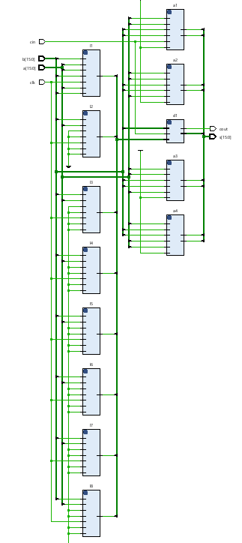

**Technology Schematic:**

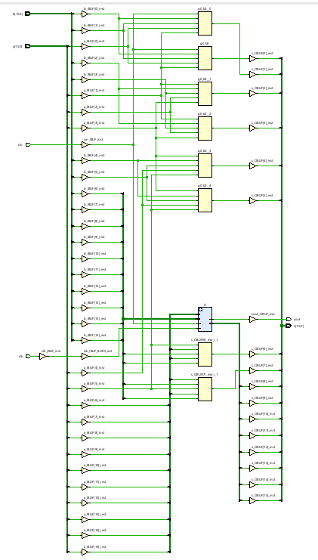

**Simulation results:**

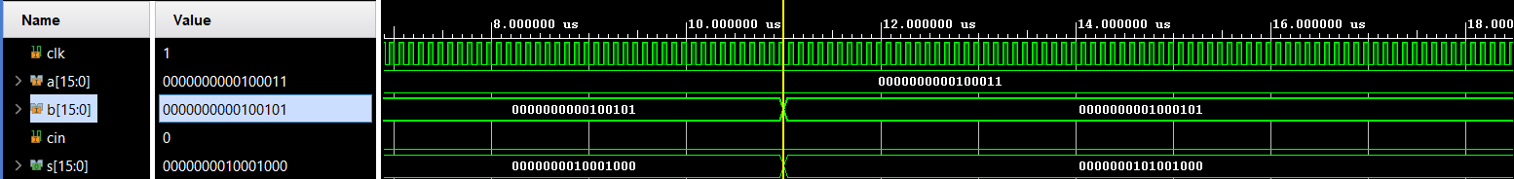

**Area:**

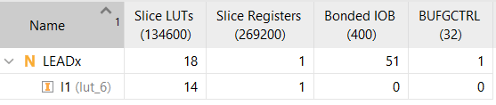

**Delay:**



**Power:**

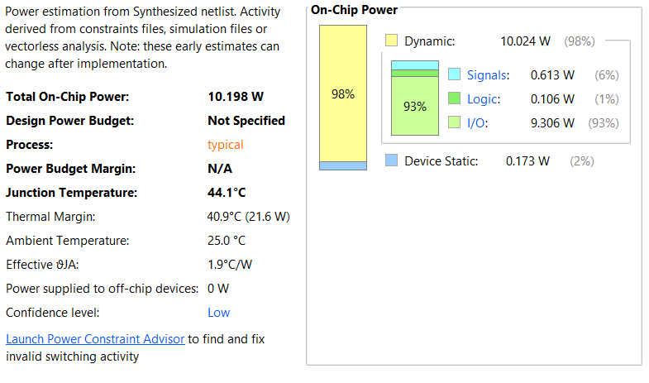

**APEx:**

**RTL schematic:**

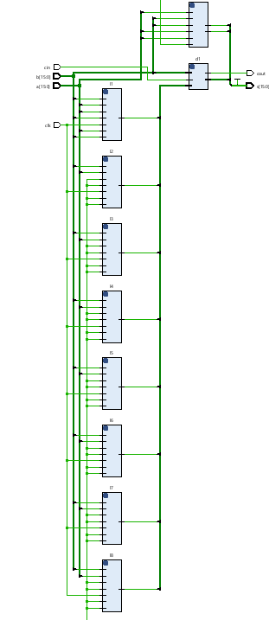

**Technology Schematic:**

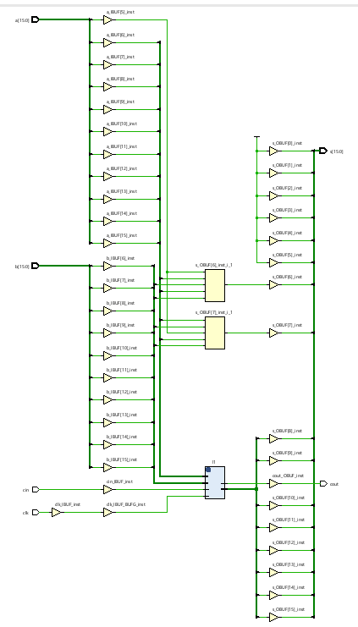

**Simulation results:**

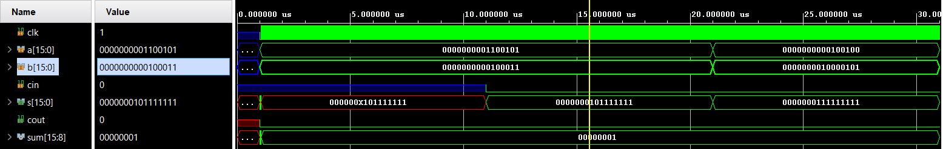

**Area:**

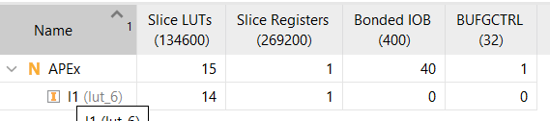

**Delay:**



**POWER:**

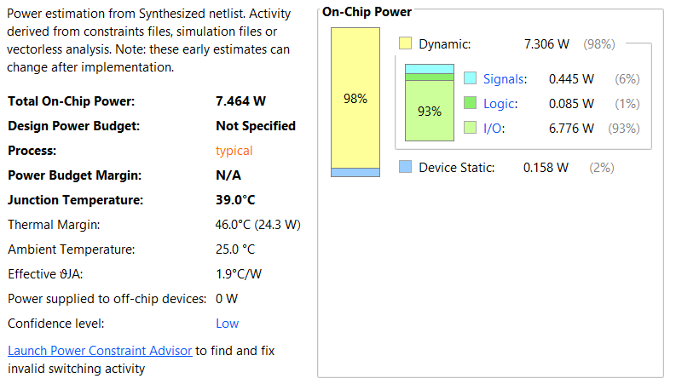

**Evaluation table:**

|  |  |  |  |
| --- | --- | --- | --- |
|  | **Area (LUT’s)** | **POWER** | **Delay (ns)** |
| **LEADx** | 18 | 10.198 | 6.511 |
| **APEx** | 15 | 7.464 | 6.511 |