Vibe Coding (AI-Assisted Development)
What is it?
Vibe coding refers to using AI tools to rapidly build, iterate, and refine ideas—especially useful in fast-paced environments like hackathons.
Why it’s useful:
- Helps non-technical participants turn ideas into working prototypes
- Speeds up development and debugging
- Enables rapid experimentation
- Reduces the need for deep coding expertise

Using Claude as a Coding Assistant

Why choose Claude?
- Strong coding capabilities – Handles complex programming tasks effectively
- Long context understanding – Remembers and works with large codebases
- Better refactoring – Improves and restructures code efficiently
- Agentic capabilities – Can take multi-step actions and assist in workflows

Setting Up Claude in VS Code

Steps:
- Install Claude (CLI or extension depending on your setup)
- Open VS Code terminal
- Start Claude by typing:
claude
- A new session will start

Basic Commands
- Switch to command mode / interact properly
Use: Shift + 1 (as per your setup)
- Exit session
/exit
- Resume a previous session
claude --resume 5228b49c-d630-4979-9f28-80b7d64f8399

Tips for Hackathons
- Start by describing your idea clearly to Claude
- Ask for:
  - Project structure
  - Boilerplate code
  - Step-by-step implementation
- Use it to:
  - Debug errors
  - Refactor messy code
  - Add features quickly

🚀 Slash Commands in Claude Code

🔹 What are Slash Commands?
Slash commands are special commands that start with / and let you control Claude Code quickly and efficiently.
They:
- Trigger actions instantly
- Remove the need for long prompts
- Make workflows faster and more structured

🔹 Why Use Slash Commands?
- Instantly trigger predefined workflows
- Save time (especially in hackathons)
- Reduce repetitive typing
- Gain better control over AI sessions

🔹 Types of Slash Commands

1. Built-in Commands
Pre-installed commands available by default.
Examples:
- /exit → Ends the current session
- /compact → Compresses/reduces context
- /context → Shows current context usage
- /help → Lists all available commands
Use Case:
Quick session management and utilities.

2. Custom Commands
User-defined commands created for specific workflows.
Purpose:
- Automate repetitive tasks
- Create shortcuts for complex instructions
- Standardize team workflows
Examples:
- /build-app → Generate full project structure
- /fix-bug → Debug and suggest fixes
- /optimize → Refactor and improve code

🔹 Key Benefits
- Faster task execution
- Cleaner workflow
- Consistent results
- Better collaboration in teams

🧠 Sessions in Claude Code

🔹 What is a Session?
A session is a continuous interaction where Claude:
- Remembers your conversation
- Tracks your code and changes
- Maintains context
👉 Think of it as a working memory or workspace

🔹 How a Session Works
During an active session, Claude:
- Remembers previous prompts
- Tracks code updates
- Maintains context automatically
👉 So you don’t need to repeat instructions every time.

🔹 How a Session Starts
Run in terminal:
claude
This:
- Starts a new session
- Begins tracking inputs and context

🔹 Resuming a Session

Using Full Command:
claude --resume <session-id>

Example:
claude --resume 5228b49c-d630-4979-9f28-80b7d64f8399
Restores:
- Previous conversation
- Code context
- Work progress

🔹 Ending a Session
Use:
/exit
This:
- Ends the session
- Clears active memory
- Session can still be resumed later if saved

🔹 Why Sessions Matter
- Maintain continuity in projects
- Essential for large codebases
- Improve suggestion accuracy
- Help debugging and iteration

🔹 Simple Analogy
- Session = Workspace/Tab
- claude = Open new tab
- --resume = Reopen old tab
- /exit = Close tab

⚡ claude -r (Shortcut for Resume)

🔹 What it is
A shorthand for:
claude --resume <session-id>

🔹 Usage
claude -r <session-id>

🔹 What it Does
- Reopens a previous session
- Restores:
  - Conversation history
  - Code context
  - Progress

🔹 Why Use -r
- Faster to type
- Useful in hackathons
- Same functionality as --resume

🔄 /resume Command (Inside Claude)

🔹 What it Does
Used inside an active session to switch or continue another session.

🔹 Usage
/resume <session-id>

🔹 Example
/resume 5228b49c-d630-4979-9f28-80b7d64f8399

🔹 When to Use /resume
- Already inside Claude
- Want to:
  - Switch projects
  - Recover earlier work
  - Change context without exiting

Important Difference
Command | Where Used | Purpose
claude -r | Terminal | Resume session directly
/resume | Inside Claude | Switch session internally

🔹 Important Notes
- /resume works only inside Claude
- claude -r works from terminal
- Use /exit to end session

✏️ /rename Command

🔹 What it Does
Renames the current session.
Syntax:
/rename [name]
Example:
/rename auth-module-debug

🔹 Why It’s Important
- Helps organize sessions clearly
- Makes it easier to identify work later
- Improves workflow in multi-project environments
If you don’t rename:
- Claude automatically uses the initial conversation as the session name

🔹 How to Verify
To view and access sessions:
claude -r
This allows you to:
- See available sessions
- Identify them by name
- Resume the correct one quickly

/btw Command (Short Explanation)
/btw <question> is a quick side-question command.

✅ What it does:
- Lets you ask something without adding it to the main conversation context
- Keeps your primary workflow clean and focused

🧠 Why it’s useful:
- Avoids cluttering your session
- Prevents unnecessary context buildup
- Great for small, unrelated doubts

Important Behavior
- If you press Space bar or Enter without continuing the command properly, the /btw input is not kept in the active session workflow
- It effectively disappears from the working context, since it is treated as a non-session interaction rather than part of the main task flow

🔹 /export Command (Claude Code)

✅ What it does:
/export is used to save or export your current session data or conversation state from Claude Code.

🧠 Uses (in short):
- Saves session history externally
- Helps back up important conversation
- Useful for sharing work or debugging later
- Preserves context outside the active session

💡 Why it’s useful:
- Prevents loss of important work
- Good for documentation and handovers
- Helps review or continue work later in another environment

👉 In simple terms:
/export = Save your Claude session for later use or sharing

/logout Command (Claude Code)

✅ What it does:
/logout is used to sign out of your Claude Code session/account.

🧠 Uses (in short):
- Ends your authenticated session
- Disconnects Claude from your account
- Helps switch users safely
- Useful on shared or public machines

⚠️ What happens after:
- You will need to log in again to start a new session
- Current session access is stopped

👉 In simple terms:
/logout = safely exit your Claude account/session

• Opus → Most powerful, best for complex reasoning and deep coding, but slower and expensive
• Sonnet → Balanced (speed + intelligence), best for most everyday development work
• Haiku → Fastest and lightest, best for simple tasks and quick answers
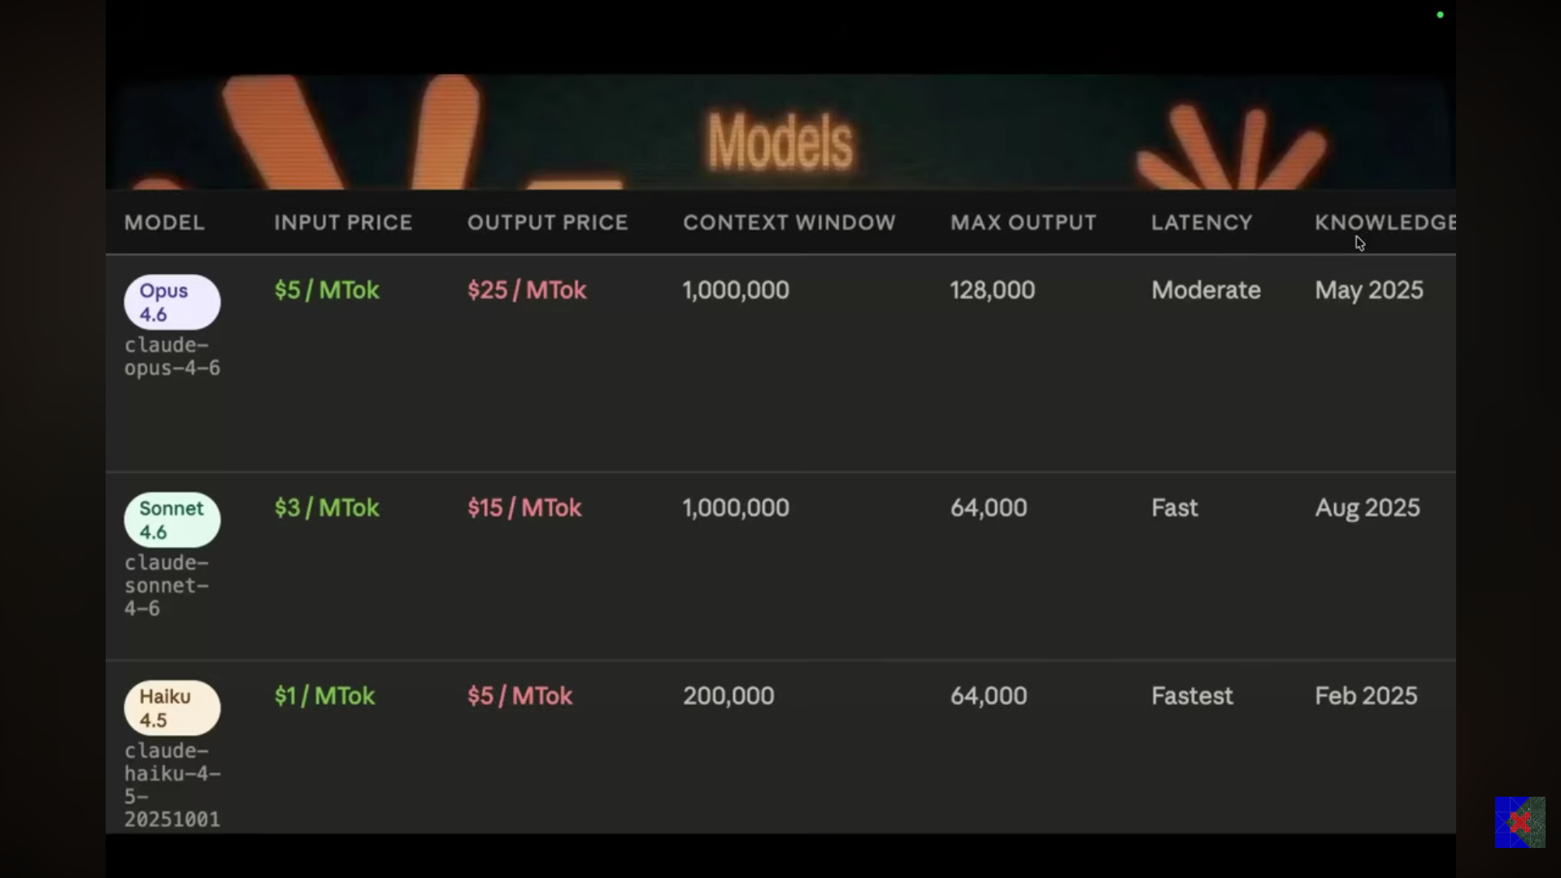
Opus = Think & Design
Sonnet = Build & Execute

🔹 /models
Shows available Claude models (Opus, Sonnet, Haiku) and lets you see/select what you can use.

🔹 /usage
Shows your current usage (tokens/limits) in the session.

👉 In short:
- /models = available AI models
- /usage = how much you’ve used

/extra-usage

What it does:
Allows continued usage after hitting plan limits by enabling paid extra usage (pay-as-you-go).
/stats = your Claude usage analytics dashboard

/insights

✅ What it does:
Analyzes your last ~30 days of Claude Code activity and generates a report of your coding behavior.

/config — opens a UI dialog to change Claude Code settings like:
- Model selection
- Theme
- Auto-compact behavior
- Other preferences

/permissions — shows and manages what tools/actions Claude is allowed to run without asking for
your approval (the allowlist). You can add or remove permissions for things like bash commands,
file edits, etc.

Both are just interactive UI shortcuts for things you could also edit directly in settings.json.

