Semantic Segmentation Failure Analysis, Label Free Failure Detection Documentation
Prepared 5 July 2026

Overview
- The model trains on LoveDA, which covers China at 0.3 m per pixel, but inference can run on aerial imagery from anywhere on earth where no labels exist, so this stage adds tools that flag likely failures without any ground truth.
- The work falls into three parts, namely the per pixel uncertainty signals, a whole image novelty detector, and a validation harness that can later measure whether the signals truly predict error, including on imagery from another continent.
- A speed fix for the free Colab T4 GPU was also baked into the training notebook, which enabled the retrain and the validation runs that followed on 8 July.

Label free failure signals
- analysis/uncertainty.py computes per pixel maps in the 0 to 1 range. Predictive entropy is high where the model spreads probability over many classes. Margin risk is high where the top two classes compete. The failure score blends entropy, margin risk and confidence shortfall into one heatmap of where the model is least trustworthy.
- analysis/ood.py adds novelty detection. Backbone features are pooled to one 2,048 dimensional vector per window, a Gaussian with a shrunk covariance is fit over 300 training tiles, and the Mahalanobis distance of a new scene is converted to a percentile rank against the training distances. A high score marks scenes unlike anything in training, where even confident predictions deserve doubt.
- scripts/fit_ood.py builds that reference once per checkpoint. scripts/scan_failures.py scans any folder of images by sliding a window at native resolution, which preserves the 0.3 m ground sample distance, then stitches the maps and writes per image panels, rankings and a report of the least trustworthy images. The upload app shows the same maps plus a plain language novelty verdict whenever no ground truth is uploaded.
The scanner writes panels like the one below, taken from the demo scan over six LoveDA validation tiles. The failure score and entropy maps light up along field boundaries and mixed settlement, exactly the regions the labeled analysis flags, and the per image mean failure score spread from 0.01 on an easy uniform scene to 0.43 on the hardest agricultural mosaic, so the ranking separates trustworthy tiles from risky ones without any labels.
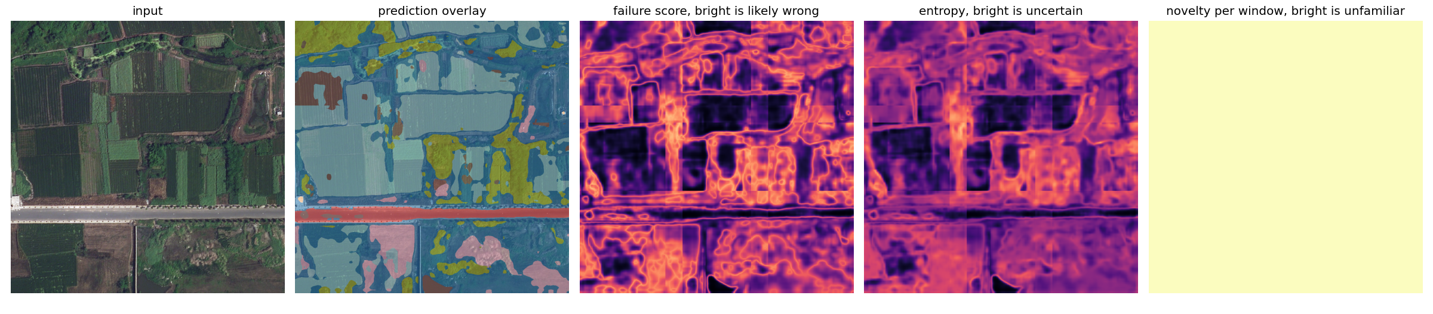
Scanner panel for the least trustworthy demo tile

Validation harness and the cross domain plan
- scripts/validate_signals.py runs the signals on a labeled split and measures whether they rank wrong pixels above correct ones, reporting AUROC, AUPR, risk coverage area and the per image Spearman correlation between mean signal and true error rate.
- The genuine test is geographic domain shift. ISPRS Potsdam covers a German city at 0.05 m per pixel with six classes. analysis/validation.py maps its classes onto LoveDA classes (impervious surfaces to road, buildings to building, low vegetation to background, trees to forest, cars and clutter ignored) and scripts/prepare_potsdam.py cuts the orthophotos into 2,304 pixel patches, which land back at 0.3 m per pixel once resized to the 384 network input.
- The harness accepts a baseline per image file from an in domain run, so a later cross domain run can compare its novelty scores against the in domain distribution directly.

Colab speed fix
- The June training run took roughly 4 hours for 15 epochs on the free T4, so the notebook now enables mixed precision, trains at image size 384 and raises the batch size to 8. The retrain on 8 July confirmed the gain, finishing the same 15 epochs in 39 minutes.

References
Anthropic. “Claude Code.” Accessed July 5, 2026. https://claude.com/claude-code.
Lee, Kimin, Kibok Lee, Honglak Lee, and Jinwoo Shin. “A Simple Unified Framework for Detecting Out-of-Distribution Samples and Adversarial Attacks.” NeurIPS, 2018. Accessed July 5, 2026. https://arxiv.org/abs/1807.03888.
scikit-learn developers. “sklearn.metrics.roc_auc_score.” Scikit-learn documentation. Accessed July 5, 2026. https://scikit-learn.org/stable/modules/generated/sklearn.metrics.roc_auc_score.html.

