Urban Segmentation ISPRS (Kaggle), Dataset Documentation
Prepared 8 July 2026

Overview
- This dataset supplies labeled out of domain imagery for the cross domain validation of the label free failure signals, since the model trains on LoveDA covering China at 0.3 m per pixel and is tested here on a German city it has never seen.
- The data came from a Kaggle mirror of the ISPRS 2D Semantic Labeling benchmark as a 7 GB zip, which was used because the official ISPRS download page has moved and its old URL now returns 404.
- Only the Potsdam folder is used, because the Toronto folder in the same zip has no labels and the Vaihingen folder is infrared false color rather than RGB.

1. Files used

Potsdam/Images
- This folder holds 38 RGB orthophotos named top_potsdam_X_Y_RGB.tif.
- Each tile is 6000 by 6000 pixels and about 104 MB.
- The ground sample distance is 0.05 m per pixel.
- The content is a true orthophoto mosaic of Potsdam, Germany, a historic city center with large buildings, narrow streets and dense settlement.

Potsdam/Labels
- This folder holds 38 label images named top_potsdam_X_Y_label.tif, one per orthophoto with a matching name and size.
- The labels are RGB color coded, so every pixel carries one of six class colors that the loader decodes into class indices.

2. Label encoding and the mapping onto LoveDA
Cars and clutter have no LoveDA counterpart and are ignored during validation, so metrics are computed on the remaining pixels.
index | class | color | mapped LoveDA class
0 | impervious surface | white 255,255,255 | road
1 | building | blue 0,0,255 | building
2 | low vegetation | cyan 0,255,255 | background
3 | tree | green 0,255,0 | forest
4 | car | yellow 255,255,0 | ignored
5 | clutter | red 255,0,0 | ignored

3. Derived patches (data/raw/PotsdamPatches)
- The patches were built by scripts/prepare_potsdam.py on 8 July 2026, with whole photos assigned per split so no scene leaks between train and val.
- The patch size is 2304 pixels, chosen so the resize to the 384 network input lands at 0.3 m per pixel and matches the LoveDA ground sample distance.
- The split gives 30 photos to train and 8 to val at a val fraction of 0.2, cutting 4 patches per photo.
- This yields 120 train patches and 32 val patches, saved as PNG image and label pairs under train/images, train/labels, val/images and val/labels.
A sample validation patch is shown below next to its color coded label, before the resize to the network input. The white impervious surfaces, blue buildings, cyan low vegetation and green trees are visible directly in the label colors.
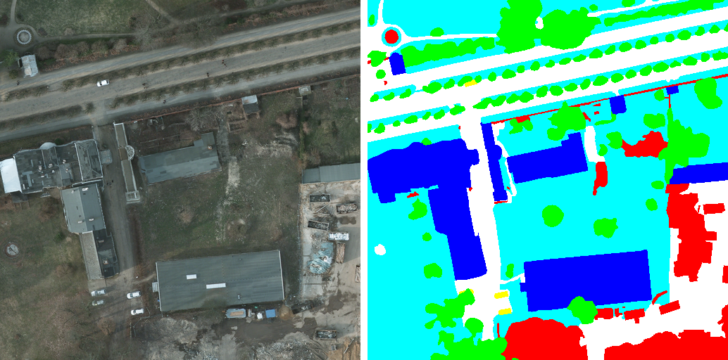
Sample Potsdam validation patch and its label

References
Anthropic. “Claude Code.” Accessed July 8, 2026. https://claude.com/claude-code.
International Society for Photogrammetry and Remote Sensing. “2D Semantic Labeling Contest, Potsdam.” Accessed July 8, 2026. https://www.isprs.org/resources/datasets/benchmarks/UrbanSemLab/2d-sem-label-potsdam.aspx.
Kaggle. “Urban Segmentation ISPRS.” Accessed July 8, 2026. https://www.kaggle.com/datasets/aletbm/urban-segmentation-isprs.

