Semantic Segmentation Failure Analysis, Validation Results Documentation
Prepared 8 July 2026

Overview
- This final stage retrains the baseline with the Colab speed fix from 5 July and then runs the full validation of the label free signals, first on the LoveDA validation split in domain and then on German Potsdam imagery as a genuine cross domain test.
- The official ISPRS download page moved and the old link now returns 404, so the Potsdam data came from a public Kaggle mirror as a 7 GB zip, and local patch cutting produced 120 training and 32 validation patches. A separate dataset document describes the files, the label encoding and the patch pipeline.
- The central claim of the project held, because every pixel level signal kept an AUROC near 0.71 on Potsdam, as high as in domain, while the whole image novelty detector failed to recognize the domain shift, which is an honest negative result worth reporting.

Retrained baseline
The notebook now trains with mixed precision at image size 384, finishing 15 epochs in 39 minutes on the T4 against roughly 4 hours before the fix. Scores on the LoveDA validation split improved slightly over the June baseline.
- The choice of 15 epochs fits a free Colab T4 session comfortably, and the June run showed validation loss creeping up after epoch 10 while train loss kept falling, so more epochs would buy overfitting rather than accuracy. The cosine schedule decays the learning rate from 5e-4 to near zero across exactly these 15 epochs, and the best checkpoint is kept by validation mIoU rather than by the last epoch.
metric | June 22 run | July 8 run
mean IoU | 0.5019 | 0.5066
pixel accuracy | 0.6936 | 0.6951
mean F1 | 0.6553 | 0.6613
Per epoch log of the July 8 run. The best validation mIoU lands at epoch 14 and that checkpoint is the one kept. The last epochs change little because the cosine schedule has nearly reached zero.
epoch | train loss | val loss | mIoU | pixel acc | lr
1 | 1.3699 | 1.0166 | 0.4273 | 0.6144 | 0.000500
2 | 1.1139 | 1.0442 | 0.4247 | 0.6435 | 0.000495
3 | 1.0485 | 0.9163 | 0.4669 | 0.6602 | 0.000478
4 | 1.0072 | 1.0554 | 0.3956 | 0.6354 | 0.000452
5 | 0.9603 | 0.9906 | 0.4420 | 0.6222 | 0.000417
6 | 0.9059 | 0.9250 | 0.4737 | 0.6855 | 0.000375
7 | 0.8925 | 0.9318 | 0.4761 | 0.6660 | 0.000327
8 | 0.8434 | 0.8583 | 0.4827 | 0.6862 | 0.000276
9 | 0.8167 | 0.9229 | 0.4904 | 0.6888 | 0.000224
10 | 0.7951 | 0.8602 | 0.5005 | 0.6943 | 0.000173
11 | 0.7525 | 0.9577 | 0.4938 | 0.6854 | 0.000125
12 | 0.7081 | 0.8895 | 0.4941 | 0.6910 | 0.000083
13 | 0.6813 | 0.9185 | 0.5039 | 0.6904 | 0.000048
14 | 0.6641 | 0.9329 | 0.5066 | 0.6951 | 0.000022
15 | 0.6539 | 0.9780 | 0.5009 | 0.6906 | 0.000005
Per class scores on the validation split, July 8 checkpoint. The same rare class weakness and boundary gap (boundary mIoU 0.31 against interior 0.58) persist, confirming the June failure modes.
class | IoU | precision | recall | F1
background | 0.527 | 0.603 | 0.808 | 0.691
building | 0.613 | 0.710 | 0.818 | 0.760
road | 0.540 | 0.845 | 0.600 | 0.702
water | 0.684 | 0.778 | 0.849 | 0.812
barren | 0.249 | 0.607 | 0.297 | 0.398
forest | 0.397 | 0.613 | 0.529 | 0.568
agriculture | 0.536 | 0.881 | 0.577 | 0.698
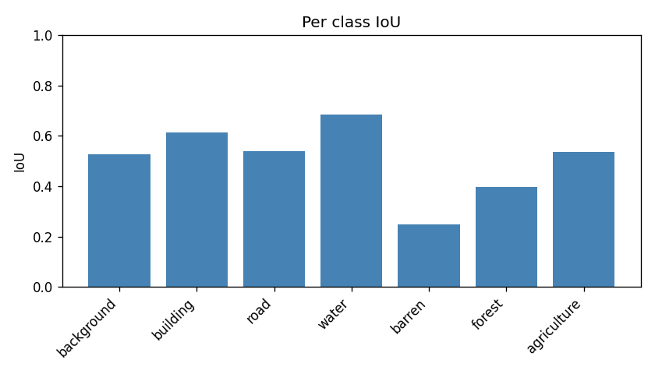
Per class IoU on the LoveDA validation split
The macro precision of 0.72 against a macro recall of 0.64 shows the model errs toward caution overall, and the confusion matrix shows where the wrong pixels go, as barren and forest drain into background while agriculture loses cropland pixels to background as well.
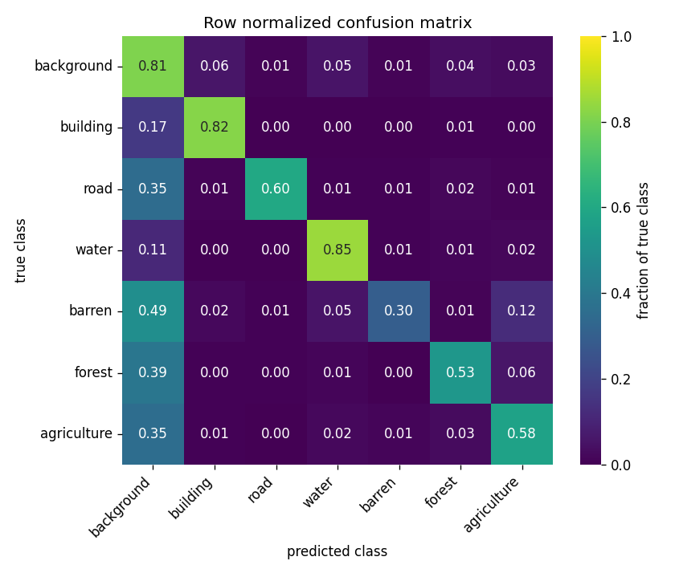
Confusion matrix on the validation split
The confidence histogram makes the overconfidence concrete, because roughly one in five wrong pixels carries a confidence above 0.9, so a confidence threshold alone cannot separate right from wrong.
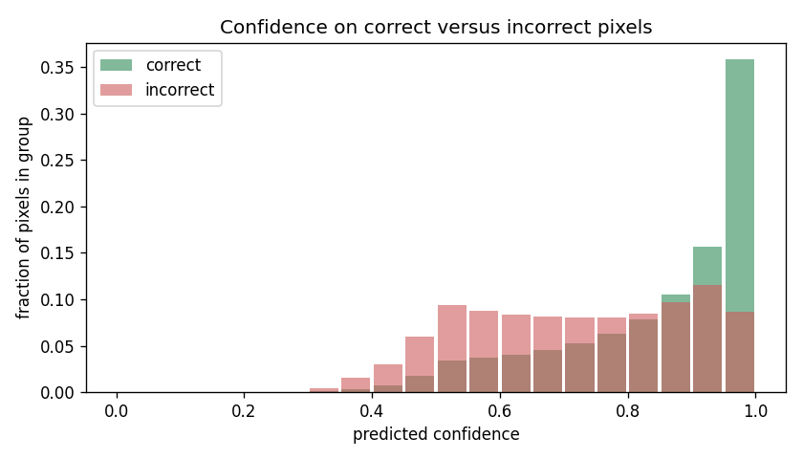
Confidence on correct against wrong pixels
Grouping classes by pixel support shows accuracy falling monotonically with frequency, from a mean IoU of 0.58 on the three most common classes through 0.51 on the middle two to 0.39 on the two rarest. A few validation scenes also fail almost completely, and the worst image scores a mean IoU of 0.00, shown below as input, ground truth, prediction and error overlay.
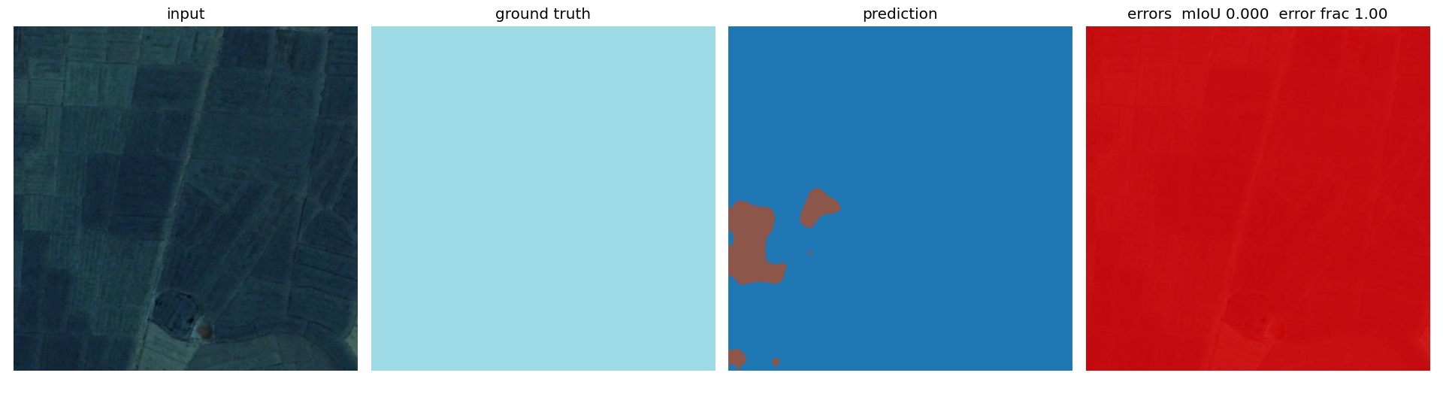
The worst validation image, mean IoU 0.00

Validation results
Both validation runs completed on the Colab T4. The in domain run covered 300 LoveDA validation images with a base error rate of 0.3118, and the cross domain run covered all 32 Potsdam validation patches with a base error rate of 0.5071. The doubling of the base error confirms a genuine domain shift, since the model performs far worse on German imagery than on the Chinese imagery it trained on.
signal | LoveDA AUROC | LoveDA Spearman | Potsdam AUROC | Potsdam Spearman
confidence shortfall | 0.6994 | 0.3526 | 0.7118 | 0.1968
entropy | 0.7094 | 0.4175 | 0.7215 | 0.2280
margin risk | 0.6920 | 0.3345 | 0.7048 | 0.1386
failure score | 0.6998 | 0.3681 | 0.7123 | 0.2093
novelty (per image) | n/a | 0.3014 | n/a | 0.3398
- The central claim holds, because every pixel level signal kept an AUROC near 0.71 on Potsdam, which is as high as in domain, so the signals rank wrong pixels above correct ones just as well on a continent the model never saw.
- The ranking is close to monotonic, since the true error rate climbs from 0.09 in the safest failure score decile to 0.71 in the riskiest one on Potsdam.
- The risk coverage curve shows the practical value, because keeping only the most trusted fifth of pixels cuts the error rate from 51 percent to under 10 percent.
- Entropy is the strongest single signal in both runs, slightly ahead of the blended failure score.
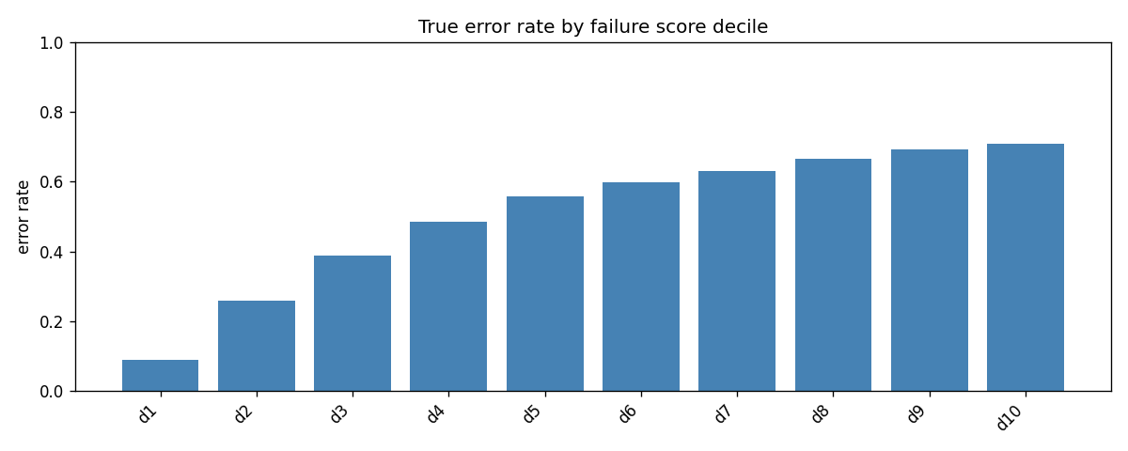
True error rate by failure score decile on Potsdam
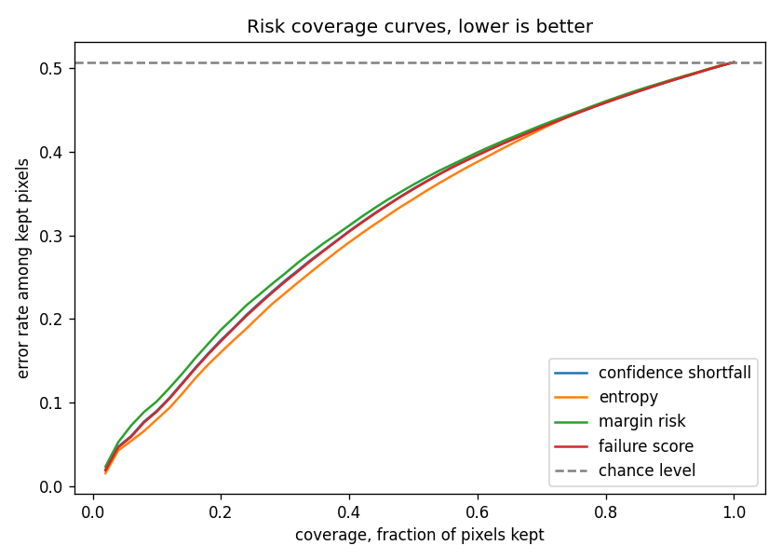
Risk coverage on Potsdam, lower is better
- One honest negative result appeared, as the whole image novelty detector failed to recognize the domain shift with a domain AUROC of 0.4018, which is below chance. The Potsdam Mahalanobis distances sit inside the LoveDA baseline spread rather than to its right, likely because global average pooling washes out the texture differences and the large downscale from 2304 to 384 pixels smooths Potsdam toward LoveDA statistics.
- The in domain scanner run confirms a calibration problem on top of that, because even LoveDA validation tiles score a novelty of 1.0, since the reference distances come from the very images that fit the Gaussian and every image outside that set lands beyond them. Per image novelty still correlates with error at Spearman 0.34, but as a new domain alarm it did not work here, which is a finding worth reporting and a clear direction for future work.
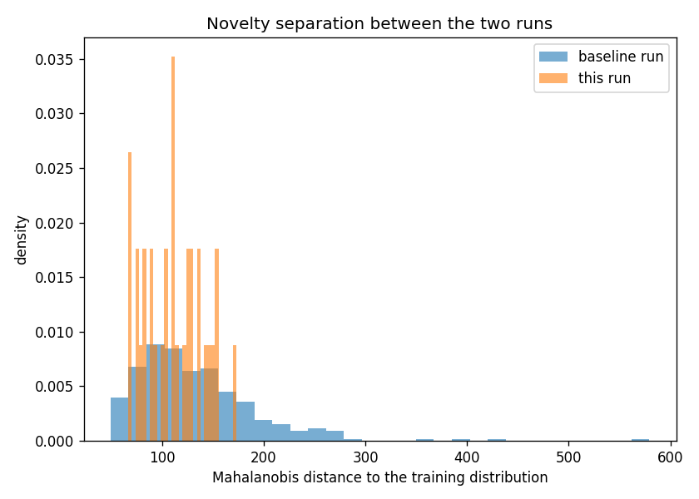
Novelty separation between the two runs

References
Anthropic. “Claude Code.” Accessed July 8, 2026. https://claude.com/claude-code.
International Society for Photogrammetry and Remote Sensing. “2D Semantic Labeling Contest, Potsdam.” Accessed July 8, 2026. https://www.isprs.org/resources/datasets/benchmarks/UrbanSemLab/2d-sem-label-potsdam.aspx.
Kaggle. “Urban Segmentation ISPRS.” Accessed July 8, 2026. https://www.kaggle.com/datasets/aletbm/urban-segmentation-isprs.

