Segmentation Model Weaknesses and Areas for Collaboration
Prepared 8 July 2026

Overview
- The project trains a DeepLabV3 ResNet50 model on the LoveDA land cover dataset and builds tooling to analyze where and why it fails, with a further goal of flagging failures on unlabeled imagery anywhere in the world.
- The current baseline reaches a mean IoU of 0.5066 on the LoveDA validation split, which is competitive for this hard dataset but leaves clear room to grow.
- The cross domain validation is complete, and the label free uncertainty signals held an AUROC near 0.71 on German Potsdam imagery, matching their in domain performance, so the core claim of the project is proven. The figure below shows the true error rate climbing steadily across failure score deciles on Potsdam, which is the ranking behavior the signals promise.
- This document summarizes the concrete weaknesses the analysis surfaced and the areas where Anand Padmanabhan could potentially advise or provide resources to push the work further.
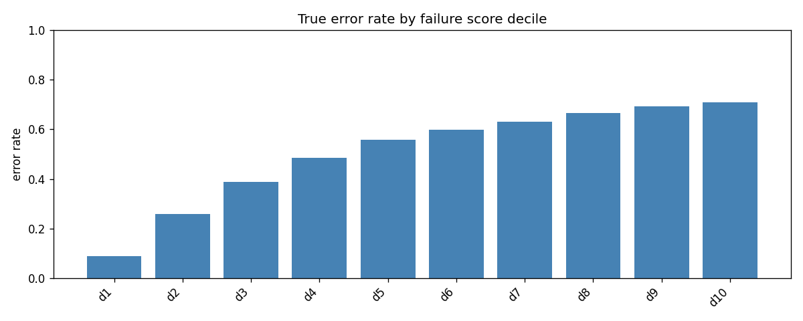
True error rate by failure score decile on Potsdam imagery

Current weaknesses
- Rare and visually plain classes collapse, since barren scores only 0.25 IoU with 0.30 recall and forest reaches 0.40, because these classes are infrequent and look like road, soil or background at 0.3 m resolution.
- The model degrades sharply at object edges, where boundary mIoU is 0.31 against an interior mIoU of 0.58, so fine detail and small objects are the weakest regions.
- The model is overconfident on its mistakes, holding a mean confidence of 0.74 on wrong pixels, so raw confidence is a poor error flag and calibration is needed.
- Training resolution is capped at 384 pixels rather than the native 512, purely because a free Colab T4 GPU cannot train the larger input in reasonable time, which directly limits boundary and small class accuracy.
- The backbone is pretrained on ImageNet natural photos rather than overhead imagery, so the model starts with a domain gap that limits its ceiling on remote sensing data.
- The whole image novelty detector failed to recognize the geographic domain shift, scoring a domain AUROC of 0.40 on Potsdam, likely because global average pooling washes out texture differences, so a better out of distribution detector is an open problem.

Areas where support could help
- Access to cluster or HPC compute would let the model train at full 512 resolution, for more epochs, and with larger backbones such as ResNet101 or a DeepLabV3 plus decoder, which target the boundary and rare class weaknesses directly and are currently blocked by the free tier GPU.
- Guidance on domain matched pretraining, or access to remote sensing pretrained backbones, would close the ImageNet domain gap and raise the accuracy ceiling more than any single training trick.
- Access to additional labeled land cover or aerial datasets would strengthen both the rare class performance and the cross domain generalization study, since barren and forest need more varied examples.
- Domain expertise in geographic information science and remote sensing would sharpen the class mapping choices, the ground sample distance handling, and the interpretation of failures as real geographic phenomena rather than model artifacts.
- Advice on framing the failure analysis and the label free detection results for publication would help turn the current findings into a paper, especially the cross domain generalization claim.

Immediate next step
- With the cross domain result in hand, the highest value next steps are a stronger training run at full resolution with a class balanced loss, which targets the barren and boundary weaknesses directly, and a better novelty detector that can actually flag new geographies, both of which benefit from cluster compute and remote sensing expertise.

References
Anthropic. “Claude Code.” Accessed July 8, 2026. https://claude.com/claude-code.
Wang, Junjue, Zhuo Zheng, Ailong Ma, Xiaoyan Lu, and Yanfei Zhong. “LoveDA, A Remote Sensing Land-Cover Dataset for Domain Adaptive Semantic Segmentation.” NeurIPS Datasets and Benchmarks, 2021. Accessed July 8, 2026. https://arxiv.org/abs/2110.08733.

