COMPREHENSIVE TECHNICAL SYSTEM ARCHITECTURE
& IMPLEMENTATION DOCUMENTATION
Real-Time Non-Destructive Ransomware Defense Pipeline

Document Classification: Technical / Engineering Reference
Version 1.0
Prepared: August 2026

Table of Contents
1. Executive System Architecture & End-to-End Pipeline Flow 3
1.1 System Architecture Flow Diagram 3
1.2 Design Principles 4
2. Detailed Stage-by-Stage Implementation Specifications 5
Stage 1: Telemetry Collection & File I/O Interception 5
Stage 2: Process Identification & Lineage Analysis 5
Stage 3: Dynamic Behavior Relationship Graph (DBRG) with TDEW 6
Stage 4: Cold-Start Gate & 4KB Multi-Layer Feature Extraction 6
Stage 5: Benign Profiling & Density-Adaptive One-Class Learning 7
Stage 6: Multi-Signal Corroboration & Sigmoidal Acceleration 7
Stage 7: Dynamic Adaptive Trust Evolution & Risk State Engine 8
Stage 8: Synthetic Ransomware Test Harness 8
Stage 9: Freeze-Graph Min-Cut Containment Engine (SIGSTOP) 9
Stage 10: Fine-Grained Enforcer, Journaling & Selective Rollback 9
Stage 11: SOC Dashboard & Interactive User Override UI 10
Stage 12: Evaluation, Parameter Ablation & Defense Preparation 10
3. Dataset & Benchmark Specifications 11
4. Core Execution & Verification Matrix 12
5. Summary 13

1. Executive System Architecture & End-to-End Pipeline Flow
The Enhanced System Architecture is a real-time, non-destructive ransomware defense pipeline designed to ingest low-level operating system events, model relationship dynamics with decay mathematics, evaluate threat intent across multiple corroborating signals, and enforce kernel-level isolation with zero-data-loss rollback capability.
The pipeline is organized into eleven sequential processing stages plus a twelfth evaluation phase, spanning telemetry ingestion, behavioral graph modeling, machine-learning-based anomaly detection, multi-signal threat fusion, adaptive trust management, kernel-level containment, and interactive analyst oversight. Each stage is described in full detail in Section 2, including its primary purpose, key and minor implementation components, algorithmic steps, and expected outcome, and each stage's function is independently verifiable against the criteria summarized in Section 4.

1.1 System Architecture Flow Diagram
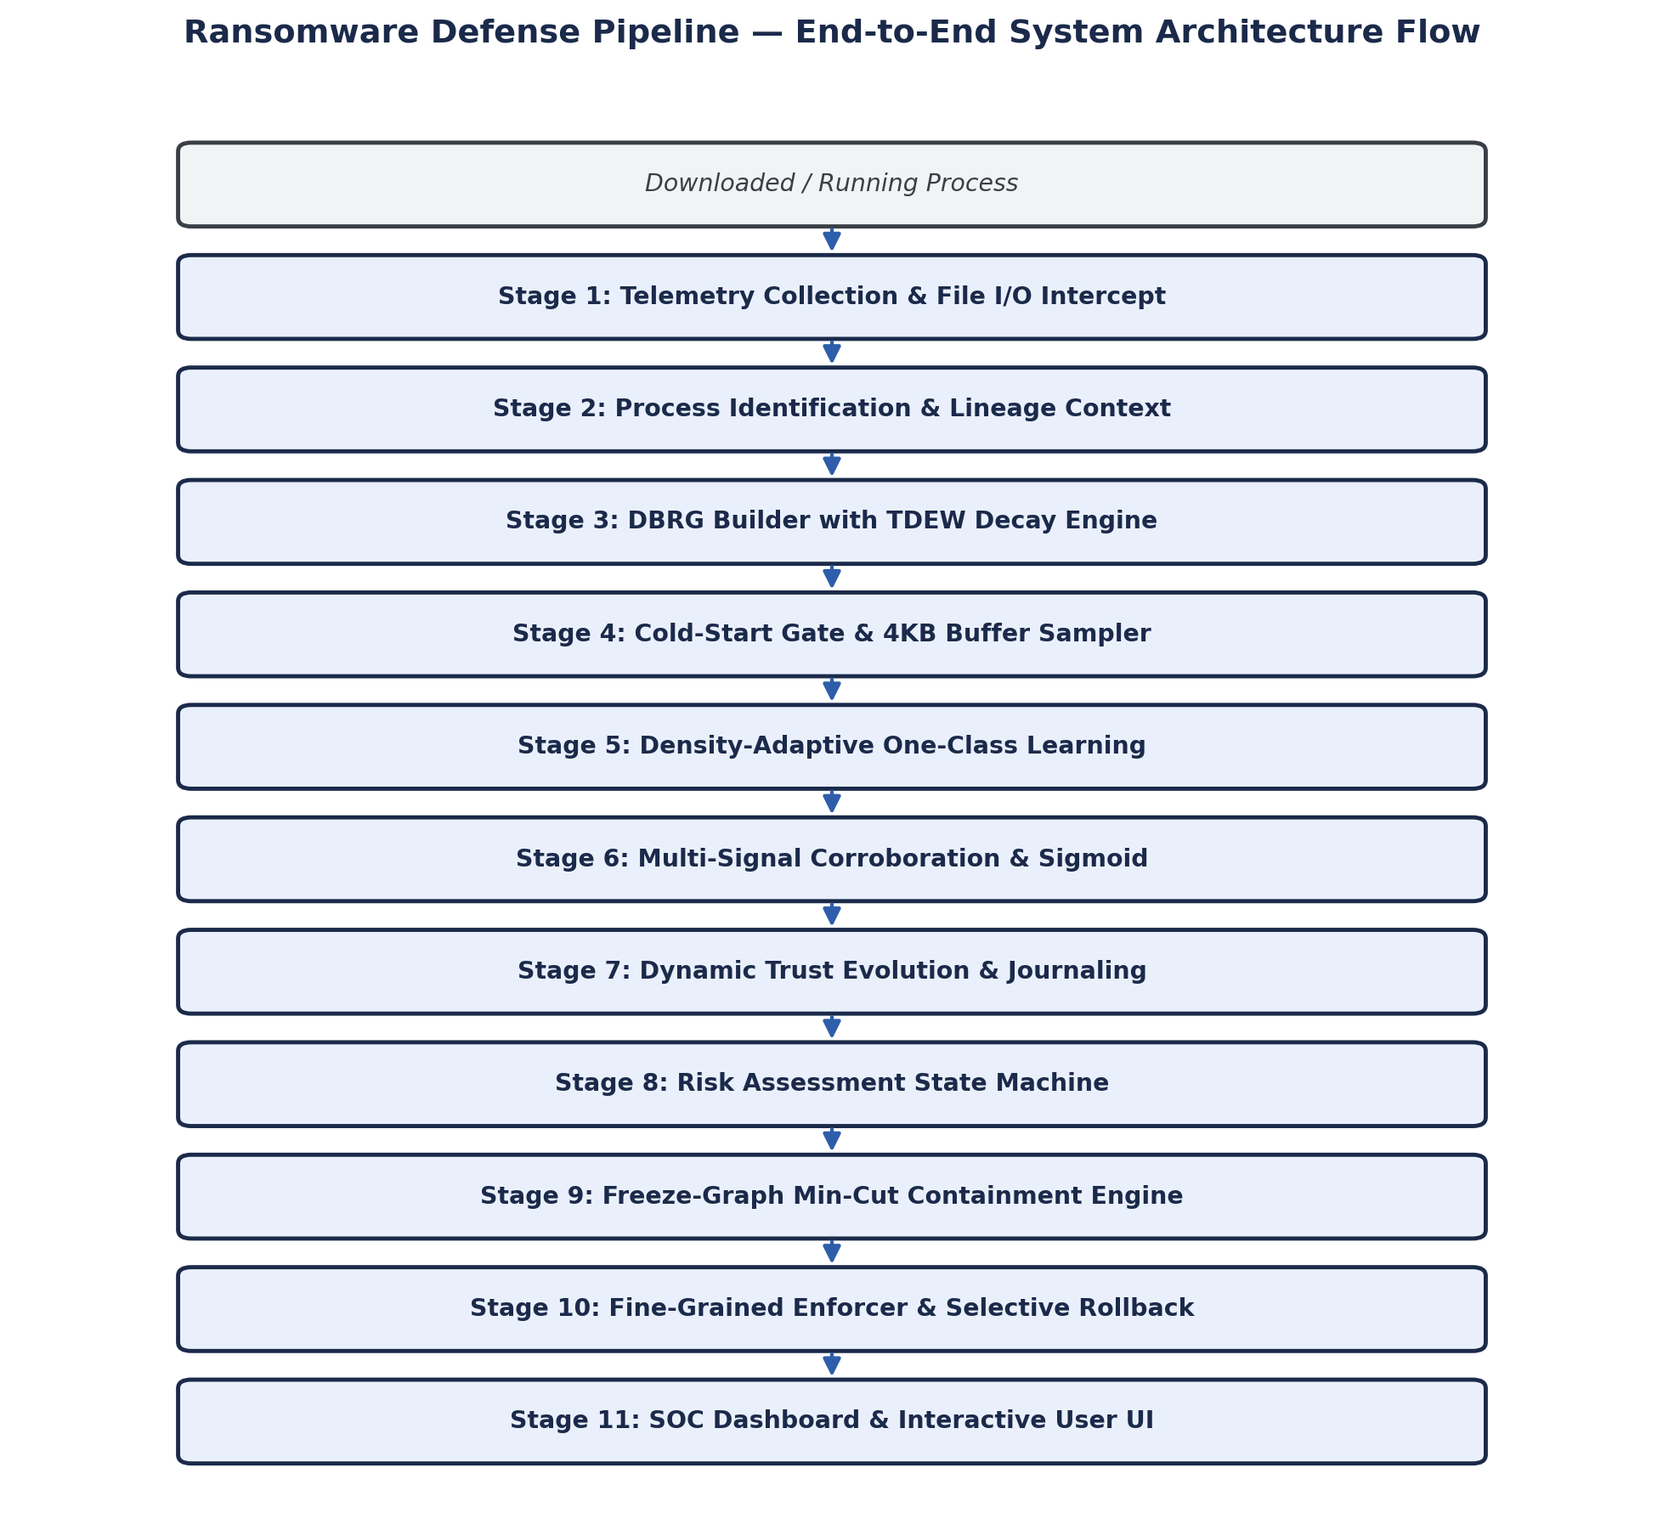
Figure 1.1 — End-to-end system architecture flow, from process spawn/download through telemetry collection, graph-based modeling, multi-signal threat fusion, kernel-level containment, and SOC dashboard oversight.

1.2 Design Principles
- Non-destructive by default: the pipeline observes, models, and scores behavior continuously without altering process execution until a quantified, multi-signal risk threshold is crossed.
- Defense in depth via signal corroboration: no single feature (e.g., high entropy alone) can trigger containment; detection requires convergence of entropy, graph-distance, trajectory, lineage, and stability signals.
- Kernel-level enforcement: containment actions (SIGSTOP/SIGCONT/SIGKILL, ACL revocation) operate at the operating-system level for deterministic, low-latency isolation.
- Zero data loss guarantee: write-ahead journaling ensures that any file blocks touched during an active investigation can be restored byte-for-byte if malicious intent is confirmed.
- Analyst-in-the-loop: the SOC dashboard preserves human override authority over automated containment decisions via the Isolate & Restore / Authorize & Resume controls.

2. Detailed Stage-by-Stage Implementation Specifications
The following subsections document each of the twelve pipeline stages in full technical detail, including primary purpose, key and minor implementation modules, algorithmic steps expressed in their governing mathematical form, and the expected, independently verifiable outcome of correct implementation.

Stage 1: Telemetry Collection & File I/O Interception
Primary Purpose: Capture low-latency, raw file system and process event streams asynchronously without blocking operating system disk I/O.
Key Implementations
- Async File Interception (collector/file_monitor.py): utilizes watchdog.Observer (leveraging Linux inotify or Windows ReadDirectoryChangesW) to capture file operations (create, modify, rename, delete).
- Process Monitor (collector/process_monitor.py): uses psutil or OS-level kernel hooks to poll and record process creation/termination, executable SHA-256 binary hash, start time, PID, and TID.
- Thread-Safe Queueing (collector/queue_joiner.py): constructs an asynchronous queue.Queue pipeline to match incoming file events with their generating PID/TID context.
Minor Implementations
- eCAR Model Formatting: formats incoming raw events into JSON structured per the extended Cyber Analytics Repository (eCAR) model, storing actorID, objectID, pid, tid, principal, and context properties map.
- SQLite Persistence: writes incoming telemetry streams to local SQLite database tables with indexed timestamp keys.
Algorithmic Steps
- Initialize asynchronous thread-safe event queue Q.
- Register kernel file watchdogs on monitored volume paths.
- On event e_i: extract file path, operation type, thread ID, and high-resolution timestamp (t_ms).
- Perform PID join matching e_i to active executing binary context P_k.
- Enqueue context-enriched eCAR JSON object into Q.

Expected Outcome: Live, asynchronous event stream persisted to local SQLite storage with sub-millisecond overhead (< 1 ms).

Stage 2: Process Identification & Lineage Analysis
Primary Purpose: Trace execution provenance to calculate operational spawning anomalies across execution hierarchies.
Key Implementations
- Process Context Engine (collector/process_context.py): instantiates ProcessContext tracking PID, executable path, digital signature status (Authenticode/GPG), and full parent chain (P_parent → P_child).
- Lineage Rarity Metric (S_rel): quantifies historical spawning frequencies between parent and child binaries.
Minor Implementations
- Binary signature checking via Windows CryptoAPI / OpenSSL bindings.
- Environmental context tracking (working directory, command-line parameters).
Algorithmic Steps
- Retrieve recursive parent chain for process P_i up to root init/explorer process.
- Query historical process launch frequencies for parent-child pair (P_parent, P_child).
- Compute Lineage Rarity Score: S_rel = 1.0 − [ Freq(P_parent → P_child) / Σ Freq(P_parent → All Children) ].
- If execution path is unseen (e.g., word.exe → powershell.exe), set S_rel → 1.0.

Expected Outcome: Complete execution lineage tree mapping every filesystem write event to its parent process context with computed rarity score S_rel.

Stage 3: Dynamic Behavior Relationship Graph (DBRG) with TDEW
Primary Purpose: Construct an active relationship graph reflecting operational velocity while decaying historical interactions.
Conceptual Diagram — Time-Decayed Edge Weighting (TDEW): on each event arrival, the existing edge weight is decayed (W_new = W_old · e^(−λΔt)), an interaction impulse of 1.0 is added (W_final = W_new + 1.0), and stale edges are pruned once W_final falls below 0.01.

Key Implementations
- Graph Builder (graph/dbrg.py): initializes networkx.DiGraph representing processes (P_i) as source nodes and touched files/directories (F_j) as sink nodes.
- TDEW Exponential Engine: applies exponential decay to edge weights on every event to prevent artificial weight accumulation over extended usage windows.
Minor Implementations
- Background garbage collector thread purging stale graph edges (W < 0.01).
- Node property tagging (e.g., file extensions, system criticality rank).
Algorithmic Steps
- Maintain edge e = (P_i, F_j) with last activity time t_last and current weight W(e).
- On new interaction at time t_curr, calculate Δt = t_curr − t_last.
- Decay previous weight: W(e) = W(e_old) · e^(−λΔt) + 1.0.
- Run background garbage collector every 30 seconds; remove any edge where W(e) < 0.01.

Expected Outcome: Dynamic graph reflecting real-time access velocity; stale edges decay below 0.01 within 120 seconds.

Stage 4: Cold-Start Gate & 4KB Multi-Layer Feature Extraction
Primary Purpose: Extract graph structural metrics alongside payload content entropy to construct a 5-dimensional feature vector S.
Key Implementations
- Cold-Start Gate (graph/cold_start.py): suspends anomaly classification until minimum baseline graph edges are established (edges(DBRG) ≥ 5).
- Buffer Sampler (graph/buffer_sampler.py): reads the initial 4,096 bytes post-write to measure Shannon Entropy (S_entropy) and byte-frequency kurtosis/variance.
- Graph Topography Features (graph/features.py): computes Trajectory Deviation (S_dev), Graph Distance (S_dist), and Operational Stability (S_stab).
Minor Implementations
- Efficient byte histogram computation (256 bins).
- Thread-safe 2-second sliding window timer for periodic feature consolidation.
Algorithmic Steps
- Check if total graph edges ≥ MIN_EDGES (5); if not, remain in Initializing state.
- Calculate Shannon Entropy over the initial 4KB buffer: S_entropy = −Σ (i=0..255) p_i log₂(p_i).
- Compute graph topological metrics across a sliding 2-second window: Trajectory Deviation (S_dev) — rate of change of outward edge generation; Graph Distance (S_dist) — average shortest path to sensitive filesystem directories; Stability (S_stab) — variance of graph structural degree distribution.
- Output consolidated feature vector S = [S_entropy, S_dist, S_dev, S_rel, S_stab].

Expected Outcome: Consolidated 5D feature vector emitted every 2-second window. Encrypted content yields S_entropy > 0.85.

Stage 5: Benign Profiling & Density-Adaptive One-Class Learning
Primary Purpose: Cluster baseline benign software behaviors and dynamically scale isolation boundaries per cluster.
Key Implementations
- Clustering Engine (model/clustering.py): clusters benign historical feature vectors using k-Means with silhouette score validation.
- Density-Adaptive Isolation Forest (model/isolation_forest.py): trains per-cluster One-Class Isolation Forests using density-adaptive contamination thresholds.
Minor Implementations
- Feature normalization using StandardScaler fitted on benign data.
- Centroid proximity scoring for incoming sample assignment.
Algorithmic Steps
- Train k-Means on benign feature vectors (data/benign_vectors.csv) to partition into K operational profiles.
- For each cluster k, calculate cluster feature mean μ_k and standard deviation σ_k.
- Compute cluster-specific density-adaptive contamination factor: Contamination_k = α · (σ_k / μ_k).
- Train separate Isolation Forests IF_k using the calculated Contamination_k.

Expected Outcome: Distinct behavioral cluster boundaries distinguishing high-entropy archivers (e.g., 7-Zip) from standard user applications.

Stage 6: Multi-Signal Corroboration & Sigmoidal Acceleration
Primary Purpose: Fuse independent threat sub-signals using priority weighting and pass the result through a non-linear sigmoid to avoid single-feature false positives.
Conceptual Diagram — Sigmoidal Acceleration Curve: IntentDrift remains near 0 for low composite scores, holds flat around the 0.50 threshold (θ), and rises sharply toward 1.0 as S_composite exceeds the threshold, driven by steepness parameter β.

Key Implementations
- Causality Fusion Engine (model/fusion.py): merges sub-signals using causality-priority weights.
- Sigmoidal Acceleration Engine (model/drift.py): transforms composite scores through a steep logistic function (β = 10.0, θ = 0.50).
Minor Implementations
- Numerical derivative calculation d(Drift)/dt tracking threat velocity.
Algorithmic Steps
- Compute Priority Composite Score: S_composite = (0.35·S_entropy) + (0.30·S_dist) + (0.20·S_dev) + (0.10·S_rel) + (0.05·S_stab).
- Apply Logistic Sigmoidal Acceleration: IntentDrift(t) = 1 / (1 + e^(−β(S_composite − θ))).
- Calculate acceleration rate: d(Drift)/dt = [IntentDrift(t) − IntentDrift(t−Δt)] / Δt.

Expected Outcome: Intent Drift score suppresses single-feature spikes (e.g., pure file compression) to IntentDrift < 0.10 while accelerating to 1.0 when multiple threat indicators align.

Stage 7: Dynamic Adaptive Trust Evolution & Risk State Engine
Primary Purpose: Dynamically decay process trust with momentum penalties and govern system transition across defined risk tiers.
Key Implementations
- Trust Decay Engine (model/trust.py): decays process Trust Score (100 → 0) using momentum penalties proportional to acceleration.
- Risk State Machine (pipeline/risk.py): manages transition across system risk tiers (SAFE, MONITOR, VERIFY, CRITICAL_RISK).
Minor Implementations
- Buffer pre-allocation triggers upon entering the VERIFY state.
Algorithmic Steps
- Calculate Trust Penalty: ΔTrust = γ · IntentDrift(t) · (1 + d(Drift)/dt) × 100.
- Update Trust Score: Trust(t) = max(0, Trust(t−1) − ΔTrust).
- Transition process risk tier: Trust ≥ 60 ⇒ SAFE; 35 ≤ Trust < 60 ⇒ MONITOR (double 4KB sampling frequency); 20 ≤ Trust < 35 ⇒ VERIFY (initialize Write-Ahead Journaling buffers); Trust < 20 ⇒ CRITICAL_RISK (trigger Stage 9 containment).

Expected Outcome: Continuous trust score tracking; multi-signal attacks drop trust below 20 in under 50 ms.

Stage 8: Synthetic Ransomware Test Harness
Primary Purpose: Safely simulate rapid, multi-directory encryption in a sandboxed folder environment to evaluate system detection bounds.
Key Implementations
- Ransomware Simulator (tests/synthetic_ransomware.py): iterates through nested directory structures, reads files, appends encrypted byte streams, and renames files to .locked.
Minor Implementations
- High-resolution log writer tracking file modification timing.
Algorithmic Steps
- Initialize sandbox directory containing test files.
- Launch background process iterating recursively over target folders.
- For each file: read raw bytes, append high-entropy XOR buffer, rename extension to .locked.
- Record execution timestamp and monitor detection latency.

Expected Outcome: Safe, repeatable attack stream demonstrating trust degradation and system containment without risking actual system files.

Stage 9: Freeze-Graph Min-Cut Containment Engine (SIGSTOP)
Primary Purpose: Instantly halt malicious process threads at the OS kernel level and compute optimal path revocations via minimum-cut graph algorithms.
Conceptual Diagram — Freeze-Graph Min-Cut Containment: when Trust Score falls below 20, the process is suspended at the kernel level (SIGSTOP), the cut cost is computed as FileImportance / (W_TDEW + ε) for each edge, and the Edmonds-Karp / Push-Relabel min-cut algorithm determines the boundary C_min.

Key Implementations
- Kernel Suspension (containment/kernel_freeze.py): issues OS-level SIGSTOP (Linux) or NtSuspendProcess (Windows) when process Trust drops below 20.
- Min-Cut Optimizer (containment/min_cut.py): computes the Minimum Cut boundary (C_min) over the frozen DBRG using the Push-Relabel or Edmonds-Karp algorithms.
Minor Implementations
- Graph topology freezing to prevent race conditions during cut computation.
Algorithmic Steps
- Upon Trust < 20, immediately execute SIGSTOP / NtSuspendProcess on the process PID.
- Freeze the current DBRG instance.
- Assign edge capacity/cost based on file importance and TDEW activity weight: CutCost(P_i, F_j) = FileImportance(F_j) / (W_TDEW(P_i, F_j) + ε).
- Run Edmonds-Karp / Push-Relabel algorithm between source PID P_i and target file nodes T to establish the minimum cut set C_min.

Expected Outcome: Sub-millisecond kernel thread suspension preserving process memory state alongside the computed cut boundary C_min.

Stage 10: Fine-Grained Enforcer, Write-Ahead Journaling & Selective Rollback
Primary Purpose: Enforce fine-grained ACL access revocations and execute zero-data-loss rollback for confirmed threats, or seamless resumption for false positives.
Key Implementations
- ACL Access Manager (enforcer/acl_manager.py): revokes file system write permissions strictly along C_min paths.
- Journaling Vault & Rollback (enforcer/journal_rollback.py): maintains pre-write file block backups in a dedicated memory-mapped vault (/tmp/.journal_vault).
Minor Implementations
- Memory-mapped file block copying for minimal performance overhead.
Algorithmic Steps
- Apply ACL write revocations to paths identified in C_min.
- Evaluate resolution branch — if confirmed malicious: issue SIGKILL to the target process PID, restore original file bytes from /tmp/.journal_vault, and keep ACL write revocations active.
- Evaluate resolution branch — if confirmed safe (false positive): re-grant ACL write permissions along C_min, reset process Trust Score to 100, and issue SIGCONT to unfreeze process threads seamlessly.

Expected Outcome: Zero data loss through byte-for-byte rollback on attack confirmation, or complete execution resumption upon false-positive authorization.

Stage 11: SOC Dashboard & Interactive User Override UI
Primary Purpose: Provide interactive system visibility into dynamic process graph structures, live trust metrics, and manual threat remediation controls.
Key Implementations
- FastAPI Backend (dashboard/backend.py): streams telemetry, Trust dynamics, and graph state updates via WebSocket endpoints.
- Interactive Dashboard Frontend (dashboard/frontend): React interface rendering live dynamic trust gauges, interactive Cytoscape.js/D3.js graph visualizers, and manual override modals.
Minor Implementations
- Real-time 256-bin byte histogram visualizer components.
Algorithmic Steps
- Maintain an open WebSocket connection between backend and frontend dashboard.
- Push state updates every 100 ms containing active process graphs, TDEW edge weights, and Trust scores.
- On kernel freeze (SIGSTOP), pop a high-priority alert modal with action options — Button 1: “Isolate & Restore” triggers SIGKILL + Journal Rollback; Button 2: “Authorize & Resume” triggers SIGCONT + ACL Restoration.

Expected Outcome: Interactive visual interface providing full operational transparency with frontend state update latency < 100 ms.

Stage 12: Evaluation, Parameter Ablation & Defense Preparation
Primary Purpose: Conduct systematic parameter sweeps across system decay and acceleration constants to optimize detection speed while minimizing false positive rates.
Key Implementations
- Ablation Sweep Engine: automates parameter variations for decay rate λ, sigmoid steepness β, and trust decay multiplier γ.
Minor Implementations
- Automated script driving benign developer workloads alongside synthetic ransomware runs.
Algorithmic Steps
- Construct parameter grid: λ ∈ [0.001, 0.1], β ∈ [5.0, 15.0], γ ∈ [0.1, 1.0].
- Execute benchmark suites across benign developer tasks (e.g., 7-Zip, Git compile) versus synthetic ransomware runs.
- Measure False Positive Rate (FPR) and Detection Latency (time to SIGSTOP freeze).
- Select the optimal parameter set minimizing FPR while achieving detection latency < 50 ms.

Expected Outcome: Validated performance matrix establishing optimal operational parameters for live system deployment.

3. Dataset & Benchmark Specifications
Three primary data resources underpin model training, schema standardization, and empirical validation across the pipeline. Each is mapped to its consuming stage(s), its functional role, and its expected contribution to system performance.
Dataset / Benchmark | Description / Resource Reference | Used in Stage(s) | Role & Usage | Expected Outcome
Benign Behavior Telemetry Corpus | System telemetry logs collected during real-world desktop sessions (code compilation, Git operations, web browsing, archive compression). | Stage 5 (Benign Profiling) & Stage 12 (Evaluation) | Used to fit StandardScaler, train k-Means behavioral clusters, and set density-adaptive Isolation Forest thresholds. | Establishes non-malicious operational profiles to prevent false positives during high-I/O actions (e.g., 7-Zip compression).
MITRE CAR / eCAR Event Specifications | Extended Cyber Analytics Repository telemetry schema specifications (car.mitre.org). | Stage 1 (Telemetry) & Stage 2 (Lineage) | Provides standardized event structures tracking actorID, objectID, process lineage, and property attributes. | Ensures standardized event schema structure across all telemetry ingestion modules.
Synthetic Ransomware Suite | Custom sandboxed test harness (tests/synthetic_ransomware.py). | Stage 8 (Test Harness), Stage 9 (Containment) & Stage 12 (Ablation) | Simulates multi-directory encryption, rapid post-write modifications, and batch file renaming. | Validates real-time trust decay, sub-50ms kernel freeze, and successful file block restoration.

3.1 Notes on Dataset Usage
- Benign Behavior Telemetry Corpus: sourced from real-world desktop sessions and used exclusively for unsupervised baseline modeling (Stage 5) and end-to-end evaluation (Stage 12); it contains no labeled malicious samples, preserving a strict one-class learning paradigm.
- MITRE CAR / eCAR Event Specifications: adopted as the canonical telemetry schema to ensure interoperability with existing SOC tooling and to standardize actor/object/property attribution across Stages 1 and 2.
- Synthetic Ransomware Suite: an internally developed, sandboxed harness used to safely generate ground-truth malicious behavior for detection-latency and containment-correctness validation across Stages 8, 9, and 12.

4. Core Execution & Verification Matrix
The table below consolidates each pipeline stage's primary module, its governing mathematical transformation or action, and the objective verification criterion used to confirm correct behavior during implementation review and regression testing.
Stage | Primary Module | Mathematical Transformation / Action | Verification Criterion
1. Telemetry | collector/file_monitor.py | Asynchronous file I/O event capture | Interception latency < 1 ms
2. Lineage | collector/process_context.py | Lineage Rarity (S_rel) computation | Spawning hierarchy traced to root PID
3. TDEW Graph | graph/dbrg.py | W(e) = W_old · e^(−λΔt) + 1.0 | Stale edges decay to < 0.01 within 120 s
4. Features | graph/buffer_sampler.py | 4KB Shannon Entropy (S_entropy) calculation | Encrypted noise yields S_entropy > 0.85
5. Clustering | model/isolation_forest.py | Contamination thresholding: α · (σ_k/μ_k) | High-entropy tools cluster into separate benign profiles
6. Fusion | model/fusion.py | Sigmoidal acceleration: (1 + e^(−β(S_composite−θ)))^−1 | Single high feature produces Intent Drift < 0.10
7. Dynamic Trust | model/trust.py | Momentum trust decay: Trust(t−1) − ΔTrust | Multi-signal threat drops Trust < 20 in < 50 ms
8. Test Harness | tests/synthetic_ransomware.py | Multi-folder synthetic file encryption simulation | Safely triggers containment without risking user data
9. Min-Cut Freeze | containment/min_cut.py | SIGSTOP kernel freeze + Push-Relabel C_min | Process threads frozen instantly without memory loss
10. Rollback | enforcer/journal_rollback.py | SIGKILL + Journal restore OR SIGCONT resume | Byte-for-byte file restoration on rollback
11. Dashboard | dashboard/frontend | WebSocket dynamic graph rendering & override buttons | UI updates graph state within < 100 ms
12. Ablation | tests/ablation_sweep.py | Parameter grid sweep (λ, β, γ) | FPR minimized with latency < 50 ms

5. Summary
This document has specified, stage by stage, the complete implementation of a real-time ransomware defense pipeline: from asynchronous telemetry capture and process-lineage rarity scoring, through a time-decayed behavioral relationship graph and density-adaptive one-class anomaly models, to sigmoidally-accelerated multi-signal threat fusion, momentum-based trust decay, kernel-level min-cut containment, write-ahead journaling with selective rollback, and a live SOC dashboard for analyst oversight.
The architecture is designed such that no single behavioral indicator can independently trigger containment, that all containment actions are reversible pending human authorization, and that every stage exposes an objective, testable verification criterion suitable for continuous integration and red-team validation, as summarized in Sections 3 and 4.

