Review 1
PROJ2999 Capstone Project Introduction
Title of the Project

Names of Team Members, Reg No. and Guide Name (As per GITAM record)

Department of Computer Science and Systems Engineering GITAM School of CSE
GITAM Deemed to be University, Visakhapatnam

September 1, 2026




Introduction Literature Review
1
2



Literature Review (Paper 1) Summary of Literature Review Research Gaps
3
4
5


Problem Statement Research Objectives
6
7


Workplan and Proposed Timeline Action Plan
8
9

Disclosure Statements
10

Students are suggested to keep the introduction to the problem short, clear and crisp.
Maximum two slides can be used for introduction.



Introduction Literature Review
1
2
Literature Review (Paper 1) Summary of Literature Review Research Gaps
3
4
5
Problem Statement Research Objectives
6
7
Workplan and Proposed Timeline Action Plan
8
9
Disclosure Statements
10

Student should review 4-6 full-length journal or IEEE conference papers.
One detailed slide per paper should be made for atleast 4 papers
Finally a summary table has to be created for literature review.
The next slide can be used as a template.

Introduction Literature Review
1
2

Literature Review (Paper 1) Summary of Literature Review Research Gaps
3
4
5
Problem Statement Research Objectives
6
7
Workplan and Proposed Timeline Action Plan
8
9
Disclosure Statements
10

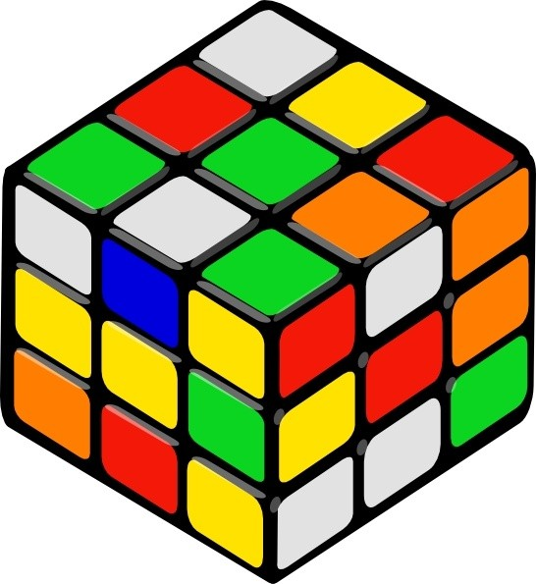
Title of the paper [1]
Main contributions
Inputs and Outputs
Methodology
Tools and Technology used
Summary of Results
Major Findings
List the
tools/technologies/algorithms used
Team No. (GSCSE, GITAM)
September 1, 2026
7 / 22
Capstone Project Introduction

Problem statement
List the contributions of the paper
Requirement analysis (if any)

Figure: Method in the paper
Main results (table or figure format preferred).
Identify the major finding of the paper

Introduction Literature Review
1
2

Literature Review (Paper 1) Summary of Literature Review Research Gaps
3
4
5
Problem Statement Research Objectives
6
7
Workplan and Proposed Timeline Action Plan
8
9
Disclosure Statements
10

Table: Comprehensive summary of literature review of 6-8 journal publications

Ref. | Overview of Paper | Model Used | Novelty | Limitations
[1]
[1]
[1]
[1]
[1]
[2]

Introduction Literature Review
1
2

Literature Review (Paper 1) Summary of Literature Review Research Gaps
3
4
5
Problem Statement Research Objectives
6
7
Workplan and Proposed Timeline Action Plan
8
9
Disclosure Statements
10

Summary of Literature Review
Gaps

Observations made from literature review

First gap Second gap Third gap

Introduction Literature Review
1
2
Literature Review (Paper 1) Summary of Literature Review Research Gaps
3
4
5

Problem Statement Research Objectives
6
7
Workplan and Proposed Timeline Action Plan
8
9
Disclosure Statements
10

Well-defined problem statement approved by the guide.

Introduction Literature Review
1
2
Literature Review (Paper 1) Summary of Literature Review Research Gaps
3
4
5

Problem Statement Research Objectives
6
7
Workplan and Proposed Timeline Action Plan
8
9
Disclosure Statements
10

Well-defined 1-3 objectives addressing the identified research gaps.

First Objective Second Objective
...

Introduction Literature Review
1
2
Literature Review (Paper 1) Summary of Literature Review Research Gaps
3
4
5
Problem Statement Research Objectives
6
7

Workplan and Proposed Timeline Action Plan
8
9
Disclosure Statements
10

Table: Proposed timeline of the project

Task | Task Owner | % of Task Completed | Sept | Oct | Nov
Problem Identification
Literature Survey
Project Objectives
Workplan
Requirement Analysis
Identification of Tools/Technology/Algorithms
System Design (DFD or UMLs)
Proposed Methodology
Closure of Phase 1

Introduction Literature Review
1
2
Literature Review (Paper 1) Summary of Literature Review Research Gaps
3
4
5
Problem Statement Research Objectives
6
7

Workplan and Proposed Timeline Action Plan
8
9
Disclosure Statements
10

Action plan here...

References in the IEEE format as follows:
A. A and A. B, “Title of the paper,” Journal Name, vol. vol. number, p. pages, Year of publication.
A. A and A. B, “Nothing,” Journal C, vol. 2, pp. 14–15, 1954.

Introduction Literature Review
1
2
Literature Review (Paper 1) Summary of Literature Review Research Gaps
3
4
5
Problem Statement Research Objectives
6
7
Workplan and Proposed Timeline Action Plan
8
9

Disclosure Statements
10

I will maintain academic honesty by doing my own work and avoiding plagiarism, cheating, unauthorized collaboration, and falsifying information, use of AI Content.
I will properly acknowledge and cite all sources I use, including information from the internet, books, software, and AI tools.
I will use institutional resources responsibly and only for authorized academic or research activities. I understand that I am responsible for my own actions and decisions.

