EPISODE 3 : LAYING THE FOUNDATION

PART-1:

ADDING SCRIPTS:
- To start the app we used npx parcel index.html , writing it again and again will cause difficulty
- So lets create scripsts for dev built and production built
- In package.json file in scripts add the following
- Now u can use npm run start or npm start (this shortcut only works with start because it is a predefined react keyword it not work if we execute npm build)instead of using npx parcel index.html.(fordev built)
- And npm run build for production built.
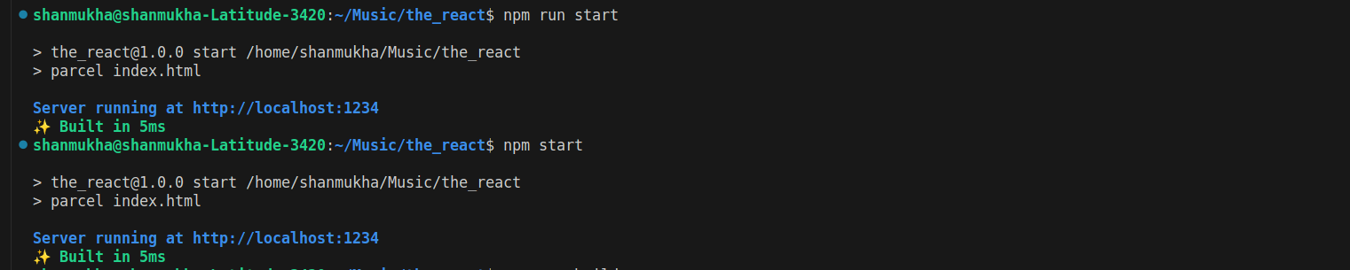
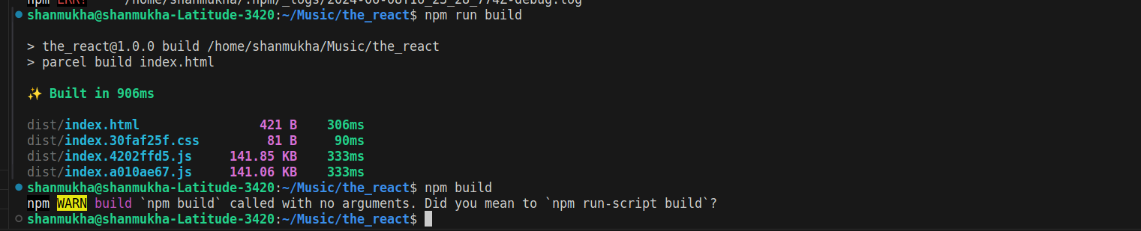
PART 02:

- Normally we used React.createElement to create react element, this React.createElement is a object
- when it rendered ,the reactDOM converts it from object to html element.
- Lets remove everything from the app.js and check the output.
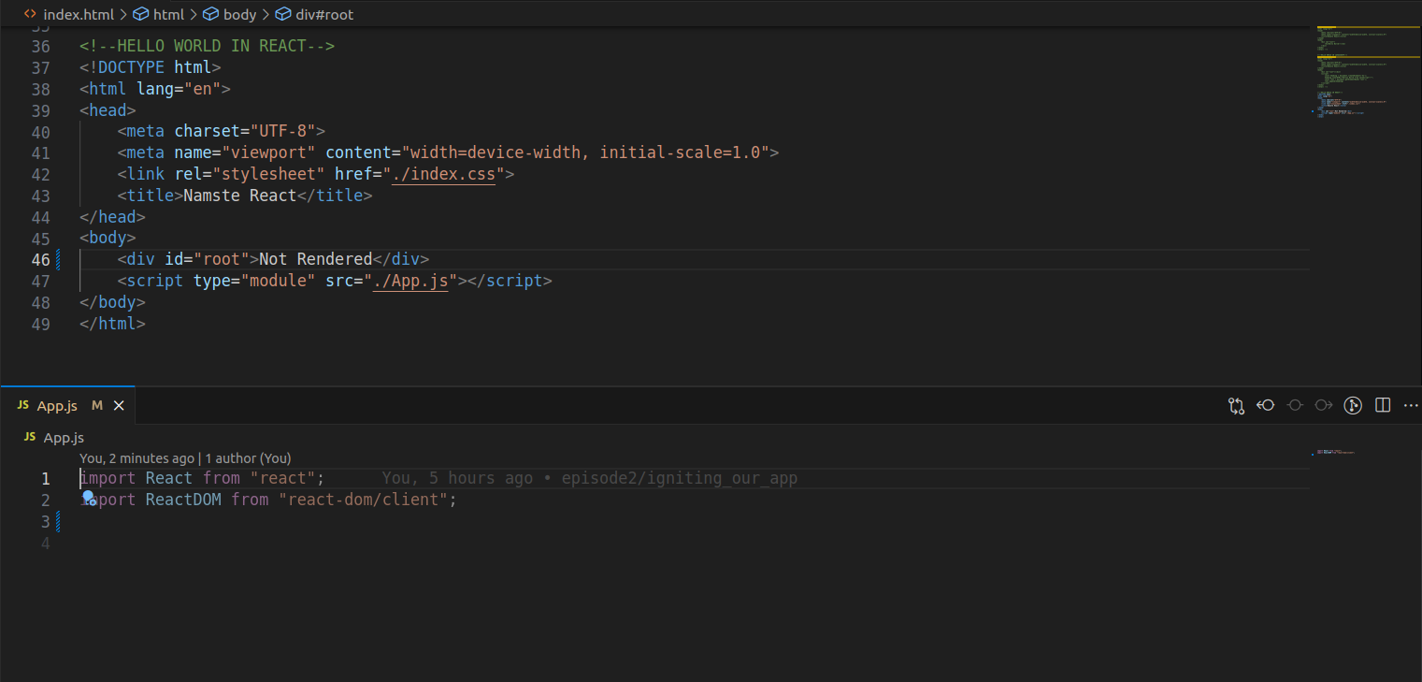
- The output will be the not rendered which is in index.html

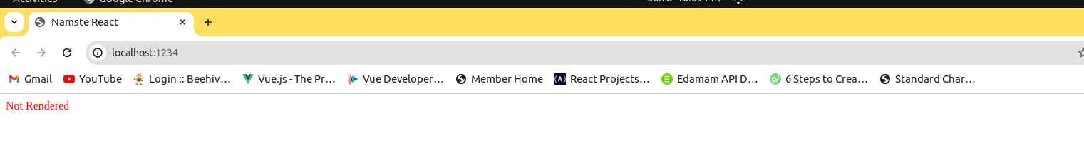
- Now create any react element in app.js and try to render it inside the root of index.html
- You can observe react element replaces the html element.
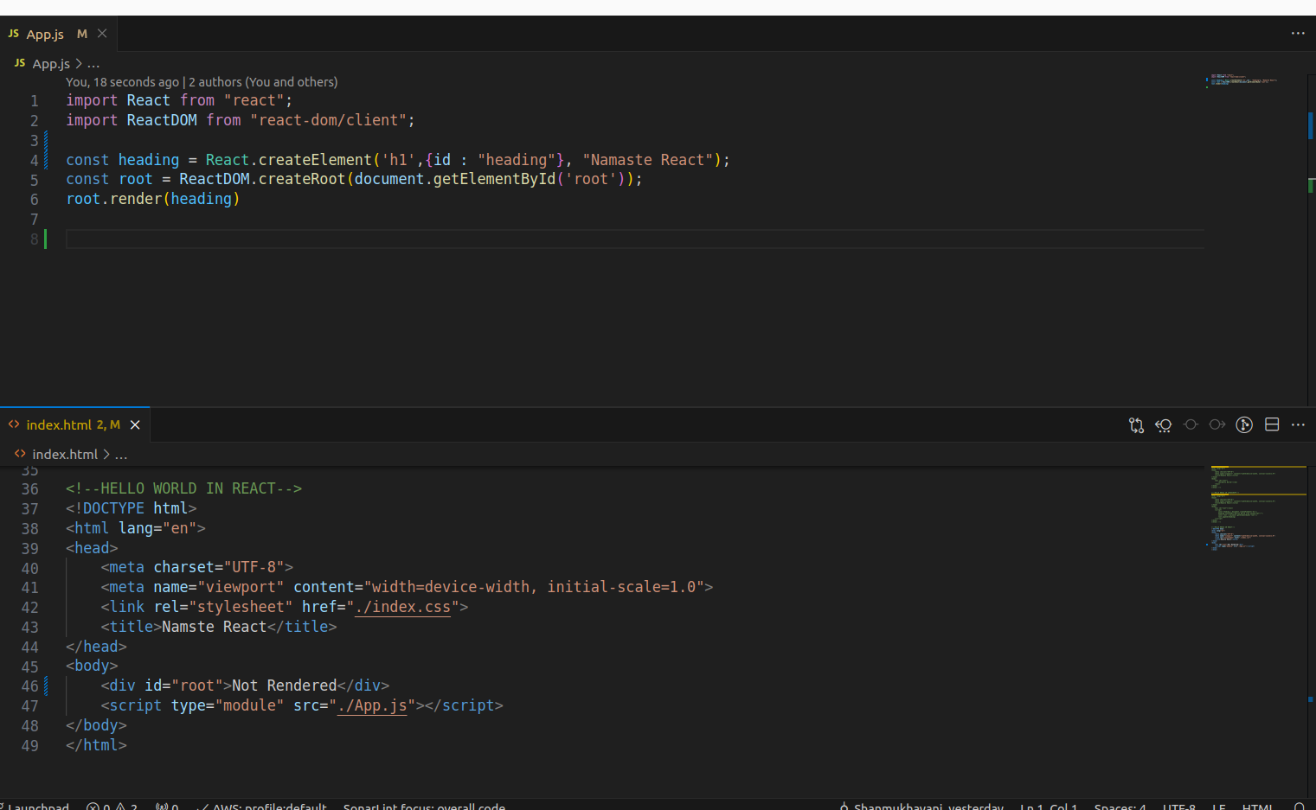

OUTPUT:
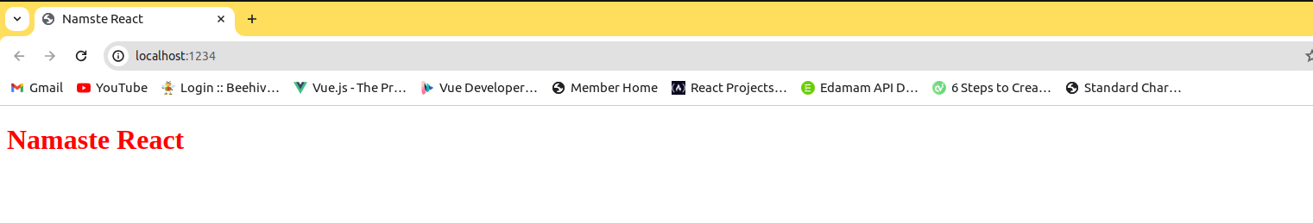
- In the output you can observe not rendered is replaced with Namaste React.

PART 03:(17:06)
Introduction to JSX
- Till now we have used react elements to create html elements like h1 etc.,
- The syntax is clumpsy so JSX is introduced.

JSX :
- JSX is not a html syntax it is html like syntax.
- We can say jsx is a combination of html and js but not as html.
- Browsers only understands js code but jsx is not a js code so before rendering to the browser the jsx is converted to js engine understandable code with the help of babel
BABEL:
- Babel is a javascript transpiler it compiles jsx to javascript engine understandable code.
- Babel is a toolchain that is mainly used to convert ECMAScript 2015+ code into a backwards compatible version of JavaScript in current and older browsers or environments. Here are the main things Babel can do for you:
- Transform syntax
- Basically REACT element is a JS object ->when it renders it converts to html and renders in browser.
REACT ELEMENT(JS OBJ)->renders->HTML
- jsx->(babel)->react element->html
- When you write jsx in console you will see browser wont understand it.
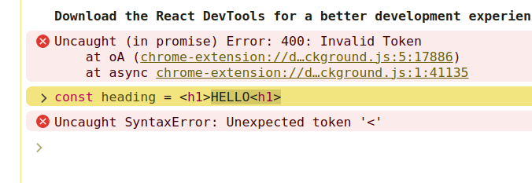
- Babel compiles jsx token by token
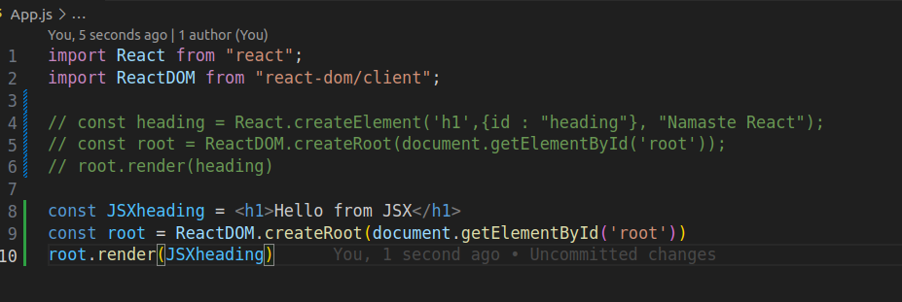
WRITING OUR CODE IN JSX
output:
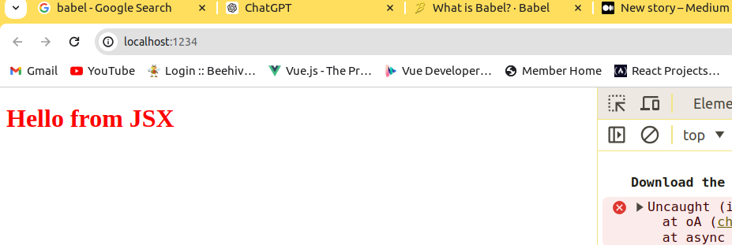
- Here JSXheading is an object
- JSX different from html because the atrributes in JSX are different when compared to html.
- In html we give the attribute as class but in jsx it is className
- We need to wrapup jsx with rounded braces when we are writing multiline jsx code no need for single line code.
• Ex:single line jsx
Const jsxheading =<h1 id=”heading”>I’m h1 tag with jsx</h1>
• Ex:multiline jsx
Const jsxheading =( <h1 id=”heading”>
I’m h1 tag with jsx
- </h1>)

EPISODE 3: PART4
COMPONENTS
- In react everything is a component that means a button, card , nav bar
- everything is a component
- Two types of components
- Class based components(oldway)
- Functional components(new way)
React Functional component is just a normal javascript function which returns a jsx code or React element.
•Name the react components with capital letter.
Syntax of functional component :

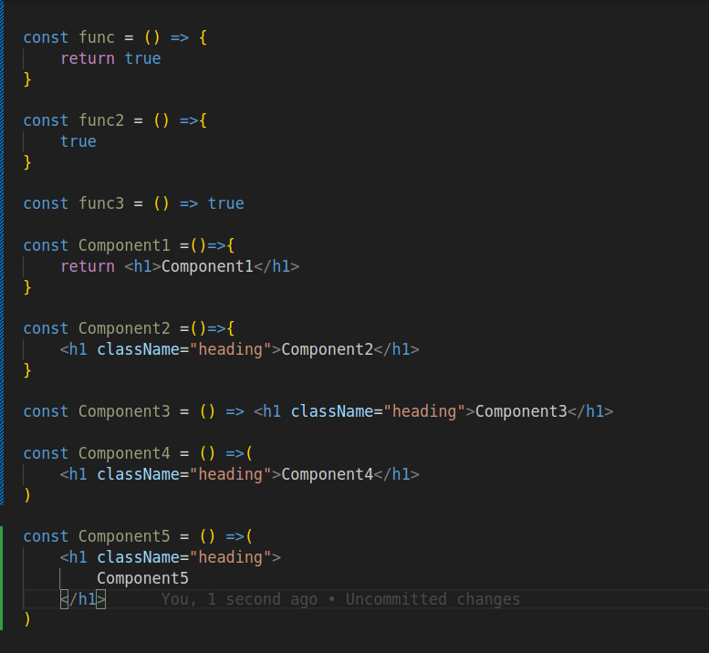
RENDERING A REACT COMPONENT:
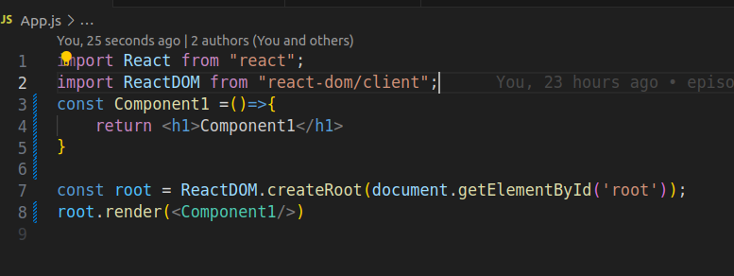
OUTPUT :

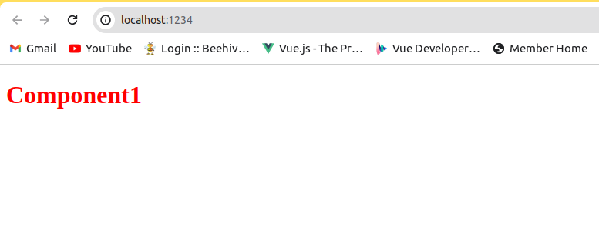
Component Composition :
Renderning component within other component is called as Component Composition.
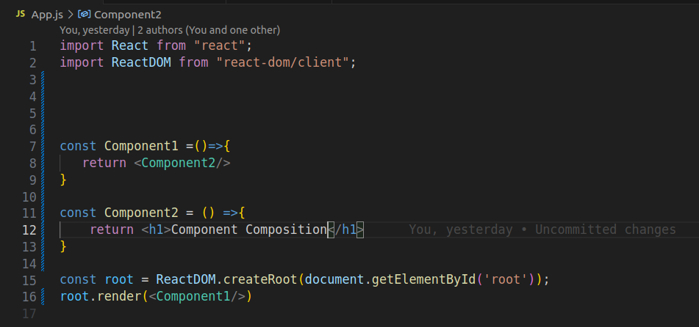
In the above example we are calling component2 in component1.

OUTPUT:

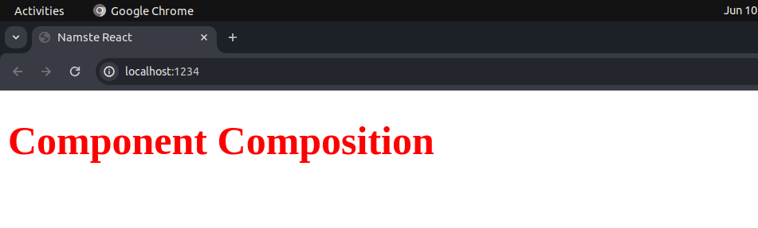
PART 05:
Using JavaScript code inside jsx:
We can write javascript code inside the jsx in curly braces{}
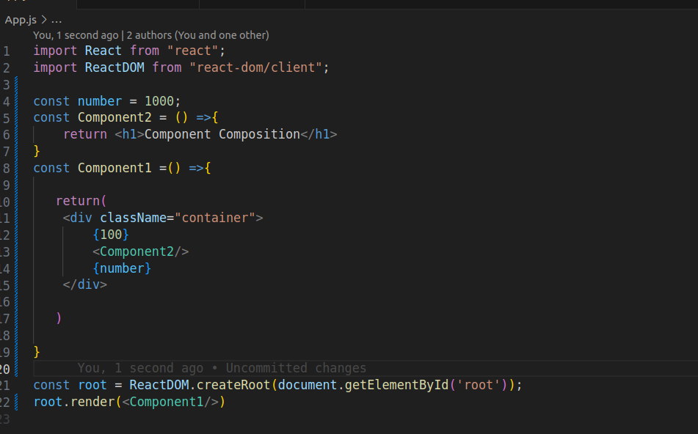

OUTPUT:
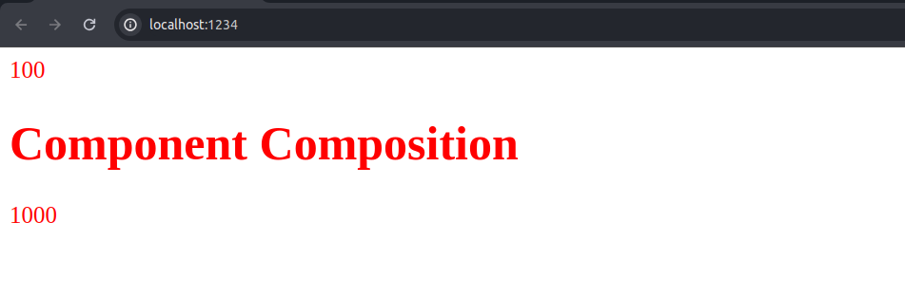
In jsx we can call component inside another component ,element inside other element,element inside component ,component inside element.

Jsx sanitizing:
Suppose if the api sends a malicious data , the data variable holds
that content and we are executing {data} in jsx , but before executing
the code inside curlybraces{} jsx sanitizes the code whether its good
or not.

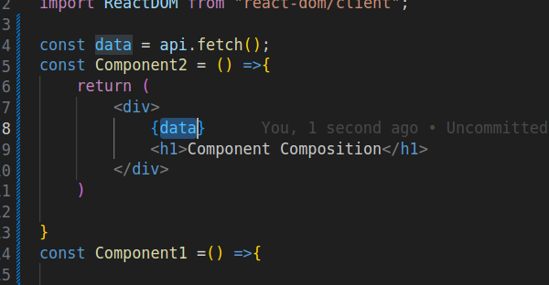
Ways of calling a component:

- <Component/>
- <Component></Component>
- {Component()}->because Component is just a normal javascript function we can call component just like a normal javascript function.
All the three things ate same

