EPISODE 5: LET’S GET HOOKED
- We can build everythinng we built in react using html also.
- But in react we can build it with less code.
PART 01:
In this part we will clean all the mess in code of episode 4.
lets seperate each component into differnt file

TYPES OF EXPORT:
Default Export:
- For every component there is only one default export.We export at end of the component.
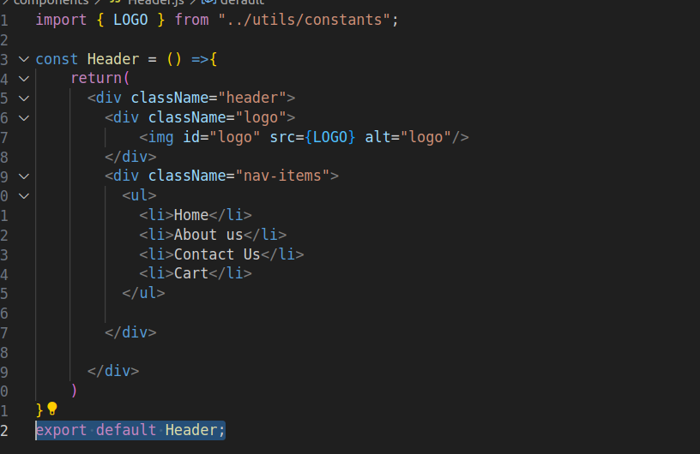
Naming Export:
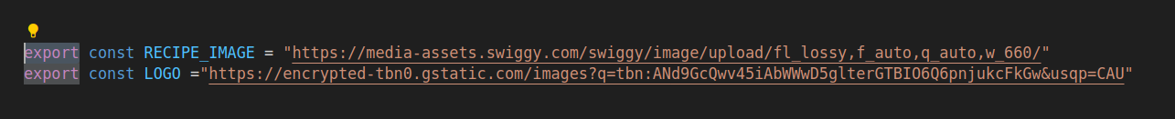
- We use it when we need to export more than one variable or component from a file.
We can even use naming export for Components but we prefer default export.

TYPES OF IMPORT:
Default Import:
Syntax:
import Component from “path”
Naming Import :
Syntax:
import { Variable } from “path”

PART :02

REACT HOOKS:
React hooks are the normal javascript utility functions
1.useState() :
- used to create state variables(scope is inside that particular component)
- Whenever the state variable updates the react rerenders the component
- RECONCILATION ALGORITHM(REACT FIBRE):
- React uses reconcilation algorithm
- In React16 a new algorithm is came out to update the DOM it is RECONCILATION ALGORITHM
- DOM is nothing but the html structure.The below structure is DOM
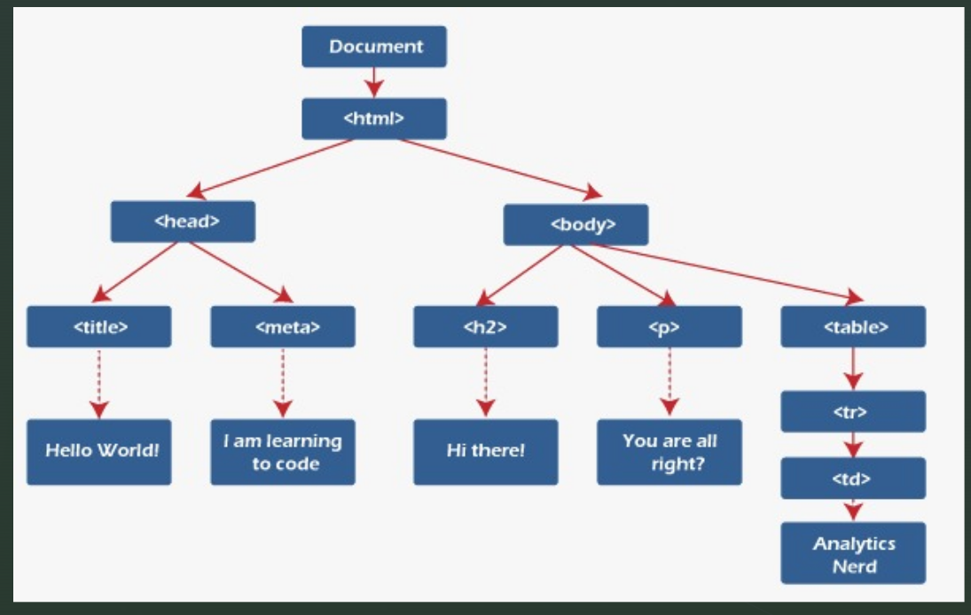
- React have virtual dom , virtual dom is nothing but the object form of the actual DOM
- This virtual dom is used to update the UI that matches the most recent tree.
- Whenever the state variables are changed the virtual dom is also changes , it checks the previous dom with the new dom and only
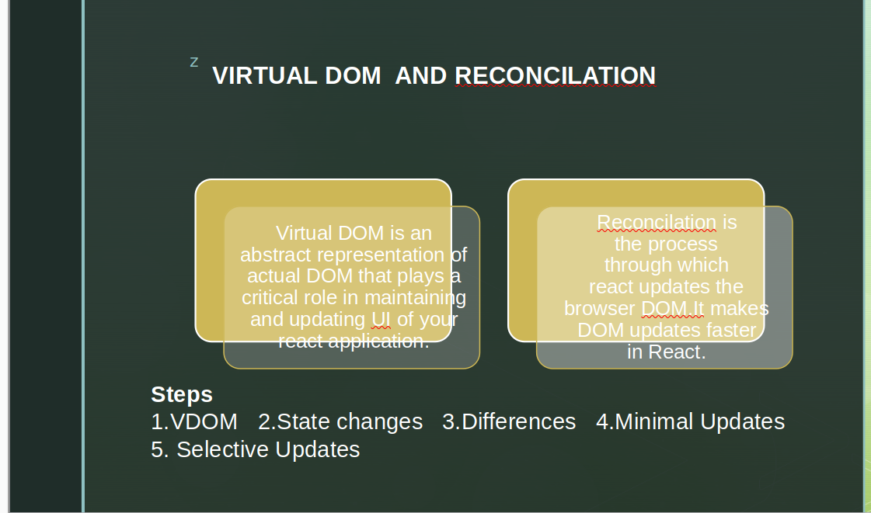
- the differences between the doms can be found with the help of diff algorithm.
- React is faster because of efficient dom manipulation
syntax of useState:
const [variable,setVariable] = useState(‘’)
- variable holds the value.
- SetVariable changes the value whenver this is done the reconcilation is happened with the help of diff algorithm.
- const [variable,setVariable] = useState(‘’) it is nothing but the array destructiong
ex: const arr = useState(data)
const [variable,setVariable] = arr

