EPISODE 6 : EXPLORING THE WORLD
PART 01 :

There are 2 types of architectures. They are
- monolith
- microservice
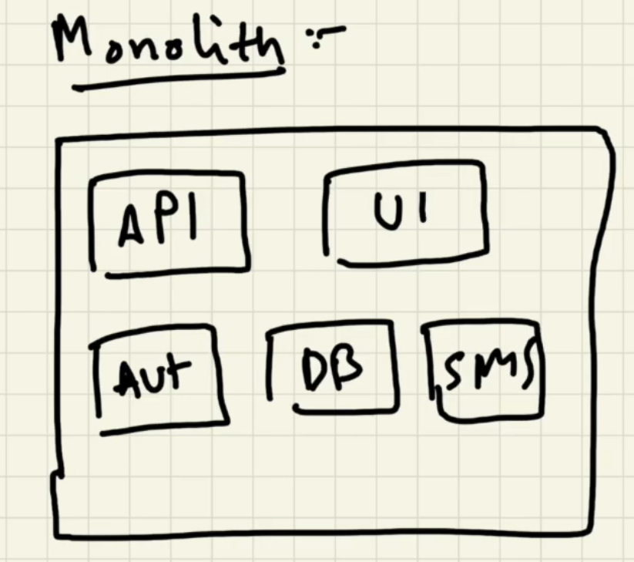

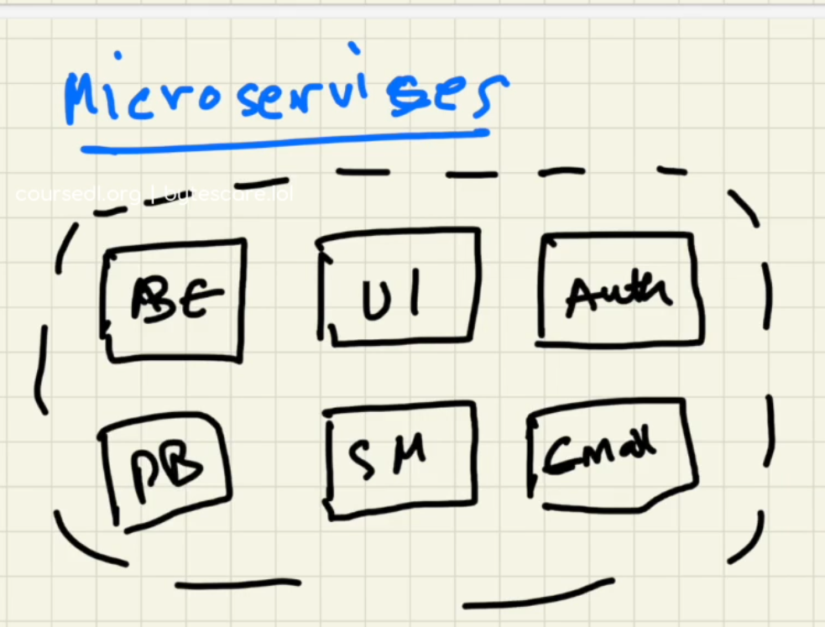

What is monolithic architecture?
General Explanation:
- In monolith architecture the ui , backend sms etc.,of the project will be in the same service and the entire tech stack should also be same.
- For example when we want to create a button we have to build this whole project, compile whole project and deploy whole project which is complex and time taking.
A monolithic architecture is a traditional model of a software program, which is built as a unified unit that is self-contained and independent from other applications. The word “monolith” is often attributed to something large and glacial, which isn’t far from the truth of a monolith architecture for software design. A monolithic architecture is a singular, large computing network with one code base that couples all of the business concerns together. To make a change to this sort of application requires updating the entire stack by accessing the code base and building and deploying an updated version of the service-side interface. This makes updates restrictive and time-consuming.
What are microservices?
- General explanation:
We have different services for different architectures.
Ex: we have service for UI ,service for backend ,service for security ,service for sms etc.,
- We can use different techstacks for different services ex: react for UI ,python for backend
- A microservices architecture, also simply known as microservices, is an architectural method that relies on a series of independently deployable services.
- These services have their own business logic and database with a specific goal.
Updating, testing, deployment, and scaling occur within each service.
- Microservices decouple major business, domain-specific concerns into separate, independent code bases nd different tech stacks.
- Microservices don’t reduce complexity, but they make any complexity visible and more manageable by separating tasks into smaller processes that function independently of each other and contribute to the overall whole.
- Different services can ran on their specific ports.

HOW DO SERVICES IN MICROSERVICES INTERACT WITH EACH OTHER?
- Generally ui need to interact with backend for apis , backend need to interact eith db for data
There are different types of connections between each services.
How these services are connected?
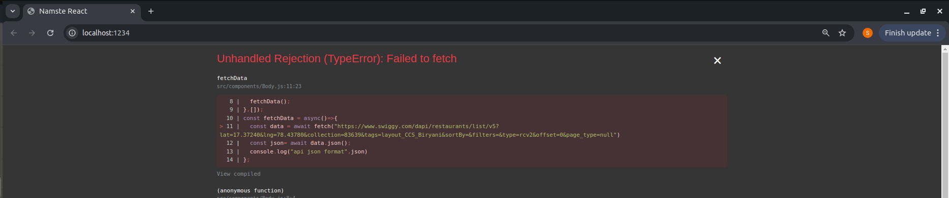
- Let’s assume our ui project we are doung in react as one of the microservice.
- We can observe it is deployed to the port
http://localhost:1234/
- Similarly each service is deployed in own specific ports.
- On different ports we can deploy different services.
- And finally all this ports are mapped to domain name


PART 02 :
- In the episode 5 we used the mock data fetched from swiggy and copied it into our code for rendering restaurents.
- But it is not a good way ,in this episode we will see how to dynamically fetch the data from api and populate our page dynamically.

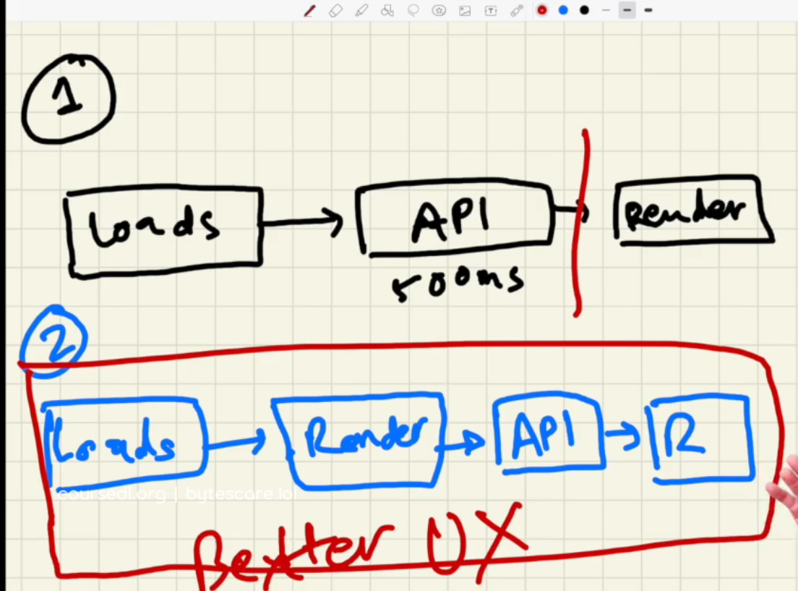
There are 2 ways of how web apps fetch the data from backend
Approach 1 :
- As soon as the page loads , we made an api call waits for the data to come , as soon as the data comes the ui will be rendered.
Approach 2 :
- As soon as the page loads , we render skeleton of the UI , then made api call , as soon as we get the api response we will render the data on the UI.
- In React we will always be using the second approach. We are using it because it gives better ux.
PART 03:
useEffect Hook:
syntax:
- useEffect(()=>{},[])
useEffect (()=>
  - {console.log(“useEffect callback”)},[])
- useEffect is just a normal js function it takes to arguments 1. callback function and
2.dependent array.
When will this useEffect callback function will be called?
- The callback function will be called after the component renders.
- So first all the component will be renderend then the callback function will be called and
useEffect callback will be printed in console after rendering the component.

What happens if you write console after the useEffect which will print first?
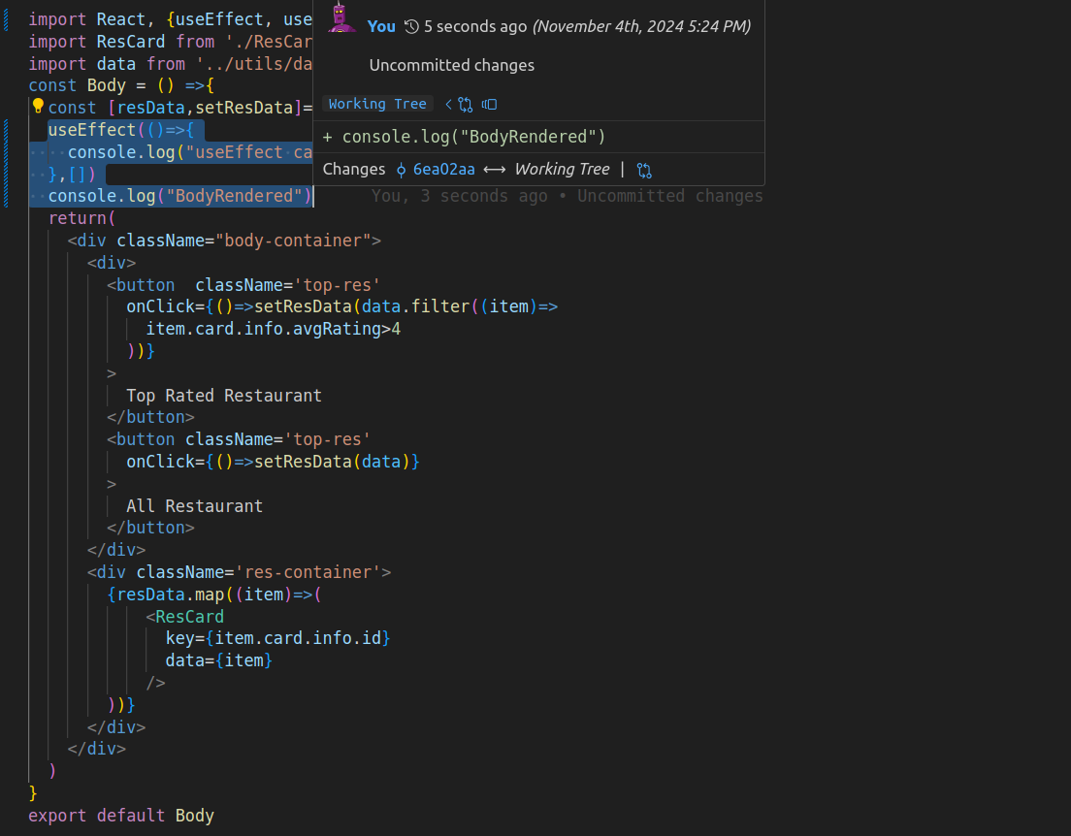
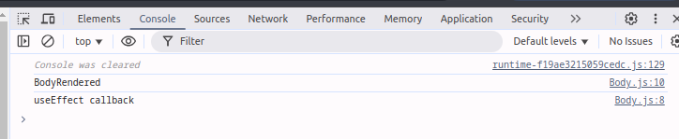
the output will be like below in the console.
This means the useEffect callback function will be called after the rendering of the component
- if you want to do something after rendering the component you have to write it inside the useEffect.
Lets understand the flow of execution ,of useEffect in a component
const Body = () =>{
const [resData,setResData]= useState(data)
useEffect(()=>{
console.log("useEffect callback")
},[])
console.log("BodyRendered")
return(
<div className="body-container">
<div>
<button className='top-res'
onClick={()=>setResData(data.filter((item)=>
item.card.info.avgRating>4
))}
>
Top Rated Restaurant
</button>
<button className='top-res'
onClick={()=>setResData(data)}
>
All Restaurant
</button>
</div>
<div className='res-container'>
{resData.map((item)=>(
<ResCard
key={item.card.info.id}
data={item}
/>
))}
</div>
</div>
)
}
export default Body(30:07)
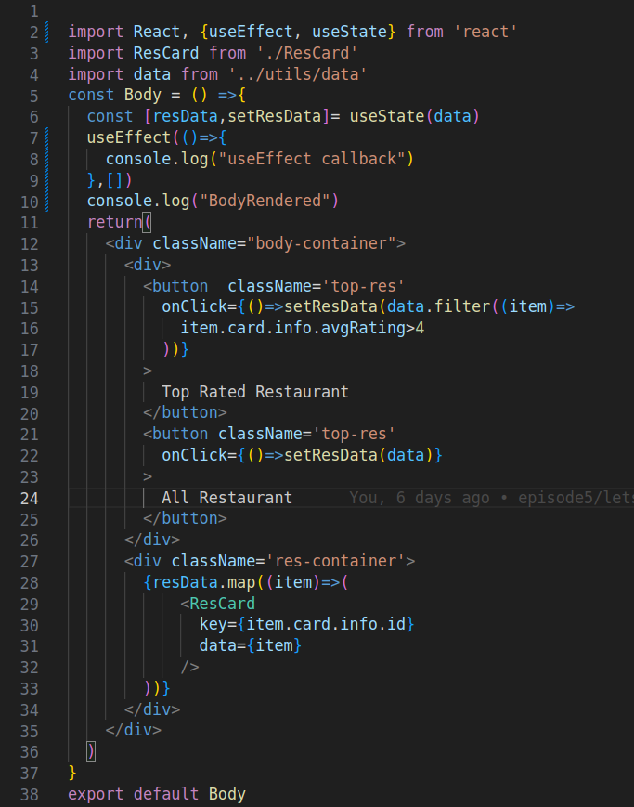
lets see how the flow of execution occurs in the component.
Observe the above component.The execution starts from line 5,
At line 6 creates state variables and when it reaches the line 7 ,the useEffect hook ,the callback function will be stored at somewhere and can be called after the component rendering ,next it reaches line 10 where the BodyRendered line will be printed in the console and next it reaches to return statements and renders the component later that the callback function in the useEffect will be executed and the line useEffect callback will be printed in the console.
Why we want use effect?
- For the 2nd approach
load->render->api->render we need useEffect to call api after the component is rendered.
- Cors chrome extension:
Lets try to fetch data directly from swiggy api with the help of fetch() rather than copying it and using as mock data.

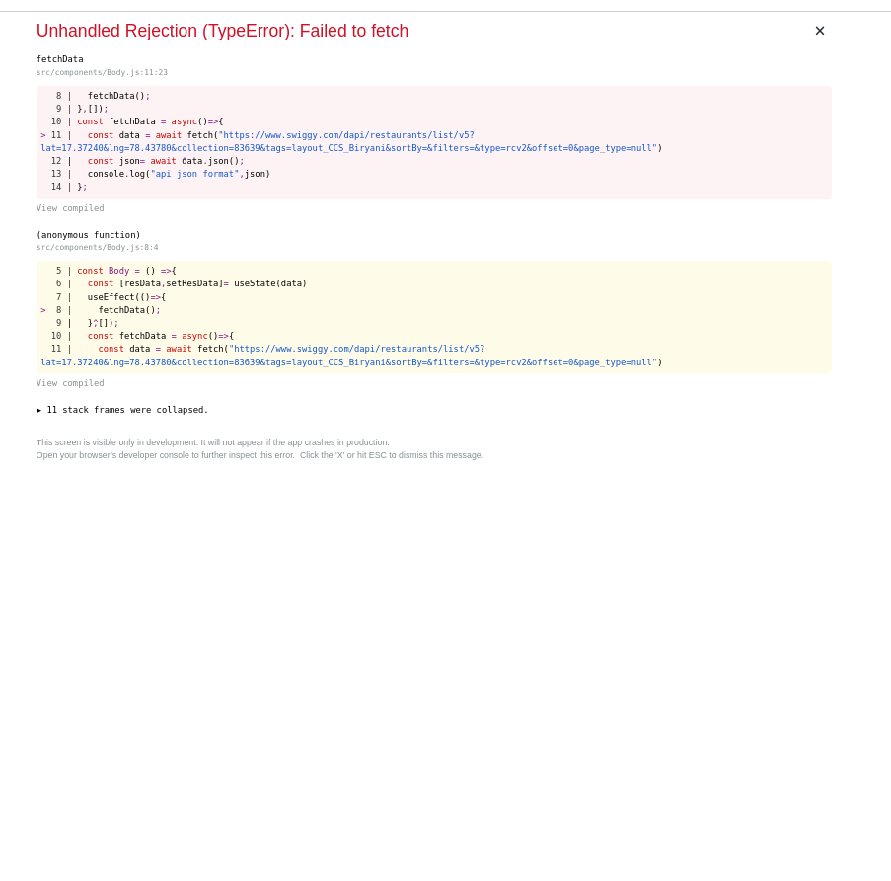

What is this CORS error?
- Cross-origin resource sharing (CORS)
- This error occurs when we try to get data from different origins like below.
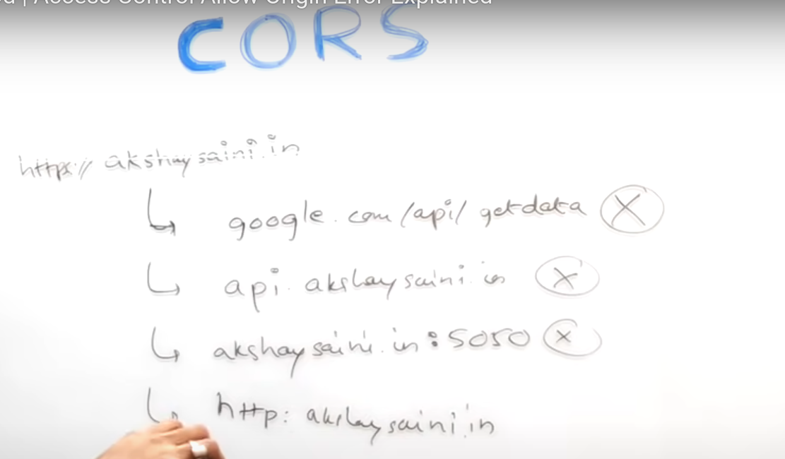

How this CORS work or resources between 2 web applications works?
- Lets assume we have different apps A and B on different domains or origins
- If A wants to request data(Assume POST api call) to B ,generally browswer itself makes CORS preflight call first.It is also called as OPTIONS Call.
- Preflight call is a call made before actual call is made.
- Later the server of B takes the responsiblity to verify if the request is valid or not.
- If it is valid it add the additional http headers
- After that the actual call is made.

