**CLASS WISE PERFORMANCE EVALUATION MEASURES BY CALCULATING VARIOUS FACTORS USING CONCEPT OF CONFUSION MATRIX**

Shanmukha Sudha Kiran.T-**211FA04003**, Sairam.P - **211FA04284**,

Sripujitha .S -**211FA04289**, Vamsi.G - **211FA04358**

**BATCH-07,3Rd B. TECH, CSE BRANCH, VFSTR DEEMED TO BE UNIVERSITY**

**ABSTRACT:**

In this Paper we begin by introducing about confusion matrix, confusion matrix has been provided to evaluate the performance of a classifier. The matrix depicts the predicted classes against the true classes. From this, various performance evaluation measures have been calculated.

**PROBLEM STATEMENT:**

A dataset has three class labels, namely Apple, Orange and Mango. The following is a possible confusion matrix for these classes.

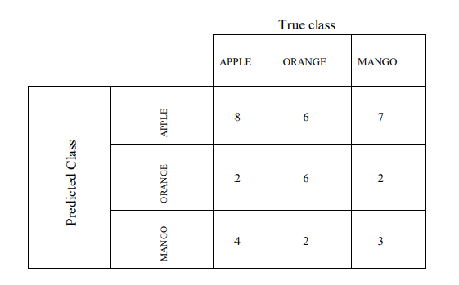

For reference: Accuracy = (true positives + true negatives) / (total examples) Precision = (true positives) / (true positives + false positives) Recall = (true positives) / (true positives + false negatives) F1 score = (2 * precision * recall) / (precision + recall) Find the class wise performance evaluation

measures and analyze which class accuracy is more out three classes. Also, measure the algorithm for classifier’s F1 score (as a value form 0 to 1.

**INTRODUCTION:**

**CONFUSION MATRIX**:

A confusion matrix is a matrix that summarizes the performance of a machine learning model on a set of test data.

**ACCURACY:**

Accuracy is one metric for evaluating classification models. Informally, accuracy is the fraction of predictions our model got right. Formally, accuracy has the following definition: Accuracy = Number of correct predictions Total number of predictions.

Accuracy = (true positives + true negatives) / (total examples)

**PRECISION:**

Precision is one indicator of a machine learning model's performance – the quality of a positive prediction made by the model.

Precision = (true positives) / (true positives + false positives)

**RECALL:**

Recall, also known as the true positive rate (TPR), is the percentage of data samples that a machine learning model correctly identifies as belonging to a class of interest—the “positive class”—out of the total samples for that class.

Recall = (true positives) / (true positives + false negatives)

**F1-SCORE:**

F1 score is a machine learning evaluation metric that measures a model's accuracy. It combines the precision and recall scores of a model.

F1 score = (2 * precision * recall) / (precision + recall)

**ALGORITHM:**

1.start

2. Import necessary libraries if needed.

3. Initialize variables:

- Create an empty dictionary `d` to store class indices and names.

- Create an empty dictionary `e` to store accuracy values and corresponding class indices.

- Initialize `tp`, `tn`, `fp`, and `fn` to 0 for counting.

4. Input the number of classes (`m`) from the user.

5. Input class names and store them in the dictionary `d`:

- Loop over `m` times:

- Input a class name and store it in the dictionary with its index.

6. Initialize an empty list `matrix` to store the confusion matrix values.

7. Input confusion matrix values for each class:

- Loop over `m` times for each row:

- Initialize an empty list `l` for the current row.

- Loop over `m` times for each column:

- Input a confusion matrix value and append it to list `l`.

- Append the list `l` to the matrix.

8. For each class index `i` (0 to `m-1`):

- Calculate true positives (`tp`):

- Assign the value from `matrix[i][i]` to `tp`.

- Initialize `fp` and `fn` to 0 for counting false positives and false negatives.

9. Nested loops for calculating false positives (`fp`), false negatives (`fn`), and true negatives (`tn`):

- Loop over `m` times for each predicted class `j`:

- If `i` is not equal to `j`:

- Increment `fp` by `matrix[i][j]`.

- Increment `fn` by `matrix[j][i]`.

- Loop over `m` times for each actual class `k`:

- Increment `tn` by `matrix[j][k]`.

- Adjust `tn` by subtracting the sum of `tp`, `fp`, and `fn`.

10. Calculate accuracy using the `accuracy` function:

- Calculate `acc` using the provided formula and values (`tp`, `tn`, `fp`, `fn`).

11. Calculate precision using the `precision` function:

- Calculate `pre` using the provided formula and values (`tp`, `fp`).

12. Calculate recall using the `recall` function:

- Calculate `rec` using the provided formula and values (`tp`, `fp`).

13. Calculate F1 score using the `f1score` function:

- Calculate `score` using the provided formula and values (`pre`, `rec`).

14. Print evaluation measures for the current class:

- Print TP, TN, FP, FN, accuracy, precision, recall, and F1 score.

- Reset counters `tp`, `tn`, `fp`, and `fn` to 0.

15. After looping through all classes, find the class with the maximum accuracy:

- Determine the class index with the maximum accuracy from dictionary `e`.

- Print the class name with the maximum accuracy.

16.Stop

**SOURCE CODE:**

def accuracy(tp,tn,fp,fn):

acc=(tp+tn)/(tp+tn+fp+fn)

return acc

def precision(tp,fp):

pre=tp/(tp+fp)

return pre

def recall(tp,fp):

rec=tp/(tp+fn)

return rec

def f1score(pre,rec):

score=(2*pre*rec)/(pre+rec)

return score

m=int(input("enter the no of classes: "))

matrix=[]

d={}

e={}

tp=tn=fp=fn=0

print("Enter the names of the class: ")

for i in range(m):

p=input()

d[i]=p

print("Now enter the values:")

for i in range(m):

l=[]

for j in range(m):

n=int(input())

l.append(n)

matrix.append(l)

for i in range(m):

tp=matrix[i][i]

for j in range(m):

if(i!=j):

fp=fp+matrix[i][j]

fn=fn+matrix[j][i]

for k in range(m):

tn=tn+matrix[j][k]

tn=tn-(tp+fp+fn)

acc=accuracy(tp,tn,fp,fn)

e[acc]=i

pre=precision(tp,fp)

rec=recall(tp,fp)

score=f1score(pre,rec)

print("*******************for class ",d[i]," values are: ")

print()

print("tp tn fp tn :",tp ,tn ,fp ,fn)

print("Accuracy is: ",acc)

print("precision is: ",pre)

print("Recall is: ",rec)

print("F1 Score is: ",score)

print()

tp=tn=fp=fn=0

print("Class with maximum accuracy is :")

print(d[e[max(e)]])

**OUTPUTS:**

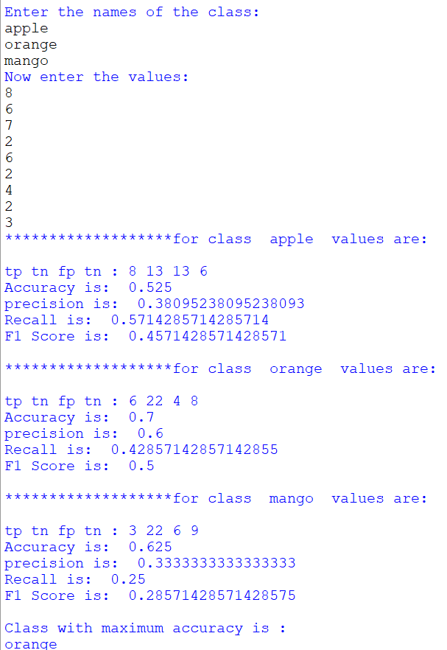

**CONCLUSION:**

In conclusion, the evaluation measures reveal that the Orange class exhibits the highest accuracy, precision, and recall among the three classes. Furthermore, the F1 score reinforces the Orange class's strong performance as a classifier.

**REFERENCE:**

1. [**https://www.geeksforgeeks.org/confusion-matrix-machine-learning/**](https://www.geeksforgeeks.org/confusion-matrix-machine-learning/)
2. [**https://www.javatpoint.com/confusion-matrix-in-machine-learning**](https://www.javatpoint.com/confusion-matrix-in-machine-learning)