

DEPARTMENT OF MECHANICAL ENGINEERING

ADDITIVE MANUFACTURING PROJECT REPORT

Design and Optimization of a Drone Frame Using Generative Design

Submitted for
23ARE213 – Additive Manufacturing

Submitted by
Agraharam Rakesh – CB.EN.U4ARE24001
Kranthi Koushik Reddy – CB.EN.U4ARE24017
Mamillapalli Shanmukha Vinayak – CB.EN.U4ARE24023
N Surya Abhiram – CB.EN.U4ARE24031

ABSTRACT

Additive manufacturing enables the production of complex geometries and lightweight structures that are difficult to achieve using conventional manufacturing methods. This project focuses on the design and optimization of a quadcopter drone frame using generative design techniques combined with structural analysis and additive manufacturing principles. Initially, a base drone frame was modeled using CAD software and evaluated using Finite Element Analysis (FEA) to study its structural behavior under operational loads such as motor thrust, rotor torque, payload weight, and component loads.
The results of the simulation were then used to guide the generative design process, where preserved regions and constraints were defined to allow the software to generate optimized structural configurations. Multiple generative design iterations were analyzed to obtain a lightweight yet structurally efficient drone frame. The selected design demonstrated improved strength-to-weight characteristics while maintaining manufacturability.
The optimized model was then prepared for fabrication through slicing, where parameters such as infill density, shell thickness, and support structures were defined. Finally, suitable additive manufacturing processes were identified for prototype development. The study demonstrates the effectiveness of combining generative design and additive manufacturing techniques for developing efficient drone frame structures.

- INTRODUCTION
Unmanned Aerial Vehicles (UAVs), commonly known as drones, have become increasingly important across industries ranging from aerial photography and logistics to search and rescue and agricultural monitoring. At the heart of every drone lies its structural frame, which must be simultaneously lightweight, stiff, and durable enough to withstand the dynamic forces generated during flight.
Conventional manufacturing processes impose significant geometric constraints on frame design, often forcing engineers to accept heavier or less optimized structures. Additive Manufacturing (3D printing) removes many of these constraints, enabling designers to produce complex, topology-optimized geometries that are impossible to machine conventionally.
This project combines parametric CAD modelling in Fusion 360 with structural FEA, generative design optimization, and additive manufacturing to develop an optimized drone frame. The workflow illustrates how modern digital manufacturing tools can be used together to achieve superior performance outcomes in aerospace-grade structures.
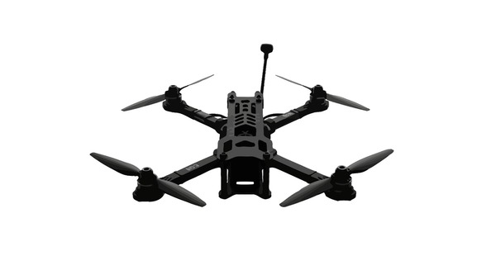

- Problem Statement
To design and optimize a lightweight Payload Drone frame that can withstand loads such as motor thrust, rotor torque, payload weight, and structural loads while minimizing material usage through generative design and additive manufacturing techniques. The frame should be having a payload capacity of 1 kilogram.

- Objective
The main objectives of this project are:
- To design a symmetric, lightweight drone frame using CAD tools (Fusion 360).
- To define realistic structural constraints and flight loads based on motor thrust, payload, and component weights.
- To perform Finite Element Analysis (FEA) to evaluate stress distribution, Factor of Safety, and displacement.
- To apply generative design optimization for weight reduction while maintaining structural integrity.
- To prepare the optimized model for additive manufacturing using slicing software.
- To fabricate and evaluate prototype iterations using SLS and FDM 3D printing processes.

- DESIGN AND MODELING
Design Calculations
Weight Breakdown
The total weight of the drone is calculated based on individual components:
Component | Weight
Chassis | ≈ 250 g
Payload | ≈ 1000 g
Electronic components | ≈ 750 g
Total Weight (Wₜₒₜ) | ≈ 2.0 kg

Thrust Requirement Calculation
Weight Force
The gravitational force acting on the drone is:
W = m × g = 2 × 9.8 = 19.6 N
Factor of Safety (FoS): nₜ = 2
Total Thrust Required
Fₜ = nₜ × Wₜₒₜ × g
Fₜ = 2 × 2 × 9.8 = 39.2 N
So, the drone must generate at least 39.2 N of total thrust.
Thrust per Motor
Since the drone uses 4 motors:
Fₜₘ = Fₜ / 4 = 39.2 / 4 = 9.8 N
For design margin and real-world losses:
Fₜₘ ≈ 10 N
Design target,
[F]= 12 N per motor

Rotor Moment Produced by the Motor
The Rotor Moment produced by a BLDC motor is given by:
(τ)= Iₘₐₓ / ((2π / 60) × KV)
(τ) = 20 / ((2π / 60) × 920)
(τ)= 20 / 96.3 = 0.208 N·m
τ ≈ 0.21 N·m
Structural Stress Analysis (Fixed Member)
To ensure the mounting structure can withstand applied loads, normal stress is calculated:
σ = P / A
Where:
- Load P = 1 N (assumed test load)
- Cross-sectional area:
A = π (100 × 10⁻³) ²
σ = 1 / (π (0.1) ²) = 3183.4 Pa
This stress value is much lower than the allowable stress of common structural materials (ABS), confirming the design is safe.

For Drone Arm:
The wing of the drone is attached to fixed plate at the center. The arm undergoes bending about X-axis and torsion.
Length of the arm (L) is 150 mm
Moment = F_{TM} * L
M= 12 * 150 *10⁻³
M= 1.8 N-m
Now we should find bending stress at the end point of arm.

Bending moment
$\left(σ\right)=\frac{\left(M * y \right)}{I}$
Where,
I = Moment of inertia
y = distance from neutral axis to outer most point of arm.
We will follow Theory of Maximum Shear Stress as ABS is ductile.

Designing Of Arm Diameter :
For the given loading, from Design Data book:
d³ = $\frac{16}{π*T max}$ (√(M² + T²))
( T max = $\frac{σy}{2n}$ = 5 MPa )
= $\frac{16}{π*5*1000000}$ (√(1.8)² +(0.21)²)
= 1.6959 x 10⁻⁶ mm
d = 12.2 mm
By maximum shear stress theory , the safe diameter of the shaft is 12 mm.

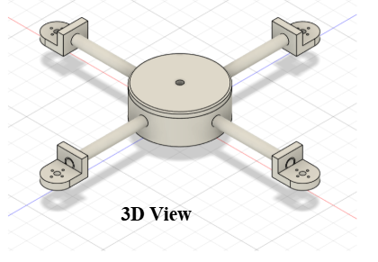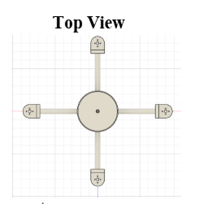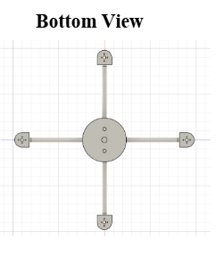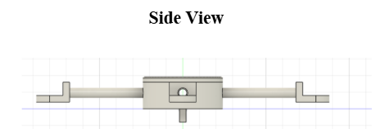

- FINITE ELEMENT ANALYSIS
Prior to generative design optimization, a comprehensive structural analysis was performed to understand the stress state of the baseline frame design under realistic flight conditions.
Constraints and Boundary Conditions
The base (central hub) of the drone frame was defined as the fixed constraint. This reflects the physical reality that the flight controller and battery — mounted at the center — provide the reference inertial frame during flight, while the motor mounts experience the primary thrust loads.
Applied Loads:
Load Parameter | Value / Formula
Motor Thrust (per motor) | 12 N(AUW = 39.2 N, FoS = 2)
Rotor Moment (Mr) | 0.21 N·m [Mr = Iₘₐₓ / ((2π/60) × KV)]
Motor Weight (Wm) | 0.7 N
Payload (Wp) | 9.8 N(1kgf)
Chassis + Components Weight (Wch) | 7.35 N(0.750kgf)
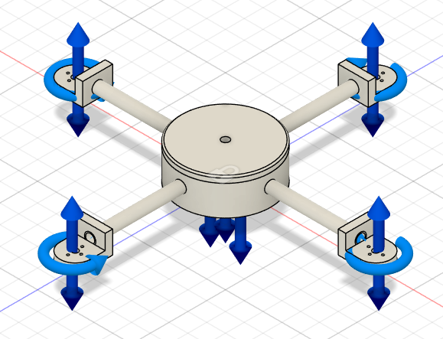
FEA Results
The following structural metrics were extracted from the Finite Element Analysis simulation:
Metric | Result
Factor of Safety (FoS) | Calculated for critical load paths
Von Mises Stress | Evaluated across all arm and hub regions
Displacement | Maximum deformation under combined loading

Factor of Safety
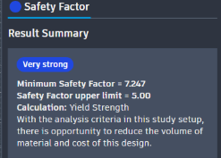
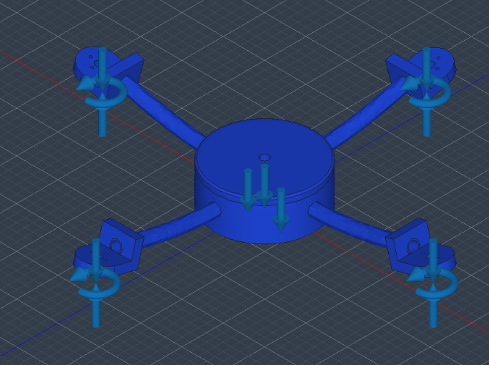

Von Misses
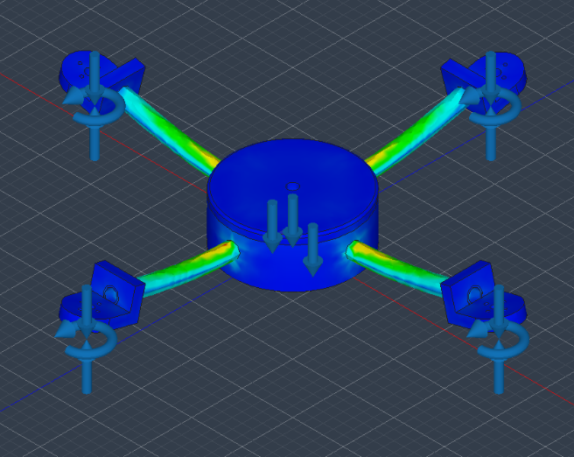
Displacement
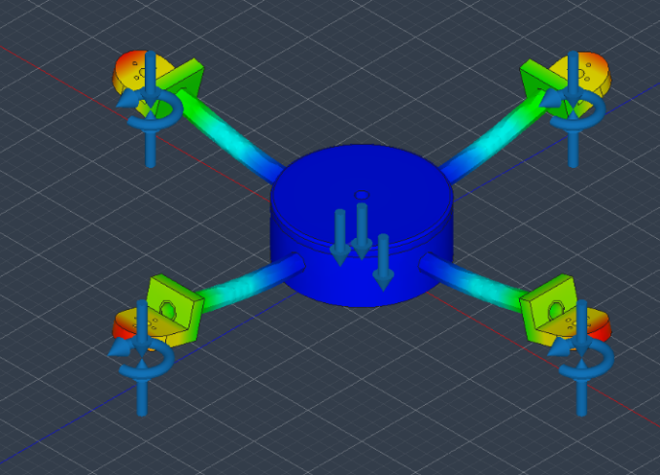

The stress analysis identified high-stress concentration zones at the arm-to-hub transition regions and at motor mount interfaces. These results directly informed the preserved geometry definitions in the subsequent generative design stage. This verifies that our design in correct

- GENERATIVE DESIGN OPTIMIZATION
Generative design was used to optimize the drone frame structure by removing unnecessary material while maintaining the structural integrity of critical functional components. The generative design process allows the software to explore multiple design alternatives based on specified constraints, loads, preserved regions, and obstacle regions.
In this project, the generative design study was performed in Fusion 360 by defining the following design inputs:
Preserved Geometry
Preserved geometry represents the regions that must remain unchanged during the optimization process. These regions are critical for maintaining the functional features of the drone frame.
The following regions were defined as preserved geometry:
• Motor mounts, where the motors are attached to the drone arms
• Wiring channels, which allow routing of electrical wires from the motors to the flight controller
• Top plate, which supports the electronic components and battery
• Central chassis region, which acts as the structural hub of the drone frame
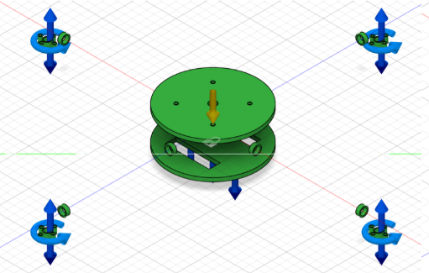

Obstacle Geometry
Obstacle geometry represents regions where material generation is restricted during the generative design process. These regions prevent the algorithm from generating material in areas that must remain free for functional or mechanical reasons.
In this project, the following obstacle regions were defined:
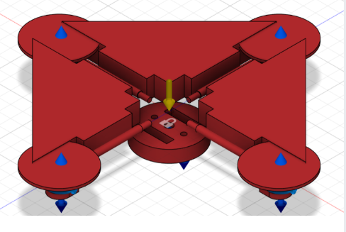
• Internal space for electronic components, to ensure sufficient clearance for the flight controller and battery
• Motor rotation clearance region, to prevent the optimized structure from interfering with the rotating propellers
• Wiring pathway clearance, ensuring that wiring channels remain accessible and unobstructed
• Central component clearance, to allow installation and maintenance of internal components
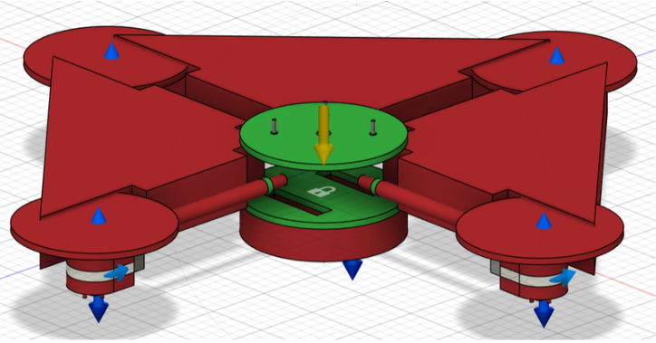
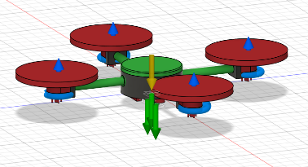 | 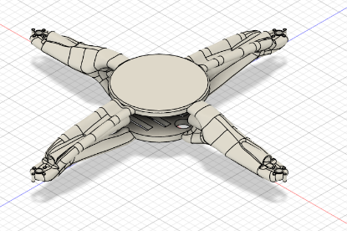  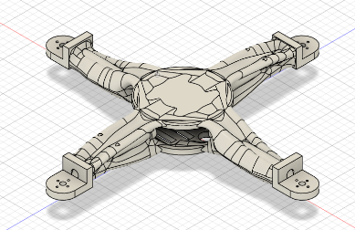 | Preserved-  Wiring channels, top plate.  Not preserved-  Motor mount  Preserved-  Wiring channels, motor mount  Not preserved-  Top plate
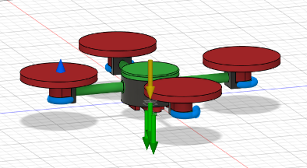 | 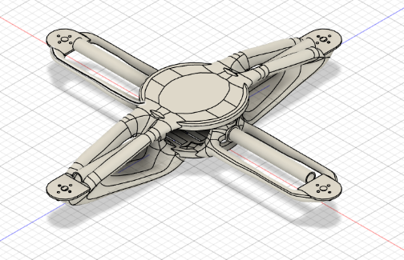  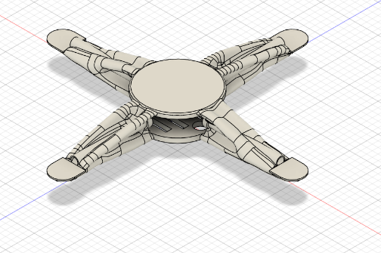 | Preserved-  Wiring channels, motor mount(2mm)  Not preserved-  Top plate.  Preserved-  Wiring channels, motor mount(2mm),  Top plate.
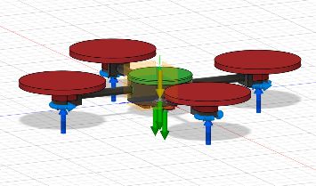 | 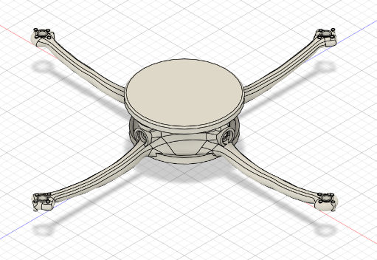 | Preserved-  Top plate  Not preserved-  Wiring channels,  motor mount
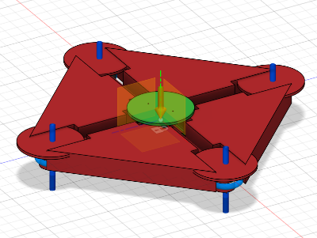 | 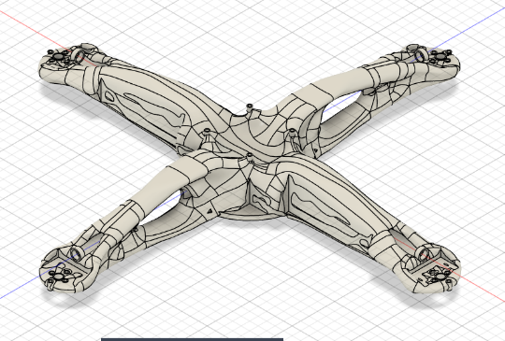  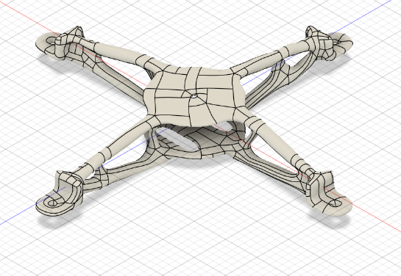 | Not preserved-  Wiring channels,  motor mount,  Top plate  Preserved-  Top plate, Wiring channels  Not preserved-  motor mount

Generative Design Final Result:
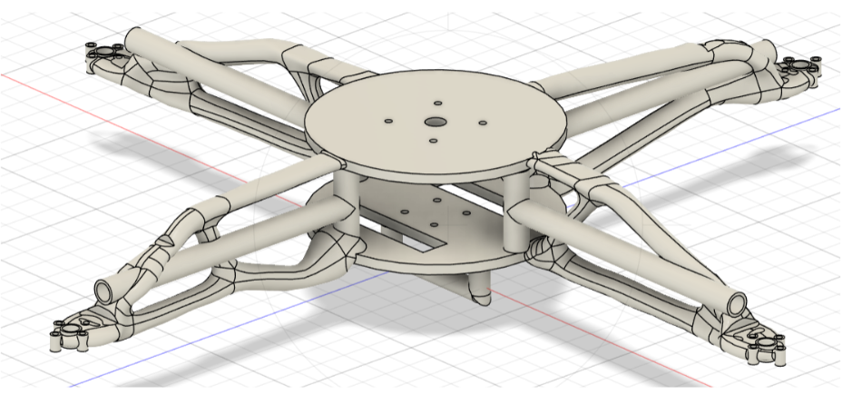
- SLICING PROCESS
After obtaining the optimized generative design model, the geometry was exported as an STL file and imported into Ultimaker Cura slicing software. Slicing converts the 3D model into multiple thin layers and generates G-code instructions that guide the 3D printer during fabrication.
Several printing parameters were defined during slicing to ensure proper printability and structural strength of the drone frame.
The selected slicing parameters are:
- Infill Density: 40%
- Infill Pattern: Gyroid
- Shell Thickness: 1.2 mm
- Support Type: Tree Support
- Material: PLA
The gyroid infill pattern was selected because it provides uniform strength distribution and good resistance to vibration. Tree supports were used since the generative design structure contains curved geometries that require minimal but efficient support during printing.
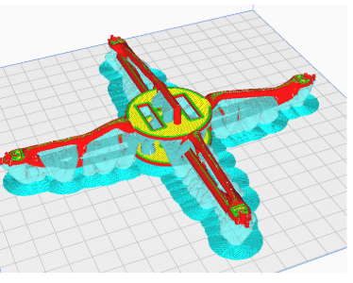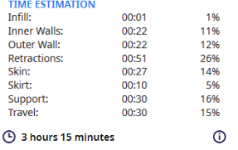

- ADDITIVE MANUFACTURING PROCESS
Additive manufacturing processes were evaluated to determine the most suitable method for fabricating the optimized drone frame.
Two additive manufacturing methods were considered for this project:
- Primary Manufacturing Process – Selective Laser Sintering (SLS)
Selective Laser Sintering is a powder-based additive manufacturing process in which a high-energy laser is used to fuse powdered material layer by layer to form the final component.
In this project, Nylon (PA12) was considered as the primary material for SLS fabrication. Nylon offers excellent mechanical properties, including high strength-to-weight ratio, impact resistance, and vibration resistance. These characteristics make it highly suitable for drone frame applications.
Another advantage of SLS is that it does not require support structures during printing. The surrounding powder acts as a natural support, allowing complex geometries such as generative designs to be manufactured without additional support material.
Advantages of SLS include:
• Ability to manufacture complex geometries
• High mechanical strength
• Good fatigue and vibration resistance
• No support structures required
• Suitable for functional end-use parts
- Secondary Manufacturing Process – Fused Deposition Modelling (FDM)
For prototype fabrication and testing, Fused Deposition Modelling (FDM) was selected as the secondary manufacturing process. FDM works by extruding thermoplastic material through a heated nozzle and depositing it layer by layer to build the part.
In this project, PLA material was used for the FDM printing process. PLA is widely used for rapid prototyping due to its ease of printing, low warping characteristics, and good dimensional accuracy.
Although PLA does not possess the same mechanical strength as engineering polymers such as Nylon, it is suitable for prototype testing and demonstration purposes.
Advantages of FDM include:
• Low manufacturing cost
• Rapid prototyping capability
• Easy setup and operation
• Suitable for design testing and iteration
• Wide availability of materials

- ADVANTAGES OF THE DESIGN
- Generative design enables significant weight reduction while maintaining or improving structural FoS compared to conventional solid frame designs
- Symmetric four-arm configuration ensures balanced thrust distribution and simplified flight controller tuning
- SLS manufacturing with Nylon PA12 produces isotropic, high-strength parts with excellent fatigue resistance
- The digital design-to-manufacture workflow enables rapid iteration without tooling costs
- Optimized material distribution reduces raw material consumption and overall drone all-up weight
- Complex internal geometries that emerge from generative design are manufacturable only through additive processes

- APPLICATIONS
The drone frame designed in this project, and the methodology developed, have broad applications across multiple sectors:
- Search and rescue operations — optimized frames improve endurance for long-range missions
- Agricultural monitoring and precision spraying — payload-efficient designs increase chemical or sensor capacity
- Logistics and last-mile delivery — structural efficiency enables heavier package delivery
- Defense and surveillance — drones require lightweight frames for extended surveillance missions
- Educational robotics and engineering design courses — demonstrates integrated design-simulate-fabricate workflows
- Aerial photography and videography — lightweight frames extend flight time for cinematic UAVs

12. CONCLUSION
In this project, a quadcopter drone frame was successfully designed and optimized using generative design and additive manufacturing principles. Initially, a base drone frame was modeled and analyzed using Finite Element Analysis (FEA) to evaluate its structural behavior under operational loads such as motor thrust, rotor torque, payload weight, and component loads. The simulation results showed that the structure could safely withstand the applied loads with a satisfactory factor of safety and minimal deformation.
Generative design was then applied to optimize the structure by defining preserved regions and obstacle geometries. Multiple design iterations were generated, and the most suitable configuration was selected based on structural strength, weight reduction, and manufacturability. The optimized design demonstrated an improved strength-to-weight ratio while maintaining the functional requirements of the drone frame.
The final model was prepared for additive manufacturing through slicing software, where appropriate printing parameters such as infill density, shell thickness, and support structures were defined. The study demonstrates that generative design combined with additive manufacturing techniques can effectively produce lightweight and structurally efficient drone frame designs suitable for modern UAV applications.

13. REFERENCES
- Balayan, A., Mallick, R., Dwivedi, S., Saxena, S., Haorongbam, B., & Sharma, A. (2023). Optimal Design of Quadcopter Chassis Using Generative Design and Lightweight Materials to Advance Precision Agriculture. Machines, MDPI.
- Gibson, I., Rosen, D., & Stucker, B. (2021). Additive Manufacturing Technologies: 3D Printing, Rapid Prototyping, and Direct Digital Manufacturing. Springer.
- Unnikrishnan D, 23ARE213 – Additive Manufacturing Course Material.
Department of Mechanical, Amrita School of Engineering

