**INFO 5100: APPLICATION ENGINEERING AND DEVELOPMENT**

**PERFORMANCE MEASUREMENT SOLUTION FOR UNIVERSITY USING SOFTWARE ENGINEERING TECHNIQUES**

**SHANMUKHA PRIYA GUNTUPALLI**  (001584929)

**JASPREET KAUR BHAMRA** (001582619)

**PAVAN SAI PATI** (001521280)

**INTRODUCTION**

**1) DESIGN OBJECTIVE:**

Design ways to define own ranking system to a University where students can decide where they want to go for their studies.

**PROPOSED SOLUTION:**

A Feedback Model was built in the proposed attempt to produce a survey questionnaire for current enrolled students and university alumni students. The responses are recorded and analyzed to return a rating of the faculty and the ranking of the course respectively.

The faculties and courses offered are the foundation to any university, so it is essential that they are productively assessed and evaluated. The attributes used to evaluate the performance of any university are the teaching faculty ranking based on the Feedback from existing students and the classification of applicable courses compliance with the job security and promotion of alumni.

A performance analysis dashboard is created that is supervised by the college administration to analyze the research findings and make corresponding improvements to the courses to enhance the standard of education to promote development of students. After which, the direction of study is matched with the modern job market.

**2) SEQUENCE DIAGRAM:**

**Department Ranking based on the Feedback of Students for Course and Faculty Ranking**

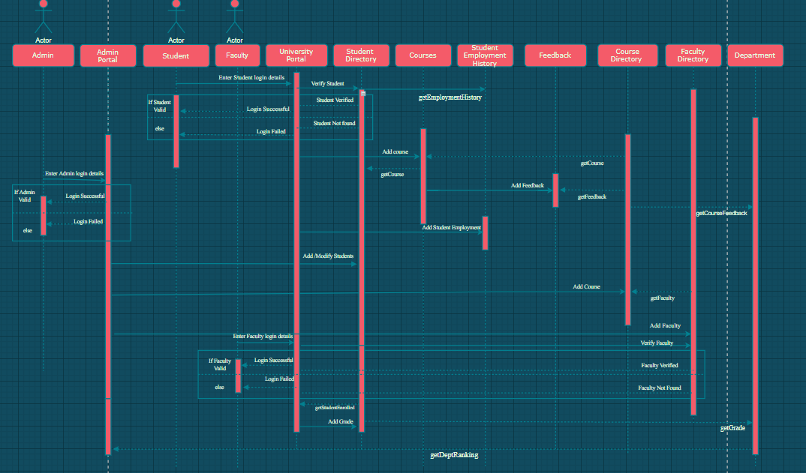

**LINK -**

[**https://drive.google.com/file/d/1Ivy8ZkL70Ll8fxBG2Nb96DY0ZNTVNFXa/view?usp=sharing**](https://drive.google.com/file/d/1Ivy8ZkL70Ll8fxBG2Nb96DY0ZNTVNFXa/view?usp=sharing)

**3) OBJECT MODEL:**

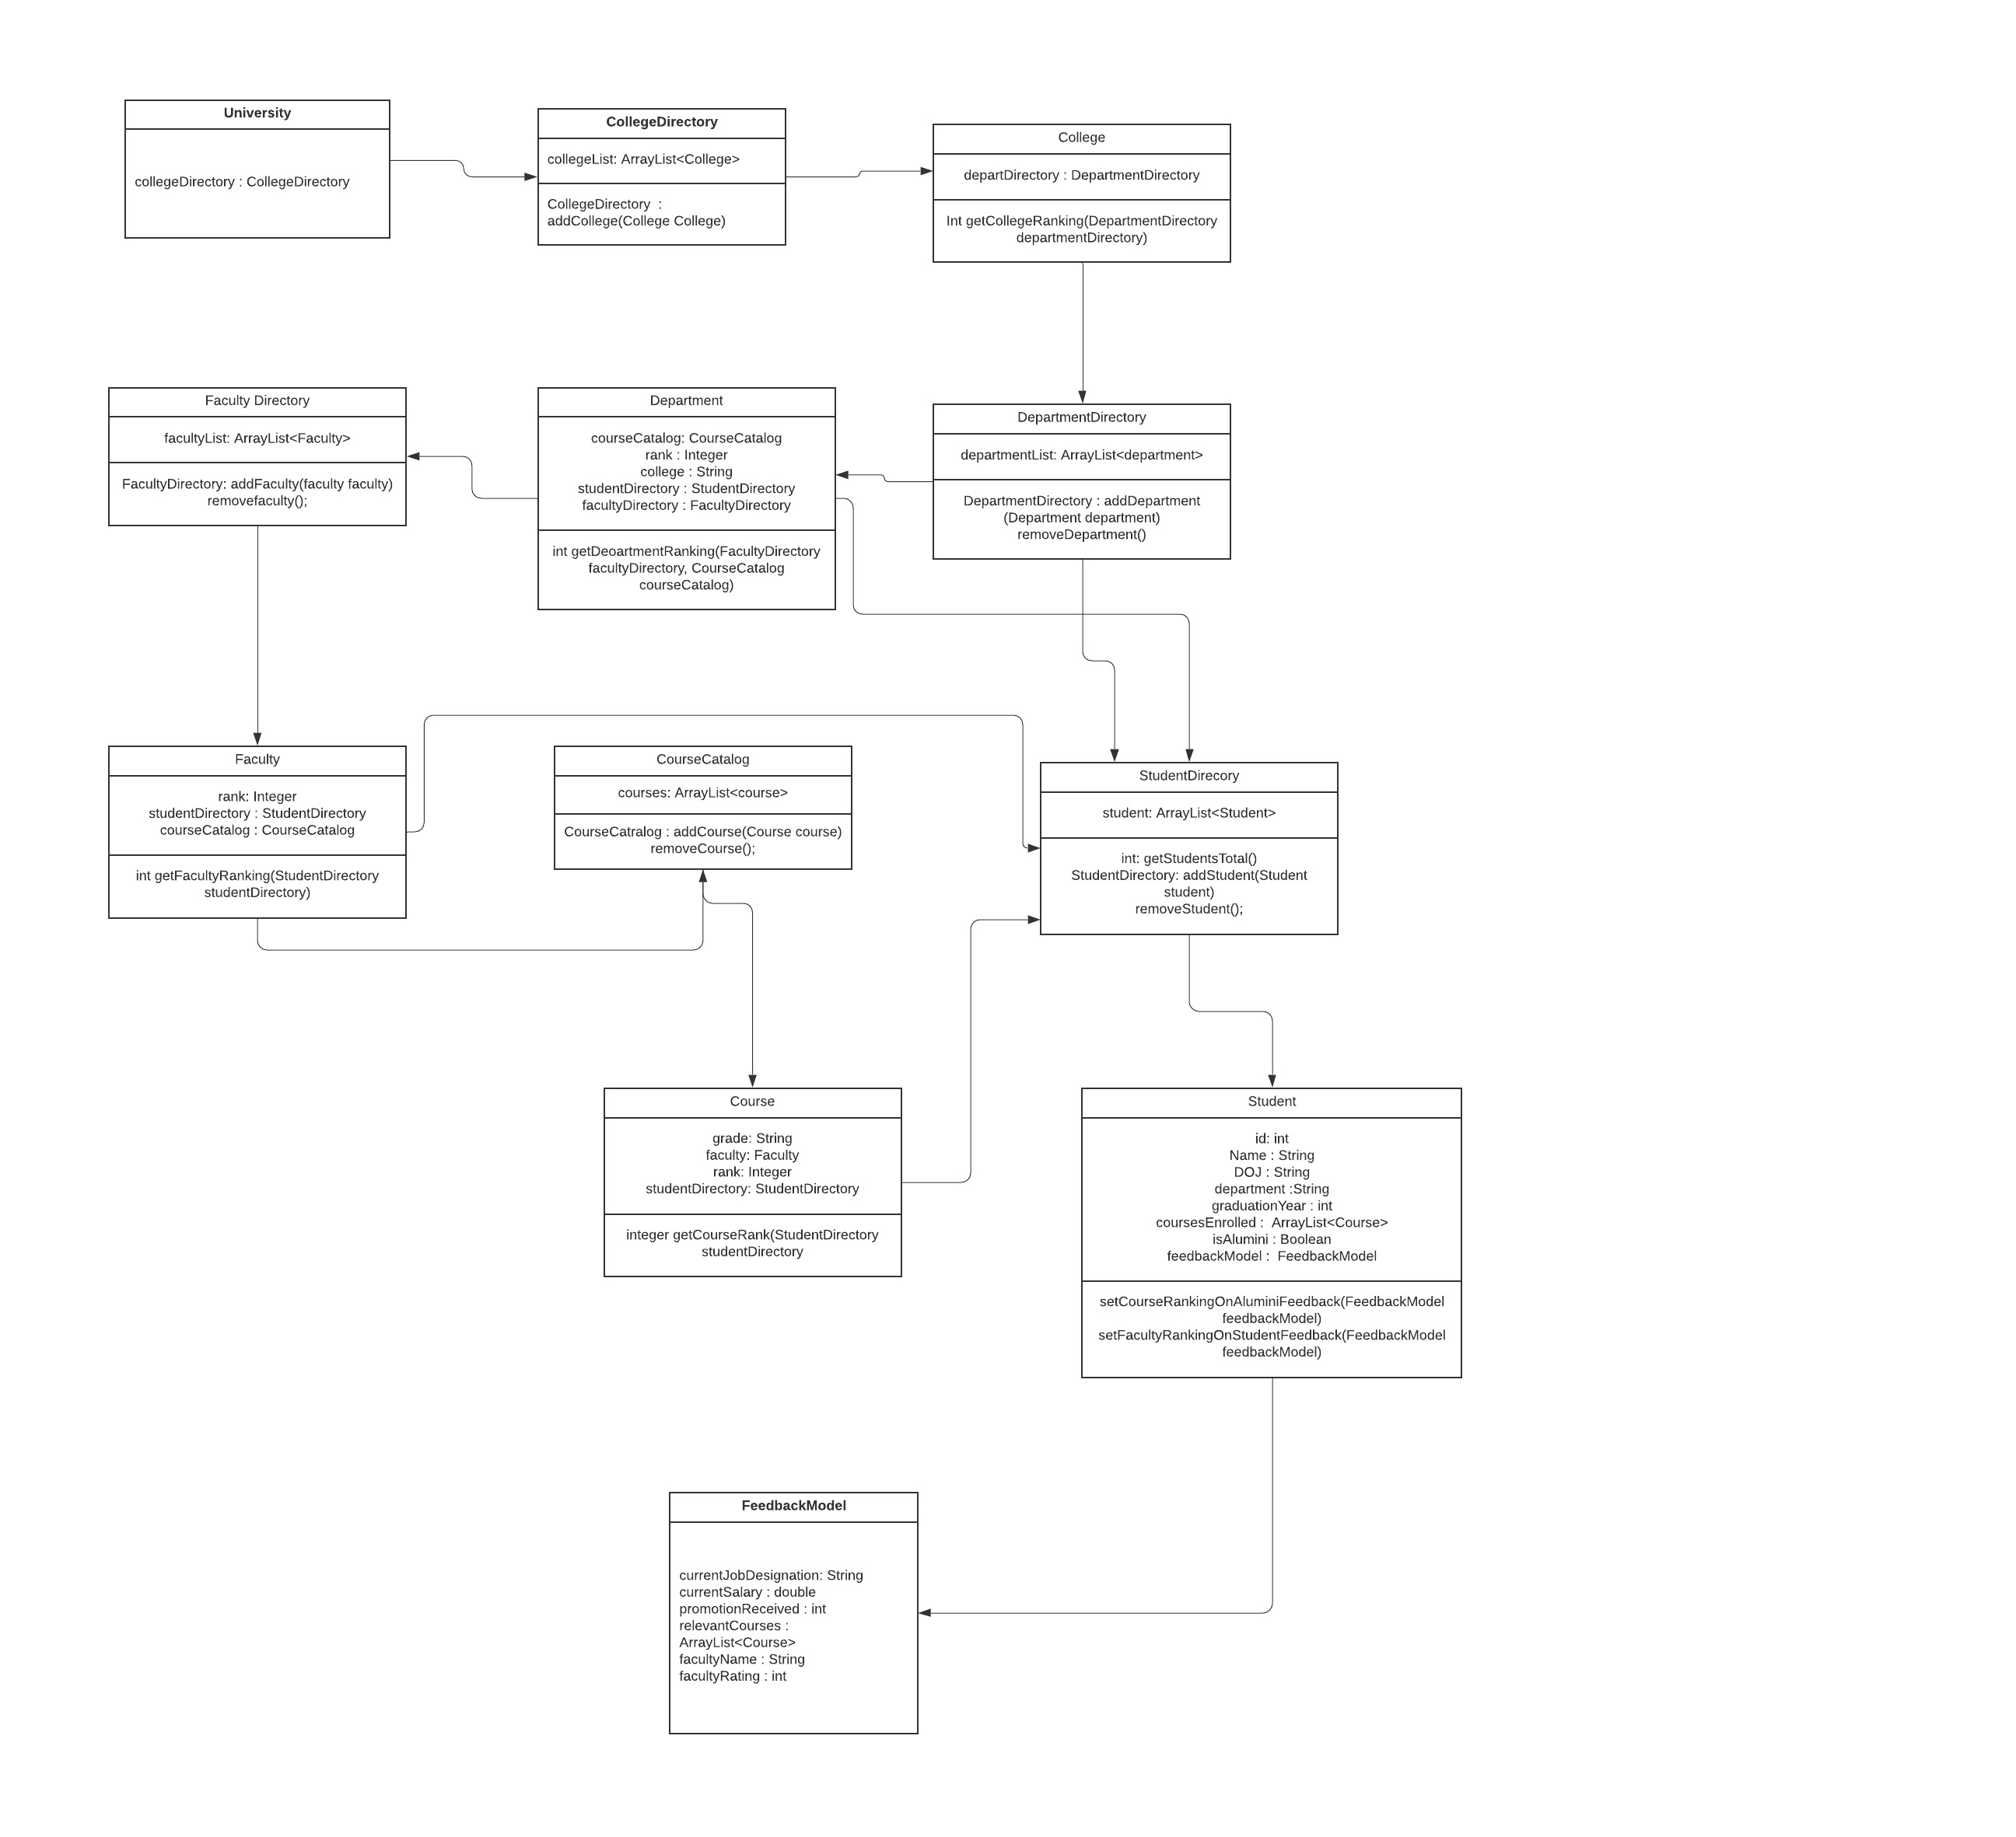**LINK -**

[**https://app.lucidchart.com/invitations/accept/de98534d-baa6-4f3c-9d63-0f8a4a0515ce**](https://app.lucidchart.com/invitations/accept/de98534d-baa6-4f3c-9d63-0f8a4a0515ce)

**https://app.lucidchart.com/lucidchart/caba4eb1-a6ed-41cd-97f8-123b2ea003a0/view?page=HWEp-vi-RSFO#?folder_id=home&browser=icon**

**METHOD DEMONSRATION**

getCollegeRanking(Department Directory)

Each college has multiple departments based on the disciplines offered. This function will return the rank of college calculated by taking average rank of all departments under the college.

Integer getDepartmentRanking(Faculty Directory, CourseCatalog)

This function returns the rank of departments based on the feedbacks from alumni students and faculty feedback from current students.

Integer getCourseRank (StudentDirectory)

This function returns the ranking of courses based on the feedback given by alumni students.

Integer getFacultyRanking (StudentDirectory)

This function returns the ranking of faculty based on the survey feedback that is taken by the currently enrolled students.

FacultyDirectory addFaculty (Faculty faculty)

This function adds a faculty to the faculty directory.

removeFaculty ()

This function removes a faculty from the faculty directory.

StudentDirectory addStudent (Student student)

This function adds a student to the student directory.

removeStudent ()

This function removes a student from the student directory.

CourseCatalog addCourse (Course course)

This function adds a course to the course catalog.

removeCourse ()

This function removes a course from the course catalog.

DepartmentDirectory addDepartment (Department department)

This function adds a department to the department directory.

removeDepartment ()

This function removes a department from the department directory.

Integer setCourseRankingBasedOnAlumniFeedback()

This method sets the rank of a course based on the feedback of alumni student w.r.t the current job designation, salary and the relevant courses the alumni had enrolled in.

Integer setFacultyRankingBasedOnStudentFeedback()

This method sets the rank of a faculty based on feedback given by current students.

**4) DASHBOARD DESIGN:**

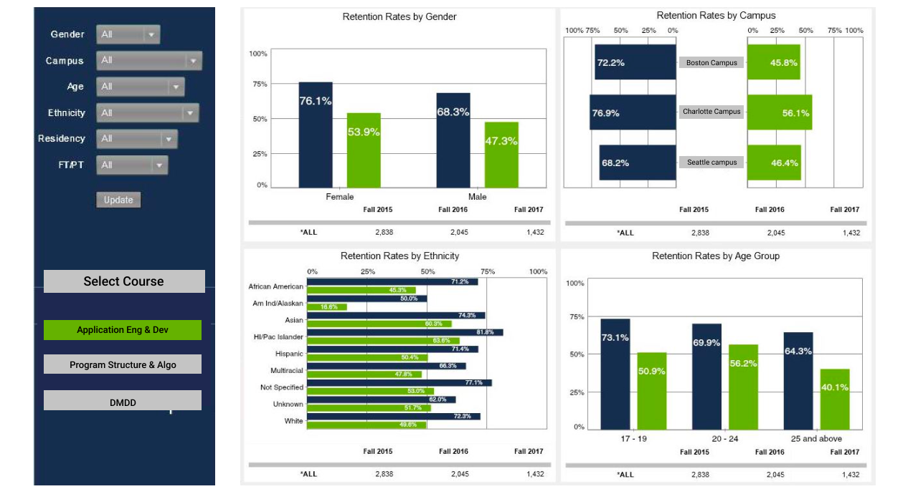

**LINK -**

**https://www.figma.com/proto/8UEWOSMskYXvYFOBJTREJp/Untitled?node-id=1%3A2&scaling=min-zoom**

**CONCLUSION :**

We have designed a performance evaluation assessment in the proposed solution, a mechanism that will encourage Universities to evaluate the quality of the education they offer to their students. The approach considers the input from the alumni on the relevant courses and the ranking of courses that have become helpful to them in terms of employment promotions and pay raises. The system also calculates the rank of the faculty based on a study carried out by current students. These rankings will, in turn, help a student find out the ranking of every department and University that will serve as a reference for prospective students seeking to choose a college, department or course. In addition, the scope of this project can be broadened by taking into consideration the feedback from the recruiter, which would help the admin to rank a specific university based on student management in the organization.