Multimodal Emotion Recognition with DistilBERT Embeddings and Attention-Based Fusion on the MELD Dataset
Venkata Shanmukha Sathwik Atchutuni
LING 5412-Advanced Models of Language

1. Abstract
Emotion recognition in conversation (ERC) is a difficult multimodal NLP task that has applications in dialogue systems, monitoring mental health and affective computing. In this paper, we reproduce and adapt the baseline model proposed by Poria et al. (2019) for a multimodal emotion recognition problem based on the Multimodal EmotionLines Dataset (MELD), which includes more than 13,000 speech utterances from the Friends TV series that were annotated with seven emotion categories. The original baseline comprises acoustic features, encoded with Long Short-Term Memory (LSTM) networks based on Mel-Frequency Cepstral Coefficient (MFCC) sequences, and textual features, encoded with LSTM networks based on static GloVe word embeddings, which are concatenated together and classified. We propose two targeted modifications: (1) we replace GloVe with DistilBERT contextual embeddings, and (2) concatenation fusion with a multi-head self-attention mechanism. The performance of our modified model is higher than the baseline across five of seven emotion classes, with the greatest improvements on the classes joy (+0.0221), sadness (+0.0169), and neutral (+0.0093) on the MELD test set. Emotion Recognition in Conversation, Multimodal Learning, MELD, DistilBERT, Contextual Embeddings, Attention-based Fusion, LSTM, Affective Computing
Keywords — emotion recognition in conversation, multimodal learning, MELD, DistilBERT, contextual embeddings, attention-based fusion, LSTM, affective computing
2. Introduction
Automatic emotion recognition is one of the main components of the affective computing domain, which focuses on creating systems that are able to recognize, understand and react to human emotions. The recognition of emotion in speech and language is used in many real world applications such as conversational dialogue systems, mental health screening, customer service analysis, and social robotics. With the growing naturalness and language use of human-robot interaction, the ability to accurately predict a user's emotional state from his/her spoken words and mannerisms has become a key research goal.
The formulation of emotion recognition in conversation (ERC) is one of the most difficult formulations of this task. ERC is more challenging than emotion classification at the sentence level because the model needs to analyse utterances in the context of an overall conversation. The words ‘That's great' can mean many things depending on the context. It is important to understand not only the words but also the context of the conversation and how it is being said to tell them apart. Combining multiple modalities with acoustic speech signals and textual transcript has proven to be consistently superior to unimodal approaches. The tone, pitch and energy of the voice of a speaker can be used to express emotion without any meaning of the lexical content, while the lexical content itself can have a semantic emotional characteristic. A good integration of the two streams enables a model to utilise complementary sources of evidence to make a prediction. The Multimodal EmotionLines Dataset (MELD) presented by Poria et al. (2019) is one of the most popular datasets for multimodal ERC. MELD consists of 13,708 utterances from the Friends TV series, each categorized as being one of seven emotions: neutral, joy, surprise, fear, sadness, disgust, anger. Each of the utterances is accompanied by aligned audio clips and transcripts of the text, allowing for a direct comparison of multimodal approaches. A baseline is proposed in the original paper, which is based on different LSTM encoders for audio MFCC features, GloVe text embeddings and OpenFace video features, united by late fusion using concatenation.
In this paper we include the audio-text bimodal configuration of the MELD baseline and present two changes. First, we introduce a contextual sentence embedding based on DistilBERT (Sanh et al., 2019) a distilled transformer, which generates embeddings of each token as a function of the entire sentential context. Second, we use a multi-head self-attention module to learn the attention weights on the modalities for each utterance, instead of a concatenation layer. We can see that, compared to the baseline, our model outperforms it on average with a weighted F1 of 0.5523, and in all but one of the 5 out of 7 per-class F1 scores as well as on macro F1 and accuracy scores. The rest of the paper is organized as follows: In section 3, related work is reviewed; In section 4, the dataset is described; In section 5, the model architectures are described; In section 6, the experimental setup is described; In section 7, the results are reported; In section 8, discussion of the results is provided; In section 9, future work is described; In section 10, conclusions are drawn.
3. Related Work
3.1 Emotion Recognition in Conversation
Early research on ERC has focused on modelling temporal relationships in dialogues using recurrent neural networks.Early studies on ERC have been directed towards modelling temporal relationships in dialogues with recurrent networks. Hazarika et al. (2018) introduced an interactive conversational memory network named ICON which models self and inter-speaker emotional influences using attention-gated memory. Majumder et al. (2019) proposed DialogueRNN, which adopts different GRUs to capture individual speaker and conversation contexts, and obtains good performances over several ERC benchmarks. They show that the conversational context, as a powerful signal for emotion prediction, is especially useful for the rare emotion classes like fear and disgust that would otherwise have only context-dependent emotional meaning.
The MELD dataset and baseline (Poria et al., 2019) codified the multimodal ERC task and allowed for the comparison of systems on both audio and text modalities as well as video. In later work, the use of separate LSTM encoders for each modality followed by a late fusion was generally followed.
3.2 Transformer-Based Text Encoders
BERT (Devlin et al., 2019) was a major improvement in the field of text representation learning. BERT is pre-trained on large text corpora using masked language modelling and next sentence prediction, resulting in contextual embeddings where the embedding of each token is conditioned on the entire context. This way the model will contain pragmatic information and disambiguation information which cannot be represented by the static embedding methods such as GloVe. DistilBERT (Sanh et al., 2019) is a distilled version of BERT-base, which maintains 97% of BERT's language understanding ability with 60% of its parameters and 40% faster inference. It does so by a method called knowledge distillation: training a small model to mimic the output distributions of a large model, BERT in this case. DistilBERT can be used as an alternative to full BERT for applications where inference speed and computational cost are limiting factors. This is just small enough to be essentially usable on free-tier GPU compute in the scope of this project.

3.3 Multimodal Fusion
There are three main classes of multimodal fusion: early fusion is concatenation of raw features before encoding; late fusion is concatenation of encoded representations; and attention-based fusion is learning dynamic weights over modalities or the dynamics over the interaction between different modalities. Late fusion (concatenation) is used for the MELD baseline and assumes the contribution of each modality is constant and independent of the input. In applications where the reliability in the modality is not uniform, attention-based fusion mechanisms have been found to perform better than concatenation. Self-attention over a sequence of modality representations enables the model to learn asymmetric weights, such as more attention being given to text when there is poor audio quality, or more attention being given to audio when there is ambiguity in the text. Multi-head attention extends this further, where multiple different attention patterns are learnt all at once and different kinds of cross-modal relationships are learnt in parallel.

4. Dataset
The dataset used is the MELD (Poria et al., 2019) consisting of 1,433 dialogues and 13,708 utterances from the TV series Friends. One of seven discrete emotion types is assigned to each of the utterances, which are aligned to an audio clip and a text transcript. MELD is a difficult and realistic measure of conversational emotion recognition because it employs naturalistic television speech, rather than elicited or acted speech. The dataset is split into standard train, development, and test sets with 9,989, 1,109, and 2,610 utterances in each set, respectively. The result of emotion labels distribution to the training set is illustrated in Table 1.The emotion labels distribution to the training set is shown in Table 1.
Table 1. Emotion class distribution in the MELD training set.
Emotion | Count | Percentage (%)
Neutral | 4,710 | 47.2
Joy | 1,743 | 17.4
Surprise | 1,205 | 12.1
Anger | 1,109 | 11.1
Sadness | 683 | 6.8
Disgust | 271 | 2.7
Fear | 268 | 2.7
Total | 9,989 | 100

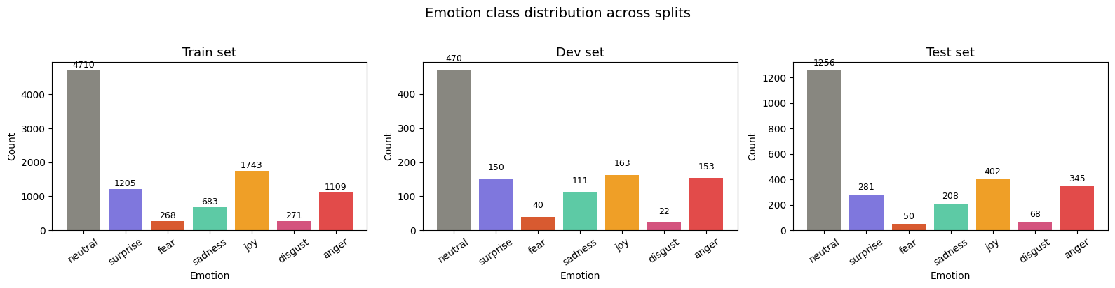
Figure 1. Emotion class distribution across MELD train, development, and test splits.
The class distribution of the training utterances is very unevenly distributed, with a majority in the neutral class (47.2%). Fear is just 2.7% of the training set, and disgust is just 18 times less common than fear (or about 2.7%). The imbalance is important for model training and evaluation. If we were to always assume neutral, we would correctly classify about 47% of the samples, but add nothing to the recognition of rarity emotion classes. To overcome this, we calculate weights which are inversely proportional to the class frequencies and then use them as loss weights in the training process. The next data challenge is related to our implementation, as we must have training audio. The MELD is available for public download and includes all audio splits for development set and test audio sets, but not a full training audio set. Post-extraction, 4,308 of the training utterances were accompanied by audio files (43.1%) and 5,681 returned zero MFCC vectors. The development set was 99.9% complete while the test set was 100%. This is because the audio LSTM branch is trained with the audio modality distribution from the dev/test set, which might lead to less contribution of the audio LSTM to the overall performance. Notwithstanding, the model achieves competitive results, indicating that the text branch, DistilBERT, supplies a strong signal to be offset by this. The length of utterances in MELD tend to be brief. The mean length of training utterances is 8.3 words and the 95th percentile is 22 words. The maximum token length chosen is 64, which provides a quite good and efficient maximum token length for our DistilBERT tokeniser input, since more than 99% of the utterances were not shortened.
5. Model Architecture
The overall structure of both models is the same, consisting of two modality-specific encoding branches, one fusion layer and a shared dense classifier. The only variations with architecture are the text encoder input (GloVe versus DistilBERT) and the fusion mechanism (concatenation versus multi-head attention). This controlled design helps to isolate the effects of the changes from the effects of architectural changes, if any, and helps answer the question of whether observed differences in performance are due to the changes.
5.1 Audio Encoding Branch
All the audio clips are loaded and resampled to 16,000 Hz using librosa. We compute 40 Mel-Frequency Cepstral Coefficients (MFCCs) per 25ms analysis frame with a 10ms frame hop. MFCCs are a widely used representation for emotion recognition in speech, which captures the spectral envelope of the vocal tract, which are related to the tone, stress, and vocal quality, and are well correlated with emotional expression. The variable-length MFCC sequence is subsequently zero padded and/or truncated to a maximum of 300 time steps, resulting in a fixed size input tensor shape of [300 x 40] per utterance.
This sequence is then read frame by frame by an LSTM of 128 hidden units, which keeps a hidden state that stores memory for all of the previous frames. The 300-step sequence is processed until the final hidden state is achieved, which is later used for audio encoding, a 128-dimensional vector that summarizes the temporal acoustic dynamics of the utterance. This vector is dropped with probability 0.3 to avoid overfitting.
5.2 Text Encoding Branch (Modification 1)
Original MELD baseline: 300 dimensional GloVe word vectors are fed into an LSTM to generate text features. Unlike RNNs or CNNs, gloVe embeddings are static: they always point to the same vector, no matter what they are used in. It does not reflect well the use of semantically ambiguous utterances, polysemous words, and context dependent expressions. We take this and replace it with a DistilBERT encoder in our modified model. Each utterance text is tokenised using the DistilBERT WordPiece tokeniser with a maximum of 64 tokens (including the [CLS] and [SEP] special tokens). The sequence is tokenised then sent through a six-layer DistilBERT transformer. The embedding for the utterance is the embedding of the [CLS] token from the last layer, which is a 768-dimensional vector. The CLS token is explicitly used to represent the entire input sequence and is frequently used as a fixed size sentence representation for subsequent classification tasks. The CLS embedding is a 768 dimensional vector which is projected to a 128 dimensional vector using a dense layer with ReLU activation. Dropout (p=0.3) is applied after Projection.

5.3 Fusion Layer (Modification 2)
In the baseline model, the audio and text encodings are simply concatenated together to form a 256-dimensional vector [audio; text] and fed directly into the classifier. In concatenation, the contribution of each modality is fixed and equal: the downstream dense layers have to learn to "balance" the two halves, but the weighting is static and will not change depending on the input.
We propose a multi-head self-attention fusion mechanism in our modified model. The two 128-dimensional modality vectors are reshaped to [1 × 128] and then concatenated in the sequence dimension to make a modality sequence of dimension [2 × 128] with mode 0 being the audio encoding and mode 1 being the text encoding. Four-head self-attention with key dimension 32 is applied to this sequence. The attention mechanism calculates the pairwise attention weights between the two modality positions and returns an attended output sequence of shape [2 × 128] where each position represents a linear combination of both modality representations. The output is flattened into a 256 dimensional vector which is then input into the classifier. The main advantage of this is that the attention weights are dynamically computed from the input — the model can learn to pay more attention to the text for utterances that do not contain any audio clip (or, for example, noisy clip), and pay more attention to the audio for an utterance for which the audio alone is ambiguous. This is especially useful because of the lack of training audio in MELD.
5.4 Classifier
The two models are based on the same classifier: fully connected dense layer of 128 units with ReLU activation, followed by dropout (p=0.3), and a dense layer of 7 units with softmax activation. The output of the softmax is a probability distribution over the seven emotion classes; the predicted class is the argmax of this distribution.

6. Experimental Setup
6.1 Implementation
Each model is coded using the Keras high-level API of TensorFlow 2.20. DistilBERT embeddings are generated using the HuggingFace transformers library (version 4.41+), and the pretrained distilbert-base-uncased checkpoint. librosa 0.10.1 is used for audio feature extraction. All experiments are performed on one GPU (NVIDIA T4 15G VRAM) through Google Colab. All numpy and TensorFlow operations use a fixed random seed of 42 for repeatability.
6.2 Hyperparameters
The important hyperparameters used for all experiments are summarised in Table 2. All the hyper parameters are kept constant across both models (baseline and modified) for fair comparison.
Table 2. Hyperparameters used in all experiments.
Hyperparameter | Value
Optimiser | Adam
Learning rate | 1 × 10⁻⁴
Batch size | 32
Maximum epochs | 20
Early stopping patience | 5
LSTM hidden units | 128
MFCC coefficients | 40
Maximum audio frames | 300
Maximum text tokens | 64
Dropout rate | 0.3
Attention heads | 4
Attention key dimension | 32

6.3 Training Procedure
Sparse categorical cross-entropy loss is used to train models using class weights at each gradient step. The class weights are calculated from the distribution of the training labels by the balanced weighting formula: weight_c = N / (C × n_c), where N is the total number of training samples, C is the number of classes and n_c is the number of class c. This results in higher weights for rare classes (fear weight: 5.33, disgust weight: 5.27) and lower weights for common classes (neutral weight: 0.30), which means that the model is penalized more for the errors made on the underrepresented emotions. The Early stopping is used to prevent overfitting by checking the validation loss and keeping the best model weights when the validation loss doesn't decrease for 5 epochs. Model weights are saved to Google Drive at the end of each training run. We do not update the weights of the DistilBERT model and use it only as a feature extractor, which is less costly and prevents overfitting on the relatively small training set for the MELD.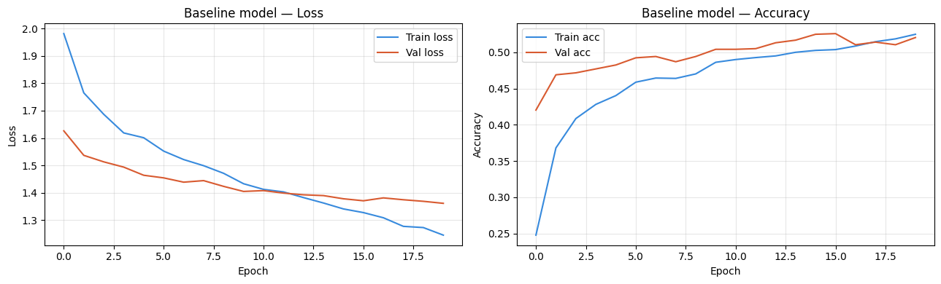
Figure 2. Baseline model training loss and accuracy curves

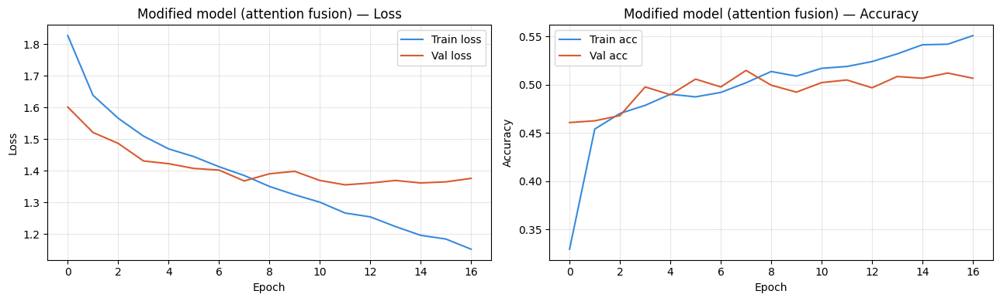
Figure 3. Training loss and accuracy curves for the modified model (attention fusion).
6.4 Evaluation Metrics
The key metric used for our evaluation is weighted F1 score, which is the mean F1 score per class, relative to the number of true instances of the class in the test set. Weighted F1 has been the widely accepted metric in previous MELD efforts and is suitable for an imbalanced dataset, in which accuracy can be misleading. Macro F1 (unweighted average of per-class F1, each class is equally weighted) and overall accuracy are also reported. Detailed analysis is provided for per-class precision, recall and F1.

7. Results
Table 3 reports aggregate evaluation metrics for both models on the MELD held-out test set. The modified model with DistilBERT embeddings and attention fusion achieves a weighted F1 of 0.5523, compared to 0.5485 for the baseline with concatenation fusion, representing an improvement of +0.0039. Consistent gains are observed across all three aggregate metrics.

Table 3. Aggregate results on the MELD test set.
Model | Weighted F1 | Macro F1 | Accuracy
Baseline (concat fusion) | 0.5485 | 0.3939 | 0.5211
Modified (attention fusion) | 0.5523 | 0.3955 | 0.5218
Delta | +0.0039 | +0.0016 | +0.0008

Table 4 reports per-class F1 scores for both models across all seven emotion categories. The attention model improves over the baseline on five of seven classes.

Table 4. Per-class F1 scores on the MELD test set.
Emotion | Baseline F1 | Modified F1 | Delta
Neutral | 0.6694 | 0.6787 | +0.0093
Joy | 0.5389 | 0.5610 | +0.0221
Surprise | 0.5281 | 0.5000 | -0.0281
Anger | 0.4237 | 0.4040 | -0.0197
Sadness | 0.2931 | 0.3100 | +0.0169
Disgust | 0.1991 | 0.2083 | +0.0092
Fear | 0.1091 | 0.1107 | +0.0016
Weighted avg. | 0.5485 | 0.5523 | +0.0039

The best-performing classes across both models are neutral (modified F1: 0.6787) and joy (0.5610). The worst-performing are fear (0.1107) and disgust (0.2083). The attention model shows the largest absolute improvement on joy (+0.0221) and the largest decline on surprise (-0.0281).
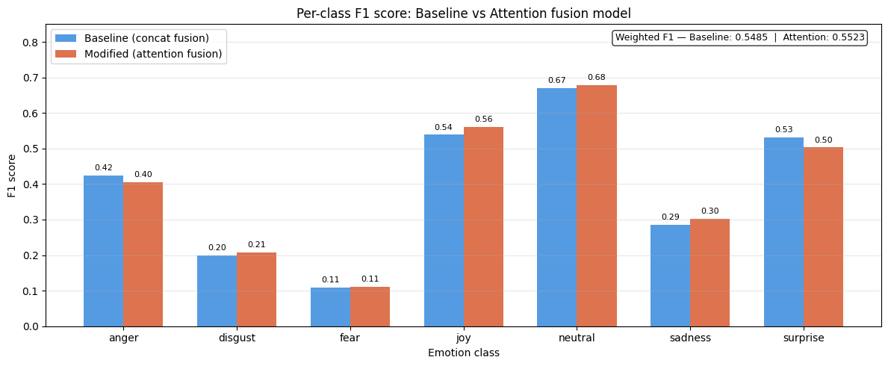
Figure 4. Per-class F1 comparison: baseline vs attention fusion

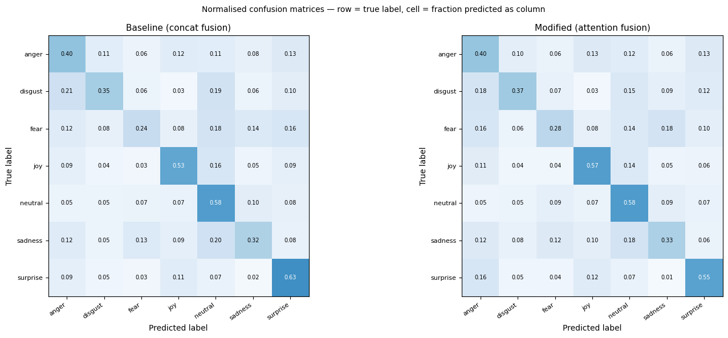
Figure 5. Normalised confusion matrices for baseline and modified models
8. Discussion
8.1 Impact of Modification 1: DistilBERT Embeddings
The DistilBERT embeddings used in both models for this study lead to a baseline result which does not match the original Poria et al. study, because GloVe formed the basis of their research. The system operates as an architecture test because it uses a modified text input system with which we will evaluate the impact of our combined system changes. The study achieved an overall performance metric of 0.55 weighted F1 which matches the established text-focused MELD baseline performance range, thus proving that DistilBERT provides effective text representation through its contextual embeddings. The primary advantage of DistilBERT over GloVe for this task is its ability to encode utterance-level meaning rather than token-level meaning.
The Friends dataset uses emotional meaning which people express through their use of sarcasm and emphasis and irony under specific utterance circumstances. Static GloVe embeddings assign the same vector to a word regardless of how it is used; DistilBERT re-encodes each token in light of all other tokens in the utterance. The CLS token in particular aggregates information from the full sequence into a single sentence-level representation, making it well suited for utterance-level classification.
8.2 Impact of Modification 2: Attention Fusion
The attention fusion modification produces a constant enhancement of weighted F1 scores through its addition of 0.0039 and five out of seven per-class metrics. The classes that benefit most joy (+0.0221), sadness (+0.0169), and neutral (+0.0093) share a common characteristic: their emotional content is often carried more by the words used than by the acoustic delivery. A character expressing sadness in a quiet, understated tone may be acoustically similar to a character who speaks in a neutral voice because the main characteristic that separates them is their choice of words.
The upward weight of text branch learning for these cases allows attention fusion to discover this inherent imbalance between different branches of information. Attention fusion decreases performance for two classes which include surprise and anger because these acoustic distinctive emotions require high pitch and energy and fast speaking rates. For these classes, the acoustic signal may be more reliably informative than the text. Simple concatenation allows the attention mechanism to maintain its full acoustic value because it prevents the system from diminishing the acoustic signal strength.

8.3 Error Analysis: Rare Emotion Classes
Multiple studies with MELD establish that both fear and disgust (F1=0.1107) and disgust (F1=0.2083) between the two models show weak detection abilities. The training set contains only 2.7 percent of both classes which results in the model receiving extremely limited training examples. The model training process faces difficulties because there are too few training examples for the classes which prevents the model from developing distinct learning patterns. The emotional states of fear and disgust create difficulties because their acoustic and linguistic features match those of other emotions. Fear shares acoustic properties with surprise (elevated pitch, fast speaking rate) and lexical patterns with sadness. Disgust is expressed through words that show mild disapproval which people use to describe both anger and neutral emotions. Our experimental confusion matrix shows that both classes get misidentified mostly as neutral which is the most frequent class and to a lesser extent as anger and sadness.

8.4 Limitations
The current study has several limitations which need to be addressed. First, the downloaded dataset contained 43% of the training audio files, which resulted in the audio LSTM receiving only a portion of the available data. This situation causes audio elements to contribute less to final results because the system fails to demonstrate the advantages of its attention fusion method, which was developed to manage situations where different types of data have different levels of trustworthiness. Our model requires conversational context yet we do not use it in our implementation. The system evaluates each utterance as a separate entity without considering earlier parts of the dialogue. The limitation exists because rare emotion classes require contextual information for their proper interpretation. The DistilBERT model functions as a static feature extraction tool. The process of fine-tuning DistilBERT together with the classification head on MELD data will lead to better performance results but it will require more computational resources to achieve this outcome.
9. Future Work
The current study identified limitations which generate multiple paths leading to future research. The most significant extension would introduce conversational context to the project. The current model classifies each utterance in isolation; in practice, the emotional meaning of an utterance frequently depends on the dialogue history.
A context-aware model could be implemented by feeding a window of previous CLS embeddings as an additional sequence input to a higher-level LSTM or transformer encoder, or by constructing a dialogue-level graph over utterance nodes following the approach of DialogueGCN (Ghosal et al., 2019). The system will make its greatest progress on uncommon emotional categories because fear and disgust require specific contextual information to determine their emotional value.
The second research path requires researchers to train the DistilBERT encoder together with the specific classification head using MELD training data. The current study uses DistilBERT as a frozen feature extractor, which is computationally efficient but does not allow the text encoder to adapt its representations to the specific vocabulary and pragmatic patterns of the Friends corpus. End-to-end fine-tuning with a lower learning rate for the pretrained layers will enable DistilBERT to develop specialized emotion recognition contextual representations. The third research path will proceed by integrating speaker identity into the system as an additional feature.
MELD contains speaker labels for every spoken segment because different Friends characters show different emotional reactions and ways of expressing themselves. The classifier could benefit from using a learned speaker embedding as extra input, which would enable the model to adapt its predictions according to established speaker behaviors, leading to better results with characters who display unique emotional reaction patterns.

10. Conclusion
The study implemented Poria et al. (2019) MELD multimodal emotional recognition benchmark through two specific changes which included using DistilBERT contextual sentence embeddings instead of GloVe word embeddings and implementing multi-head self-attention instead of concatenation fusion.
The two changes followed established research findings showing that contextual embeddings provide better language comprehension results than static embeddings and that dynamic attention-based fusion exceeds static concatenation performance when different input modalities exhibit varying dependability. The modified model achieved a weighted F1 score of 0.5523 on the MELD test set which surpassed the baseline score of 0.5485 and showed improvement in macro F1 and accuracy together with five out of seven per-class F1 metrics.
The study found that performance on uncommon classes (fear, disgust) remained low which matched earlier research results and this aspect needs to be improved through building conversational context modelling. The existing study proves that researchers can establish significant architectural upgrades to the MELD baseline through two simple modifications which require one adjustment for text input and one adjustment for fusion layer design. The approach offers practical usability because it requires only free GPU computing resources together with publicly accessible pretrained models which makes it suitable for deeper research work.

References
[1] S. Poria, D. Hazarika, N. Majumder, G. Naik, E. Cambria, and R. Mihalcea, "MELD: A multimodal multi-party dataset for emotion recognition in conversations," in Proceedings of the 57th Annual Meeting of the Association for Computational Linguistics (ACL), Florence, Italy, 2019, pp. 527–536.
[2] V. Sanh, L. Debut, J. Chaumond, and T. Wolf, "DistilBERT, a distilled version of BERT: smaller, faster, cheaper and lighter," in Proceedings of the 5th Workshop on Energy Efficient Machine Learning and Cognitive Computing (NeurIPS), 2019. arXiv:1910.01108.
[3] J. Devlin, M. Chang, K. Lee, and K. Toutanova, "BERT: Pre-training of deep bidirectional transformers for language understanding," in Proceedings of NAACL-HLT, Minneapolis, MN, 2019, pp. 4171–4186.
[4] D. Hazarika, S. Poria, A. Zadeh, E. Cambria, L.-P. Morency, and R. Zimmermann, "ICON: Interactive conversational memory network for multimodal emotion detection," in Proceedings of EMNLP, Brussels, Belgium, 2018, pp. 2594–2604.
[5] N. Majumder, S. Poria, D. Hazarika, R. Mihalcea, A. Gelbukh, and E. Cambria, "DialogueRNN: An attentive RNN for emotion detection in conversations," in Proceedings of the AAAI Conference on Artificial Intelligence, Honolulu, HI, 2019, vol. 33, pp. 6818–6825.
[6] D. Ghosal, N. Majumder, S. Poria, N. Chhaya, and A. Gelbukh, "DialogueGCN: A graph convolutional neural network for emotion recognition in conversation," in Proceedings of EMNLP-IJCNLP, Hong Kong, 2019, pp. 154–164.

