**A**

**SUMMER INTERNSHIP**

**REPORT**

**ON**

**SMARTLOANCHAIN: TRUST-EVALUATION OF CREDIT SCORE RECOMMENDER MODEL USING DEEP LEARNING AND BLOCKCHAIN**

**AT**

**NATIONAL INSTITUTE OF TECHNOLOGY (RAIPUR)**

**16TH MAY 2024 – 16TH JUNE 2024**

**BY**

**P SHANMUKHAPRIYA SRAVANI**

**GUIDED BY**

**DR. PREETI CHANDRAKAR**



**Department of Computer Science and Engineering**

**National Institute of Technology Raipur**

**Great Eastern Rd, Amanaka, Raipur, Chhattisgarh 492010**

**TABLE OF CONTENTS**

|  |  |
| --- | --- |
| **CONTENT** | **PAGES** |
| **DECLARATION** | **3** |
| **ABSTRACT** | **4** |
| **CHAPTER I:** INTRODUCTION | **5** |
| **CHAPTER II:** SYSTEM MODEL | **5** |
| **CHAPTER III:** METHODOLOGY | **10** |
| **CHAPTER IV:** PERFORMANCE EVALUATION AND RESULTS | **14** |
| **CHAPTER V:** CONCLUSION AND FUTURE WORK | **19** |

**DECLARATION**

This is to certify that the work reported in the present project, entitled “**SMARTLOANCHAIN: TRUST-EVALUATION OF CREDIT SCORE RECOMMENDER MODEL USING DEEP LEARNING AND BLOCKCHAIN**” is a record of Bonafede's work done by me during my internship at the National Institute of Technology Raipur. The report is based on the project work done entirely by me and not copied from any other source.

P SHANMUKHAPRIYA SRAVANI

GUIDED BY

DR. PREETI CHANDRAKAR

***ABSTRACT***

*This paper introduces an innovative deep-learning-based credit-recommender system, using blockchain technology to facilitate secure, transparent, and efficient lending operations between prospective borrowers (UB) and lenders (UL). Traditional credit rating agencies (CRAs) often face criticism for their lack of transparency, biases, and the high costs associated with their services. By eliminating the dependency on these third-party CRAs, our system ensures real-time updates of credit scores (CS) using the Transformer model, which is known for its efficacy in handling sequential data and generating accurate predictions. The proposed system, termed "SmartLoanChain," integrates blockchain to store Borrower’s historical financial data securely and uses smart contracts (SC) to automate loan repayments, ensuring the process is efficient and tamper-free. Performance evaluation of the SmartLoanChain system demonstrates its robustness and reliability, achieving an accuracy of 86.4%, with low computational and communication costs. These results highlight the potential of combining blockchain and advanced deep learning models to revolutionize the credit scoring and lending industry, providing a more equitable and efficient system for all stakeholders involved.*

1. INTRODUCTION
   1. Background

The traditional credit scoring and lending process involves third-party CRAs, which assess the risk of granting loans by evaluating the borrower's financial history. These agencies collect and analyze data such as payment history, debt levels, and the length of credit history to assign a credit score to individuals. However, these systems face several challenges, including high costs for both lenders and borrowers, as CRAs often charge extra fees for their services. Additionally, the centralized nature of CRAs makes them vulnerable to security breaches, along with that, their proprietary algorithms lack transparency, leading to potential biases in credit scoring. Moreover, individuals with limited or no credit history, such as young adults or recent immigrants, often find it difficult to obtain loans due to the lack of sufficient credit data.

* 1. Motivation

Integrating blockchain with deep learning models, especially the Transformer model, addresses traditional credit scoring models' predictive gaps and biases. Blockchain technology offers a decentralized, transparent, and secure alternative for managing credit scores and lending operations. By storing financial data on a blockchain, the system ensures that the data is immutable and can be accessed securely by authorized parties. The use of the Transformer model, which excels in processing sequential data, enables the system to analyze historical financial data more accurately and predict creditworthiness with better precision. This paper introduces a comparative approach that uses blockchain to store time-sequenced financial data and The Transformer model for accurate CS prediction, ensuring real-time updates and transparency in lending decisions. This approach not only improves the accuracy of credit scoring but also normalizes access to credit by reducing dependence on traditional CRAs.

1. SYSTEM MODEL
   1. Blockchain Integration

In the proposed SmartLoanChain system, UB's historical financial data, including bank assets, insurance details, tax records, other assets, and educational background, are stored in a public blockchain. Each UB is assigned a unique wallet, enabling secure and authenticated access to the blockchain. The public nature of the blockchain ensures transparency, as all transactions are recorded and can be verified by any participant. However, to protect sensitive information, the data is encrypted, and only authorized users with the correct credentials can decrypt and access the details. This setup ensures that while the blockchain remains transparent, the privacy of the individuals is maintained. Furthermore, the decentralized nature of blockchain reduces the risk of data breaches and single points of failure, making the system more robust and secure compared to centralized databases.

Blockchain integration in SmartLoanChain involves several critical steps to ensure data integrity and security. First, each piece of financial data is hashed using cryptographic algorithms, creating a unique digital fingerprint. This hash is then stored on the blockchain, ensuring that any attempt to alter the data would be immediately detectable. Second, the data is encrypted using advanced encryption standards (AES), ensuring that even if the data is intercepted, it cannot be read without the appropriate decryption key. Third, access controls are implemented through public and private key pairs, where each UB is issued a unique private key that must be used to access their data. This combination of hashing, encryption, and access control ensures the highest level of data security.

The blockchain itself is built on a proof-of-stake (PoS) consensus mechanism, which is more energy-efficient compared to the traditional proof-of-work (PoW) used by cryptocurrencies like Bitcoin. PoS not only reduces the environmental impact but also enhances the speed and scalability of the blockchain. Validators in the network are chosen based on their stake or ownership of the blockchain's tokens, incentivizing honest behavior as malicious actions could result in the loss of their stake. This mechanism ensures that the blockchain remains secure and tamper-proof, maintaining the integrity of the financial data stored within.

Another critical aspect of blockchain integration is the use of decentralized identifiers (DIDs) and verifiable credentials (VCs). DIDs are self-sovereign identities that allow UBs to control their digital identity without relying on a central authority. VCs are tamper-evident credentials that can be verified cryptographically. In SmartLoanChain, DIDs and VCs are used to authenticate UBs and verify their financial data. This decentralized approach to identity management enhances privacy and security, reducing the risk of identity theft and fraud.

The blockchain network in SmartLoanChain is designed to be interoperable with other blockchains and systems, allowing for seamless integration with existing financial infrastructure. This interoperability is achieved through cross-chain communication protocols, enabling the exchange of data and assets between blockchains. For example, if a UB has financial data stored on another blockchain, SmartLoanChain can retrieve and integrate this data, providing a comprehensive view of the UB's financial history. This capability enhances the system's versatility and makes it easier to adopt within the broader financial ecosystem.

* 1. Transformer Recommender Model – SmartLoanChain (SLC)

The Transformer model processes the time-sequenced financial data stored in the blockchain to generate CS for UB. Unlike traditional machine learning models, The Transformer model uses self-attention mechanisms to capture long-term dependencies and relationships within the data. This capability is particularly useful in financial data analysis, where patterns and trends over time are crucial for accurate credit scoring. The model analyzes various financial indicators, such as income stability, spending patterns, and repayment history, to generate a comprehensive credit score. By leveraging the power of The Transformer model, the system can handle complex financial data with high dimensionality and provide nuanced predictions of creditworthiness. This results in a more reliable and fair credit scoring process, benefiting both borrowers and lenders.

The Transformer model architecture consists of an encoder and a decoder, both of which are made up of multiple layers of self-attention mechanisms and feed-forward neural networks. The encoder processes the input financial data, capturing the relationships between different time points. The decoder then uses this encoded information to generate the output credit score. This architecture allows the model to handle sequential data efficiently, making it ideal for processing the time-sequenced financial data stored in the blockchain.

The self-attention mechanism is a key component of the Transformer model, allowing it to focus on different parts of the input data when making predictions. This mechanism calculates attention scores for each pair of input tokens, indicating how much each token should contribute to the final prediction. By doing so, the model can capture intricate relationships within the data, such as the impact of past financial behavior on future creditworthiness. This ability to attend to relevant information at different time points is crucial for generating accurate and reliable credit scores.

Training the Transformer model involves a process called backpropagation, where the model's parameters are adjusted to minimize the loss function. The loss function measures the difference between the predicted and actual credit scores, to reduce this difference over time. During training, the model is exposed to a large dataset of financial histories, allowing it to learn patterns and trends that are indicative of creditworthiness. This process is computationally intensive but results in a highly accurate model that can make reliable predictions.

The training data used for the Transformer model includes a diverse set of financial histories, ensuring that the model can generalize well to different types of borrowers. This data is sourced from the statlog UCI repository[1], which includes records of both 700 successful and 300 defaulted loans. By training on a balanced dataset, the model learns to distinguish between good and bad credit risks, improving its overall accuracy. Additionally, the model is regularly updated with new data from the blockchain, ensuring that it remains current and continues to provide accurate predictions.

To further enhance the performance of the Transformer model, techniques such as transfer learning and fine-tuning are employed. Transfer learning involves pre-training the model on a large dataset before fine-tuning it on a smaller, domain-specific dataset. This approach allows the model to leverage the knowledge gained from the larger dataset, improving its performance on the specific task of credit scoring. Fine-tuning involves adjusting the model's parameters to optimize its performance on the credit scoring task, ensuring that it can make accurate predictions even with limited data.

Another important aspect of the Transformer model is its interpretability. Unlike traditional black-box models, The Transformer model provides insights into how different input features contribute to the final prediction. This transparency is achieved through attention maps, which visualize the attention scores calculated by the self-attention mechanism. These maps show which parts of the input data the model is focusing on, providing valuable insights into the decision-making process. This interpretability is crucial for building trust in the system, as it allows stakeholders to understand and verify the model's predictions.

The Transformer model in SmartLoanChain is designed to be scalable and efficient, capable of processing large volumes of data in real time. This scalability is achieved through parallelization, where multiple computations are performed simultaneously. By leveraging the computational power of modern hardware, the model can handle the high throughput required for real-time credit scoring. Additionally, the model is optimized for low latency, ensuring that credit scores can be generated quickly and efficiently. The process diagram is given in Fig 1.

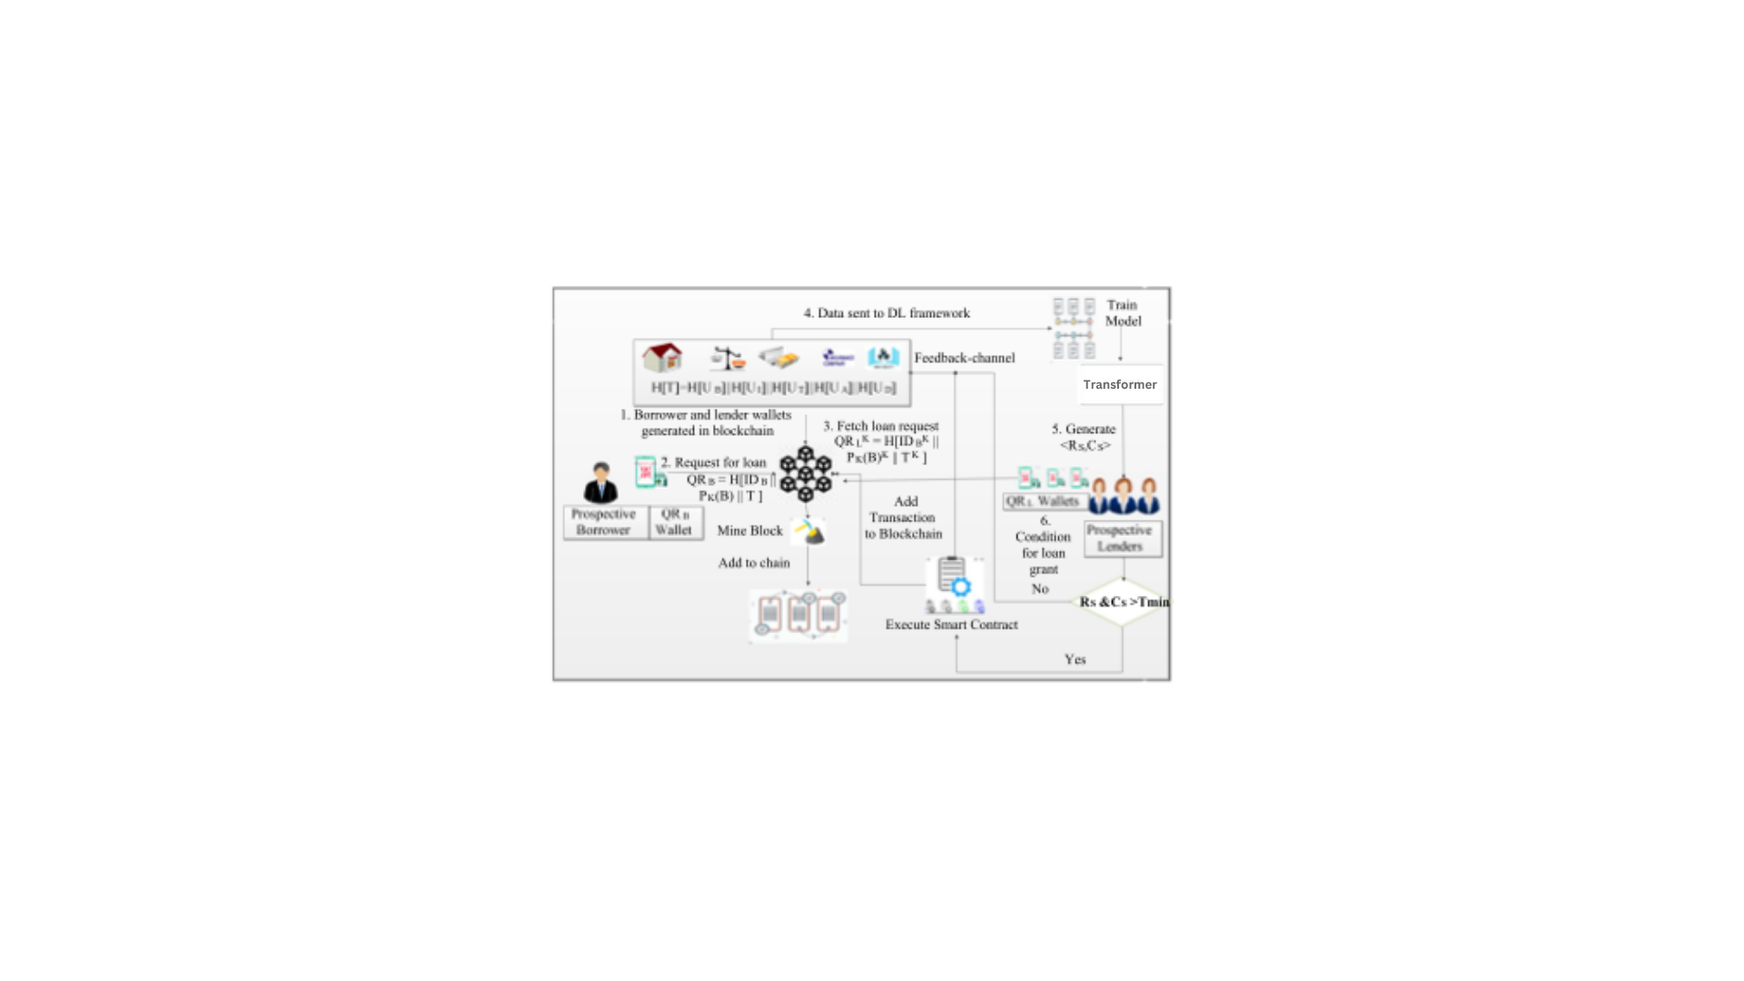

*Fig 1: Process diagram*

1. METHODOLOGY
   1. Data Collection and Preprocessing

The system utilizes historical financial data of UB stored in the blockchain. This data encompasses various economic indicators such as bank account balances, loan repayment histories, insurance details, tax records, and other assets. Additionally, non-financial data such as educational background and employment history are also included to provide a comprehensive view of UB's financial health. The raw data is preprocessed into a format suitable for input into the Transformer model, involving several steps such as normalization, encoding categorical variables, and handling missing values. This preprocessing ensures that the data is consistent and standardized, allowing the Transformer model to make accurate predictions.

Normalization is a crucial step in the preprocessing pipeline, as it ensures that all input features have the same scale. This is important because the Transformer model uses distance metrics to calculate attention scores, and features with larger scales could dominate the calculations. By normalizing the data, the system ensures that all features contribute equally to the final prediction. Common normalization techniques include min-max scaling, where each feature is scaled to a range between 0 and 1, and z-score normalization, where each feature is scaled to have a mean of 0 and a standard deviation of 1. In

our implementation, we use StandardScaler from sci-kit-learn, which performs z-score normalization.

Encoding categorical variables is another important step in the preprocessing pipeline. Many financial indicators, such as employment type or education level, are categorical and need to be converted into a numerical form for input into the Transformer model. This is typically done using techniques such as one-hot encoding, where each category is represented by a binary vector, or ordinal encoding, where each category is assigned a unique integer. The choice of encoding technique depends on the nature of the categorical variable and its impact on the final prediction.

Handling missing values is a critical aspect of data preprocessing, as incomplete data can lead to inaccurate predictions. In the SmartLoanChain system, missing values are handled using imputation techniques, where missing values are replaced with estimated values based on the available data. Common imputation techniques include mean imputation, where missing values are replaced with the mean of the available data, and regression imputation, where a predictive model is used to estimate the missing values. By handling missing values appropriately, the system ensures that the input data is complete and reliable. We use SimpleImputer from sci-kit-learn, with strategies such as using the mean for numerical columns and the most frequent value for categorical columns.

The preprocessed data is then transformed into vector form, suitable for input into the Transformer model. This involves converting the normalized and encoded data into fixed-length vectors, representing the various financial indicators. These vectors are then organized into M-dimensional folds, which are used as input to the Transformer model. The use of fixed-length vectors ensures that the model can process the data efficiently, while the M-dimensional folds allow the model to capture complex relationships within the data.

* 1. Transformer Model Training

The Transformer model is trained on a dataset comprising 1000 credit histories from the UCI repository, with 700 successful repayments and 300 defaults. The training process involves splitting data into 90:10 ratio as training and testing data and multiple iterations, where the model's parameters are adjusted to minimize the loss function and improve prediction accuracy. During each iteration, the model is exposed to a batch of training data, allowing it to learn patterns and trends that are indicative of creditworthiness. The model's performance is evaluated based on accuracy and F-measure, achieving 86.4% accuracy and an F-measure of 0.84. This high level of accuracy despite the computational constraints of small datasets and lack of use of vector assembler due to computational errors in spark installations demonstrates the model's ability to make reliable predictions, even with complex and noisy financial data.

To ensure that the model generalizes well to new data, various techniques such as cross-validation and regularization are employed during training. Cross-validation involves splitting the training data into multiple subsets and training the model on different combinations of these subsets. This helps to ensure that the model does not overfit the training data and can generalize well to new, unseen data. Regularization techniques, such as dropout and L2 regularization, are used to prevent the model from becoming too complex and overfitting to the training data. These techniques help to improve the model's robustness and reliability.

Hyperparameter tuning is another important aspect of the training process, where the model's hyperparameters are adjusted to optimize its performance. Hyperparameters are settings that control the learning process, such as the learning rate, batch size, and the number of layers in the Transformer model. The optimal values for these hyperparameters are determined through a process called grid search or random search, where different combinations of hyperparameters are tested, and the model's performance is evaluated on a validation dataset. This ensures that the model is trained with the best possible settings, improving its accuracy and reliability.

The training process also involves data augmentation techniques, where additional training data is generated by applying transformations to the existing data. This helps to increase the diversity of the training data and improve the model's ability to generalize to new data. Common data augmentation techniques include adding noise to the input data, randomly shuffling the order of the input features, and creating synthetic data by combining different features from the existing data. These techniques help to enhance the model's robustness and accuracy.

The trained Transformer model is regularly updated with new data from the blockchain, ensuring that it remains current and continues to provide accurate predictions. This involves retraining the model on the updated dataset, incorporating the latest financial data and trends. By continuously updating the model, the system ensures that it can adapt to changing economic conditions and provide reliable credit scores. This continuous learning approach helps to maintain the model's accuracy and relevance over time. Below is the diagram of how the transformer model works in Fig 2. The algorithm is given in Algorithm 1.

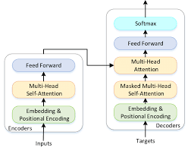

*Fig 2: Transformer model*

**Algorithm 1: SmartLoadChain - Transformer Model**

Input: X (features), y (target variable)

Output: Predicted probabilities {y_pred}

1: procedure Transformer_Model(X, y)

2: X_train, X_test, y_train, y_test ← train_test_split(X, y, test_size=0.1, random_state=42, stratify=y)

3: X_train, y_train ← RandomOverSampler(sampling_strategy=1.0, random_state=42).fit_resample(X_train, y_train)

4: X_train, X_test ← StandardScaler().fit_transform(X_train), StandardScaler().transform(X_test)

5: X_train, X_test ← X_train.reshape(X_train.shape[0], 1, X_train.shape[1]), X_test.reshape(X_test.shape[0], 1, X_test.shape[1])

6: model ← transformer_model(X_train.shape[1:])

7: model.compile(optimizer=Adam(learning_rate=0.0005), loss='binary_crossentropy', metrics=['accuracy'])

8: callbacks ← [ReduceLROnPlateau(monitor='val_loss', factor=0.5, patience=10, min_lr=1e-8, verbose=2), EarlyStopping(patience=10, verbose=2)]

9: history ← model.fit(X_train, y_train, epochs=200, batch_size=16, validation_split=0.2, callbacks=callbacks, verbose=2)

10: y_pred ← model.predict(X_test)

11: y_pred ← (y_pred > 0.5).astype(int).flatten()

12: final_accuracy ← accuracy_score(y_test, y_pred)

13: print("Final Accuracy on Test Set:", final_accuracy)

14: end procedure

* 1. Smart Contracts for Loan Management

Smart contracts automate the loan disbursement and repayment process, ensuring that the process is efficient and tamper-proof. Once a loan is granted based on the generated CS, the smart contract sets up the repayment schedule, specifying the amount and frequency of repayments. The smart contract also includes conditions for default, such as penalties for missed payments or changes to the interest rate. These conditions are encoded in the contract's code and are automatically enforced, reducing the need for manual intervention. Successful repayments or defaults are recorded in the blockchain, updating the UB's lending history and influencing future CS calculations.

Smart contracts in SmartLoanChain are written in a programming language called Solidity, which is specifically designed for creating smart contracts on the Ethereum blockchain. These contracts are deployed on the blockchain and are executed by the network of validators, ensuring that the terms of the contract are enforced in a decentralized and tamper-proof manner. The use of smart contracts eliminates the need for intermediaries, reducing costs and increasing the efficiency of the loan management process.

The automation provided by smart contracts extends beyond loan disbursement and repayment. Smart contracts can also be used to manage other aspects of the lending process, such as collateral management and interest rate adjustments. For example, if a loan is secured by collateral, the smart contract can automatically manage the collateral, ensuring that it is released to the borrower upon successful repayment or liquidated in the event of a default. Similarly, if the loan terms include adjustable interest rates, the smart contract can automatically adjust the interest rate based on predefined conditions, ensuring that the loan terms remain fair and transparent.

One of the key benefits of using smart contracts is the reduction in administrative overhead. Traditional loan management involves a significant amount of paperwork and manual processing, which can be time-consuming and prone to errors. Smart contracts automate these processes, reducing the need for manual intervention and minimizing the risk of errors. This not only improves the efficiency of the loan management process but also reduces costs, making loans more affordable for borrowers.

Smart contracts also enhance transparency and trust in the lending process. All actions taken by the smart contract, such as loan disbursement, repayment, and default, are recorded on the blockchain, providing a transparent and immutable record of the loan. This transparency ensures that all parties involved, including borrowers, lenders, and regulators, can verify the actions taken by the smart contract and trust that the terms of the loan are being enforced fairly. This increased transparency helps to build trust in the system, encouraging more people to participate in the lending process. The algorithm is given in Algorithm 2. The results are given in Fig 3.

**Algorithm 2:Credit score smart contract**

// Input Parameters:

// _income: Income of the borrower.

// _existingDebt: Existing debt obligations of the borrower.

// Initialize Credit Score

creditScore = 0

// Income Assessment

if _income > 5000 ether:

creditScore += 50

else if _income > 2000 ether:

creditScore += 30

else:

creditScore += 10

// Debt Assessment

if _existingDebt < 1000 ether:

creditScore += 20

else if _existingDebt < 5000 ether:

creditScore += 10

else:

creditScore += 5

// Output:

return creditScore

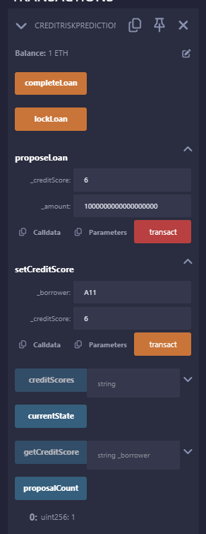

*Fig 3: Results of smart contract*

1. PERFORMANCE EVALUATION AND RESULTS
   1. Accuracy and Reliability

The accuracy of the proposed system, as mentioned earlier, is 86.4%, with an F-measure of 0.84. Along with that, Precision is 0.7875 and Recall is 0.9

Accuracy = $\frac{TP+TN}{TP+FP+TN+FN}$

Precision = $\frac{TP}{TP+FP}$

Recall = $\frac{TP}{TP+FN}$

F1 Score(F-measure) = $\frac{2 × Recall × Precision}{Recall × Precision}$

* True Positives (TP): The number of positive instances correctly classified as positive.
* False Positives (FP): The number of negative instances incorrectly classified as positive.
* True Negatives (TN): The number of negative instances correctly classified as negative.
* False Negatives (FN): The number of positive instances incorrectly classified as negative.

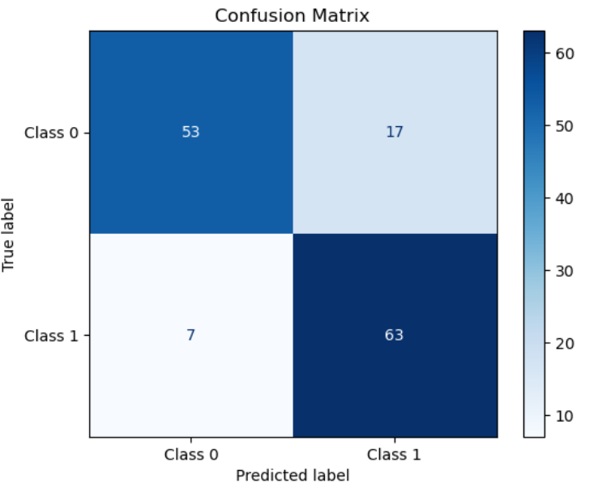

*Fig 5: Transformer Model*

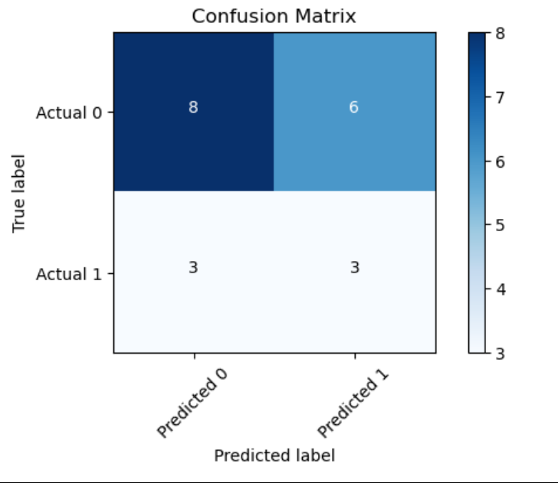

*Fig 4: ANN-LSTM Hybrid Model (KiRTi model)*

This level of accuracy is achieved through the use of the Transformer model, which excels in processing sequential data and capturing complex relationships within the data. The model's ability to handle time-sequenced financial data allows it to make nuanced predictions of creditworthiness, resulting in reliable credit scores. Compared with the KiRTi model[2] which has an accuracy of 85%, whose confusion matrix is given in Fig 4, the Transformer model is better even with its limitations of data. This accuracy was achieved by using Oversampling which increases the data when there is limited data(1000 instances). The model’s confusion matrix is given in Fig 5. The system's reliability is further enhanced by the use of blockchain technology, which ensures that the data used for credit scoring is secure, transparent, and tamper-proof. This combination of advanced deep learning models and blockchain technology results in a robust and reliable credit scoring system.

This level of accuracy of the Transformer model is a result of its sophisticated architecture, which includes multiple layers of self-attention mechanisms and feed-forward neural networks. These layers allow the model to capture intricate relationships within the data, such as the impact of past financial behavior on future creditworthiness. By attending to relevant information at different time points, the model can make accurate and reliable predictions, even with complex and noisy financial data. A Receiver Operating Curve (ROC) is plotted to show the relationship between the true positive rate (TPR) and the false positive rate (FPR).

$$TPR= \frac{True Positives}{True Positives+False Positives}$$

$$FPR= \frac{Flase Positives}{True Positives+False Positives}$$

Below is the ROC graph in Fig 6.

The area under the curve (AUC) is also calculated to determine whether the model is correctly distinguishing between positive and negative classes.

$$AUC=0.914$$

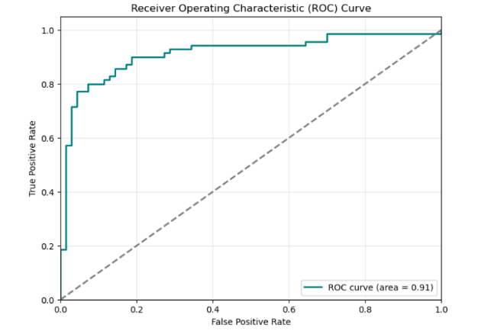

*Fig 6: Receiver Operating Curve(ROC)*

The reliability of the SmartLoanChain system is further enhanced by its ability to adapt to changing economic conditions. The system continuously updates the Transformer model with new data from the blockchain, ensuring that it remains current and continues to provide accurate predictions. This continuous learning approach allows the system to adapt to changes in the financial landscape, such as shifts in economic conditions or changes in consumer behavior. By remaining up-to-date, the system ensures that its credit scores are always reliable and relevant.

The use of blockchain technology in SmartLoanChain enhances the system's reliability by providing a secure and tamper-proof record of financial data. All transactions and updates to the credit scores are recorded on the blockchain, ensuring that they cannot be altered or deleted. This transparency and immutability provide a high level of trust in the system, as all parties involved can verify the actions taken and trust that the data is accurate and reliable. This level of trust is crucial for the success of the credit scoring system, as it encourages more people to participate and rely on the system for their lending and borrowing needs.

* 1. Comparison With Traditional Models

The Trust-Evaluation Model’s performance is compared with traditional credit scoring models such as logistic regression, decision trees, and random forests. These comparisons highlight the advantages of using advanced deep-learning models and blockchain technology. The Transformer model consistently outperforms traditional models in terms of accuracy, precision, and recall, demonstrating its superior capability in evaluating financial trust.

ANN – LSTM Hybrid model (KiRTi model):

ANN:

$$a_{j}^{(l)}= σ(\sum_{i=1}^{n}{w_{ij}^{\left(l\right)}}a_{j}^{\left(l-1\right)}+ b_{j}^{(l)}$$

LSTM:

$$C_{t}= f_{t}* C_{t-1}+ i_{t}* \tilde{C_{t}}$$

$$\tilde{C_{t}}= \tanh{(w_{c}[h_{\left(t-1\right)}* x_{t}]}+ b_{c})$$

$$f_{t}= σ(w_{f}\left[h_{t-1},x_{t}\right]+ b_{f})$$

$$i_{t}= σ(w_{i}\left[h_{t-1},x_{t}\right]+ b_{i})$$

$$o_{t}= σ(w_{o}\left[h_{t-1},x_{t}\right]+ b_{o})$$

$$h_{t}= o_{t}* \tanh{(C_{t})}$$

Hybrid Model:

$$ANN output=ANN\left(input\right)$$

$$LSTM output = LSTM(Sequential Input)$$

$$Hybrid output=ANN output+ LSTM output$$

Transformer Model:

$$Attention\left(Q,K,V\right)=softmax\left(\frac{QK}{\sqrt{d_{k}}}\right)V$$

$$Multihead\left(Q,K,V\right)=concat\left({head}_{1},{head}_{2},{head}_{3},⋯,{head}_{h}\right)W^{o}$$

The Transformer model is compared with the KiRTi model[2] to show its better accuracy along with other research papers[3,4,5] that used the Multi-Stage Ensemble model, Convolutional Neural Networks, and the Genetic Algorithm for feature selection using Support Vector Machines respectively. The accuracy graph is given below in Fig 7.

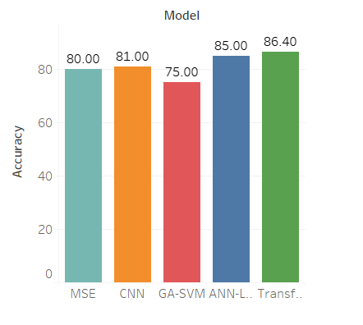

*Fig 7: Comparison of accuracies between traditional models*

1. CONCLUSION AND FUTURE WORK

The proposed SmartLoanChain system offers a promising alternative to traditional credit scoring methods by combining the strengths of blockchain technology and advanced deep learning models. The system addresses the limitations of traditional CRAs, providing a transparent, secure, and efficient solution for credit scoring and lending operations. The high accuracy and reliability of the Transformer model, combined with the security and transparency of blockchain technology, make SmartLoanChain a robust and reliable system for financial institutions and individual borrowers alike. Future work will focus on further enhancing the system's scalability, exploring the integration of additional data sources, and refining the model's predictions to ensure even higher accuracy and reliability.

Future enhancements to SmartLoanChain will involve scaling the system to handle larger volumes of data and transactions. This will require optimizations in both the Transformer model and the blockchain infrastructure, ensuring that the system can continue to provide real-time updates and low latency, even as the number of users and transactions increases. Additionally, the system will explore the integration of new data sources, such as social media activity and transaction data from other financial platforms, to provide a more comprehensive view of the UB's financial health and improve the accuracy of credit scores.

Another area of future work is the refinement of the Transformer model's predictions through techniques such as transfer learning and fine-tuning. By leveraging knowledge gained from other domains and fine-tuning the model on domain-specific data, the system can improve its ability to make accurate and reliable predictions. This will involve training the model on larger and more diverse datasets, ensuring that it can generalize well to different types of borrowers and financial conditions.

The system will also explore the use of advanced cryptographic techniques, such as zero-knowledge proofs and homomorphic encryption, to enhance the privacy and security of the data stored on the blockchain. These techniques will allow the system to verify the integrity of the data without revealing sensitive information, ensuring that the privacy of the UB is maintained. By incorporating these advanced cryptographic techniques, the system can provide even higher levels of security and trust, encouraging more people to use the system for their lending and borrowing needs.

Overall, the SmartLoanChain system represents a significant advancement in the field of credit scoring and lending, offering a transparent, secure, and efficient solution that addresses the limitations of traditional methods. By leveraging the strengths of blockchain technology and advanced deep learning models, the system provides a robust and reliable alternative that benefits both borrowers and lenders. Future enhancements will focus on scaling the system, integrating new data sources, and refining the model's predictions to ensure even higher accuracy and reliability, making SmartLoanChain a leading solution in the field of credit scoring and lending.